Supplementary Figure 1
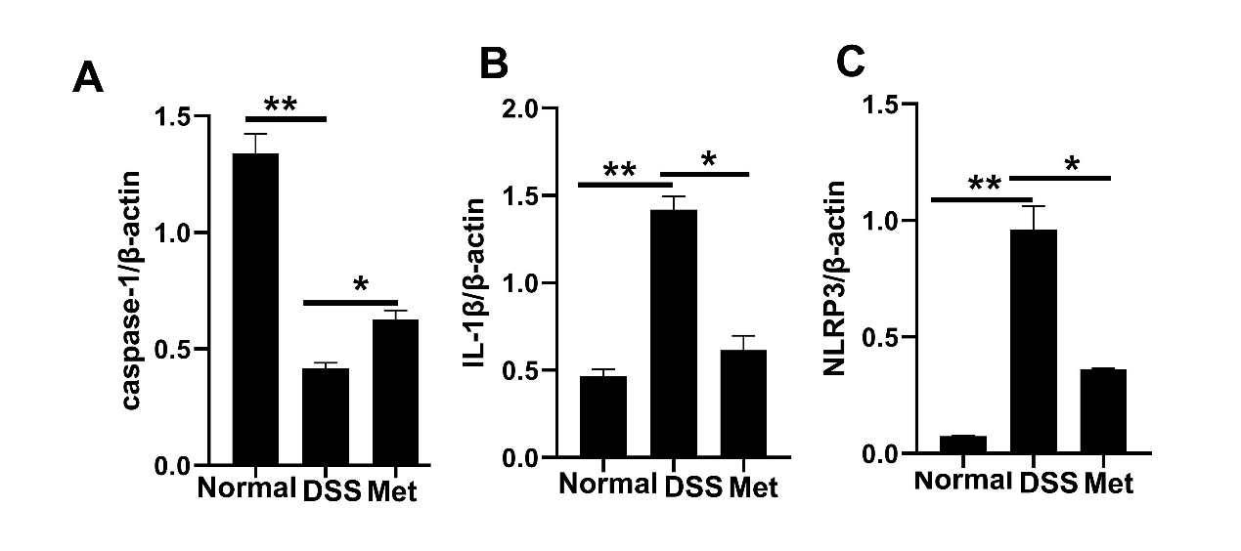
A: Relative levels of caspase-1secretion were determined by densitometry analysis of released caspase-1 in lysates, normalized to β-actin in lysates.
B : Relative levels of IL-1βsecretion were determined by densitometry analysis of released IL-1β in lysates, normalized to β-actin in lysates.
C: Relative levels of NLRP3 secretion were determined by densitometry analysis of released NLRP3 in lysates, normalized to β-actin in lysates.
*P ≤ 0.05, **P ≤ 0.01. Values are mean ± SEM. Data are representative of three independent experiments.

Supplementary Figure 2
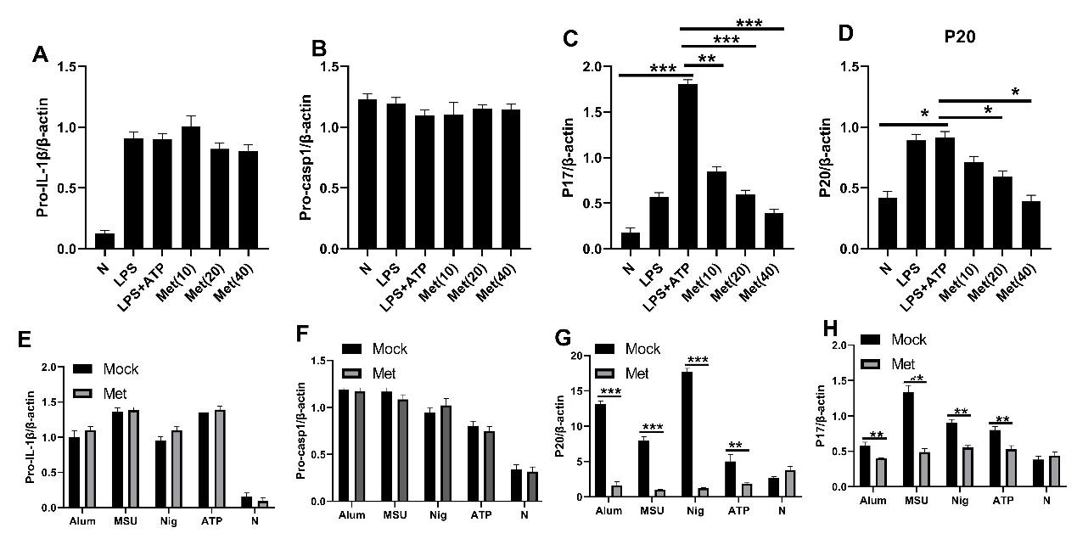
A: Relative levels of Pro-IL-1β secretion were determined by densitometry analysis of released Pro-IL-1β in lysates, normalized to β-actin in lysates.
B: Relative levels of Pro-casp1 secretion were determined by densitometry analysis of released Pro-casp1 in lysates, normalized to β-actin in lysates.
C: Relative levels of P17secretion were determined by densitometry analysis of released P17in supernatants, normalized to β-actin in lysates.
D: Relative levels of P20secretion were determined by densitometry analysis of released P20 in supernatants, normalized to β-actin in lysates.
E: Relative levels of Pro-IL-1β secretion were determined by densitometry analysis of released Pro-IL-1β in lysates, normalized to β-actin in lysates.
F: Relative levels of Pro-casp1 secretion were determined by densitometry analysis of released Pro-casp1 in lysates, normalized to β-actin in lysates.
G: Relative levels of P17secretion were determined by densitometry analysis of released P17in supernatants, normalized to β-actin in lysates.
H: Relative levels of P20secretion were determined by densitometry analysis of released P20 in supernatants, normalized to β-actin in lysates.
*P ≤ 0.05, **P ≤ 0.01, ***P ≤ 0.001. Values are mean ± SEM. Data are representative of three independent experiments.

Supplementary Figure 3
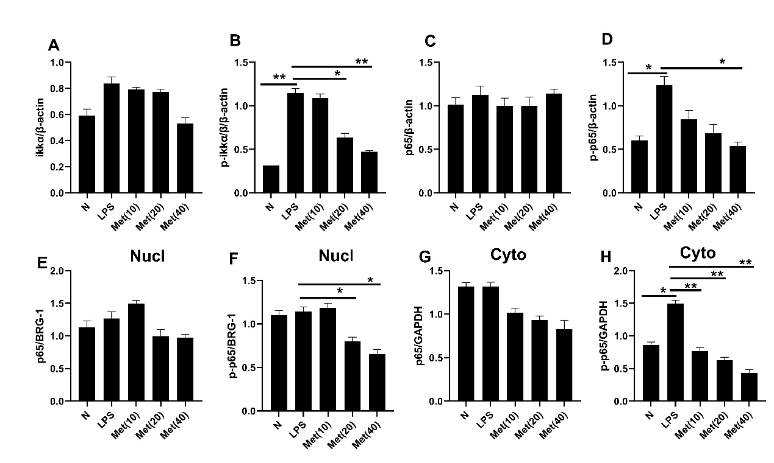
A: Relative levels of ikkα/βsecretion were determined by densitometry analysis of released ikkα/β in lysates, normalized to β-actin in lysates.
B: Relative levels of p-ikkα/β secretion were determined by densitometry analysis of released p- ikkα/β in lysates, normalized to β-actin in lysates.
C: Relative levels of P6 secretion were determined by densitometry analysis of released p65 in lysates, normalized to β-actin in lysates.
D: Relative levels of p-p65 secretion were determined by densitometry analysis of released p-p65 in lysates, normalized to β-actin in lysates.
E: Relative levels of P65 secretion were determined by densitometry analysis of released p65 in Nucl, normalized to BRG1 in lysates.
F: Relative levels of p-p65 secretion were determined by densitometry analysis of released p-p65 in Nucl, normalized to BRG1 in lysates.
G: Relative levels of P65 secretion were determined by densitometry analysis of released p65 in Cyto, normalized to GAPDH in lysates.
H: Relative levels of p-p65 secretion were determined by densitometry analysis of released p-p65 in Cyto, normalized to GAPDH in lysates.
*P ≤ 0.05, **P ≤ 0.01.Values are mean ± SEM. All of the experiment repeated three times and shown the representative result.

Supplementary Figure 4
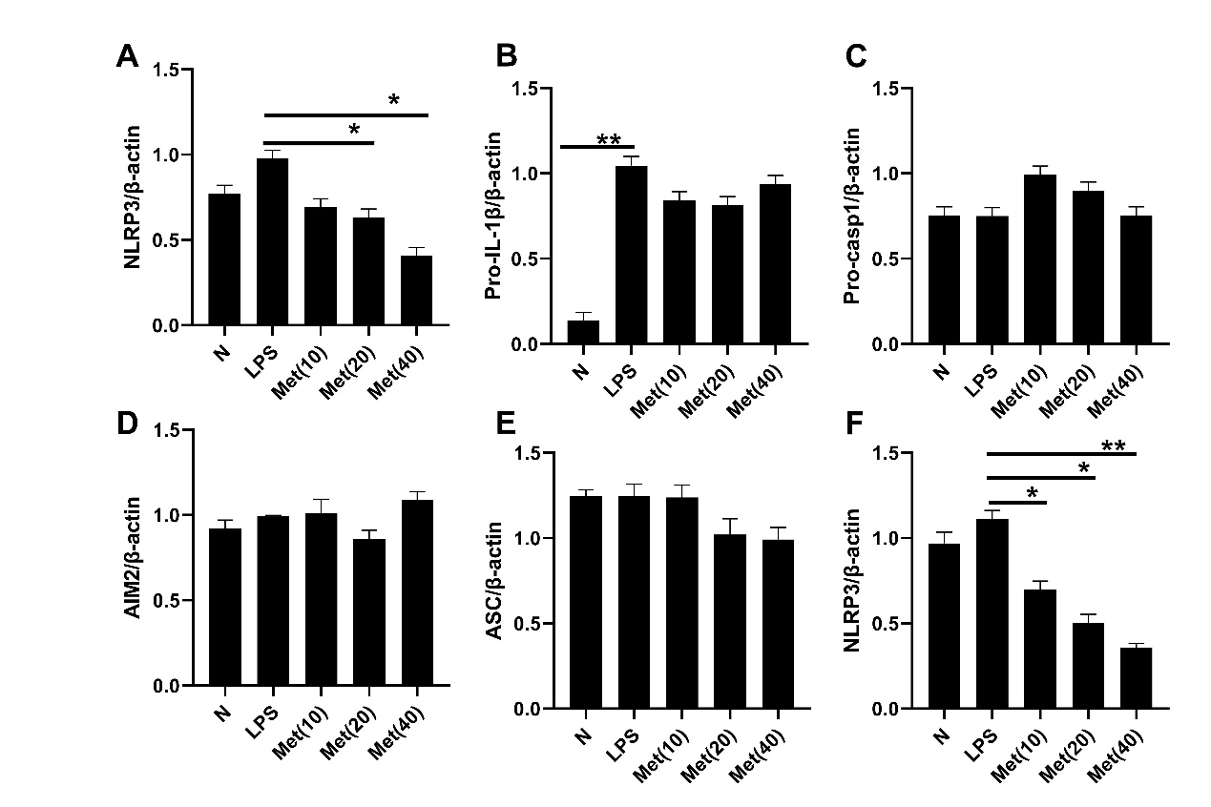
A: Relative levels of NLRP3secretion were determined by densitometry analysis of released NLRP3 in lysates, normalized to β-actin in lysates.
B: Relative levels of Pro-IL-1β secretion were determined by densitometry analysis of released Pro-IL-1β in lysates, normalized to β-actin in lysates.
C: Relative levels of Pro-casp1 secretion were determined by densitometry analysis of released Pro-casp1 in lysates, normalized to β-actin in lysates.
D: Relative levels of AIM2 secretion were determined by densitometry analysis of released AIM2 in lysates, normalized to β-actin in lysates.
E: Relative levels of ASC secretion were determined by densitometry analysis of released ASC in lysates, normalized to β-actin in lysates.
F: Relative levels of NLRP3 secretion were determined by densitometry analysis of released NLRP3 in lysates, normalized to β-actin in lysates.
*P ≤ 0.05, **P ≤ 0.01.Values are mean ± SEM. All of the experiment repeated three times and shown the representative result.
Supplementary Figure 5

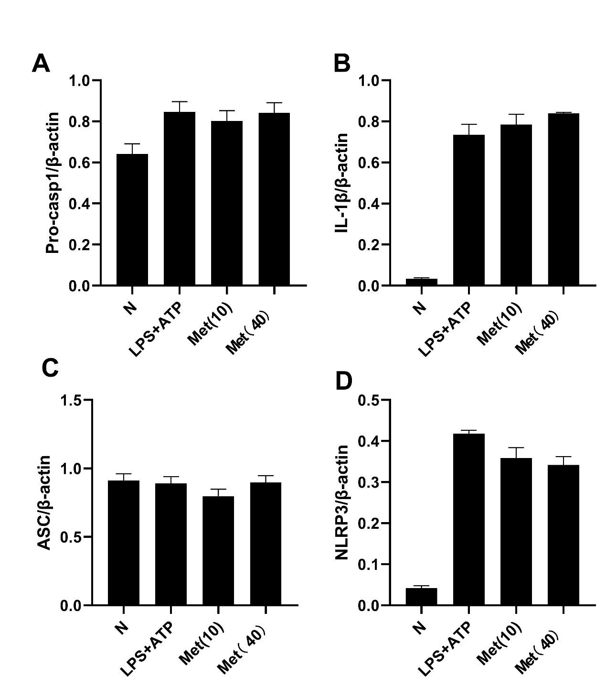
A: Relative levels of Pro-casp1 secretion were determined by densitometry analysis of released Pro-casp1 in lysates, normalized to β-actin in lysates.
B: Relative levels of Pro-IL-1β secretion were determined by densitometry analysis of released Pro-IL-1β in lysates, normalized to β-actin in lysates.
C: Relative levels of ASC secretion were determined by densitometry analysis of released ASC in lysates, normalized to β-actin in lysates.
D: Relative levels of NLRP3 secretion were determined by densitometry analysis of released NLRP3 in lysates, normalized to β-actin in lysates.

Supplementary Figure 6

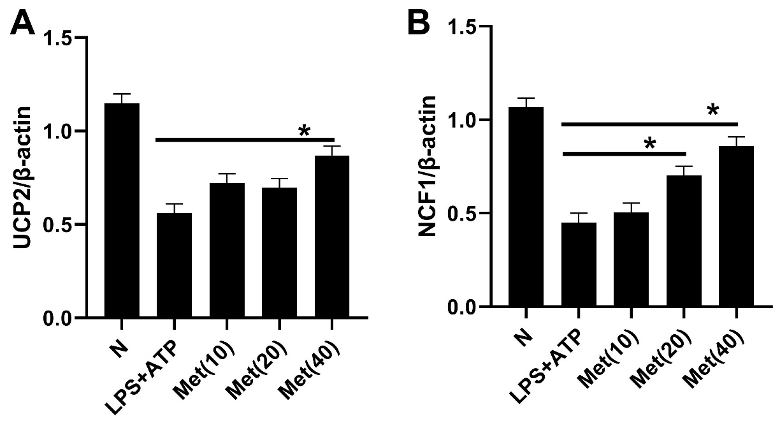
A: Relative levels of UCP2 secretion were determined by densitometry analysis of released UCP2 in lysates, normalized to LC3I in lysates.
B: Relative levels of NCF1 secretion were determined by densitometry analysis of released NCF1 in lysates, normalized to β-actin in lysates. *P ≤ 0.05. Values are mean ± SEM. All of the experiment repeated three times and shown the representative result.

