Supplementary figure and figure explaining

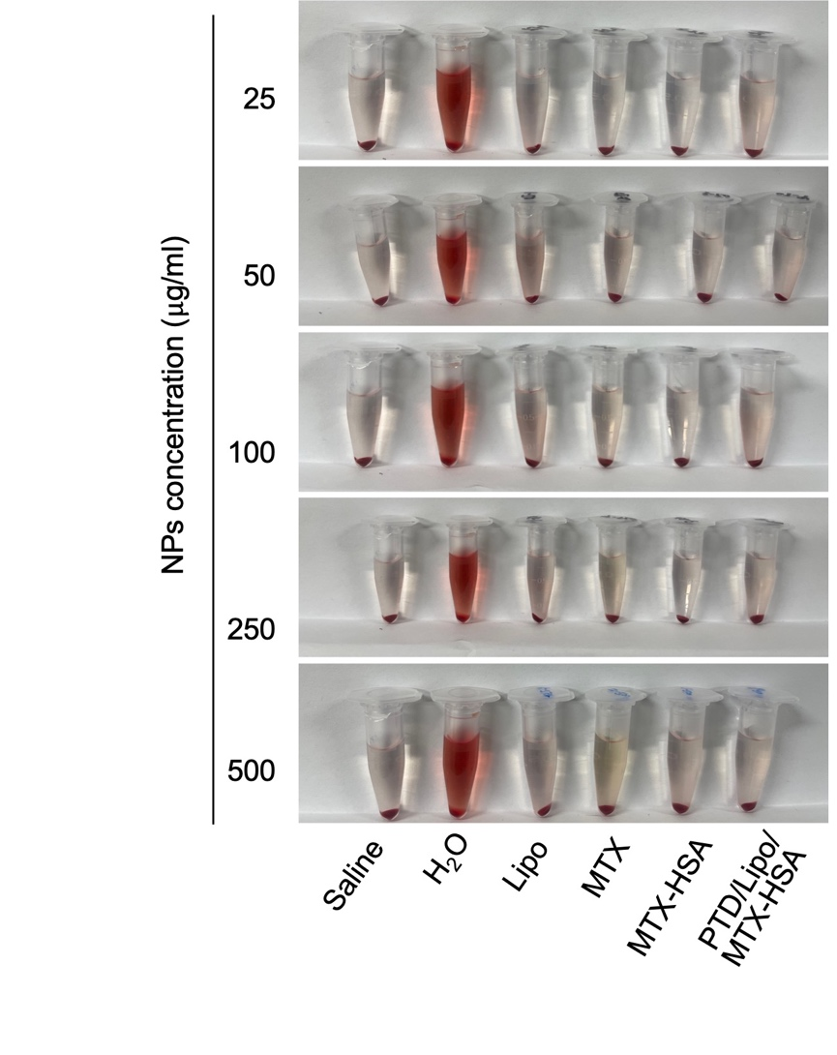
Figure S1. Partial characterization of formulations
Pictures of hemolysis in different preparations.

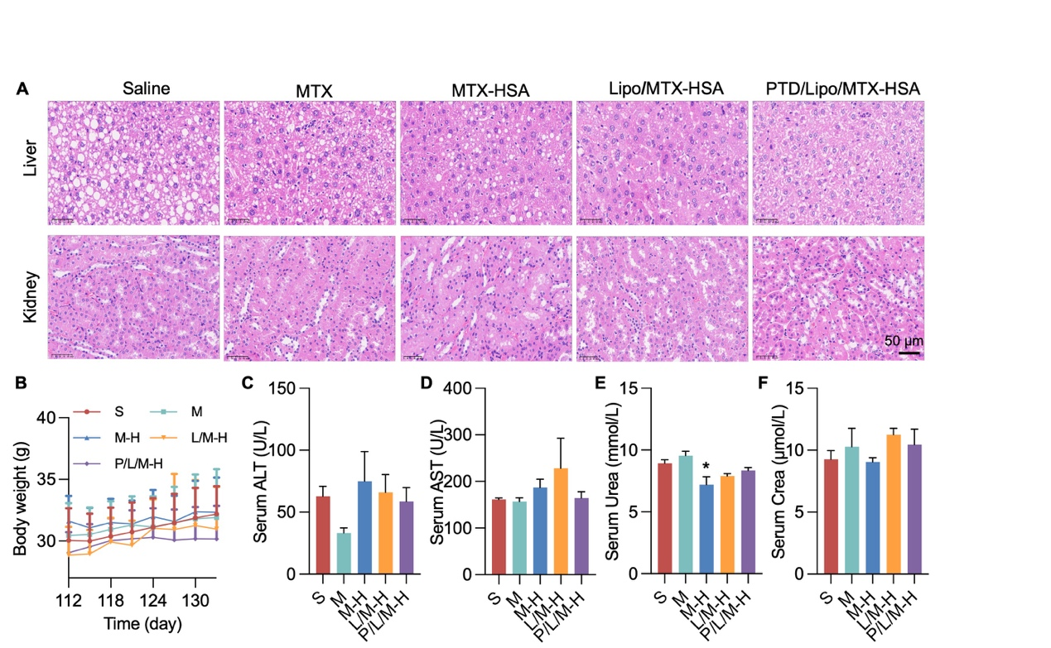
Figure S2. Drug safety for in vivo experiments
A. HE plots of liver and kidney tissue (scale 50 μm). B. Body weight monitoring of ApoE-/- mice; C, D, E, and F show the serum ALT, AST, urea and Crea levels, respectively. (S, saline; M, MTX; M-H, MTX-HSA; L/M-H, Lipo/MTX-HSA; P/L/M-H, PTD/Lipo/MTX-HSA; *, <0.05 vs saline)

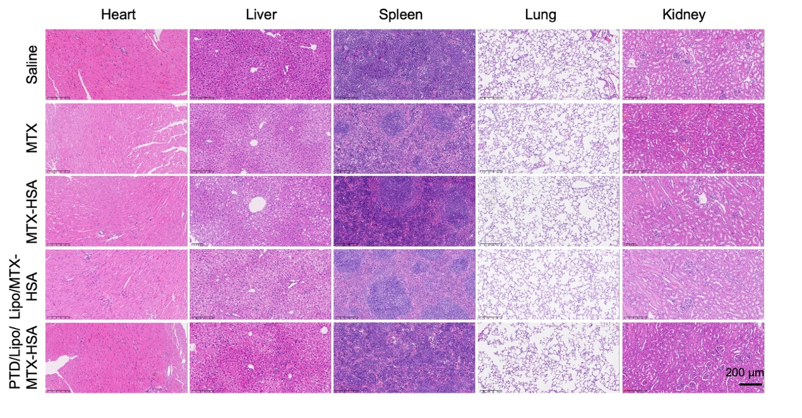
Figure S3. Drug safety for in vivo experiments and antiplaque effects
H&E plots of heart, liver, spleen, lung and kidney tissues (scale bar: 200 μm).

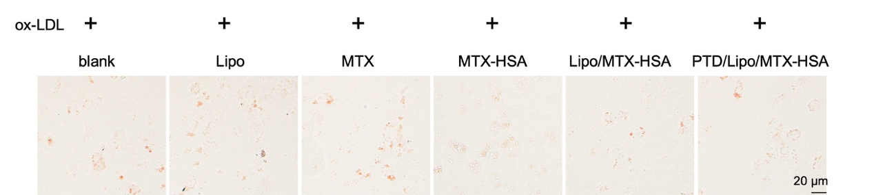
Figure S4. Oil red O staining of HASMCs
The model (ox-LDL), ox-LDL+Lipo, ox-LDL+MTX, ox-LDL+MTX-HSA, ox-LDL+Lipo/MTX-HSA and ox-LDL+PTD/Lipo/MTX-HSA preparations were treated with HASMCs, and white light imaging of oil red O staining was performed (scale 20 μm).

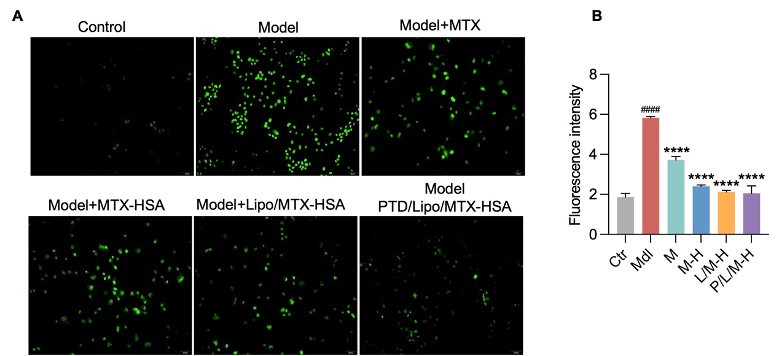
Figure S5. Antiadhesion effects of the nanomaterials in vitro
A. Adhesion imaging of THP-1 cells carrying the BCECF probe after treatment of HUVECs with the control, model (LPS), LPS+MTX, LPS+MTX-HSA, LPS+Lipo/MTX-HSA and LPS+PTD/Lipo/MTX-HSA preparations (scale 50 μm); B is a statistical graph of E. (Ctr, control; Mdl, model ox-LDL); M, model+MTX; M-H, model+MTX-HSA; L/M-H, model+Lipo/MTX-HSA; P/L/M-H, model+PTD/Lipo/MTX-HSA; ####, <0.0001 vs control; *, <0.05; **, <0.01; ***, <0.001; ****, <0.0001 vs Model)

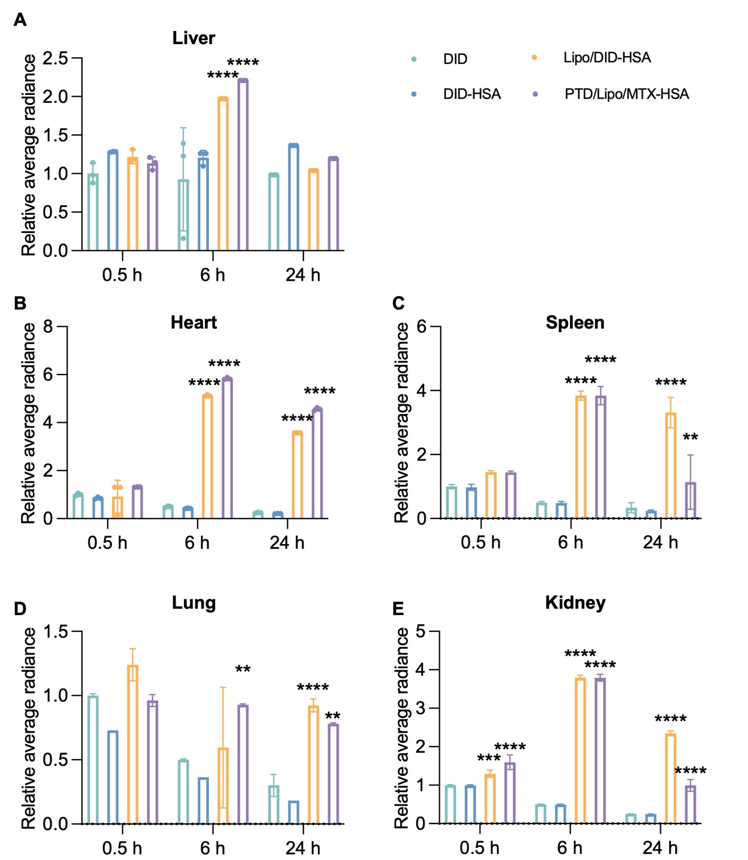
Figure S6. Statistical graphs of other organs images.
A．Liver; B. Heart; C. Spleen; D. Lung; E. Kidney. (**, <0.01 vs DID; ***, <0.001 vs DID; ****, <0.0001 vs DID)

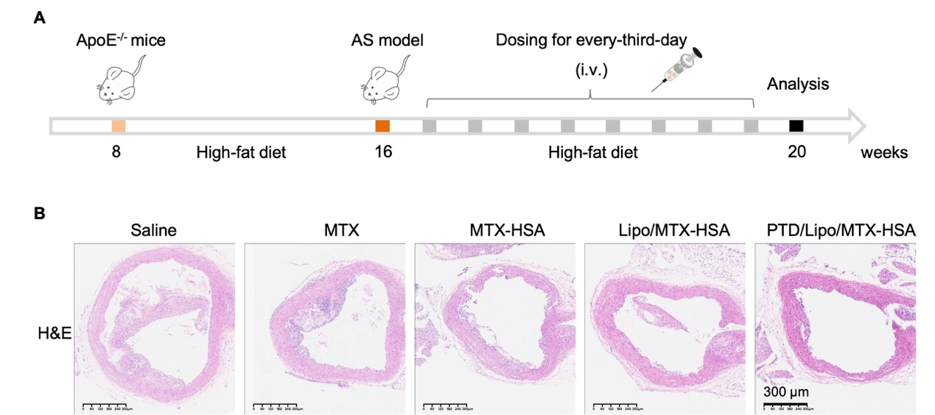
Figure S7. Schematic and antilipidemic effects of nanomedicines
A. Schematic of the model used for in vivo experiments. B. H&E-stained aortic arch tissues (scale bar: 200 μm).

