Supplementary Information of PAD4 Inhibitor-loaded Magnetic Fe₃O₄ Nanoparticles for Magnetic Targeted Chemotherapy and Magnetic Resonance Imaging of Lung Cancer
Yu Lu ^{a, b, †}, Xin Wang ^{a, b, †}, Yijiang Jia ^{a, b}, Shuai Zhang ^{a, b}, Jinkui Yang ^{c}, Qi Li ^{c}, Yuanming Li ^{d} *, Yuji Wang ^{a, b *}

- Results
Scheme S1 sythesis route of YW403. i) DCC, HOBt, NMM, THF; ii) 4M HCl/EA; iii) DCC, HOBt, NMM, THF; iv) H₂, Pd/C; v) DIPEA, MeOH.
1.1 Charactrization of YW403
ESI-MS (m/z): 477.28 [M+H]+；¹H NMR (300 MHz, DMSO-_{d6}) δ (ppm) = 8.76 (d, J = 7.9 Hz, 1H), 8.60 (t, J = 6.0 Hz, 1H), 8.23 (s, 1H), 7.92 (d, J = 7.8 Hz, 1H), 7.85 (d, J = 7.7 Hz, 1H), 7.76 (d, J = 7.5 Hz, 2H), 7.55 (dt, J = 18.7, 7.6 Hz, 3H), 7.43 (d, J = 7.4 Hz, 1H), 7.36-7.14 (m, 5H), 4.56 (s, 1H), 4.39 (s, 2H), 4.32 (d, J = 5.8 Hz, 2H), 3.26 (s, 2H), 2.00-1.73 (m, 2H), 1.65 (m, 2H).
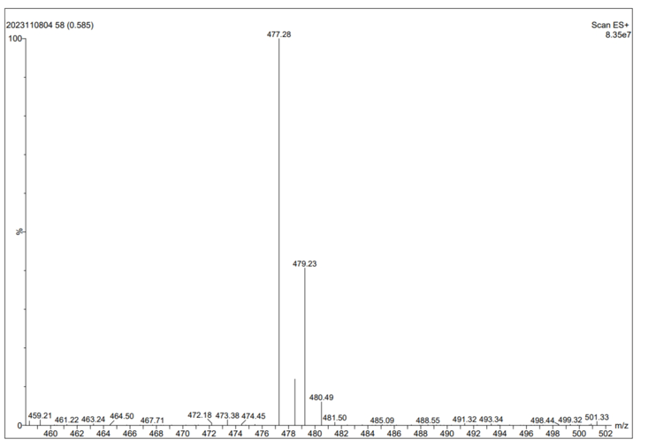
Figure S1 MS spectum of YW403
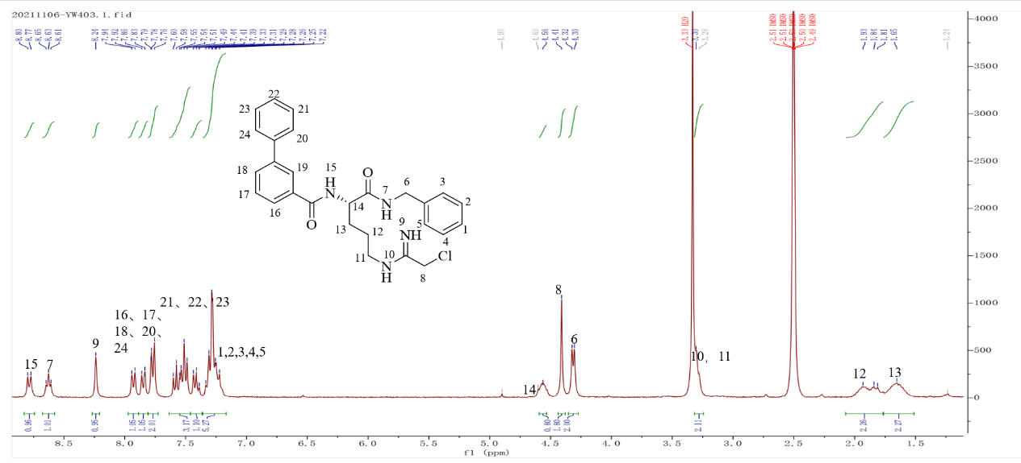
Figure S2 ¹HNMR spectrum of YW403 (300 MHz, DMSO-_{d6})
1.2 IR spectrograms
Figure S3. IR spectrograms of Fe₃O₄-OCMC, YW403 and YW403@Fe₃O₄-OCMC.
1.3 Body weight of C57 mice
Figure S4. Weight change of mice during administration
1.4 Organ index ratios of tumor-bearing mice
Figure S5 organ index ratios of tumor-bearing mice
1.5 Hematoxylin-eosin (HE) staining
Figure S6 HE-stained sections of organs after administration
2.1 Materials and methods
2.2 Preparation of Fe₃O₄-OCMC
EDC and sulfo-NHS activate the carboxyl group on carboxymethyl chitosan (OCMC) to amide with the amino group on Fe₃O₄, thus allowing OCMC to encapsulate Fe₃O₄ nanoparticles in a chemically cross-linked form. The specific steps are as follows:
25 mg of carboxymethyl chitosan (OCMC) was dissolved in 20 mL of MES buffer (containing 20 mM EDC, 50 mM sulfo-NHS) and activated for 30 min in an ice bath, followed by the addition of 50 mg of amino-modified Fe₃O₄, and shaking for 24 h at room temperature. At the end of the reaction, the magnetic nanocarrier Fe₃O₄-OCMC was magnetically collected and washed with anhydrous ethanol several times to remove unbound OCMC and other impurities. The magnetic nanocarrier Fe₃O₄-OCMC was then dialyzed with a dialysis bag in a refrigerator at 4 ℃ for 3 days to remove the unreacted Fe₃O₄ and obtain the magnetic carrier Fe₃O₄-OCMC.
2.3 Characterization of YW403@Fe₃O₄-OCMC MNPs
Transmission electron microscopy (TEM, JEM-2100, Japan) was used to observe the average particle size and morphological characteristics of Fe3O4, Fe3O4-OCMC, and YW403@Fe₃O₄-OCMC. 10 μL of the nanoparticle dispersion was aspirated and dropped onto the copper mesh, which was then dried thoroughly at 37 ºC for 7 days using an electric air drying chamber (Model 101-1AB, Tianjin Tester Instrument Co., Ltd., China). The transmission electron microscope operating voltage was 80 kV and images were recorded on an imaging plate (Gatan Bioscan Camera Model 1792) with an energy window of 10 eV, 6000-400,000X, and digitally magnified.
The infrared information of Fe₃O₄, OCMC, Fe₃O₄-OCMC, YW403, and YW403@Fe₃O₄-OCMC was collected by a Fourier transform infrared spectrometer (FTIR, Nicolet iS5), and the wavelengths were set in the range of 4000 cm⁻¹~500 cm⁻¹.
The UV absorption of Fe₃O₄-OCMC, YW403, and YW403@Fe₃O₄-OCMC in the range of 200-500 nm was measured using a UV spectrophotometer (UV-2600, Shimadzu, Japan) to collect UV spectral information.
Thermogravimetric analysis (TGA, Mettler, Switzerland) was performed on Fe₃O₄, Fe₃O₄-OCMC, YW403@Fe₃O₄-OCMC and YW403 powders.The temperature was set at 30~1000°C with a ramp rate of 10 °C/min, and the samples were placed and tested in an atmosphere of high-purity nitrogen using an alumina crucible.
The magnetic properties of Fe₃O₄, Fe₃O₄-OCMC, and YW403@Fe₃O₄-OCMC were tested using a vibrating sample magnetometer (VSM, LakeShore 7404, USA). Set the test temperature to 300 K and the test range to +20000 ~ -20000 Oe.
The crystal structures of Fe₃O₄, Fe₃O₄-OCMC, and YW403@Fe₃O₄-OCMC were investigated by X-ray diffractometer (XRD, Rigaku SmartLab SE). The test voltage is 40 kV and the current is 40 mA. Set the scanning range to 5-90 ° and the scanning rate to 2 º/min.
Different concentrations of YW403@Fe₃O₄-OCMC were dispersed in 0.5 mg/mL xanthan gum solution, and YW403@Fe₃O₄-OCMC were dispersed homogeneously using an ultrasonic instrument and a helical instrument, and the T2 values and resonance images were measured using the conventional spin-echo sequences in the magnetic resonance imager (MRI, Bruker, Germany) with a magnetic field strength of 7.0 T at 20 °C and pH 6.8. For measurements of their T2 relaxation times, a multiple spin-echo sequence with a TR of 3000 ms and viable TEs (TE = 11, 33, 55, 77 and 99 ms) was used. The common acquisition parameters were: 256 × 256 matrices, 50 × 50 mm field of view, and a slice thickness of 1.00 mm. The concentration of iron was quantified utilizing ICP-MS. Initially, a well-dispersed solution of YW403@Fe3O4-OCMC magnetic nanoparticles (MNPs) at a concentration of 180 μg/mL was subjected to a 1000-fold dilution prior to analysis via ICP-MS. A calibration curve was constructed using iron standard solutions, which facilitated the determination of an iron content of 31.27 ± 4.24%.
The YW403@Fe₃O₄-OCMC were dispersed in PBS buffer solution at pH 2, 5.5 and 7.4, and detected by a laser nanoparticle sizer (Nano-ZS90; Malvern Instruments Ltd, Malvern, UK) at five time points: 0.5 h, 24 h, 48 h, 72 h and 96 h. The Zeta potential of the YW403@Fe₃O₄-OCMC were measured at 0.5 h, 24 h, 48 h, 72 h and 96 h.
2.4 Cell culture
All cell culture protocols were performed under sterile conditions in a biosafety cabinet (1300 series A2, Thermo Fisher, USA). Cell culture medium requires the addition of 10% fetal bovine serum and 1% penicillin/streptomycin amphotericin B mixture. All cells were required to be cultured in a CO₂ incubator (HERACELL Vios 160i, Thermo Fisher) at 37 ºC and 5% CO₂ and passaged every 2-3 days to maintain logarithmic growth. LLC cells and 95D cells were cultured in DMEM medium containing 10% FBS; A549 cells was cultured in RPMI-1640 medium containing 10% FBS.
2.5 MTT
MTT (3-(4,5-dimethylthiazol-2)-2,5-diphenyltetrazolium bromide) colorimetric assay was used to detect the cell viability after different sample treatments. The cells were uniformly inoculated into 96-well plates at a density of 3×10³ cells/mL, 100 μL per well, and incubated in a cell culture incubator at 37 ºC with 5% CO₂ for 12 h. Then 25 μL of the test drug was added to the 96-well plate and incubated for 48 h. In the magnetic field group, a NdFeB permanent magnet (5 mm×3 mm cylinder with a surface magnetic field of 0.2 T) was placed under the 96-well plate, and the magnetic suction was performed for 0.5 h. After the magnetic suction was completed, the 96-well plate was taken out and placed in a cell culture incubator and continued to incubate for 47.5 h. At the end of the incubation, 25 μL of MTT solution at a concentration of 5 mg/mL was added to each well, and the incubation was continued for 4 h. After incubation, the supernatant was discarded, and 100 μL of DMSO was added to each well, and the OD values of each well were determined using an enzyme labeling instrument (Molecular Devices SpectraMax M3, Thermo, USA) after shaking on a cell shaker for 15 min, so as to make formazan fully dissolved.
Cell viability (%) = (OD-treated cells)/(OD control cells) × 100%
2.6 Cellular uptake assay
A549 cells were used for cellular uptake studies. Selected A549 tumor cells were inoculated in laser confocal dishes (5×10⁴ cells/mL) and incubated at 37 ºC, 5% CO₂ for 24 h in an incubator. After incubation, add serum-free medium to wash three times, add 3 mL of new complete medium, then add 100 μL of nanosolution of YW403&FITC@Fe₃O₄-OCMC to the laser confocal dish, and incubate for 8 hours at 37 ºC with 5% CO₂. After incubation, cells were washed three times by adding PBS solution, and 1 mL of 4% paraformaldehyde was added to the laser confocal dish and fixed for 20 min at room temperature. 200 μL of DAPI staining solution containing anti-fluorescence quencher was added to the laser confocal dish, stained for three minutes, observed by a STED ultra-high resolution confocal microscope (TCS SP8 STED, Leica, Germany), and photographed.
2.7 Cell migration assay
Transwell migration assay was used to detect the effect of YW403@Fe₃O₄-OCMC MNPs on A549 cell migration. Add 100 μL of cell suspension in serum-free medium to the upper chamber, add 600 μL of 10% serum-containing medium to the lower chamber, and incubate for 8 h with 25 μL of the test drug. In the magnetic field group, NdFeB permanent magnet (12 mm×3 mm cylinder, surface magnetic field 0.2 T) was placed under a 24-well plate for 0.5 h. Then the plate was placed in a cell culture incubator and incubated for 7.5 h at 37℃ with 5% CO₂. After incubation, the cells were washed twice, 4% paraformaldehyde was added, and the cells were fixed for 30 min. After washing, crystal violet staining solution was added to each well, and the cells were stained for 15 min. The staining solution was aspirated, and the chamber was washed with ultrapure water, then photographed under the microscope after drying and counted.
2.8 Bio-TEM observations
A549 cells were inoculated and cultured for 24 h. After incubation with the test drug for 16 h, the cells were washed three times, gently scraped with a cell scraper, added with electron microscope fixative (2.5% glutaraldehyde) and fixed at 4 ºC for 2 h. The fixative was removed, and cells were washed three times, each time for 15 min, by adding 0.1 M PB buffer solution. Then they were embedded in epoxy resin, and ultrathin sections of about 70 nm thickness were cut using a diamond knife and transferred to a copper mesh, and the sections were prepared and placed under a transmission electron microscope (TEM, JEM-2100, Japan) for observation and photographed.
2.9 Cell apoptosis by flow cytometry
After resuscitation of A549 cells for 24 h, 500 μL of the test drug was added to each well and incubated for 24 h at 37 ºC with 5% CO₂. In the magnetic field group, NdFeB permanent magnets (surface magnetic field 0.2 T) were placed under the wells and incubated for 0.5 h. After the magnetic field was finished, the cells were continued to be incubated for 23.5 h. Cells were collected and fluorescently stained with Annexin V-FITC and PI (propidium iodide) staining solution, and the cells were incubated at room temperature and protected from light for 20 min, and then placed in a flow cytometer (Becton, Dickinson and Company, USA) to detect the fluorescence intensity.
2.10 Cellular iron content by inductively coupled plasma-mass spectrometry
In order to evaluate the uptake of Fe₃O₄-OCMC, YW403@Fe₃O₄-OCMC and the effect of magnetic field on cellular uptake, resuscitated cultivated A549 cells were tested. Pipette the test drug into the medium and incubate for 8 h. In the magnetic field group, NdFeB permanent magnets (surface field 0.2 T) were placed under the dish and incubated magnetically for 0.5 h. After incubation, the incubator was incubated for 7.5 h at 37 °C with 5% CO₂. The cells were washed three times with PBS buffer solution by pipette aspiration, digested by trypsin and counted, digested by adding concentrated nitric acid, diluted to 10 mL and then detected by inductively coupled plasma-mass spectrometry (ICP-MS , Agilent) for iron content.
2.11 In vivo biosafety
Fresh blood was collected from the eyes of each group of mice. Blood for routine blood tests was added to a test tube containing saturated EDTA. Blood tests were performed with the URIT-5160Vet Hematology Analyzer. Tumors and organs were dissected and sectioned for HE staining.
2.12 Prussian blue staining
Paraffin sections were made from the tumors and tissues of mice in each group, and the paraffin sections were dewaxed to water sequentially, then Prussian blue stain A and Prussian blue stain B were mixed in equal proportions to form the Prussian blue stain, and the slices were stained in the stain for 1 h, and then washed with distilled water for two times. The nuclei were then stained with Prussian blue staining solution C for 3 min and rinsed with running water. After dehydration and sealing, the slices were examined by microscope, and the images were captured and analyzed.
2.13 Immunofluorescence
After paraffin sections were dewaxed to water, antigen repair was performed, and after repair was completed, they were cooled naturally. The slides were washed 3 times in PBS (pH=7.4), and the sections were shaken dry slightly and then sealed by drawing a circle around the tissue with a histochemical pen and sealing it with a drop of 3% BSA for 30 min. Add the prepared primary antibody (anti-histone H3 citrulline R2 antibody) dropwise and incubate at 4°C overnight. The slides were washed three times in PBS (pH=7.4), and the corresponding secondary antibody (HRP-labeled goat anti-rabbit IgG antibody) was added and incubated for 50 min at room temperature, protected from light. The slides were washed three times in PBS (pH=7.4), then DAPI staining solution was added and incubated for 10 min at room temperature away from light. After incubation, the slices were washed three times in PBS (pH=7.4), added with autofluorescence quencher B for 5 min, rinsed under running water for 10 min, and sealed with antifluorescence quenching sealer. Microscopic examination was used and images were captured and analyzed.
2.14 TUNEL
Paraffin sections were deparaffinized to water, shaken slightly dry, and a histochemical pen was used to draw a circle around the tissue (to prevent fluid from running off). Proteinase K working solution was added to the circle for proteinase K repair, and after a slight drying, membrane-breaking working solution was added to the circle (membrane-breaking solution is 0.1% triton. Configuration method is triton stock solution:PBS=1:1000) to cover the tissue. After incubation, the slices were washed, slightly shaken dry, and then buffer was added dropwise in the circle to cover the tissues and incubated for 10 min at room temperature. Take the appropriate amount of TDT enzyme, dUTP, and buffer in the tunel kit and mix them in the ratio of 1:5:50, add them to the circle to cover the tissues, and incubate for 1 hour at 37℃ in a thermostat. After incubation, the sections were taken out and washed three times with PBS buffer solution (pH=7.4) for 5 min each time. After removing PBS, DAPI staining solution was added dropwise in the circle and incubated for 10 min at room temperature and protected from light. The slices were washed 3 times in PBS buffer solution (pH=7.4). The slices were slightly dried and sealed with an anti-fluorescence quenching sealer. The slices were sealed and observed under a fluorescence microscope and images were captured.

