Supplement materials

Method
- Solubility assay
The solubility of progesterone in different solvents was determined as follows: 10mg progesterone was weighed and dispersed in 1mL respective solvents and vortexed. Subsequently, more corresponding solvent was added until the sample was complete dispersion. The drug content was detected using HPLC method after filtering using a 0.22μm syringe.

- Quantification of progesterone (HPLC/MS/MS)
A validated method of quantification of progesterone in vivo was developed in an API 3200 MD® HPLC/MS/MS system (AB SCIEX, US) using a Mars-C18 column(5.0μm, 150mm×4.6mm, Hming technologies, China) under 40 ◦C. The mobile phase used was A (0.1% formic acid) and B (acetonitrile, LC-MS grade) using a gradient system as Table S 2 3, with a flow rate of 0.5mL/min and an injection volume of 10 μL. The mass spectrometers were practice in the positive mode and the parameters consisted of desolvation gas flow (N₂) 300 L/hora, desolvation temperature (200℃), collision gas flow (Ar) 1 L/h, ionization source temperature at 150 ℃, capillary voltage (3.5 kV) and cone voltage (45 V), fragmentation voltage(118V), collision energy(8V), dry gas flow rate: 10L/min, dry gas temperature:350℃, atomization chamber pressure(40psi), capillary voltage(4000V). the MRM mode was applied to detect the ionic reactions of progesterone ([M+H]⁺, m/z 315.2~97.2) and methyl progesterone acetate ([M+H]⁺, m/z 385.2~325.3, internal standard).
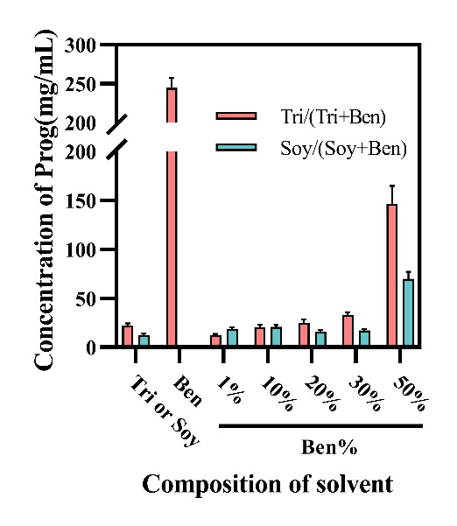
Figure S 1 Solubility of progesterone in different solvent.

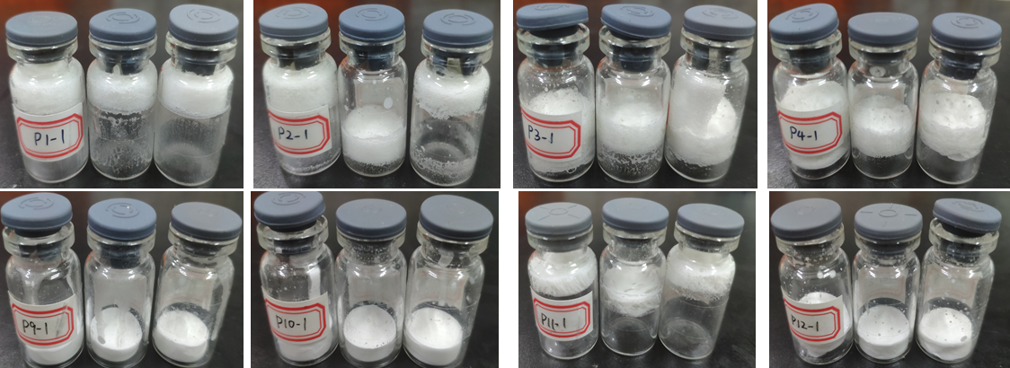
Figure S 2. Appearance of progesterone emulsion lyophilized powder added with different protectants

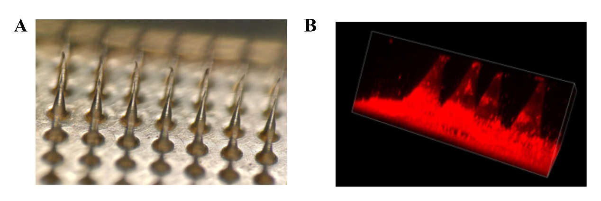
Figure S 3 Microscopic images(A) of progesterone MNs. 3D construction image(B) of Nile red loaded MNs acquired from CLSM.

Table S 1 Components of protectants for progesterone emulsion#
Groups  Formulations | P1 | P2 | P3 | P4 | P5 | P6 | P7 | P8 | P9 | P10 | P11 | P12
1 | 5% M | 10% M | 20% M | 30% M | 15% M | 15% M | 15% M | 15% M | - | 15% M | 15% M | 15% M
2 | 5% S | 10% S | 20% S | 30% S | 15% L | 15% T | 15% G | 15% D | 10% PVP | 10%PVP | - | 10% PVP
#Abbreviations: M: mannitol; S: Sucrose; L:Lactose; D: Dextran; G:Glucose; PVP: Povidone K30, Groups P9 described here is the selected one.

Table S 2 Parameters of microneedle template
Type of Patch | Size of Template | Height of Microneedle | Diameter of Microneedle | Count of Microneedle
Small | 15.8mm*15.8mm | 800 | 225 | 20*20
Medium | 16.7mm*16.7mm | 800 | 300 | 20*20
Large | 29mm*29mm | 800 | 310 | 39*39

Table S 3 Parameters of mobile phase
Time（min） | Phase A（%） | Phase B（%）
0.01 | 60 | 40
1.0 | 30 | 70
2.0 | 20 | 80
4.0 | 2 | 98
12.0 | 2 | 98
13.0 | 30 | 70
15.0 | 60 | 40

