primary source of infections | All(n=147) | Secondary  infection(n=43) | Without secondary infection(n=104)
Lung, n (%) | 58(39.46) | 15(34.88) | 43(41.35)
Abdomen, n (%) | 35(23.81) | 10(23.26) | 25(24.04)
Urinary tract infection, n (%) | 43(29.25) | 16(37.21) | 27(25.96)
Other sources, n (%) | 11(7.47) | 2(4.65) | 9(8.65)
Table S1: Primary source of infections

Table S2: Critical laboratory date in survivors and no-survivors
Laboratory date | All(n=147) | Survivor(n=109) | No-survivor(n=38) | p
PCT(ng/ml) | 18.8(6.1-50.9) | 18.5(5.8,42.78) | 19.86(101.69,7.37) | 0.256
PCT 72 h(ng/ml) | 8.52(3.02-25.9) | 7.81(2.82,20.58) | 17.63(3.94,67.6) | 0.041
ALB at adm(g/L) | 35.3(31.6-40) | 34.8(31.4,40.0) | 35.8(32.2,40.0) | 0.128
ALB 72h(g/L) | 36.5(33.05-39.5) | 36.2(33.0,39.2) | 37.4(33.2,41.2) | 0.622
PCT/ALB adm | 0.55(0.17-1.4) | 0.55(0.162,1.13) | 0.56(0.21,2.44) | 0.301
PCT/ALB 72 h | 0.24(0.08-0.71) | 0.21(0.07,0.56) | 0.53(0.10,1.64) | 0.047
ΔPCT/ALB adm-72h | 0.14(0.02-0.48) | 0.15(0.03,0.49) | 0.12(0.01,0.31) | 0.460

Table S3: Multivariate analysis of independent risk factors for secondary infection
Variable | B | SE | Wald | p-value | Odds ratio | 95% CI for odds ratio
 |  |  |  |  |  | Lower limit | Upper limit
ΔPCT/ALB adm-72h | 0.863 | 0.374 | 5.315 | 0.021 | 2.370 | 1.138 | 4.935
mechanical ventilation | 0.234 | 0.642 | 8.704 | 0.003 | 6.639 | 1.888 | 23.351
Adjusted for variables including age, sex, SOFA score, APACHE-II score, the primary source of infection, indwelling catheters and mechanical ventilation at ICU admission.

Table S4: Analysis of dead at 28-Days
Group | Number Dead at 28-Days(%) | Mortality rate（%） | p
1 | 7(19.44) | 19.44
2 | 9(24.32) | 24.32
3 | 10(27.03) | 37.03
4 | 12(32.43) | 32.43
According to the quartile of ΔPCT/ALB adm-72h , patients were divided into four groups: group 1 (>0.49), group 2 (0.15-0.48), group 3 (0.02-0.14) and group 4(<0.02).

Fig S1: Secondary infection of surviving patients and secondary outcomes in various groups
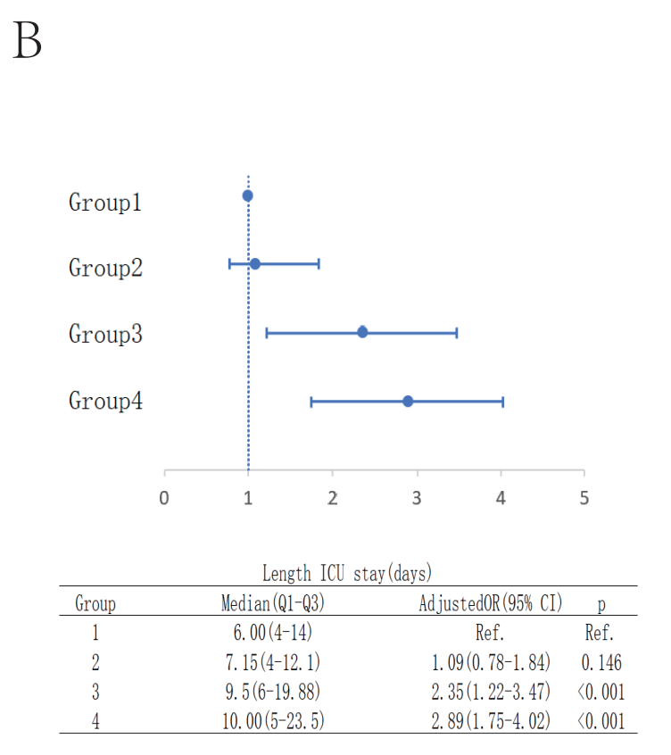
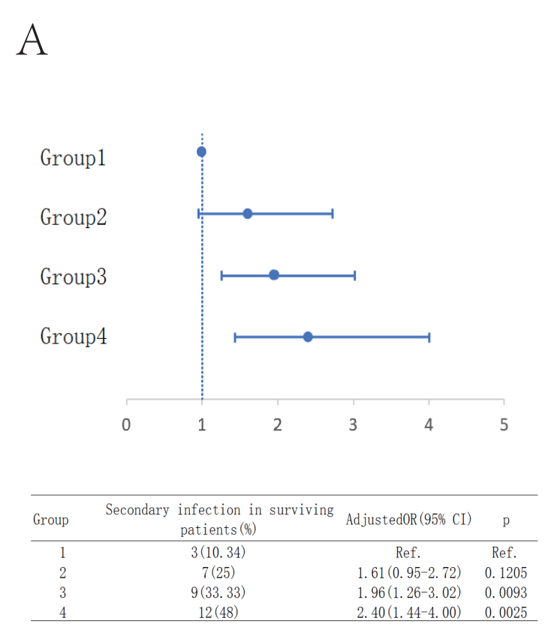

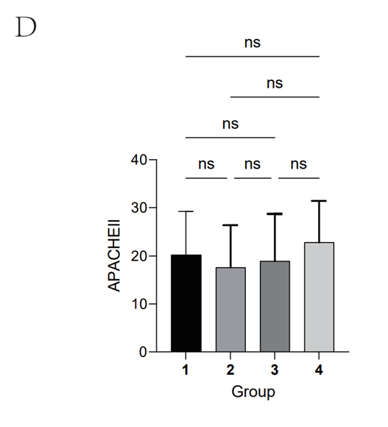
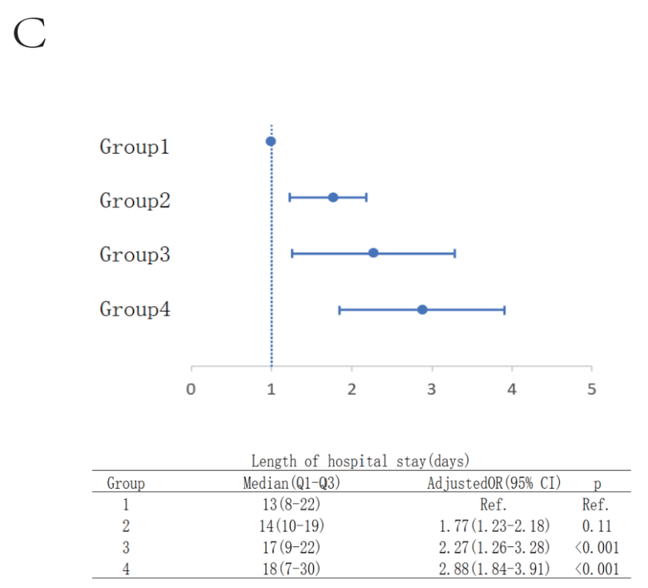

A-C：According to the quartile of ΔPCT/ALB adm-72h, patients were divided into four groups: group 1 (>0.49), group 2 (0.15-0.48), group 3 (0.02-0.14) and group 4(<0.02). Adjusted for variables including age, sex, SOFA score, APACHE-II score, the primary source of infection, indwelling catheters and mechanical ventilation at ICU admission. D：There was no significant statistical difference in APACHEII scores between different groups.

Fig S2: ROC curve analysis of predicting secondary infection in sepsis using PCT、ALB、PCT 72h、ALB72h、PCT/ALB adm、PCT/ALB 72h、△ PCT/ALB adm-72h

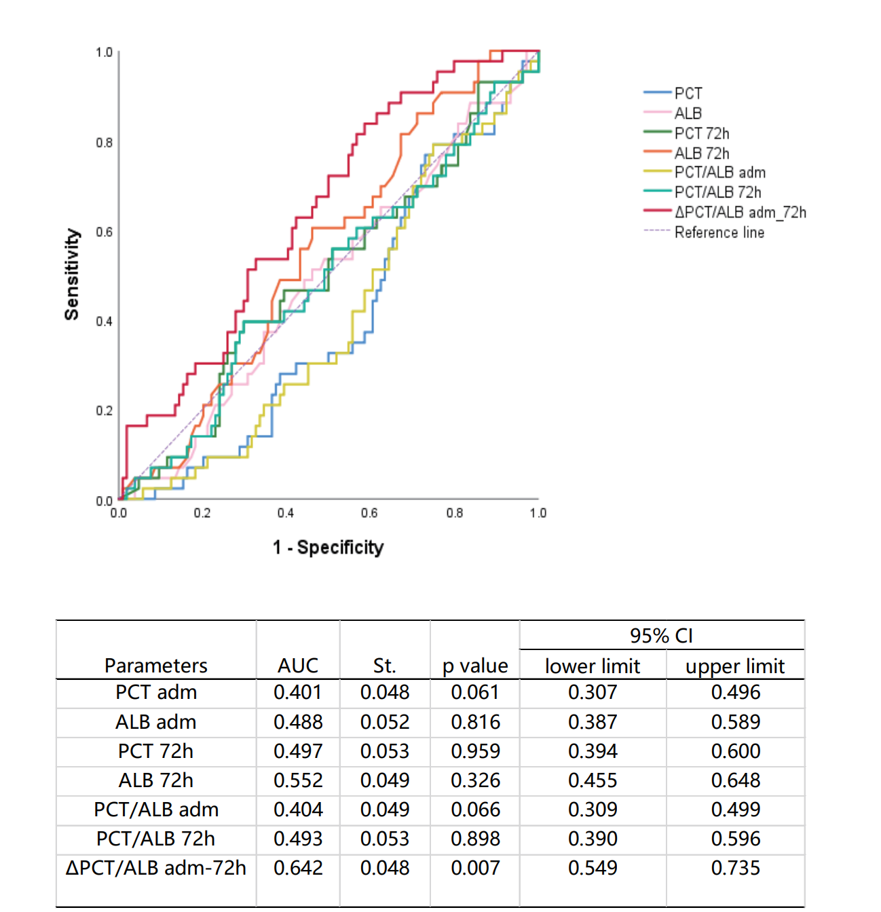
Performing ROC curve analysis on PCT, ALB, PCT 72h, ALB72h, PCT/ALB-adm, PCT/ALB 72h, and ΔPCT/ALB-adm-72h, the area under the curve for ΔPCT/ALB-adm-72h was 0.642 (p=0.007), while all other indicators had p＞0.05.

