Supplementary Material
Dynamic Complement Protein Changes in Aqueous Humor and Plasma of Patients with Retinal Vein Occlusion During Ranibizumab Treatment

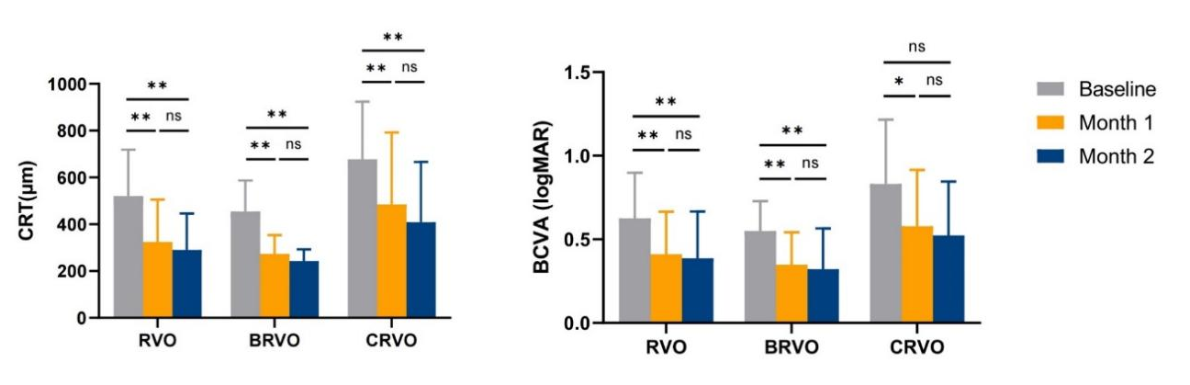
Supplement Figure 1. Changes in the mean CRT and the mean logMAR of BCVA during the course of 3 consecutive monthly IVR injections for the treatment of RVO. Error bars indicate the SD from the mean. * p＜ 0.05, ** p ≤ 0.01.
Abbreviations: CRT, central retinal thickness; BCVA, best-corrected visual acuity; logMAR, logarithm of minimal angle of resolution; IVR, intravitreal ranibizumab; RVO, retinal vein occlusion; BRVO, branch retinal vein occlusion; CRVO, central retinal vein occlusion; SD, standard deviation.
Supplementary Table S1. Correlation analysis of complement proteins and disease duration at baseline in the aqueous humor and plasma of RVO patients.
Variables  (ng/ml) | Aqueous humor |  |  |  |  | Plasma
Variables  (ng/ml) | ≤ 1m (n=12) | ＞1m (n=15) | r | p |  | ≤ 1m (n=12) | ＞1m (n=14) | r | p
C1q | 73.69 ± 80.70 | 54.92 ± 48.32 | 0.196 | 0.542 |  | 151810.00 ± 24948.26 | 161131.43 ± 28040.59 | 0.028 | 0.936
C2 | 716.35 ± 1023.02 | 268.02 ± 229.65 | 0.264 | 0.407 |  | 34714.08 ± 14787.96 | 31464.49 ± 14363.04 | -0.467 | 0.147
C4 | 436.74 ± 192.92 | 394.11 ± 195.97 | 0.209 | 0.515 |  | 1045220.00 ± 343768.00 | 1159088.57 ± 301740.34 | -0.637 | 0.035
C4b | 100.88 ± 89.77 | 99.80 ± 93.69 | 0.132 | 0.683 |  | 64943.20 ± 20220.64 | 77195.99 ± 22482.32 | -0.466 | 0.149
C3 | 397.75 ± 108.76 | 389.40 ± 135.85 | -0.343 | 0.275 |  | 1375246.67 ± 1693177.70 | 1298660.00 ± 830196.52 | -0.398 | 0.226
C3b/iC3b | 3958.53 ± 3268.29 | 3192.20 ± 2765.19 | 0.399 | 0.199 |  | 120493.33 ± 150907.58 | 110062.86 ± 59503.99 | -0.393 | 0.231
C5 | 431.56 ± 391.49 | 426.31 ± 488.20 | -0.118 | 0.715 |  | 27794.14 ± 6933.83 | 36448.11 ± 12346.79 | -0.589 | 0.057
C5a | 0.40 ± 0.36 | 0.36 ± 0.35 | -0.080 | 0.806 |  | 8.85 ± 3.29 | 10.00 ± 2.66 | -0.010 | 0.976
CFB | 256.62 ± 52.96 | 239.35 ± 106.02 | 0.109 | 0.736 |  | 319246.67 ± 80216.38 | 352705.71 ± 95251.03 | -0.307 | 0.358
CFD | 57.53 ± 28.87 | 59.51 ± 39.08 | 0.010 | 0.977 |  | 4646.67 ± 1594.29 | 7625.16 ± 9450.14 | -0.326 | 0.328
CFH | 400.17 ± 249.38 | 325.25 ± 204.05 | 0.394 | 0.205 |  | 482163.33 ± 93380.05 | 545271.43 ± 104442.92 | -0.237 | 0.483
CFI | 622.41 ± 476.56 | 481.07 ± 342.30 | 0.271 | 0.394 |  | 88101.22 ± 37557.07 | 95291.89 ± 30443.82 | -0.170 | 0.618
MBL | 0.51 ± 0.34 | 0.50 ± 0.74 | 0.340 | 0.280 |  | 3007.12 ± 2068.32 | 5955.75 ± 5867.64 | 0.523 | 0.099

Pearson correlation analysis the link between aqueous humor levels of complement proteins and disease duration.
Pearson correlation coefficients and P values are presented. Bold p < 0.05.
Abbreviations: RVO, retinal vein occlusion; CFB, complement factor B; CFD, complement factor D; CFH, complement factor H; CFI, complement factor I; MBL, mannose-binding lectin.

Supplementary Table S2. Correlation analysis of complement proteins and BCVA logMAR in the aqueous humor of RVO patients.

Variables | Baseline |  | Δ1 |  | Δ2
Variables | r | P | r | P | r | P
C1q | 0.382 | 0.054 | -0.010 | 0.963 | 0.151 | 0.525
C2 | 0.377 | 0.057 | -0.108 | 0.607 | -0.179 | 0.451
C4 | 0.285 | 0.158 | -0.053 | 0.803 | 0.135 | 0.571
C4b | 0.337 | 0.092 | -0.041 | 0.846 | -0.103 | 0.667
C3 | -0.260 | 0.199 | -0.286 | 0.166 | -0.210 | 0.375
C3b/iC3b | 0.264 | 0.193 | 0.099 | 0.636 | 0.221 | 0.350
C5 | 0.180 | 0.379 | 0.187 | 0.371 | 0.121 | 0.610
C5a | 0.249 | 0.219 | 0.175 | 0.401 | 0.039 | 0.870
CFB | -0.113 | 0.582 | -0.181 | 0.387 | 0.088 | 0.713
CFD | 0.360 | 0.071 | 0.028 | 0.894 | 0.239 | 0.311
CFH | 0.218 | 0.285 | -0.009 | 0.965 | 0.198 | 0.402
CFI | 0.262 | 0.197 | 0.051 | 0.808 | 0.186 | 0.434
MBL | 0.002 | 0.991 | -0.237 | 0.255 | -0.255 | 0.278
Pearson’s correlation analysis was used. Pearson correlation coefficients and P values are presented.
Δ1 = Change from baseline to month 1, Δ2 = Change from baseline to month 2.
Abbreviations: RVO, retinal vein occlusion; CFB, complement factor B; CFD, complement factor D; CFH, complement factor H; CFI, complement factor I; MBL, mannose-binding lectin.

