Figure S1: Goodness of fit of multivariate logistic regression prediction model in men

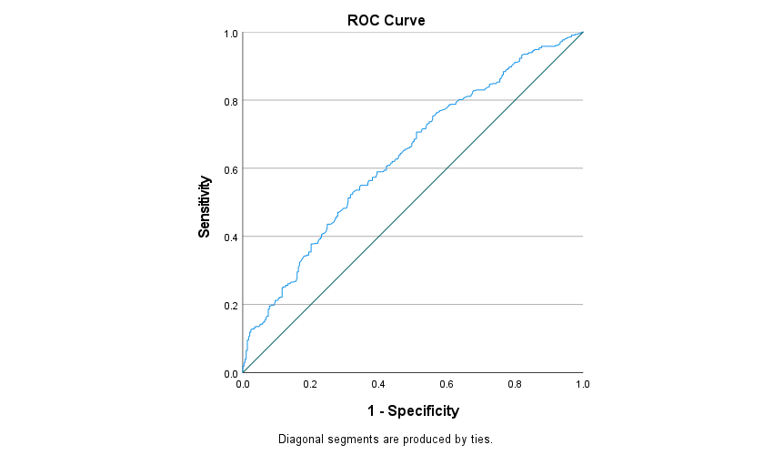

Figure S2: Goodness of fit of multivariate logistic regression prediction model in women

