Title: CircPRMT5, a potential salivary biomarker, facilitates the progression of head and neck squamous cell carcinoma via the IGF2BP3-SERPINE1 pathway

Supplementary Table S1: shRNA/siRNA sequences.
Gene | Sequence (5’-3’)
sh1-circPRMT5 | CAAGTTCTGGATGCGGGTA
sh2-circPRMT5 | TCCGGCTCCTCAAGTTCTG
sh-NC | TTCTCCGAACGTGTCACGT
si1-IGF2BP3 | GCACAUUUAAUUCCUGGAUUA
si2-IGF2BP3 | GCAGGAAUUGACGCUGUAU
si1-SERPINE1 | GCCACUGGAAAGGCAACAU
si2-SERPINE1 | CGAGUCUUUCAGACCAAGA
si-NC | UUCUCCGAACGUGUCACGU

Supplementary Table S2: qRT-PCR primers.
Gene | Forward Primer | Reverse Primer
circPRMT5 | GGCTGACCTCCCATCTAATCA | ACCCGCATCCAGAACTTGAG
PRMT5 | TGTCATTGATCGCTGGCTTG | ATGAGCCTCTGGTGCATCTT
GAPDH | CTCCTCCTGTTCGACAGTCAGC | CCCAATACGACCAAATCCGTT
IGF2BP3 | CTTCCTGGTGAAGACTGGCT | TATCCAGCACCTCCCACTGTAA
SERPINE1 | CGCTGTCAAGAAGACCCACA | CTCAGAGGTGCCTTGCGATT

Supplementary Table S3: Antibodies information.
Name | Item number | Company name
Mouse CD63 | 25682-1-AP | Proteintech
Mouse CD81 | 66866-1-Ig | Proteintech
Mouse TSG101 | 28283-1-AP | Proteintech
Mouse beta-Actin | T0022 | Affinity
Rabbit Ki67 | ab16667 | Abcam
Rabbit SERPINE1 | 13801-1-Ap | Proteintech
Rabbit IGF2BP3 | 14642-1-AP | Proteintech
Rabbit FMRP | 13755-1-AP | Proteintech
Rabbit pan-keratin | 26411-1-AP | Proteintech
CoraLite488-conjugated Goat Anti-Rabbit IgG(H+L) | SA00013-2 | Proteintech
HRP-conjugated Goat Anti-Rabbit IgG(H+L) | SA00001-2 | Proteintech
HRP-conjugated Goat Anti-Mouse IgG(H+L) | SA00001-1 | Proteintech
Goat Anti-Rabbit IgG H&L (HRP) | G1213 | Servicebio
Anti-Rabbit IgG HRP-linked Antibody | 7074S | Cell Signaling Technology

Supplementary Table S4: RIP primers.
Gene | Forward Primer | Reverse Primer
circPRMT5 | TGTCATTGATCGCTGGCTTG | TACCCGCATCCAGAACTTGA
SERPINE1 | CGCTGTCAAGAAGACCCACA | CTCAGAGGTGCCTTGCGATT

Supplementary Figure S1: Impact of circPRMT5 on the overall physiological condition of tumor-bearing mice. A Comparison of weight differences among subcutaneous tumor-bearing mice across various experimental groups. B Representative liver, kidney, and lung tissue images from mice with subcutaneous tumors. C Analysis of body weight changes in different groups of mice bearing orthotopic tumors. D Representative images of liver, kidney, and lung tissues from different groups of mice with orthotopic tumors. **p<0.01, ***p<0.001
Abbreviation: ns, not significant.

Supplementary Figure S2: Screening of RNA binding proteins specifically bound to circPRMT5. A Circintercome database predicts proteins binding directly to circPRMT5. B RIP was used to detect the binding efficiency of IGF2BP3 to circPRMT5 in HNSCC cells. ***p<0.001, ****p<0.0001.
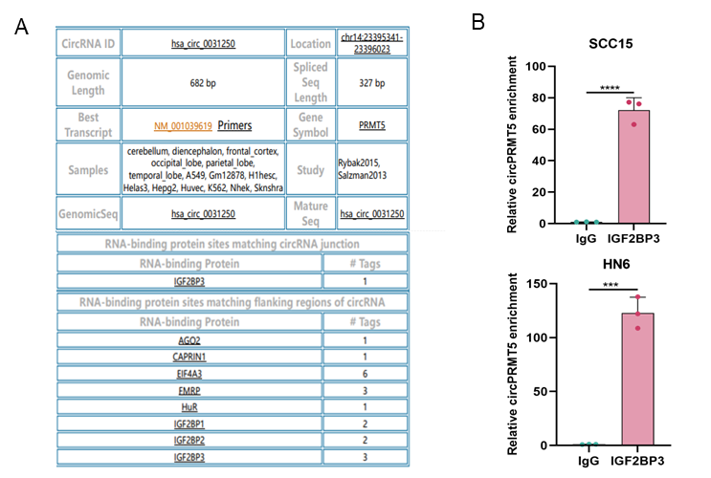

Supplementary Figure S3: Silencing IGF2BP3 impedes the proliferation, migration, and invasion of HNSCC cells. A The interference efficiency of IGF2BP3 siRNA, along with its impact on circPRMT5, was assessed using qRT-PCR. B The efficiency of IGF2BP3 interference at the protein level in HNSCC cells was evaluated. C The proliferation capacity of HNSCC cells was measured using the CCK8 assay. D Representative images and statistical analyses of HNSCC cell migration were obtained through a wound-healing assay. E Representative images and statistical analyses of HNSCC cell invasion and migration were conducted using the transwell assay. *p<0.05, **p<0.01, ***p<0.001, ****p<0.0001.
Abbreviation: ns, not significant.

Supplementary Figure S4: The suppression of SERPINE1 expression impedes the proliferation, migration, and invasion of HNSCC cells. A The interference efficiency of SERPINE1 siRNA and its impact on IGF2BP3 and circPRMT5 was assessed using qRT-PCR. B The efficiency of SERPINE1 interference at the protein level in HNSCC cells was evaluated. C The proliferative capacity of HNSCC cells was measured using the CCK8 assay. D Representative images and statistical analyses of HNSCC cell migration ability were obtained through a wound-healing assay. E Representative images and statistical analyses of HNSCC cell invasion and migration abilities were determined using the transwell assay. **p<0.01, ***p<0.001, ****p<0.0001.
Abbreviation: ns, not significant.

