Supporting Information
Development of Cytolytic Iridium-Complexed Octaarginine Peptide Albumin Nanomedicine for Hepatocellular Carcinoma Treatment
1. Experimental section
1.1Materials
1 M Tris-HCl buffer, chlorpromazine and cell freezing medium were purchased from BiyunTian Biotechnology Co., Ltd. Iridium standard was purchased from National Standard Testing and Certification Co., Ltd. [Ir(ppy)₂(H₂O)₂]OTf was purchased from Suzhou Nakai Technology Co., Ltd. The cRn peptide was purchased from Shanghai GL-Biochem Co., Ltd. The 3% phosphotungstic acid staining solution was purchased from Beijing Zhongjing Science Instrument Co., Ltd. Bosentan and thiazole blue (MTT) were purchased from Shanghai Titan Scientific Co., Ltd. Ibuprofen was purchased from MedChemExpress. Digitalis glycoside and polyethylene glycol 8000 (PEG 8000) were purchased from Shanghai Macklin Biochemical Co., Ltd. Bovine serum albumin (BSA) powder was purchased from Shanghai Sangon Biotech Co., Ltd. CCK-8, propidium iodide (PI), cell relaxin D, streptomycin and 20× PBS buffer were purchased from Dalian Meilun Biotechnology Co., Ltd. Fetal bovine serum, RPMI 1640 medium and DMEM were purchased from Gibco Company, USA. 100× antibiotics (penicillin-streptomycin mixed solution) and 0.25% trypsin digestion solution were purchased from American HyClone Company. The lysosome fluorescent probe dye LysoTracker Red DND-99 was purchased from Invitrogen Company, USA. Mice were obtained from Suzhou Jingweiyu Biotechnology Co., Ltd. Oxaliplatin was purchased from Sain Chemical Technology (Shanghai) Co., Ltd. Red blood cell lysis buffer and neutral 4% paraformaldehyde fixative were purchased from Wuhan Servicebio Technology Co., Ltd. Mouse macrophage colony-stimulating factor (M-CSF), interleukin-4 (IL-4) and mouse granulocyte-macrophage colony-stimulating factor (GM-CSF) were purchased from Pepro Tech Biotechnology Co., Ltd. New Zealand White rabbits were obtained from Suzhou Gaoxin District Zhenhu Experimental Animal Co., Ltd. D-luciferin sodium salt was purchased from J&K Scientific Co., Ltd. Hydrochloric acid, nitric acid, alcohol and perchloric acid were purchased from China National Pharmaceutical Group Chemical Co., Ltd. Standard matrix gel was purchased from Shanghai NovaPharm Pharmaceutical Technology Co., Ltd.
1.2 Preparation of Ir-cR8-BSA-NP
(1) Standard curve generation: 1000 μM Ir-cR8 was diluted in 1× pH 7.4 PBS buffer to concentrations of 0.625, 1.25, 2.5, 5, 10 and 20 μM. Fluorescence emission intensity was measured at 520 nm after excitation at 328 nm to generate a standard curve at 520 nm.
(2) Mixture preparation: Bovine serum albumin (BSA) powder was weighed and dissolved in sterile ultrapure water to prepare a 1000 μM solution. The Ir-cR8 stock solution was diluted to 1000 μM. Equal volumes of BSA solution and Ir-cR8 solution were mixed in an EP tube in a 1:1 molar ratio and allowed to stand for 2 hours at room temperature.
(3) Ultrafiltration: The prepared Ir-cR8-BSA-NP were diluted to 10 μM in 1× PBS buffer (pH 7.4). The mixture was loaded into a 10 kDa ultrafiltration centrifuge tube and centrifuged (6000 rpm, 10 min).
(4) Detection: The emission intensity of Ir-cR8 in the liquid was measured after ultrafiltration using a fluorescence spectrophotometer. Finally, the drug loading rate of bovine serum albumin was calculated from the standard curve.
2. Cellular experiments
2.1 The ζ (zeta) potential of cells
Cells in the logarithmic growth phase, such as H22 cells or induced BMDCs and BMDMs, were resuspended in 1× pH 7.4 PBS buffer. After counting, the cell density was adjusted to 10^5 cells/ml and the zeta potential (ζ) of these three cell types was measured.
2.2 The cellular uptake pathway of Ir-cR8-BSA-NPs
(1) To generate a standard curve, 500 μM Ir-cR8-BSA-NP was diluted in 1640 base medium to concentrations of 0.78125, 1.5625, 3.125, 6.25, 12.5 and 25 μM. The fluorescence emission intensity at 520 nm was scanned with excitation at 328 nm for each solution and the concentration was determined using the Em520 nm standard curve equation.
(2) For cell seeding, H22 cells in the logarithmic growth phase were digested, centrifuged and resuspended in 1640 base medium. The H22 cell density was adjusted to 10^5 cells/ml. Three millilitres of the H22 cell suspension was added uniformly to each well of a 6-well cell culture plate to ensure a cell number of 3 × 10^5 cells in each well. Three parallel groups were used for the control group, the endocytosis pathway inhibition group and the energy inhibition group.
(3) Pre-incubation with endocytosis inhibitors: Inhibitors of specific endocytic pathways, including nystatin (NY, working concentration 9 μg/mL) for caveolin-mediated endocytosis, chlorpromazine (CPZ, working concentration 2.5 μg/mL) for clathrin-mediated endocytosis, and cytochalasin D (CytoD, working concentration 2.5 μg/mL) for macropinocytosis, were added to each endocytosis inhibition group. Cells were incubated in a cell culture incubator at 37°C and 5% CO₂ for 1 hour.
(4) Ir-cR8-BSA-NPs incubation: After pre-incubation, Ir-cR8-BSA-NP was added directly to reach a working concentration of 5 μM. The cells in the endocytosis inhibition group and the control group were incubated at 37°C in 5% CO₂ for 2 hours, and the cells in the energy inhibition group were incubated at 4°C in a refrigerator for 2 hours.
2.3 The intracellular distribution of Ir-cR8-BSA-NPs
(1) For cell seeding, H22 cells in logarithmic growth phase were digested, centrifuged and resuspended in complete culture medium (RPMI 1640 + 10% FBS + 1% antibiotics). The H22 cell density was adjusted to 4 × 10^5 cells/mL, 1 mL of H22 cell suspension was added to a 20 mm diameter glass bottom dish, and the mixture was incubated at 37°C in a 5% CO₂ incubator for 24 hours.
(2) Ir-cR8-BSA-NPs preincubation: After discarding the supernatant, the cells were gently washed once with 1× PBS buffer (pH 7.4). Ten μM Ir-cR8-BSA-NPs (diluted in 1640 base culture medium) was added and incubated for 1 hour in a 37°C, 5% CO₂ incubator.
(3) Lysosome staining incubation: After discarding the supernatant, the cells were gently rinsed twice with 1× pH 7.4 PBS buffer. The lysosome fluorescent probe dye LysoTracker Red DND-99 was diluted to 200 nM in 1640 base culture medium and incubated at 37°C and 5% CO2 for 15 minutes.
(4) For confocal microscopy, the medium was removed in the dark and the cells were gently rinsed three times with 1× pH 7.4 PBS buffer after the supernatant was discarded. Finally, the colocalization of Ir-cR8-BSA-NPs with lysosomes was observed by laser confocal microscopy.
2.4 The toxicity of Ir-cR8, Ir-cR8-BSA-NPs and oxaliplatin on H22 cells was detected using CCK-8 assay.
(1) Ir-cR8, Ir-cR8-BSA-NPs preparation: 1000 μM Ir-cR8, which was well coordinated, was taken and diluted to 256 μM with 1640 basal medium, and sequentially twofold diluted. Take 500 μM Ir-cR8-BSA-NPs as above.
(2) Oxaliplatin preparation: weigh oxaliplatin powder, dilute to 2048 μM with 1×PBS buffer, and standby by two-fold dilution sequentially
(3) Cell spreading and drug incubation: H22 cells in logarithmic growth phase were digested and centrifuged, and resuspended in 1640 basal medium. After cell counting, the density of H22 cells was adjusted to 4×10⁵ mL⁻¹, and 50 μL of H22 cell suspension was added uniformly to each well of a 96-well cell culture plate, so that the number of cells in each well was 2×10⁴. 50 μL of Ir-cR8/Ir-cR8-BSA-NPs/oxaliplatin was added according to the concentration gradient (at this time, the final concentration of each drug was 1/2 of the original), and the 1640 basal medium was added as a control. 1640 basal medium was added as control, and blank wells were set up. Three parallel groups were set up for each concentration of the above drugs. Finally, 100 μL of PBS buffer was added to each well of the outer layer of the 96-well cell plate, and the cells were incubated at 37℃ for 24 h in an incubator with 5% carbon dioxide.
(4) Measurement: After 24 h incubation, 10 μL of CCK-8 assay solution was added to each well in turn, and the incubation was continued in the incubator for 2 h. Finally, the absorbance at 450 nm was read by using an enzyme marker, and the IC50 value of half inhibitory concentration was calculated.
2.5 Detect the toxicity of Ir-cR8, Ir-cR8-BSA-NPs and oxaliplatin on VX2 cells using thiazolyl blue (MTT) method.
(1) Ir-cR8, Ir-cR8-BSA-NPs and oxaliplatin preparation.
(2) Cell spreading: VX2 cells in logarithmic growth phase were digested and centrifuged, and resuspended in 1640 complete medium. After cell counting, the density of VX2 cells was adjusted to 8×10⁴ mL⁻¹. 100 μL of VX2 cell suspension was added uniformly to each well of a 96-well cell culture plate, so that the number of cells in each well was 8×10³. 100 μL of PBS buffer was added to each well of the outer layer of the 96-well plate, and then it was placed in the incubator at 37 ℃ with 5% carbon dioxide for 24 h. The cells were then incubated for 24 h in the incubator.
(3) Drug incubation: Discard the culture medium in the 96-well plate, add 100 μL of Ir-cR8/Ir-cR8-BSA-NPs/Oxaliplatin in accordance with the concentration gradient, and add 1640 basal medium as a control group and set up blank wells. Three parallel groups were set up for each concentration of drugs above.
(4) Measured data: After incubation for 24 h, the drug culture solution was discarded from the 96-well plate, 120 μL of 1640 basal medium containing MTT (0.83 mg-mL⁻¹) was added to each well, and incubation was continued in the incubator for 4 h. MTT was discarded from the 96-well plate, and 150 μL of DMSO was added and shaken, to fully dissolve the mezanine in the wells, and then finally the absorbance luminance value of 490 nm was read with the zymography. Finally, the absorption luminosity value at 490 nm was read using an enzyme marker, and the IC50 value of half inhibitory concentration was calculated.
3. Tumor models
3.1 In vivo pharmacokinetics of Ir-cR8-BSA-NPs
(1) For serum preparation, 100 μL of 1× pH 7.4 PBS buffer, Ir-cR8 (500 μM) or Ir-cR8-BSA-NPs (500 μM) was added by tail vein injection to 6- to 8-week-old BALB/c mice. For the Ir-cR8 group, blood was collected from the eye at 0.017, 1.5, 4, 8, 24 and 48 hours post injection. For the Ir-cR8-BSA-NPs group, blood was collected at 1.5, 4, 8, 24 and 48 hours post injection. Three mice were collected at each time point. Serum was collected after centrifugation (10,000 rpm, 8 min).
(2) For serum sample processing, 100 μL of the supernatant was collected, to which 1 mL of perchloric acid and 4 mL of aqua regia (hydrochloric acid: nitric acid = 3:1, v/v) were added sequentially. The mixture was heated to 260 ℃ until digestion was complete and the liquid residue was approximately 1 mL. Sterile ultrapure water was added to bring the total volume to 10 mL.
(3) Standard curve preparation and detection: The 1000 ppm standard solution was diluted with sterile ultrapure water to concentrations of 0.78125, 1.5625, 3.125, 6.25, 12.5, 25, 50 and 100 ppb, after which the standard curve equation was obtained. Finally, the iridium content in each group was measured by ICP-MS.
3.2 Arterial infusion dosage of Ir-cR8-BSA-NPs/oxaliplatin
According to the body surface area conversion formula, Dose(b) = Dose(a) × (kb/ka) × (Wb/Wa) ^{(2/3)}, the dosage for the arterial infusion treatment of Ir-cR8-BSA-NPs and oxaliplatin was calculated. Where Dose(a) is the known dose for animal a (mg/m2); Dose(b) is the desired dose for animal b (mg/m2); ka and kb are body surface area coefficients as shown in Table S1; and Wa and Wb are the weights of the animals in kilograms.
3.3 Arterial infusion treatment of VX2 orthotopic tumors with Ir-cR8-BSA-NPs/oxaliplatin
Rabbits were anesthetized intravenously with 3% pentobarbital sodium (30 mg·kg^-1) via the marginal ear vein. The dose was maintained at 0.5 mL/30 min. The right inguinal area was prepared, disinfected, and draped. After identifying the femoral artery pulse, an incision was made along its course following longitudinal skin cutting. The femoral artery sheath was exposed by separating the subcutaneous and muscle tissues. Using a small vascular stripper, the femoral artery sheath was removed, exposing around 2 cm of the femoral artery. The near and far ends of the artery were then threaded with surgical sutures, and the near-end suture was tightened to temporarily block blood flow. Following successful puncture with an 18G needle, the needle core was removed, and a 2.6 F microcatheter was inserted into the sheath. Abdominal angiography was performed at the T12-L1 level to confirm the opening of the hepatic artery. Selective catheterization was then carried out on the proper hepatic artery/left hepatic artery. Following confirmation of adequate tumor imaging through digital subtraction angiography (DSA), PBS, Ir-cR8-BSA-NPs, and oxaliplatin were injected through the catheter. Following the procedure, the microcatheter and sheath were removed, and the femoral artery was ligated and sutured layer by layer. Postoperatively, penicillin sodium (40 WU/d) was administered intramuscularly for three consecutive days to prevent infection.

Appendix Figure:

Table S1:Body surface area coefficients (k) for different animals.
Animals (standard weight). | Mouse | Hamster | Rat | Guinea pig | Rabbit | Cat | Dog | Monkey | Human
body surface area coefficient | 0.0899 | 0.0862 | 0.086 | 0.092 | 0.1014 | 0.1086 | 0.1077 | 0.118 | 0.10

Table S2: Blood biochemical changes in liver function in various groups of mice
 |  | ALT(U/L) | AST(U/L) | TP(g/L) | ALB(g/L) | TBIL(μmol/L) | ALP(U/L) | LDH(U/L)
Healthy control |  | 46.31±7.69 | 150.08±19.75 | 41.44±1.01 | 30.28±0.25 | 25.26±1.24 | 219.86±121.37 | 449.98±25.51
Ir-cR8-BSA-NPs |  | 49.32±6.28 | 148.73±12.19 | 44.92±1.49 | 33.52±1.03 | 29.22±10.63 | 292.95±53.86 | 436.22±12.79
Oxaliplatin |  | 40.06±2.90 | 141.75±39.73 | 44.74±1.31 | 34.77±0.51 | 34.24±7.70 | 218.89±45.73 | 434.19±39.09

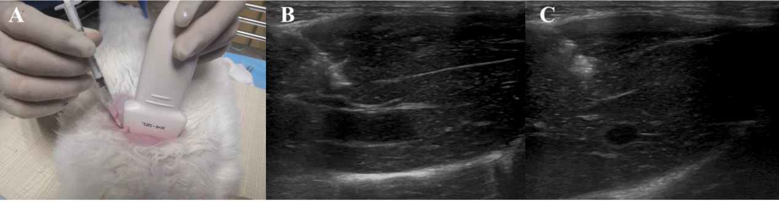
Supplementary Figure 1. Ultrasound guidance was successfully used for tumor loading in a rabbit model of liver cancer(A). The images clearly demonstrate the precise placement of the puncture needle (B) and tissue block during the procedure (C).

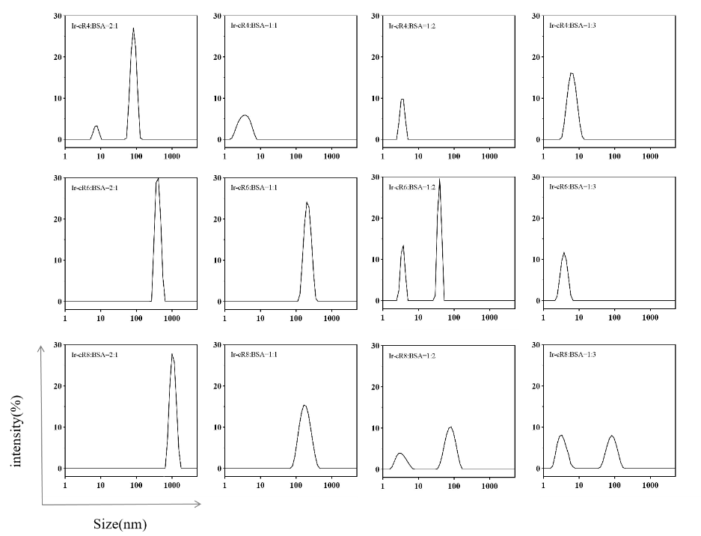
Supplementary Figure 2. Particle size distributions of peptides with different charges mixed with bovine serum albumin (BSA) at different molar ratios. The peak at approximately 100 nm is observed only when Ir-cR4 is mixed with albumin at a 2:1 ratio. Ir-cR6 and Ir-cR8 have average particle sizes of 224 nm and 170 nm, respectively, when mixed with albumin at a molar ratio of 1:1. Ir-cR8 was selected for further study due to its advantageous nanoparticle size range of 50 nm to 200 nm, which allows for accumulation at the tumor site.
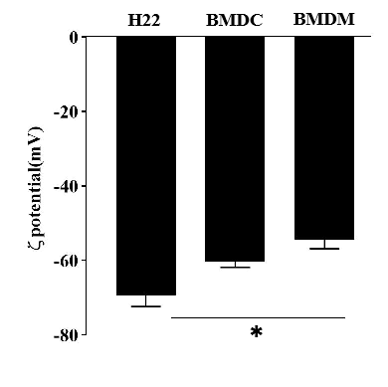

Supplementary Figure 3. Zeta potential values are currently being assessed for the H22, BMDC, and BMDM cell lines.

Supplementary Figure 4. TUNEL staining of tumor sections from a mouse model of in situ hepatocellular carcinoma TUNEL-positive cells show brown color, indicating apoptosis. Scale bar, 50 µm.

Supplementary Figure 5. Ki-67 staining of tumor sections from a mouse model of in situ hepatocellular carcinoma Ki-67-positive cells appear blue, indicating active cell proliferation. Scale bar, 50 µm.
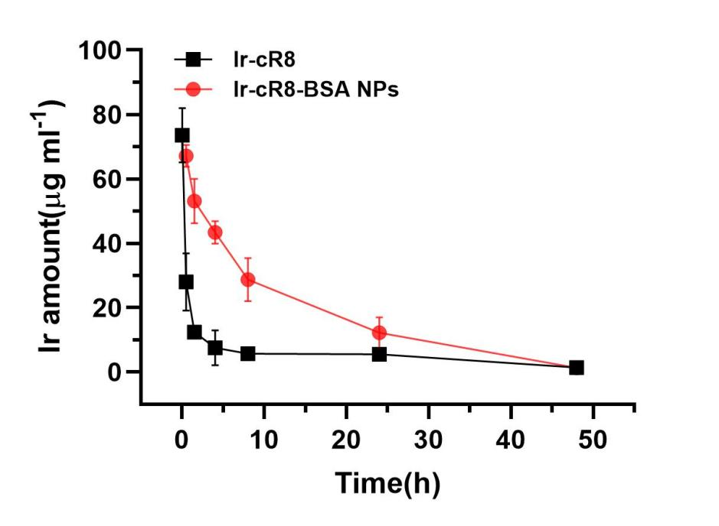

Supplementary Figure 6. The pharmacokinetics of Ir-cR8 and Ir-cR8-BSA-NPs were studied. After approximately 30 minutes, the concentration of Ir-cR8 in the blood decreased by more than half, while the half-life of Ir-cR8-BSA-NP was found to be 9.8 hours. This suggests that the formation of albumin nanoparticles significantly prolongs the retention time of peptide drugs in systemic circulation.

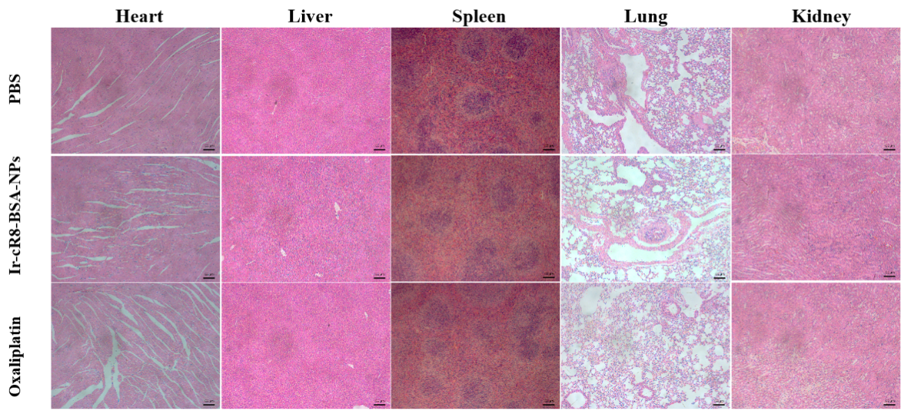
Supplementary Figure 7. HE staining pictures of normal tissues of each group

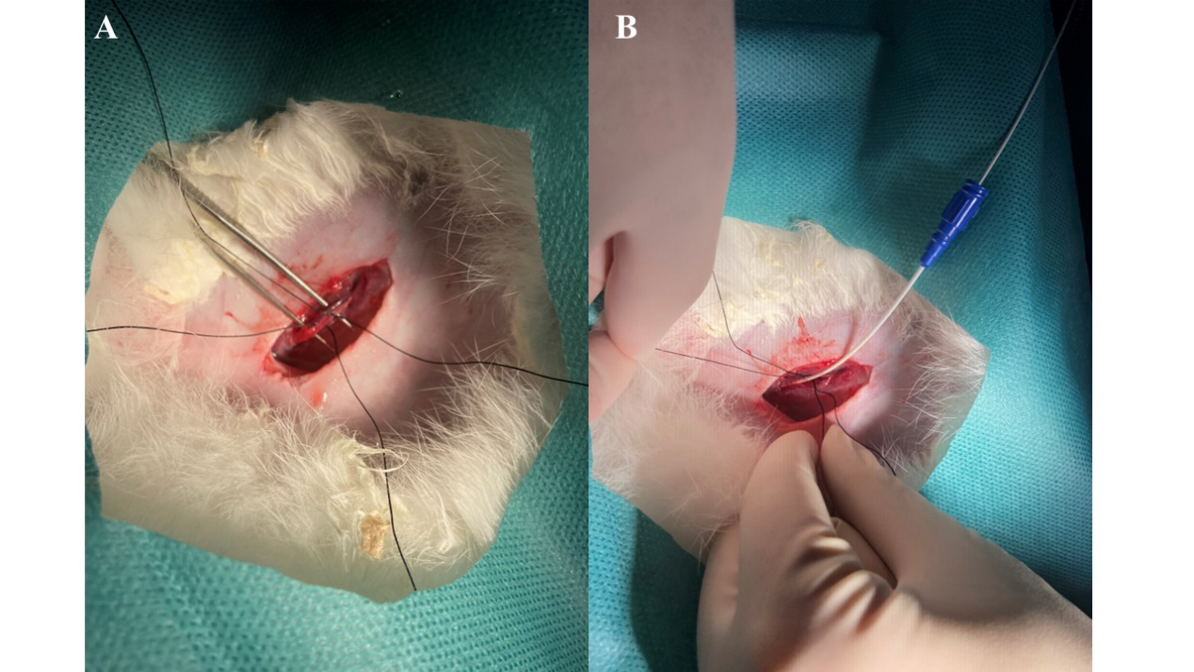
Supplementary Figure 8. Isolate the femoral artery (A) and introduce a microcatheter by puncturing the artery (B).

