Supplementary materials

Supplementary Material 1: Survey Questionnaire

1: Year of birth:
_______________

2. Gender:
- Male
- Female

3. Ethnicity:
- Chinese
- Indian
- Malay
- Others:__________

4. What is the highest educational level that you have attained?
- No education
- Primary school
- Secondary school
- ‘A’ level/ Polytechnic/Diploma or equivalent
- University
- Others:___________

5. How would you describe your financial situation?
- After paying the medical bills, you have more than enough money to buy things that you want
- After paying the medical bills, you have to cut back on things that you need.
- You have difficulty paying the medical bills.

6. Do you have private/company medical insurance (excluding Medishield Life) which covers medication cost?
- Yes
- No
- I do not know

7. What is your current household income per month?
- ≤ S$2000 per month
- S$2000 – 2800 per month
- > S$2800 per month
- Prefer not to say
- I do not know

8. Are you currently on the following healthcare packages?
- Pioneer generation package
- Merdeka generation package
- Not on any packages
- I do not know

9. When were you diagnosed with heart failure?
- 0 to 12 months ago
- More than 12 months ago

10. In the past 12 months, how many times were you hospitalised for worsening heart failure symptoms? i.e. shortness of breath, swelling of the hands and feet, lack of energy
- Not hospitalized
- 1 to 2 times in a year
- More than 2 times in a year

11. When you are informed about the different types of medication that is available, how would make the decision about which medication to choose?
- You prefer to make the decision about which medication you will receive
- You prefer to make the decision about your medication after seriously considering your clinician’s* opinion
- You prefer that your clinician* and you discuss and decide which medication is best for you
- You prefer that your clinician* makes the decision about which medication will be used, after seriously considering your opinion
- You prefer to leave all decisions regarding medication to your clinician*

*Clinician refers to doctor, pharmacist or nurse

12. If given a choice, would you like to discuss cost of medications with your clinician*? Please elaborate.
- Yes. why?
____________________________________________________________
____________________________________________________________
____________________________________________________________
____________________________________________________________
____________________________________________________________

- No, why?
____________________________________________________________
____________________________________________________________
____________________________________________________________
____________________________________________________________
____________________________________________________________

*Clinician refers to doctor, pharmacist or nurse

13. In the past 12 months, how often did you discuss cost of medications with your clinician*?
- Always (Finish)
- Often (Go to 14)
- Sometimes (Go to 14)
- Rarely (Go to 14)
- Never (Go to 14)

*Clinician refers to doctor, pharmacist or nurse

14. What is/are your reason/s for NOT discussing cost of medications with the clinician*? Please elaborate:
_________________________________________________________________
_________________________________________________________________
_________________________________________________________________
_________________________________________________________________
_________________________________________________________________

*Clinician refers to doctor, pharmacist or nurse

15. If given a choice, would you like to know the cost of medications before your clinician* prescribe your medication?
- Yes
- No

*Clinician refers to doctor, pharmacist or nurse

16. In the past 12 months, how often do you know the cost of your medication before the medication is prescribed?
- Always
- Often
- Sometimes
- Rarely
- Never

The following questions are based on the two hypothetical medications (Medication A and B) in the decision aid. Please answer these questions after viewing the decision aid.
17. Based on what you read, if you are newly starting on either one of these medications and both medications cost the same, which medication would you prefer?
- Medication A
- Medication B
- No preference

18. Based on what you read, if you are newly starting on either one of these medications (considering the cost of both medications), which medication would you prefer?
- Medication A
- Medication B
- No preference

Supplementary Material 2: Prototype decision aid

Decision Aid
The decision aid contains information of 2 medications which help your heart function better. You only need to take 1 of these 2 medications. The table below is for you to compare the 2 medications.
Medication |  |  | Medication A (Oral tablet) | Medication B (Oral tablet)
Frequency of use |  |  | 2 times a day | 1 or 2 times a day
Benefits  (Not Hospitalized)  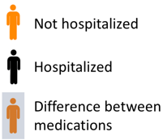 |  |  | 87 of 100 patients  were not hospitalized over 2 years  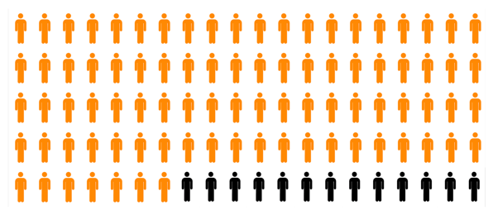 | 84 of 100 patients  were not hospitalized over 2 years  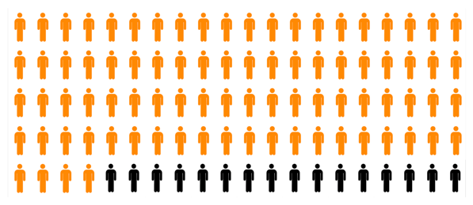
Benefits  (Survival)  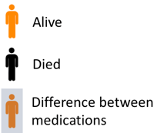 |  |  | 83 of 100 patients  were alive at the end of 2 years  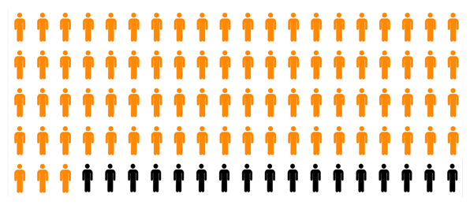 | 80 of 100 patients  were alive at the end of 2 years  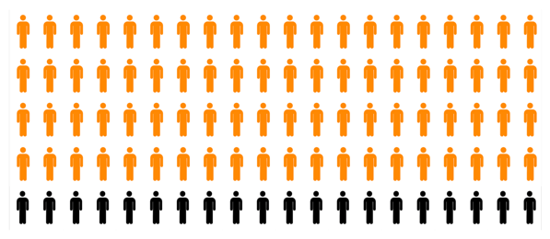
Side effects  (Low blood pressure symptoms – Dizziness, tiredness, blurred vision)  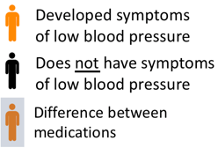 |  |  | 14 of 100 patients  developed symptoms of low blood pressure over 2 years  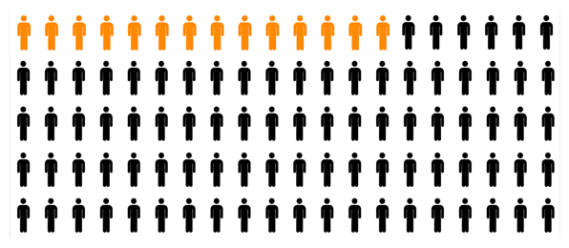 | 10 of 100 patients  developed symptoms of low blood pressure over 2 years  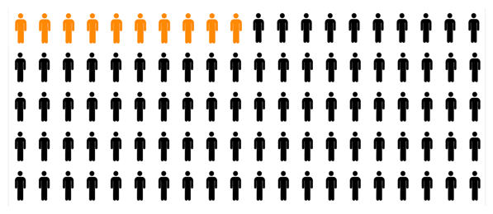
Cost  PG = Pioneer generation  MG = Merderka generation  MHI = Monthly household income |  |  | Medication A is NOT Medisave claimable  Before subsidy  S$42.00 – 84.00 per month  After subsidy* | Medication B is Medisave claimable  Before subsidy  S$3.00 – 6.00 per month  After subsidy
PG | MG | MHI
 |  | ≤ $2000 | S$5.25 – 10.50 per month | S$0.40 – 0.75 per month
 |  | ≤ $2000 | S$7.90 – 15.75 per month | S$0.60 – 1.15 per month
 |  | ≤ $2000 | S$10.50 – 21.00 per month | S$0.75 – 1.50 per month
 |  | $2001–2800 | S$10.50 – 21.00 per month | S$0.75 – 1.50 per month
 |  | $2001–2800 | S$15.75 – 31.50 per month | S$1.15 – 2.25 per month
 |  | $2001–2800 | S$21.00 – 42.00 per month | S$1.50 – 3.00 per month
 |  | > $2800 | No subsidies | S$0.75 – 1.50 per month
 |  | > $2800 | No subsidies | S$1.15 – 2.25 per month
 |  | > $2800 | No subsidies | S$1.50 – 3.00 per month
*Subsidy (Medication Assistance Fund) tier is assessed by medical social service based on capita household income and may not be approved for all applicants

Decision Aid Version 6.0, Dated 10/04/202

Supplementary Material 3: COREQ (COnsolidated criteria for REporting Qualitative research) Checklist

Topic | Item No. | Guide Questions/Description | Report
Domain 1: Research team and reflexivity
Personal characteristics
Interviewer/facilitator | 1 | Which author/s conducted the interview or focus group? | QYS conducted the qualitative survey and performed the analysis. WJC also performed the analysis.
Credentials | 2 | What were the researcher’s credentials? E.g. PhD, MD | QYS: BSc(Pharm); WJC: B.Soc.Sci (Hons)
Occupation | 3 | What was their occupation at the time of the study? | QYS: PhD Student; WJC: Master Student
Gender | 4 | Was the researcher male or female? | Male
Experience and training | 5 | What experience or training did the researcher have? | Researchers have completed qualitative research modules from National University of Singapore and have experience with the conduct and analysis of in-depth interviews.
Relationship with participants
Relationship established | 6 | Was a relationship established prior to study commencement? | The researcher has no established relationship with the participants prior to study commencement.
Participant knowledge of  the interviewer | 7 | What did the participants know about the researcher? e.g. personal  goals, reasons for doing the research | Qualitative survey was conducted at the hospital clinic. Participants only got to know about the researcher when they were approached to join the study. Participants were informed about the study context, purpose, potential risks and benefits, and rights via a consent form before the survey was conducted.
Interviewer characteristics | 8 | What characteristics were reported about the interviewer/facilitator?  e.g. Bias, assumptions, reasons and interests in the research topic | The researcher has an interest in the field of heart failure and has previously engaged with patients who had medications related cost matters. To avoid bias in the collection of responses from the participants, the study was purposefully administered as a self-completed survey so that the researcher will not influence the participant’s response.
Domain 2: Study design
Theoretical framework
Methodological orientation and Theory | 9 | What methodological orientation was stated to underpin the study? e.g. grounded theory, discourse analysis, ethnography, phenomenology,  content analysis | This study used a qualitative survey data collection approach to capture experiences and perspectives of participants, followed by conventional content analysis of the data.
Sampling | 10 | How were participants selected? e.g. purposive, convenience,  consecutive, snowball | Participants were recruited via convenience sampling in the clinic.
Method of approach | 11 | How were participants approached? e.g. face-to-face, telephone, mail,  email | Participants were approached via face to face method.
Sample size | 12 | How many participants were in the study? | Forty-eight participants were enrolled in the study. This survey was conducted alongside the usability testing of a prototype decision aid, which was already recruiting 48 patients.
Non-participation | 13 | How many people refused to participate or dropped out? Reasons? | Eleven participants refused to participate as they were not interested in the study.
Setting of data collection | 14 | Where was the data collected? e.g. home, clinic, workplace | Survey data were collected from a heart failure clinic in a general hospital.
Presence of non-  participants | 15 | Was anyone else present besides the participants and researchers? | No one else were present besides the participants and researchers.
Description of sample | 16 | What are the important characteristics of the sample? e.g. demographic  data, date | All recruited participants are people with heart failure. Majority of participants were of middle age and of Chinese ethnicity but there was an even spread of participants between different genders and educational levels.
Data collection
Interview guide | 17 | Were questions, prompts, guides provided by the authors? Was it pilot tested? | This study did not include an interview guide as this was a qualitative survey. However, the survey questions were pilot tested with two external volunteers who were not involved in the study. The questions were found to be clear and understandable by the two volunteers.
Repeat interviews | 18 | Were repeat interviews carried out? If yes, how many? | No repeat surveys were carried out.
Audio/visual recording | 19 | Did the research use audio or visual recording to collect the data? | No audio or visual recording were used. Data was collected via a self-administered questionnaire.
Field notes | 20 | Were field notes made during and/or after the interview or focus group? | There were no field notes made for the qualitative survey.
Duration | 21 | What was the duration of the interviews or focus group? | The survey took an average of 10 minutes for each participant.
Data saturation | 22 | Was data saturation discussed? | Data saturation were reached for the open-ended questions.
Transcripts returned | 23 | Were transcripts returned to participants for comment and/or correction? | There were no transcripts created in this study. Furthermore, participants provided their responses independently without assistance by the researcher.
Domain 3: analysis and findings
Data analysis
Number of data coders | 24 | How many data coders coded the data? | Coding was done individually by 2 analysts (QYS and WJC)
Description of the coding  tree | 25 | Did authors provide a description of the coding tree? | Yes, a description of the coding tree/codebook can be found in Table 2 and 3.
Derivation of themes | 26 | Were themes identified in advance or derived from the data? | Themes were derived entirely from the participant’s response.
Software | 27 | What software, if applicable, was used to manage the data? | No software was used, manual coding was performed.
Participant checking | 28 | Did participants provide feedback on the findings? | No feedback was sought from participants. All participants’ responses were de-identified upon collection.
Reporting
Quotations presented | 29 | Were participant quotations presented to illustrate the themes/findings?  Was each quotation identified? e.g. participant number | There are quotations to all themes and participant number is added.
Data and findings consistent | 30 | Was there consistency between the data presented and the findings? | Yes, data and findings are consistent.
Clarity of major themes | 31 | Were major themes clearly presented in the findings? | Yes, major themes are presented in the findings.
Clarity of minor themes | 32 | Is there a description of diverse cases or discussion of minor themes? | As data were collected using qualitative survey to answer specific questions, participants’ responses were direct and concise, without any diverse cases or minor themes.

Developed from: Tong A, Sainsbury P, Craig J. Consolidated criteria for reporting qualitative research (COREQ): a 32-item checklist for interviews and focus groups. International Journal for Quality in Health Care. 2007. Volume 19, Number 6: pp. 349 – 357

