Supplemental Materials
Contents
Supplement Table 1 Coordinates of each hospital in the study area
Supplement Figure 1 The locations of air pollutants monitoring stations and hospitals in Henan, China
Supplement Table 2 Coordinates of each city air monitoring station in the study area
Supplement Figure 2 Monthly number of CM case ,Low DTR (0-3 °C) and High DTR (15.5 -23.2°C) during the study period of 2016-2021
Supplement Figure 3 The exposure–response curve between CM and DTR with changing the degrees of freedom from 3-5 for mean temperature, humidity, PM2.5, and SO2velocity; 7-9 for long-term trend and seasonality

Supplement Table 1 Coordinates of each hospital in the study area
City | Hospital Name | Longitude, N | Latitude, E
Xinxiang | The First Affiliated Hospital of Xinxiang Medical University | 114.059 | 35.408
Xinxiang | The Third Affiliated Hospital of Xinxiang Medical University | 113.925 | 35.281
Xinxiang | The Affiliated People's Hospital of Xinxiang Medical University | 113.869 | 35.306
Nanyang | Nanyang Central Hospital | 112.529 | 33.008
Anyang | Anyang First People's Hospital | 114.412 | 36.076
Kaifeng | Hospital of Traditional Chinese Medicine Affiliated to Henan University | 114.368 | 34.805
Luoyang | The First Affiliated Hospital of Henan University of Science and Technology | 112.427 | 34.599

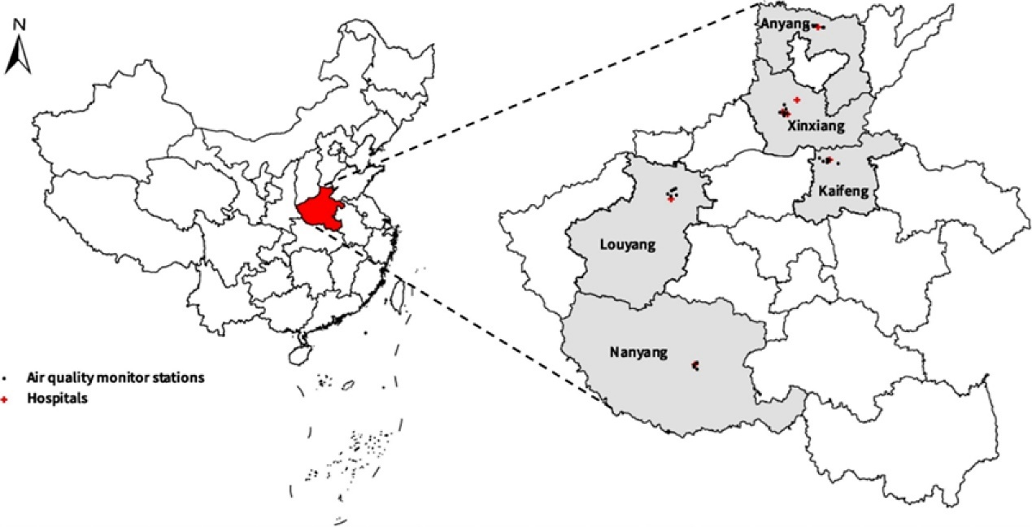
Supplement Figure 1 The locations of air pollutants monitoring stations and hospitals in Henan, China.

Supplement Table 2 Coordinates of each city air monitoring station in the study area
City | City code | Station code | Longitude, N | Latitude, E
Xinxiang | 410700 | 2389A | 113.836 | 35.310
Xinxiang | 410700 | 2390A | 113.884 | 35.272
Xinxiang | 410700 | 2391A | 113.883 | 35.303
Xinxiang | 410700 | 3054A | 113.919 | 35.285
Xinxiang | 410700 | 3476A | 113.914 | 35.333
Xinxiang | 410700 | 3689A | 113.900 | 35.372
Nanyang | 411300 | 2403A | 112.519 | 32.992
Nanyang | 411300 | 2404A | 112.522 | 33.012
Nanyang | 411300 | 2406A | 112.557 | 33.027
Nanyang | 411300 | 2407A | 112.550 | 32.968
Anyang | 410500 | 1818A | 114.484 | 36.062
Anyang | 410500 | 1819A | 114.355 | 36.102
Anyang | 410500 | 1820A | 114.358 | 36.087
Anyang | 410500 | 3141A | 114.392 | 36.088
Anyang | 410500 | 3669A | 114.471 | 36.064
Anyang | 410500 | 3703A | 114.292 | 36.095
Kaifeng | 410200 | 1824A | 114.339 | 34.778
Kaifeng | 410200 | 1826A | 114.289 | 34.797
Kaifeng | 410200 | 3147A | 114.344 | 34.811
Kaifeng | 410200 | 3210A | 114.364 | 34.796
Kaifeng | 410200 | 3473A | 114.249 | 34.831
Kaifeng | 410200 | 3592A | 114.464 | 34.756
Luoyang | 410300 | 1812A | 112.394 | 34.651
Luoyang | 410300 | 1814A | 112.466 | 34.687
Luoyang | 410300 | 1815A | 112.494 | 34.689
Luoyang | 410300 | 1817A | 112.428 | 34.626
Luoyang | 410300 | 3341A | 112.495 | 34.633
Luoyang | 410300 | 3636A | 112.439 | 34.678

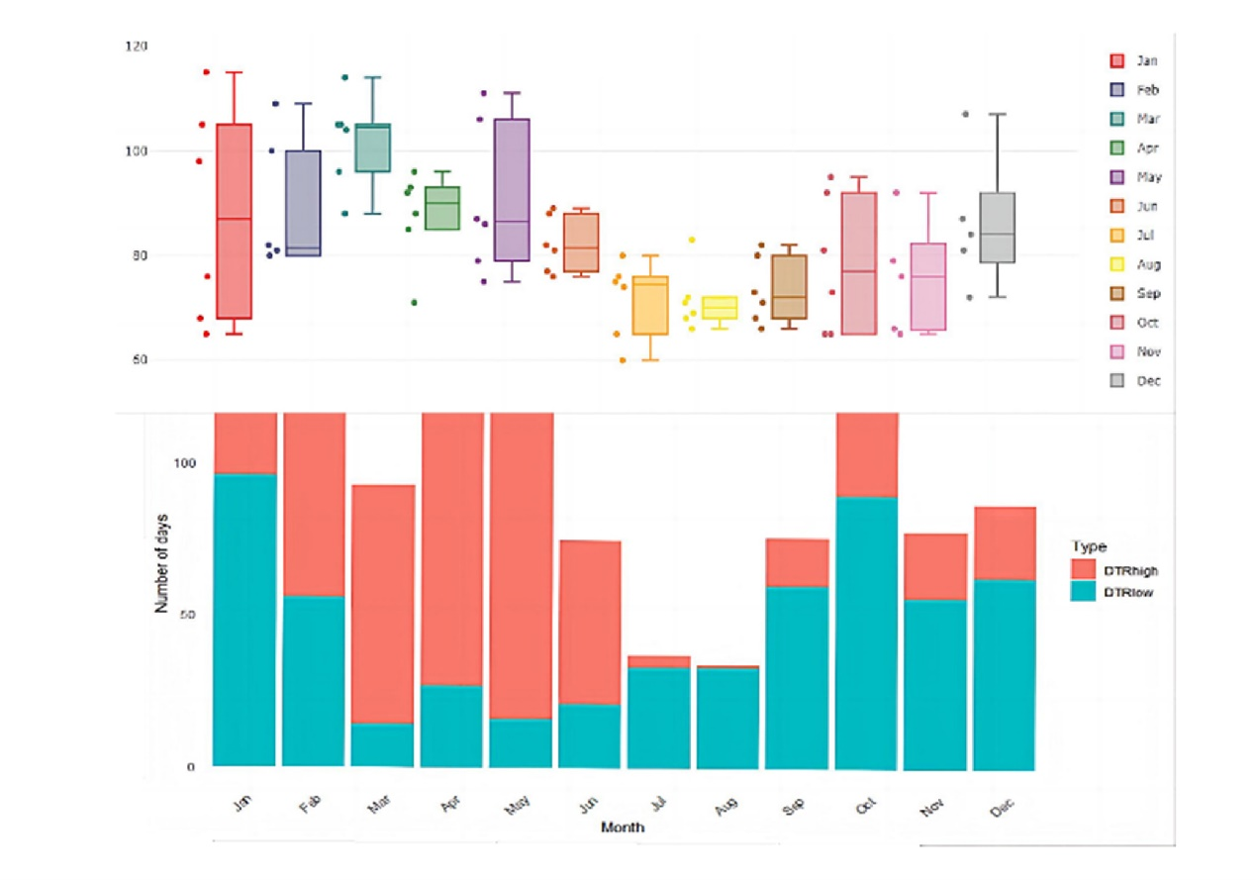
Supplement Figure 2 Monthly number of CM case ,Low DTR (0-3 °C) and High DTR (15.5 -23.2°C) during the study period of 2016-2021.

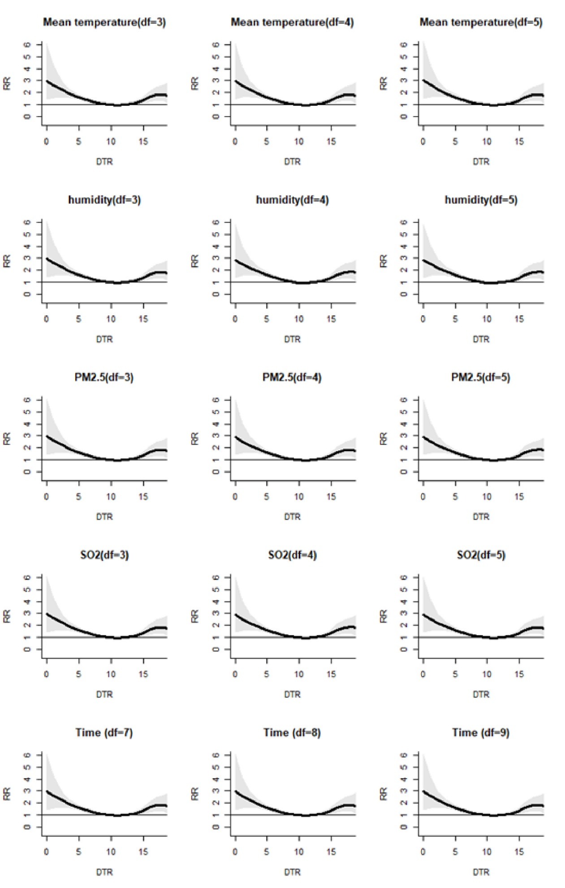
Supplement Figure 3 The exposure–response curve between CM and DTR with changing the degrees of freedom from 3-5 for mean temperature, humidity, PM2.5, and SO2velocity; 7-9 for long-term trend and seasonality.

