SUPPLEMENTAL TABLE 1: Respondent Characteristics
Characteristics | Patients (N=113)
Age (years)
Mean (SD) | 48.5 (13.6)
Median | 45
IQR | 24
Average years since the first diagnosis of Demodex blepharitis
Mean (SD) | 4.3 (6.7)
Median | 2
IQR | 4
Average years since the first diagnosis of Demodex blepharitis among patients with cataracts | n = 22
Mean (SD) | 6.3 (8.1)
Median | 2
IQR | 7
Average years since the first diagnosis of Demodex blepharitis among patients with glaucoma | n = 11
Mean (SD) | 6.6 (7.2)
Median | 3
IQR | 6
Insurance coverage status*
Employer-provided private/commercial insurance | 36 (32%)
Medicare only | 33 (29%)
Medicaid only | 21 (19%)
Self-purchased private/commercial insurance | 20 (18%)
Medicaid and Medicare | 8 (7%)
No insurance | 2 (2%)
Other government insurance | 1 (1%)
Wearing contact lenses | 34 (30%)
Received/receiving prescription dry eye medications | 35 (31%)
Abbreviations: IQR, Interquartile range; SD, Standard deviation
*Note: This question was multi-select and respondents may have provided more than one response, as appropriate (e.g., respondent had multiple types of insurance)

SUPPLEMENTAL TABLE 2: Health Care Providers Visited by Patients Before Diagnosis with Demodex Blepharitis
Health Care Providers Visited by Patients
(% patients, N=113)
 | Ophthalmologists | Optometrists | Primary Care Physicians
Before diagnosis, n (%) | 51 (45%) | 47 (42%) | 47 (42%)
Diagnosing provider, n (%) | 50 (44%) | 45 (40%) | 18 (16%)
Note: This question was multi-select and respondents may have provided more than one response, as appropriate (e.g., respondent visited more than one type of health care provider)

SUPPLEMENTAL FIGURE 1: Frequency of Symptoms of Demodex Blepharitis (N=113)
(% of Patients with Each Symptom)
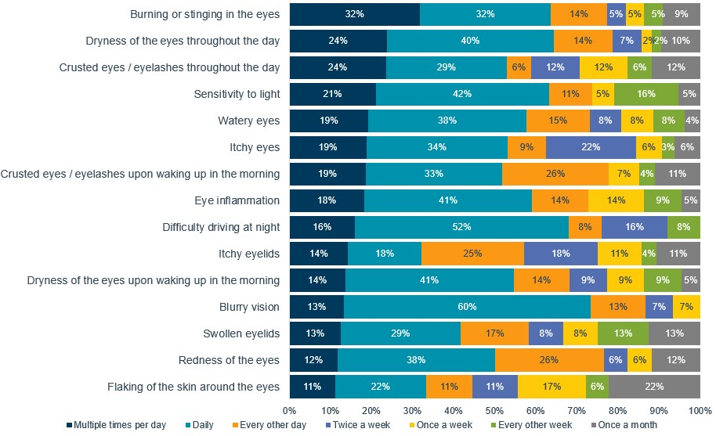
Supplemental Figure 1: Patient reported frequency of several symptoms of Demodex blepharitis at the time of the survey

SUPPLEMENTAL FIGURE 2: Impact of Eye Symptoms Prior to Demodex Blepharitis Diagnosis (N=113) (% of Patients with Each Symptom)
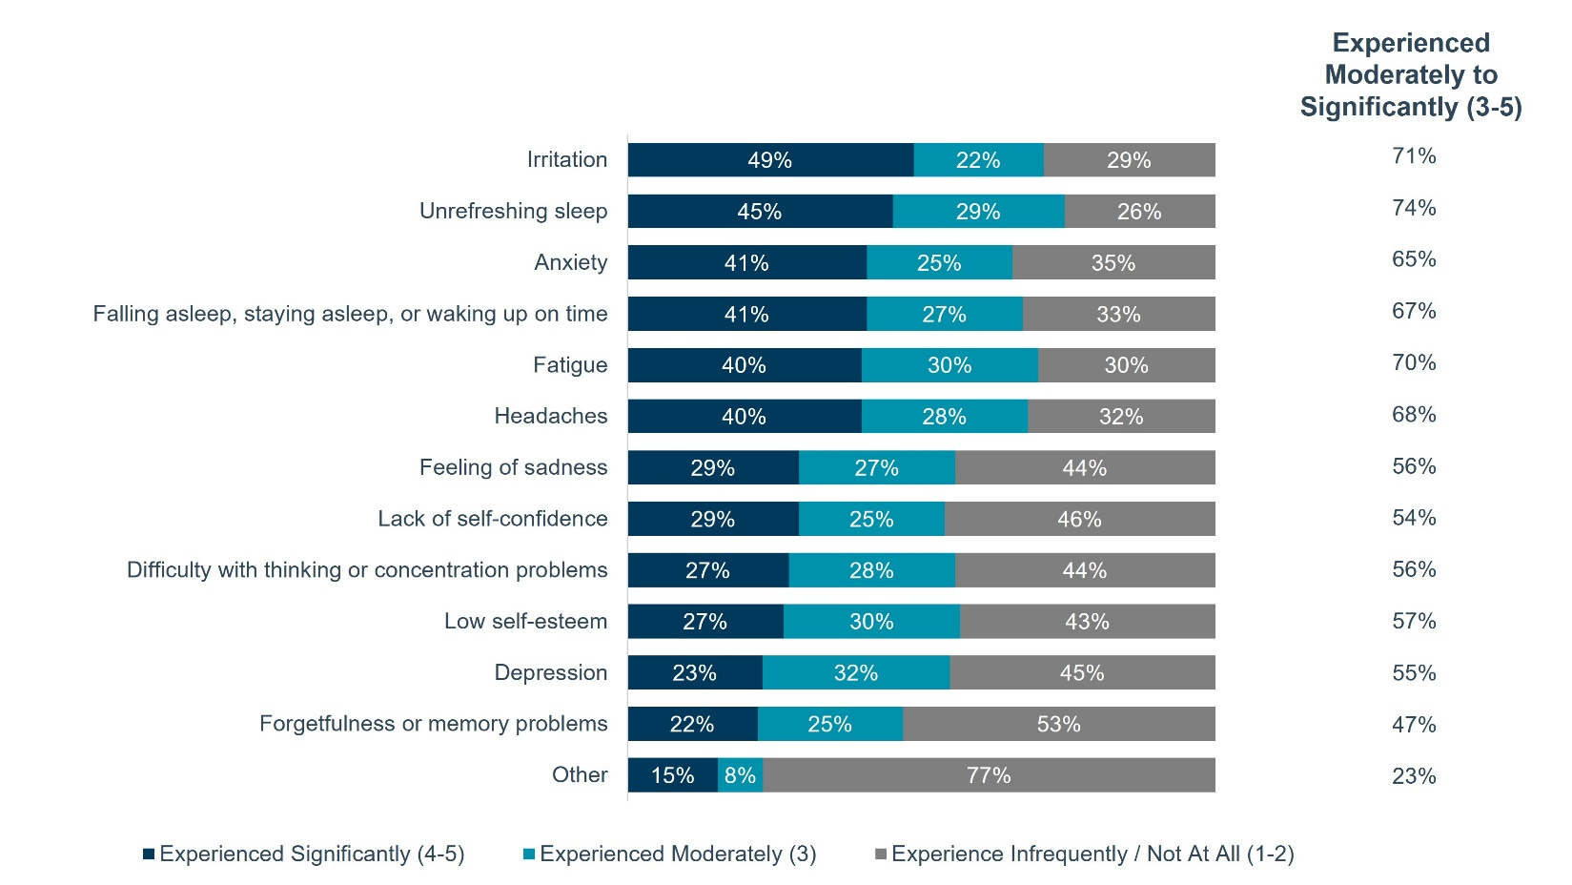
Supplemental Figure 2: Patient-reported direct and indirect impact of several symptoms before being diagnosed with Demodex blepharitis. Other reported comments include feeling ugly, increased irritation associated with having to visit healthcare providers, difficulty focusing, and decreased optimism.

SUPPLEMENTAL FIGURE 3: Challenges in Getting a Definitive Diagnosis of Demodex Blepharitis (N=113)
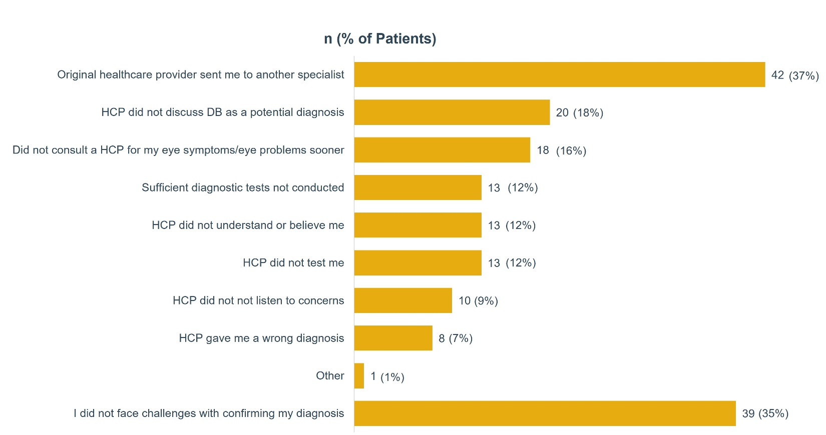
Supplemental Figure 3: Patients identified the challenges they encountered in obtaining a confirmed diagnosis from a list of 10 options, including “did not face challenges with confirming my diagnosis” and “other” (N = 113).
Note: This question was multi-select and respondents may have provided more than one response, as appropriate (e.g., respondents had multiple challenges). If respondents selected “I did not face challenges with confirming my diagnosis”, they were not able to select any other options.
Abbreviations: DB, Demodex blepharitis; HCP, healthcare provider

SUPPLEMENTAL FIGURE 4: Over-the-counter Medications and Therapies Used for Demodex
Blepharitis Across Time (N=113)
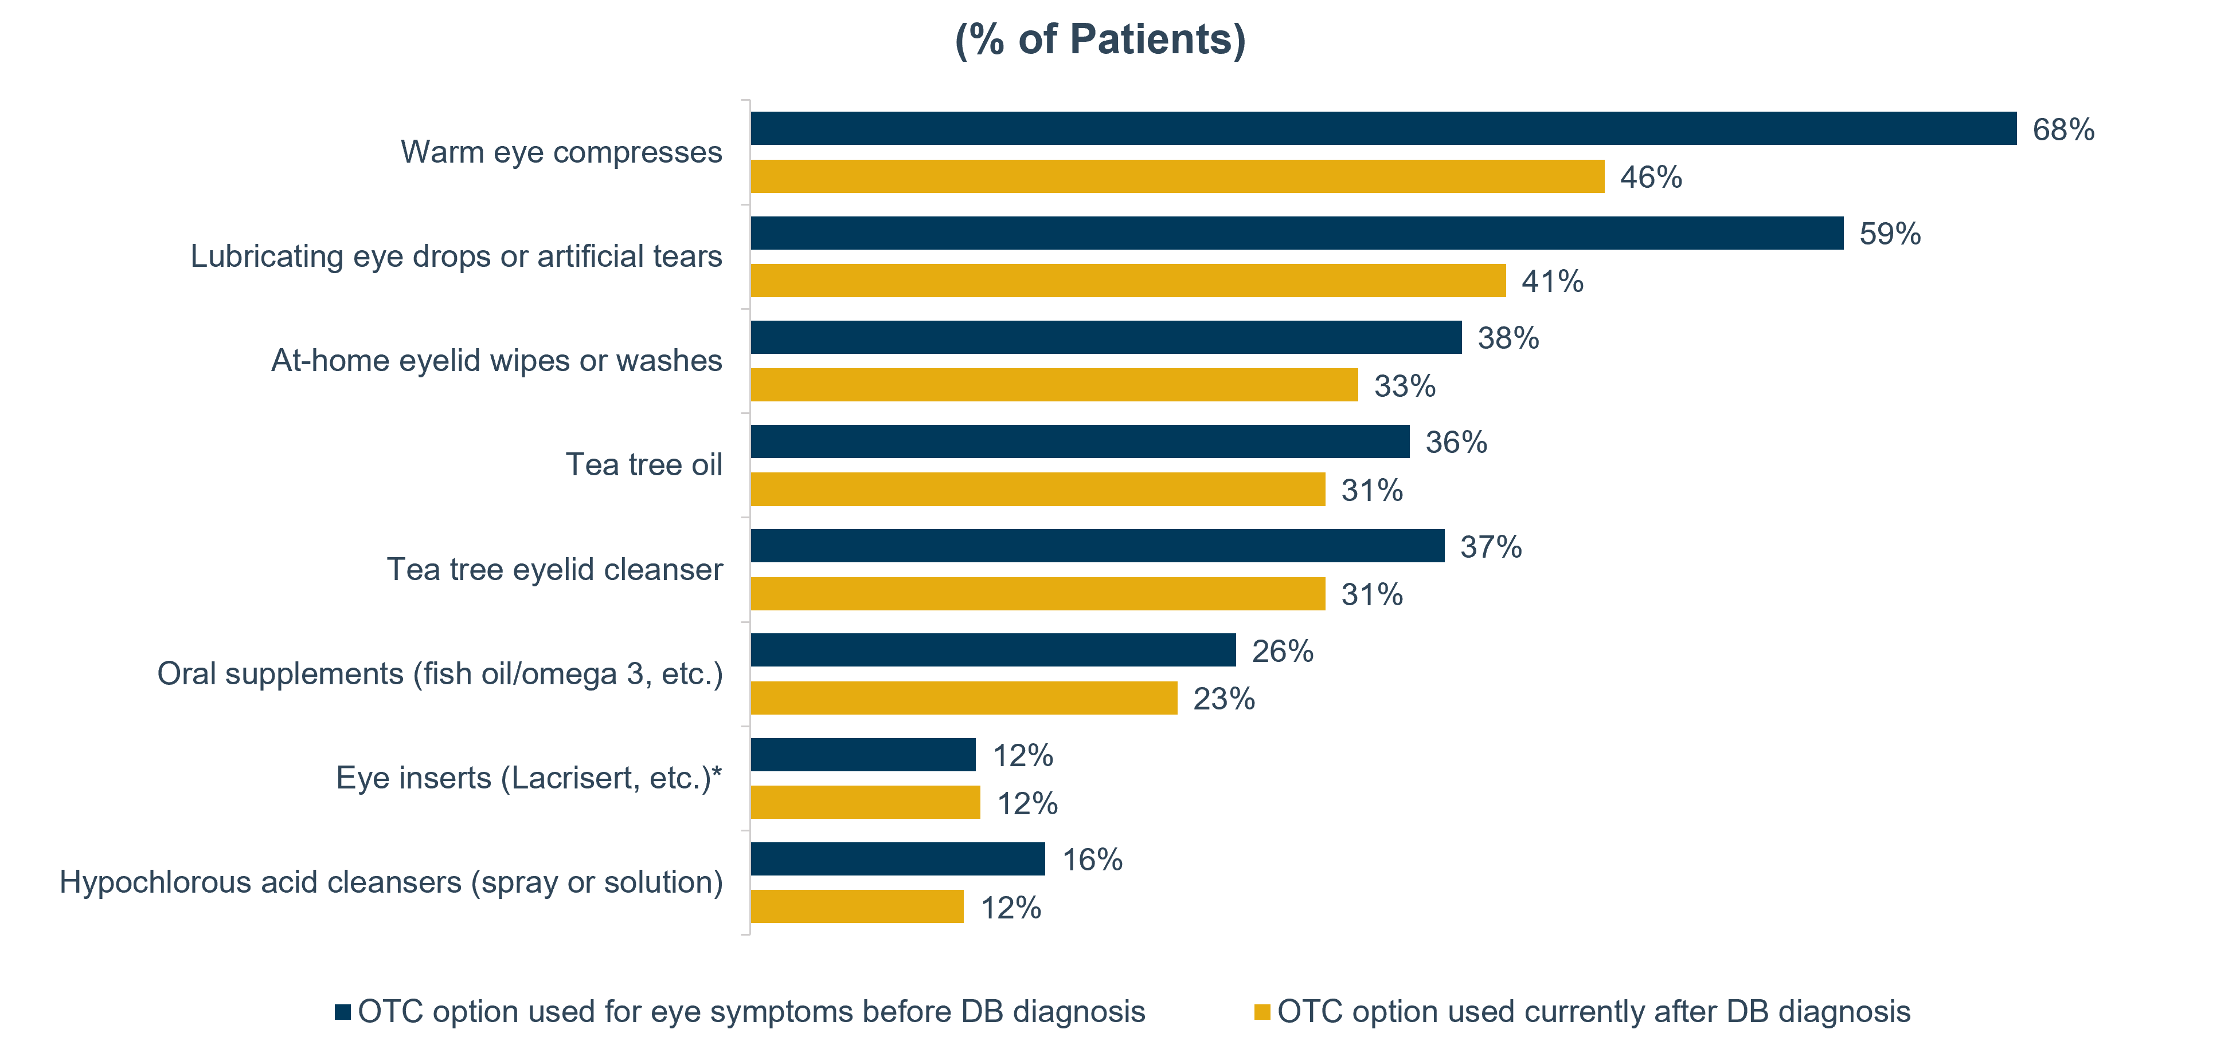
Supplemental Figure 4: Patients reported whether they used various OTC therapies before receiving a confirmed diagnosis of Demodex blepharitis, in the past after diagnosis, or currently.
Note: This question was multi-select and respondents may have provided more than one response, as appropriate (e.g., respondent used / was currently using more than one type of over-the-counter treatment)
Abbreviations: OTC, Over-the-counter, DB, Demodex blepharitis;
* Eye inserts may also be available as prescription therapy

SUPPLEMENTAL FIGURE 5: Impact of Demodex Blepharitis on Activities of Daily Living in the Last 12 Months (N=113) (% of Patients)
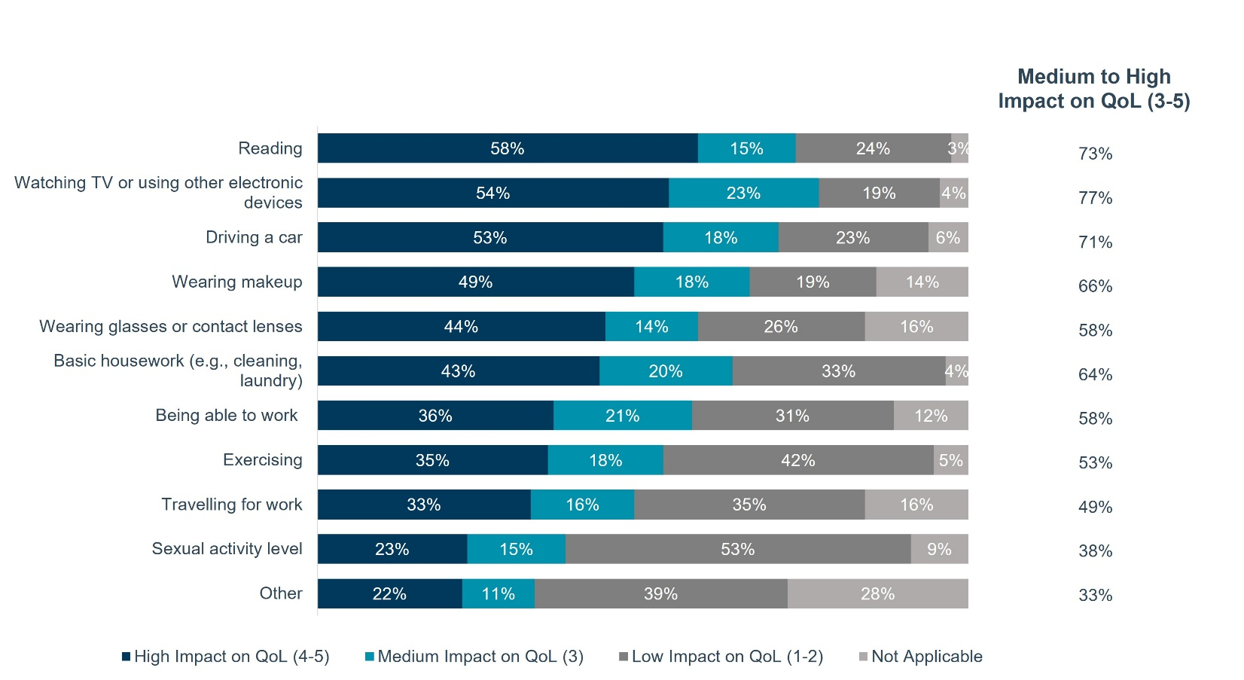
Supplemental Figure 5: Patients reported the magnitude of impacts on a 5-point scale, with 1 representing the lowest impact and 5 representing maximal impact. The total proportion of patients reporting a medium to high impact (score 3-5) for each activity of daily living is shown on the right side.
Abbreviations: DB, Demodex blepharitis; QoL, Quality of life

SUPPLEMENTAL FIGURE 6: Emotional Impact of Demodex Blepharitis in the Last 12 Months (N=113)
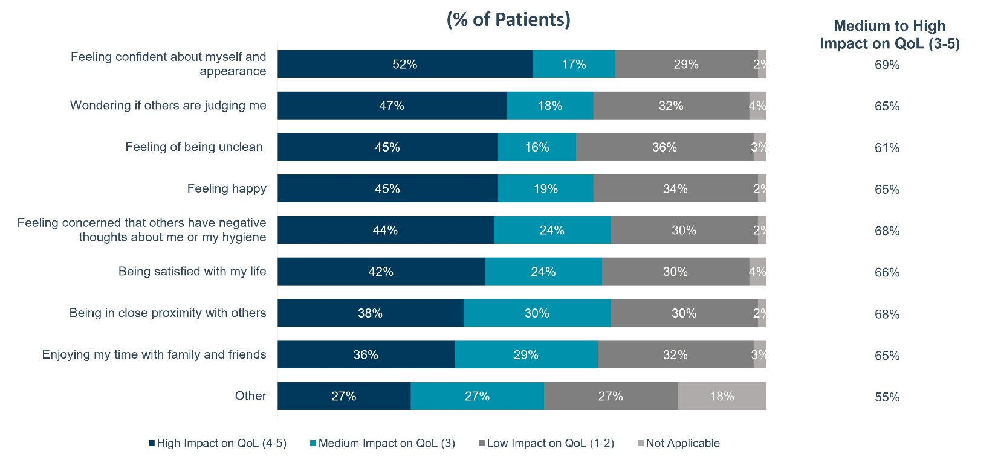
Supplemental Figure 6: Patients reported the impact on quality of life using a 5-point scale, with 1 representing the lowest impact and 5 representing maximal impact. The total proportion of patients reporting a medium to high impact (score 3-5) is shown in the right-hand column.
Abbreviations: QoL, Quality of life

SUPPLEMENTAL FIGURE 7: Patient’s Agreement on Willingness for New Demodex Blepharitis Options (N=113)
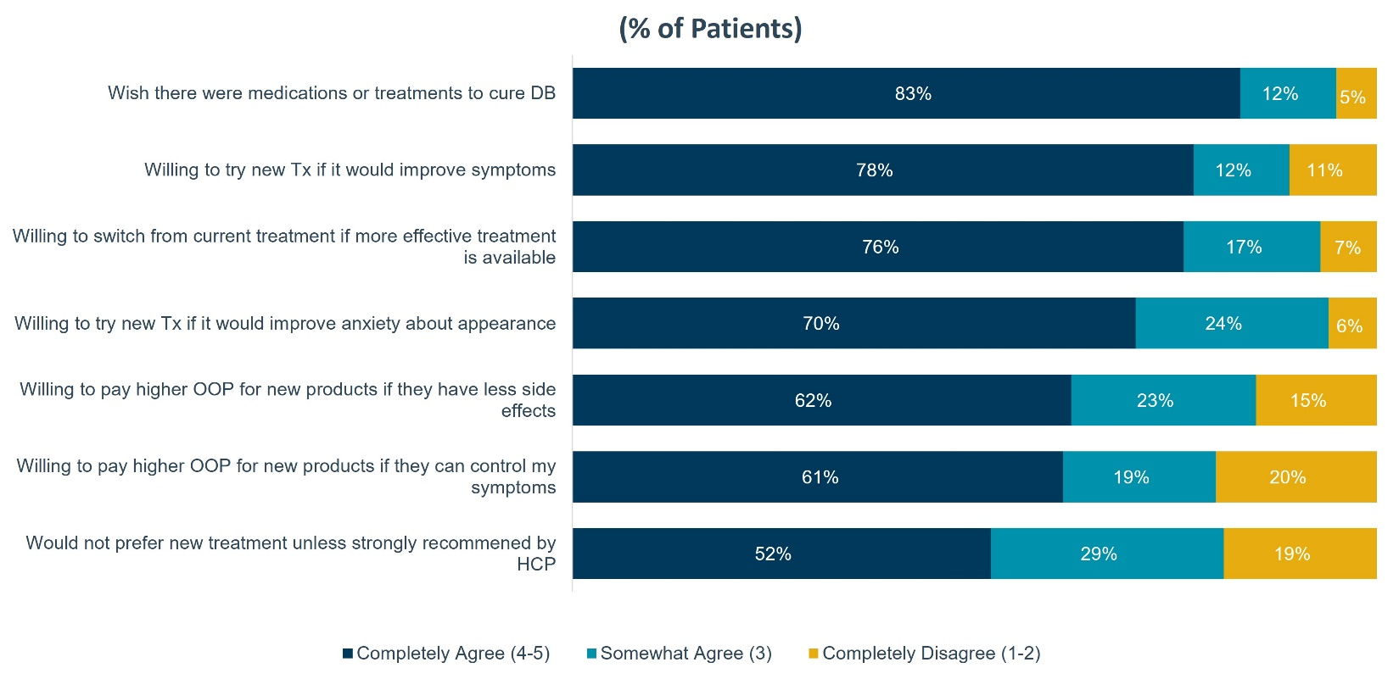

Supplemental Figure 7: Patients reported their degree of agreement on a 5-point scale, with 1 representing complete disagreement and 5 representing complete agreement (N = 113).
Abbreviations: DB, Demodex blepharitis; HCP, Healthcare provider; OOP, Out-of-pocket; Tx, Treatment

