Supplementary Figure1: The enrichment results of ACVRL1 in CC samples with GO enrichment analysis.
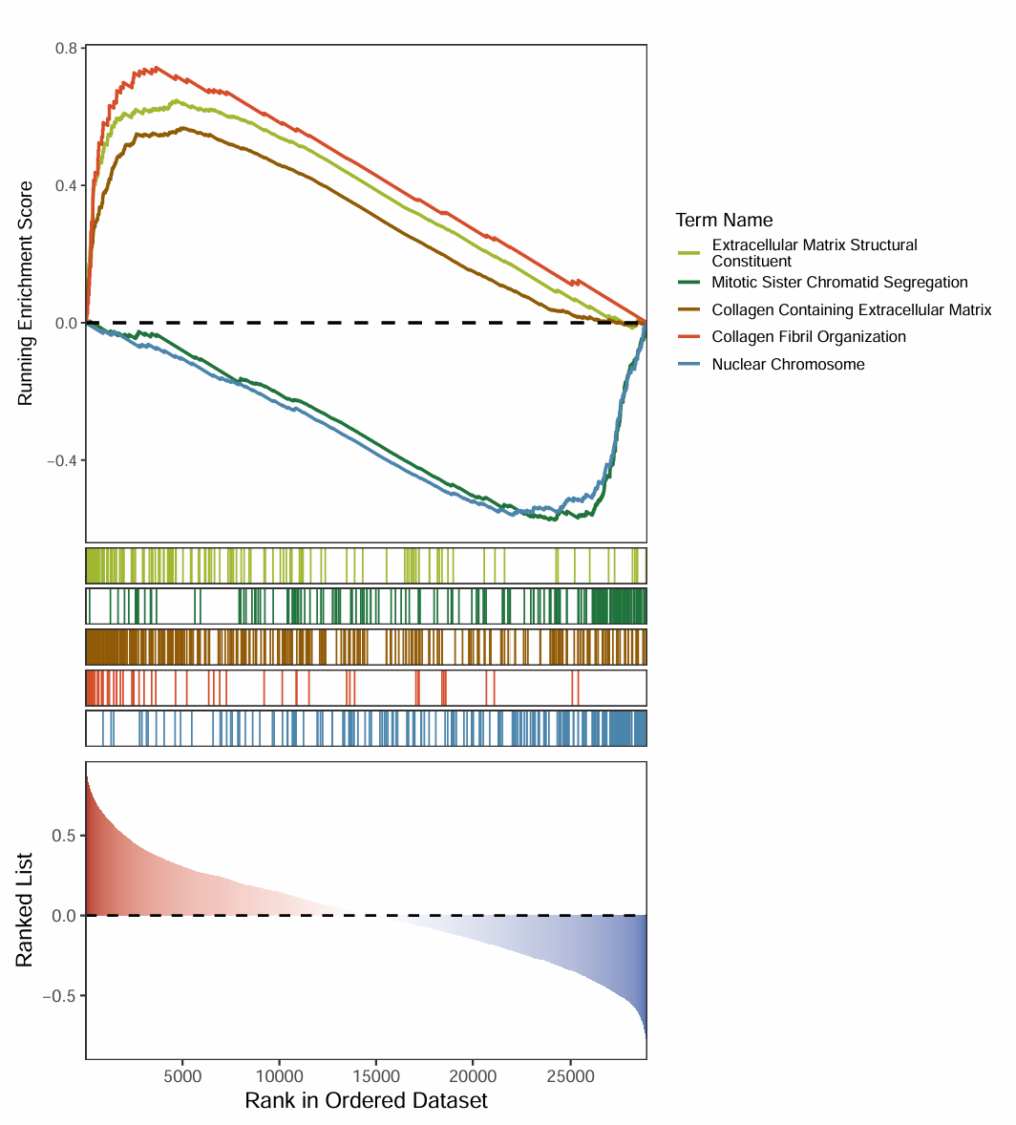

Supplementary Figure 2: The enrichment results of ACVRL1 in CC samples with KEGG enrichment analysis.
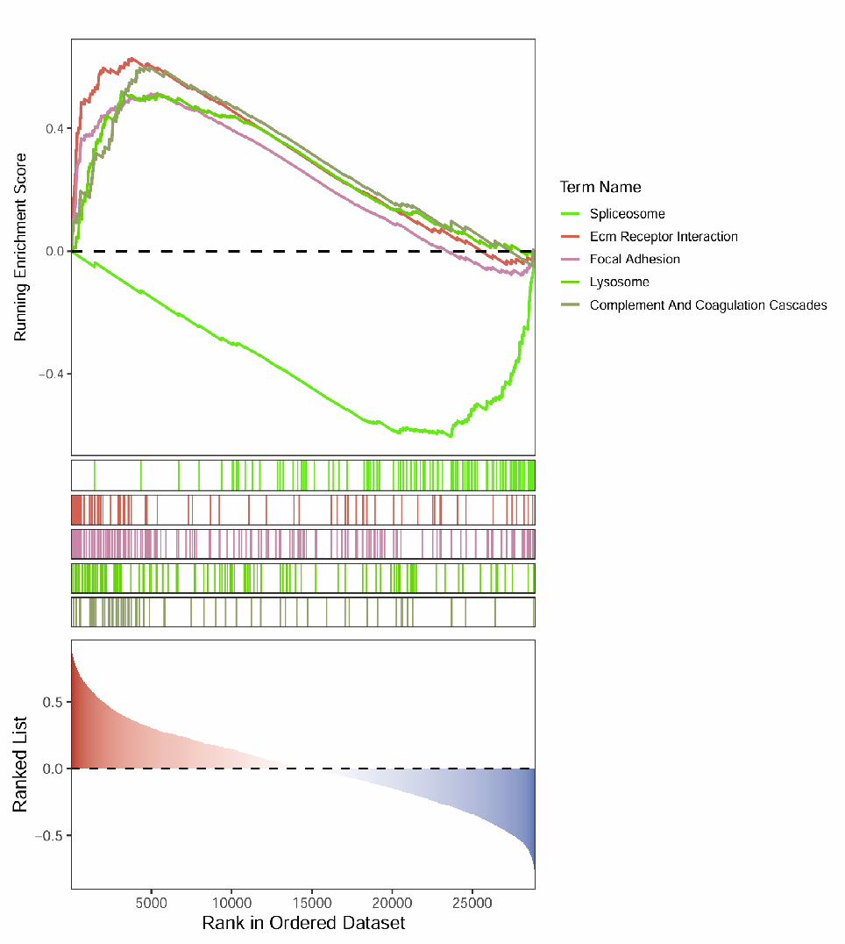
Supplementary Figure 3: The enrichment results of MUC1 in CC samples with GO enrichment analysis.
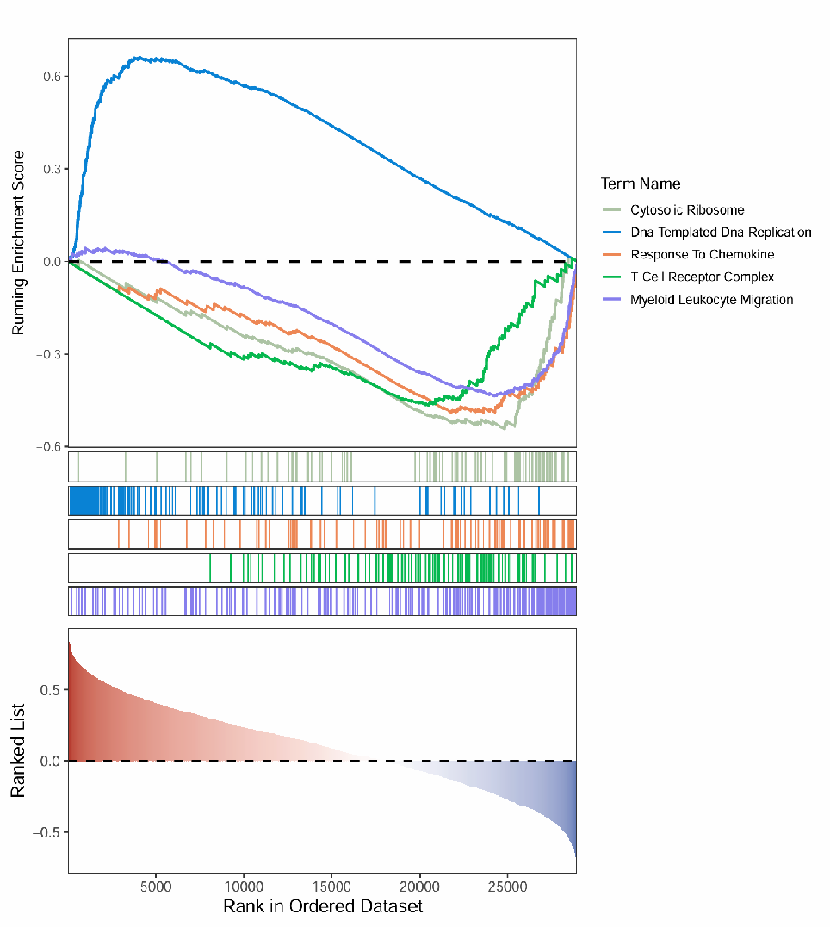

Supplementary Figure 4: The enrichment results of MUC1 in CC samples with KEGG enrichment analysis.
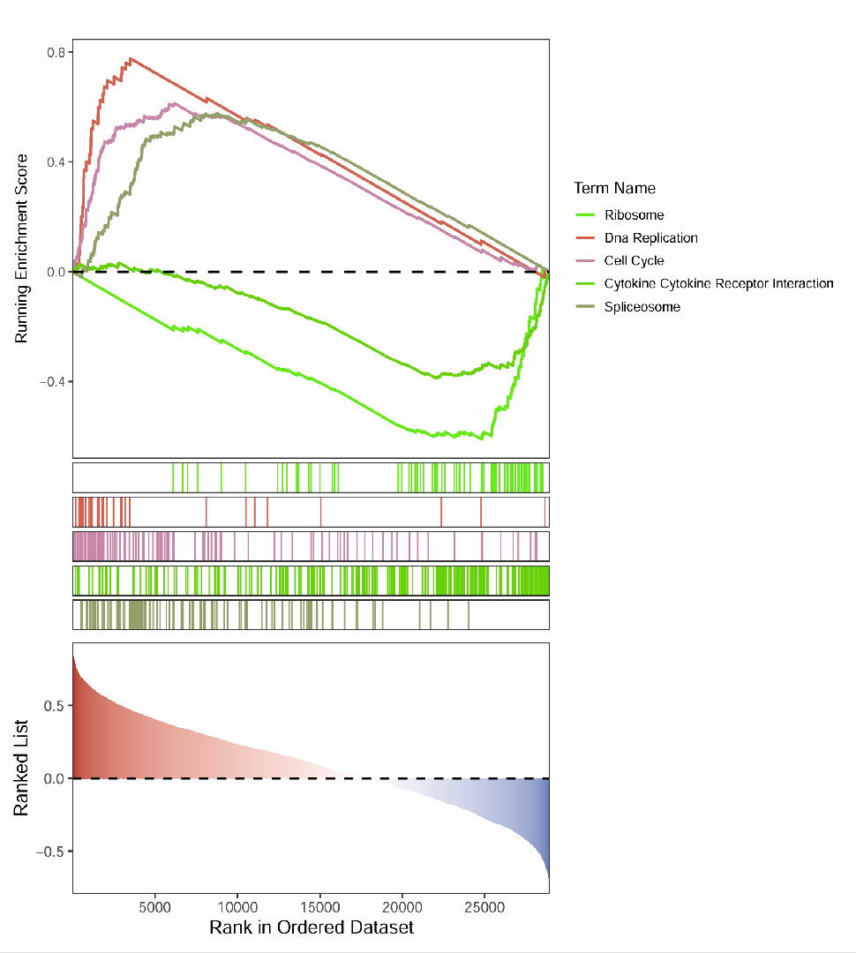

Supplementary Figure 5: The enrichment results of UCHL1 in CC samples with GO enrichment analysis.
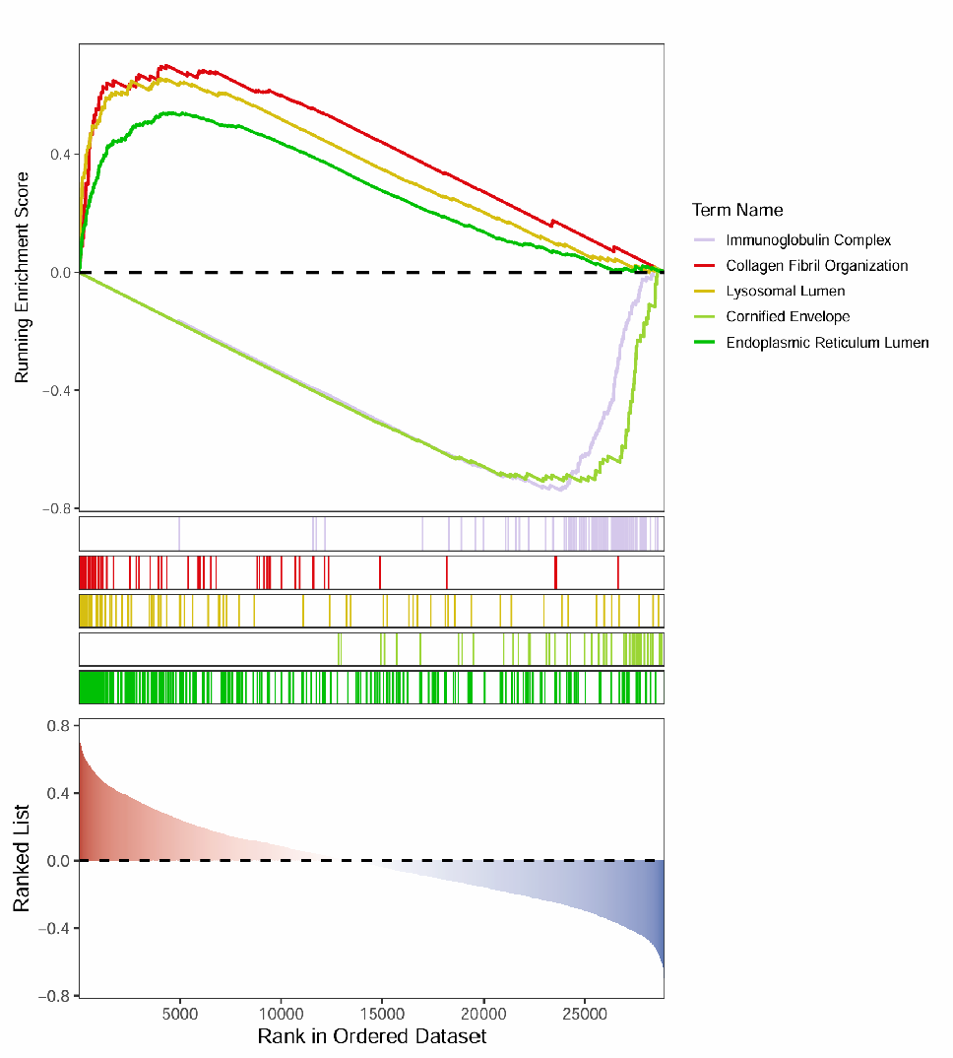
Supplementary Figure 6: The enrichment results of UCHL1 in CC samples with KEGG enrichment analysis.
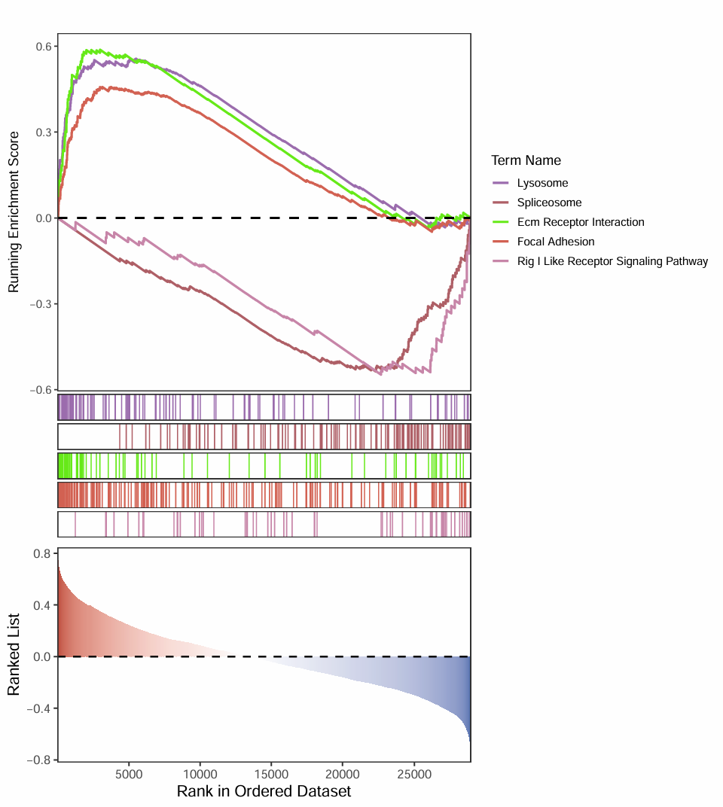
Supplementary Figure 7: The enrichment results of CALCRL in CC samples with GO enrichment analysis.
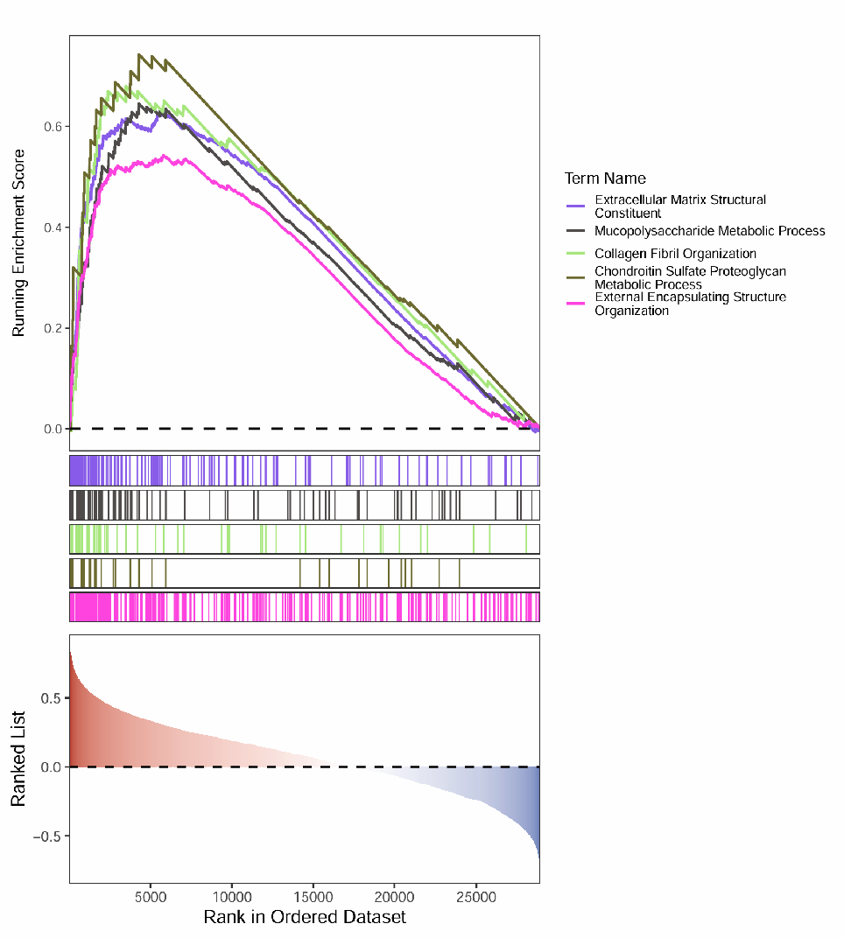
Supplementary Figure 8: The enrichment results of CALCRL in CC samples with KEGG enrichment analysis.
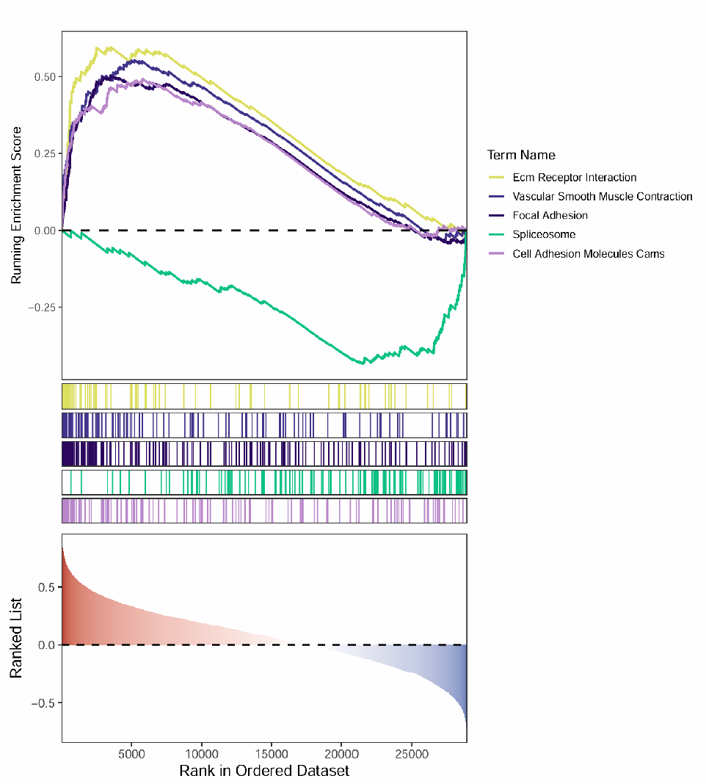

Supplementary Figure 9: The enrichment results of ACVRL1 in GSE44001 with GO enrichment analysis.
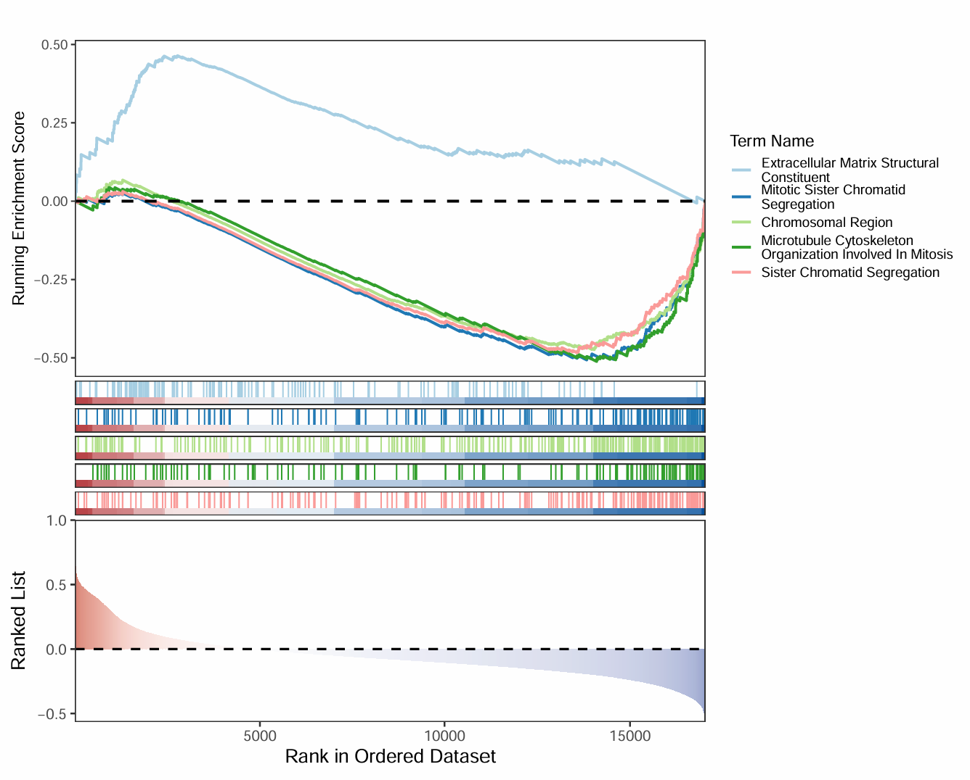

Supplementary Figure 10: The enrichment results of ACVRL1 in GSE44001 with KEGG enrichment analysis.
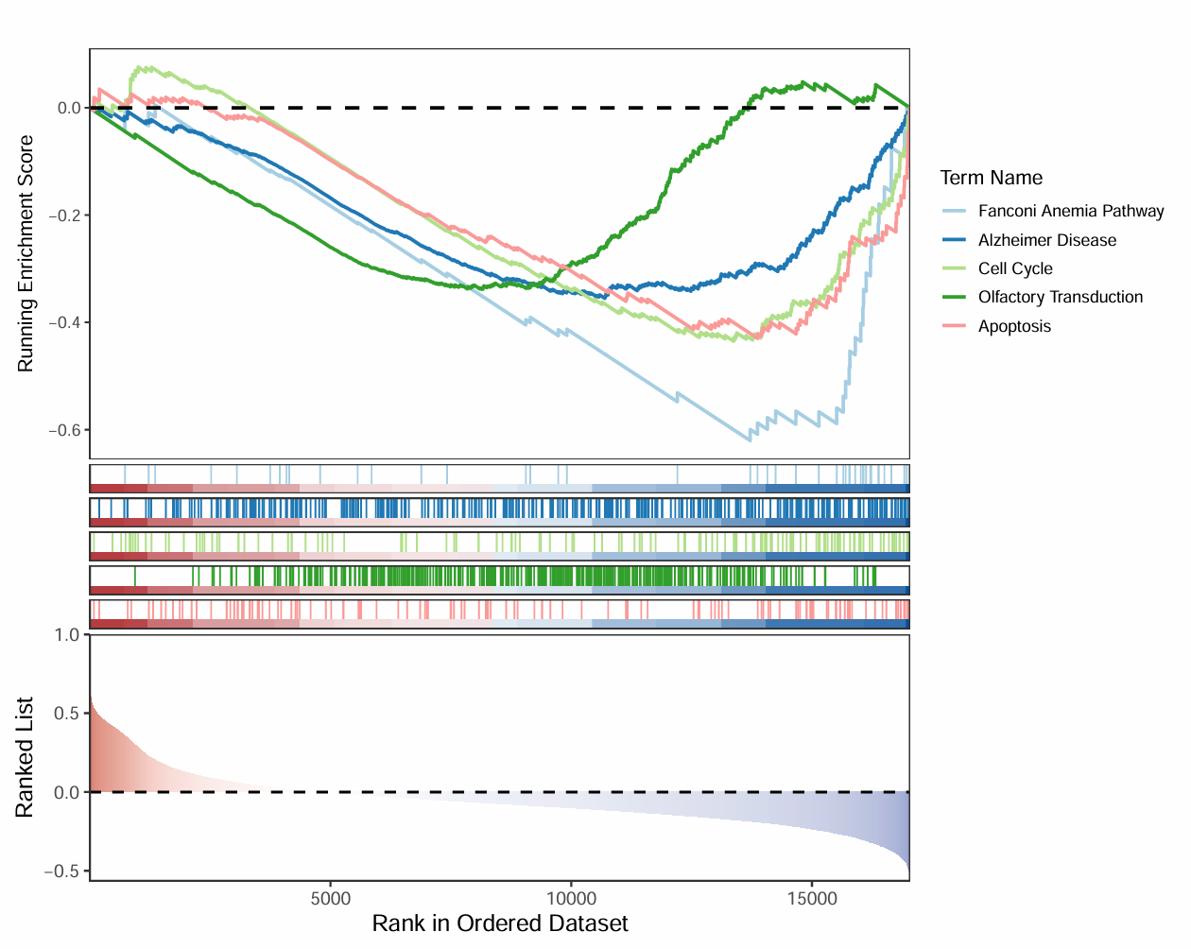

Supplementary Figure 11: The enrichment results of MUC1 in GSE44001 with GO enrichment analysis.
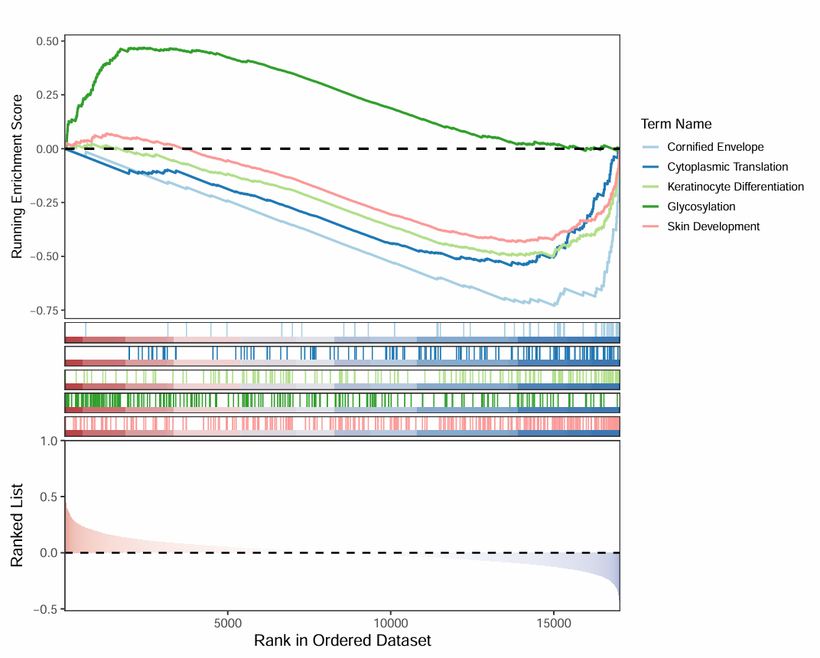

Supplementary Figure 12: The enrichment results of MUC1 in GSE44001 with KEGG enrichment analysis.
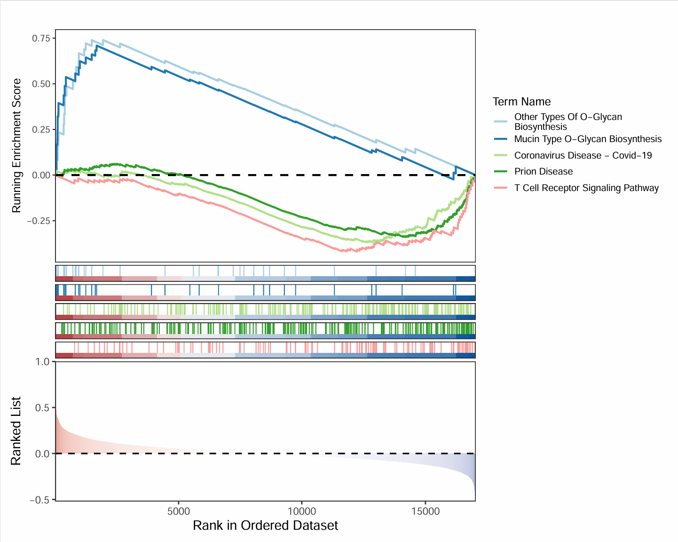

Supplementary Figure 13: The enrichment results of UCHL1 in GSE44001 with GO enrichment analysis.
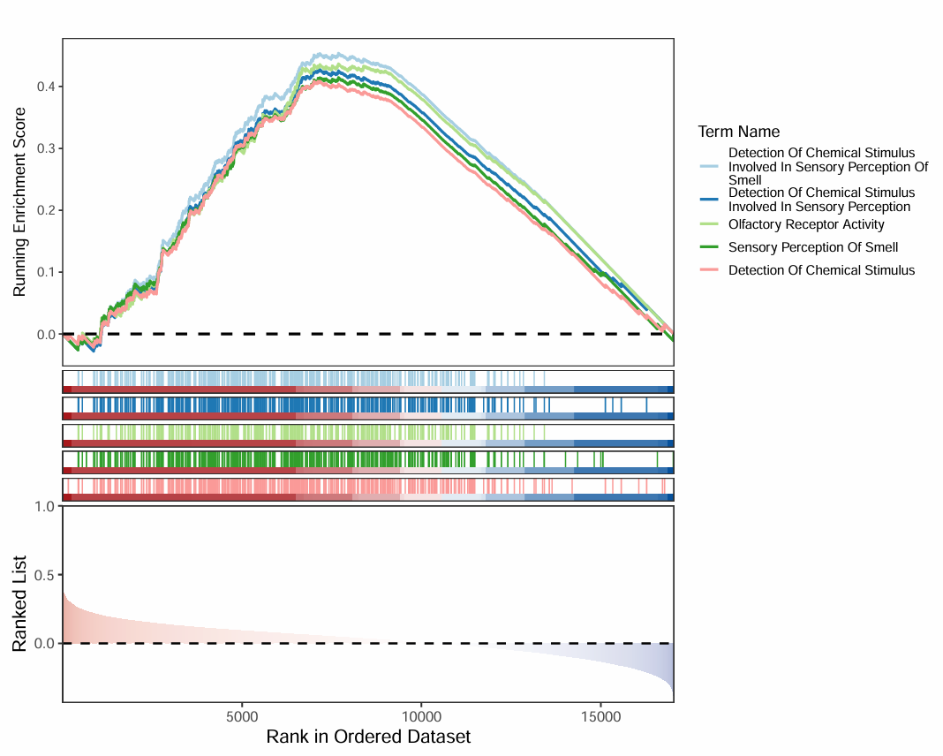

Supplementary Figure 14: The enrichment results of UCHL1 in GSE44001 with KEGG enrichment analysis.
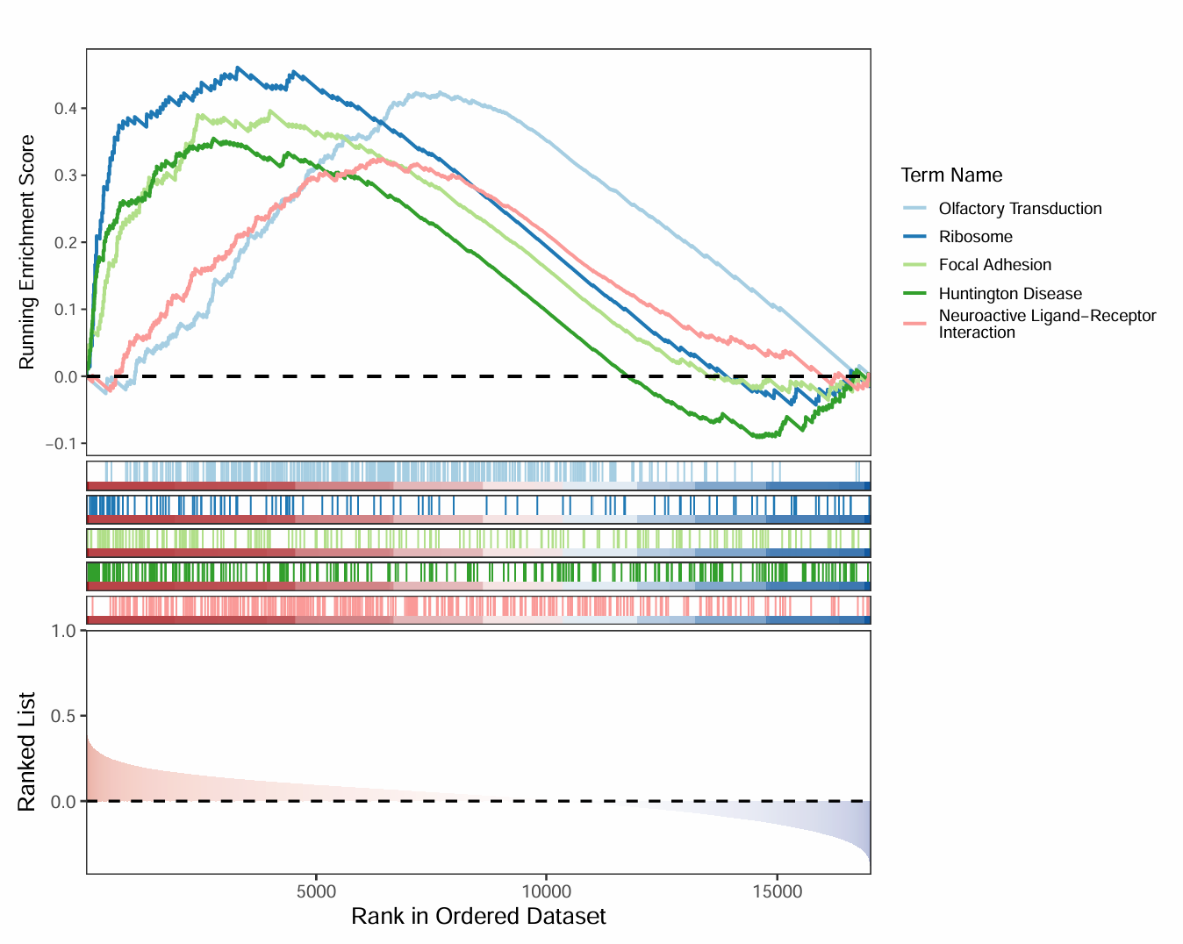

Supplementary Figure 15: The enrichment results of CALCRL in GSE44001 with GO enrichment analysis.
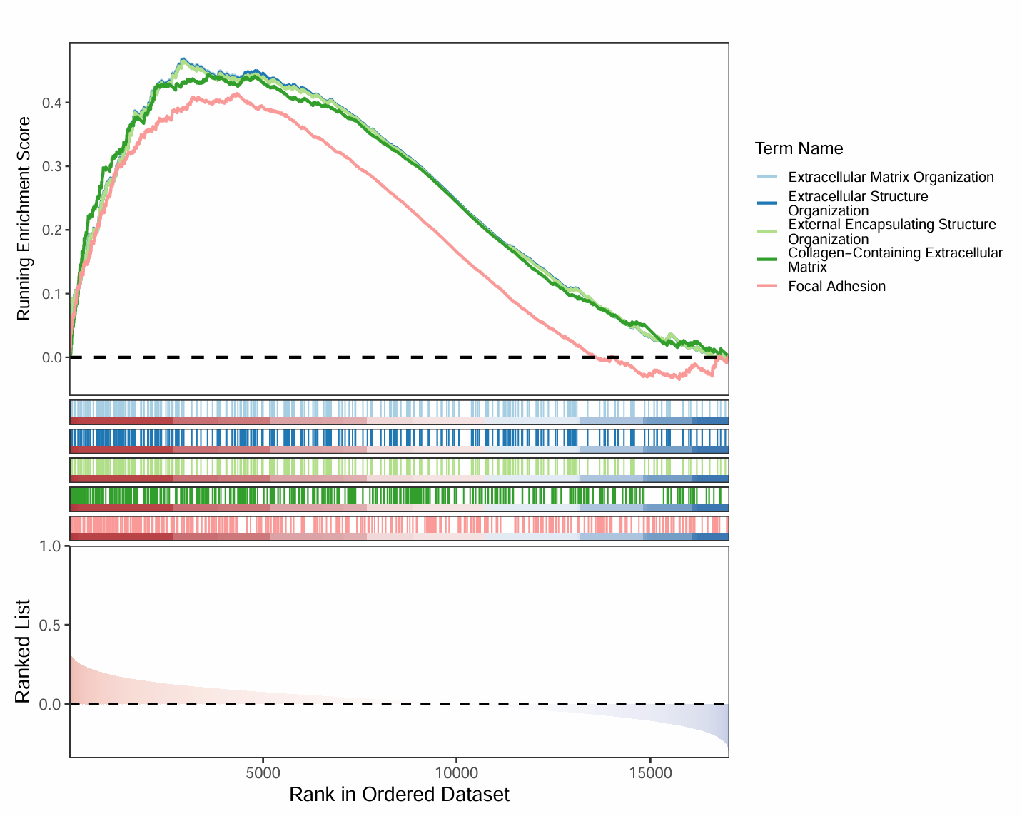

Supplementary Figure 16: The enrichment results of CALCRL in GSE44001 with KEGG enrichment analysis.
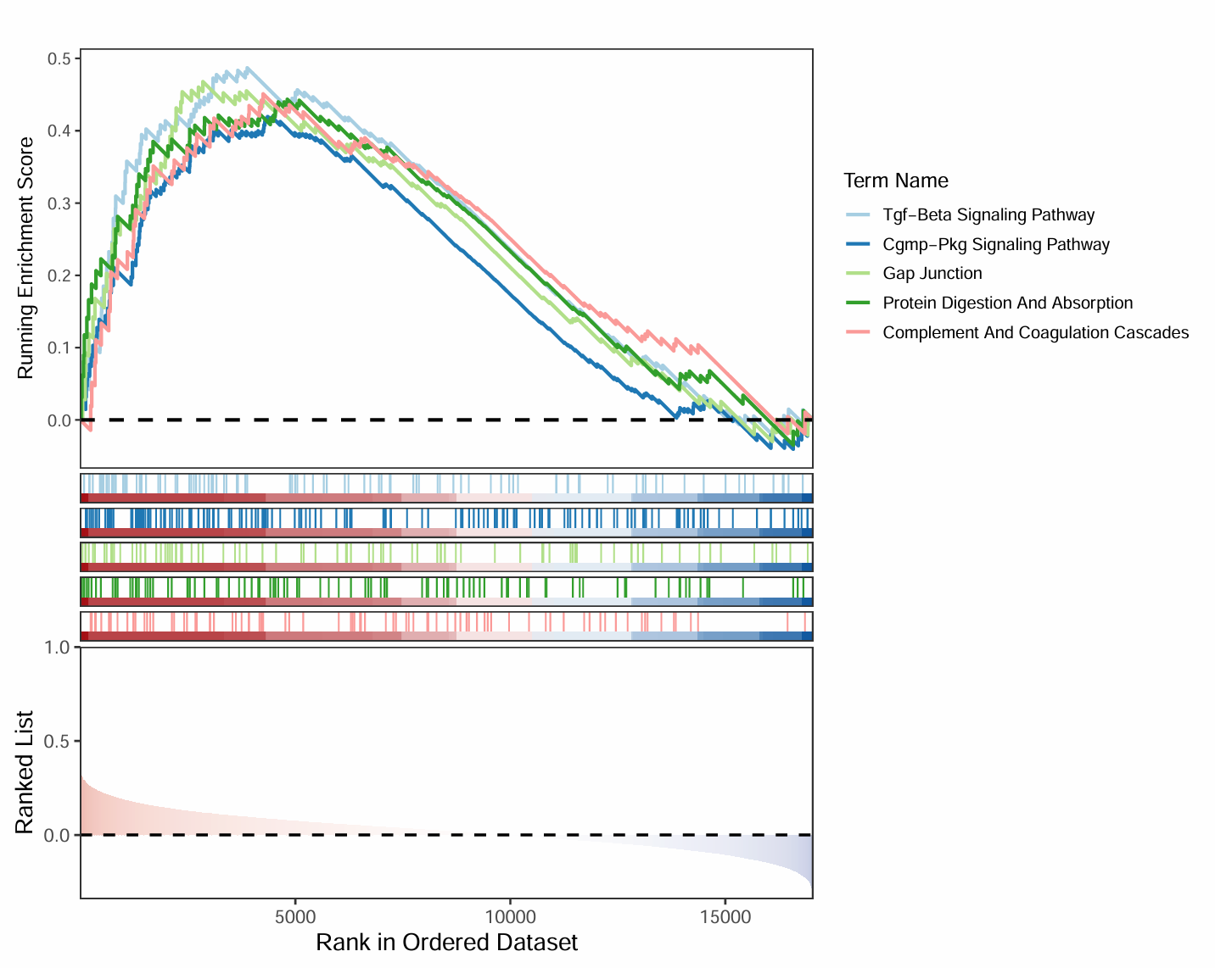

Supplementary Figure 17: Violin plot of differences in immune score, matrix score.
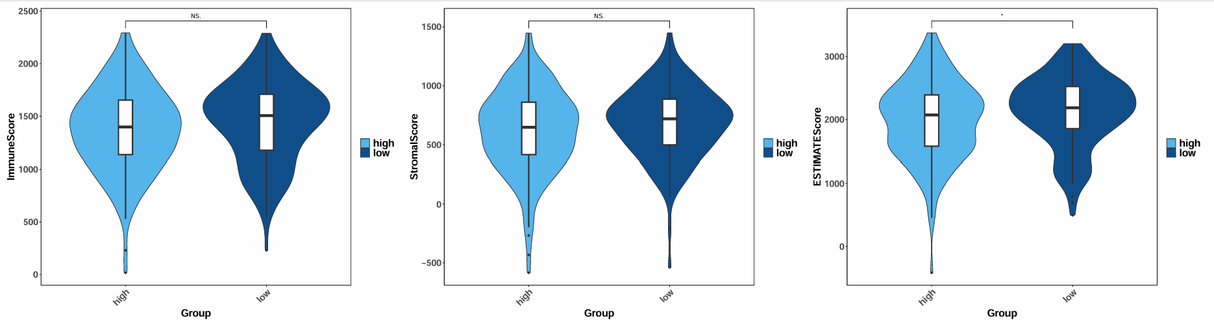
*p<0.05; ns p>0.05.

Supplementary Figure 18: Scatter plot of correlation between risk score and immune score, matrix score, and ESTIMATE score.
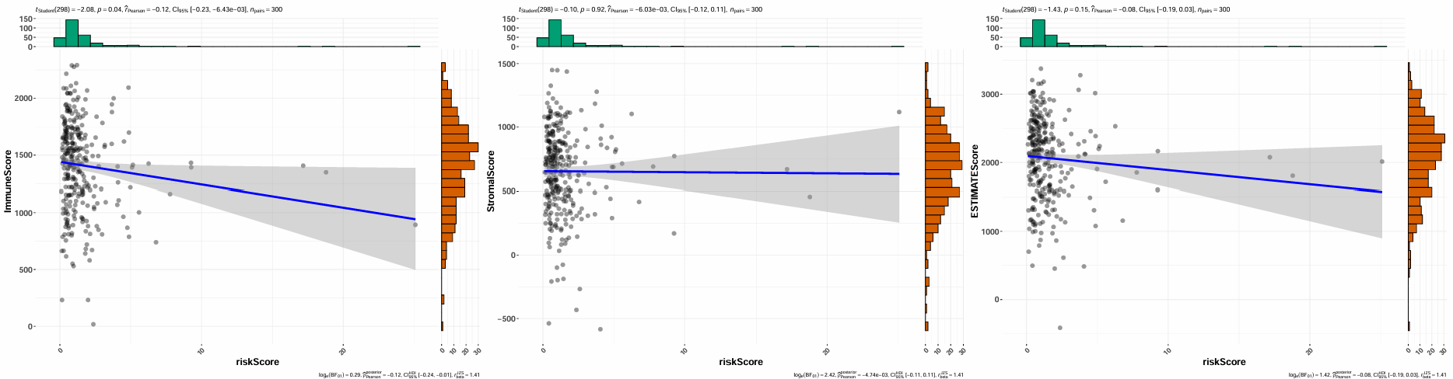

Supplementary Figure 19: Transcription factors in the 2000bp upstream promoter region of gene ACVRL1 in the UCSC database.

Supplementary Figure 20: Transcription factors in the 2000bp upstream promoter region of gene CALCRL in the UCSC database.

Supplementary Figure 21: Transcription factors in the 2000bp upstream promoter region of gene GNRH1 in the UCSC database.

Supplementary Figure 22: Transcription factors in the 2000bp upstream promoter region of gene MUC1 in the UCSC database.

Supplementary Figure 23: Transcription factors in the 2000bp upstream promoter region of gene UCHL1 in the UCSC database.

Supplementary Figure 24: Venn plot of the intersection of MUC1.
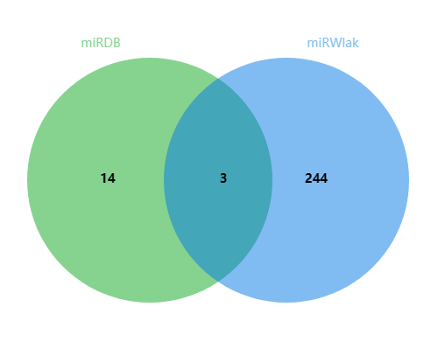

Supplementary Figure 25: Venn plot of the intersection of ACVRL1.
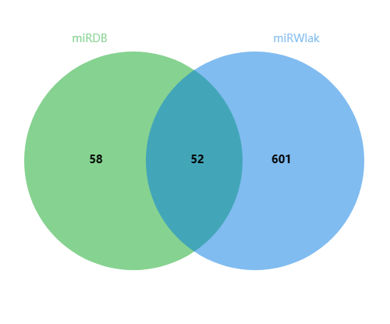

Supplementary Figure 26: Venn plot of the intersection of CALCRL.
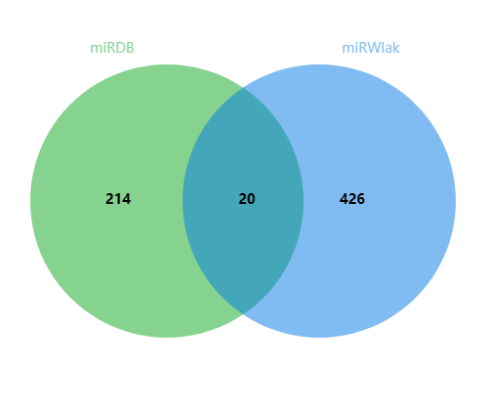

Supplementary Figure 27: Venn plot of the intersection of UCHL1.
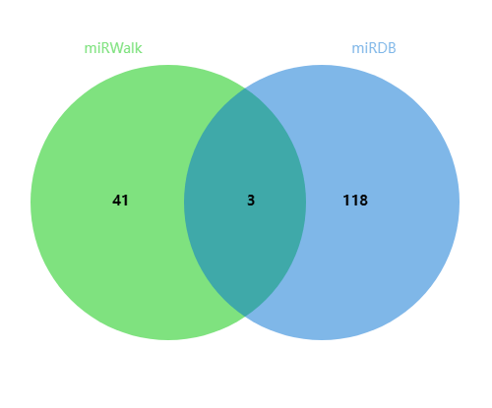

Supplementary Figure 28: PCA analysis of highly variable genes.
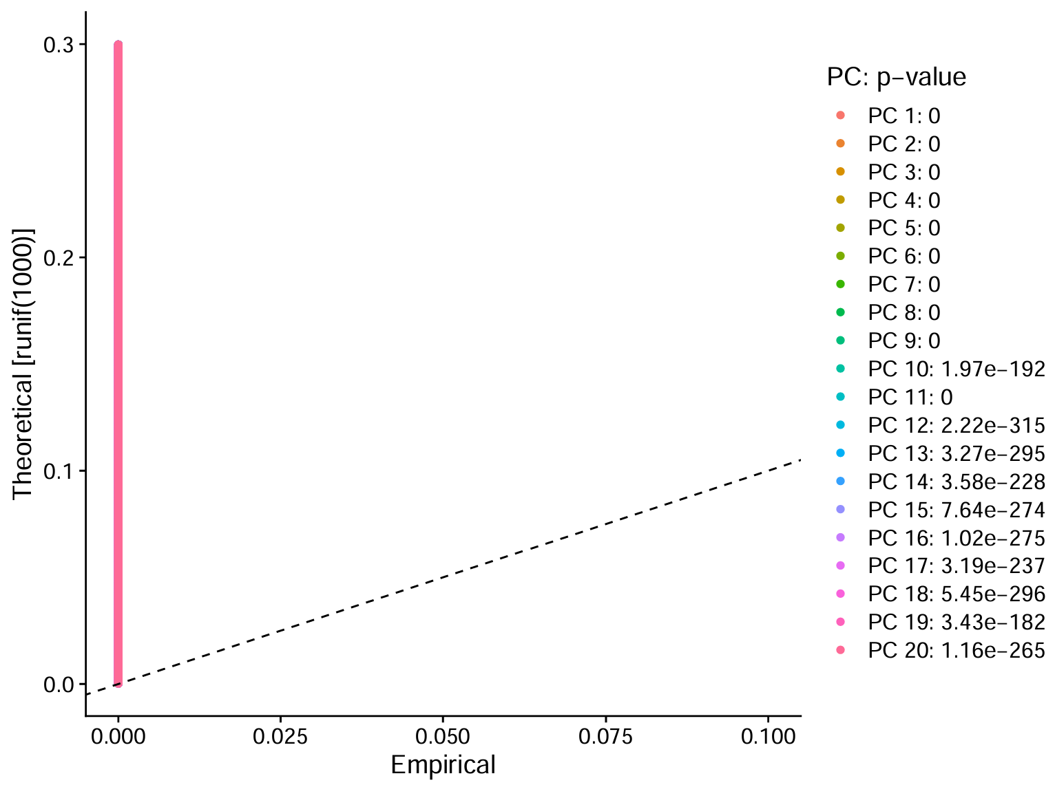

Supplementary Figure 29: Identification of available dimensions.
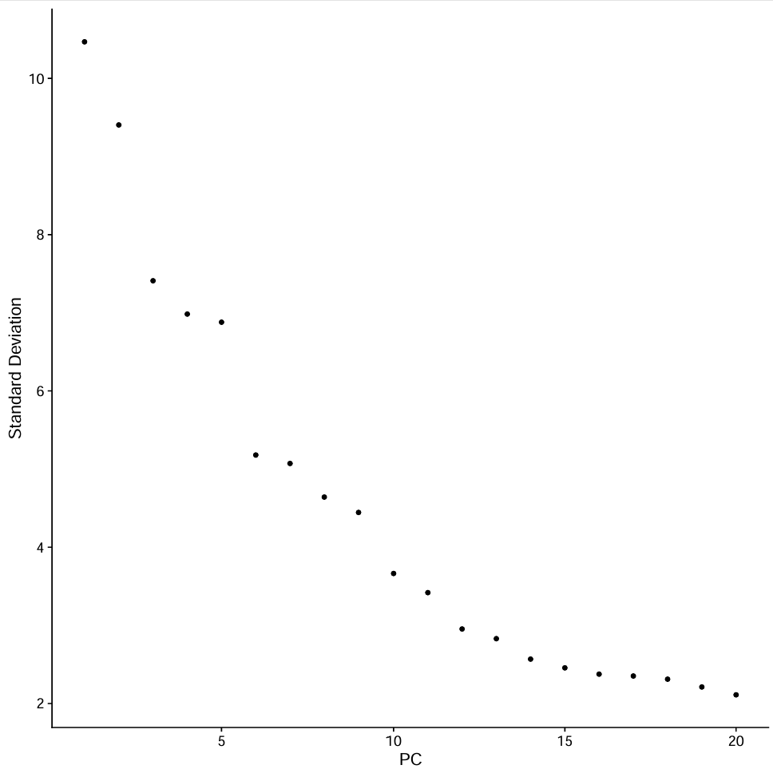

Supplementary Figure 30: Expression of biomarkers in different cell types in normal and disease.
