SUPPLEMENTARY INFORMATION

Electroacupuncture alleviates neuropathic pain and negative emotion in mice by regulating gut microbiota

Chenchen Feng, Haotian Pan, Yanan Zhang, Zi Ye, Yiren Zhou, Hong Zou, Ke Wang

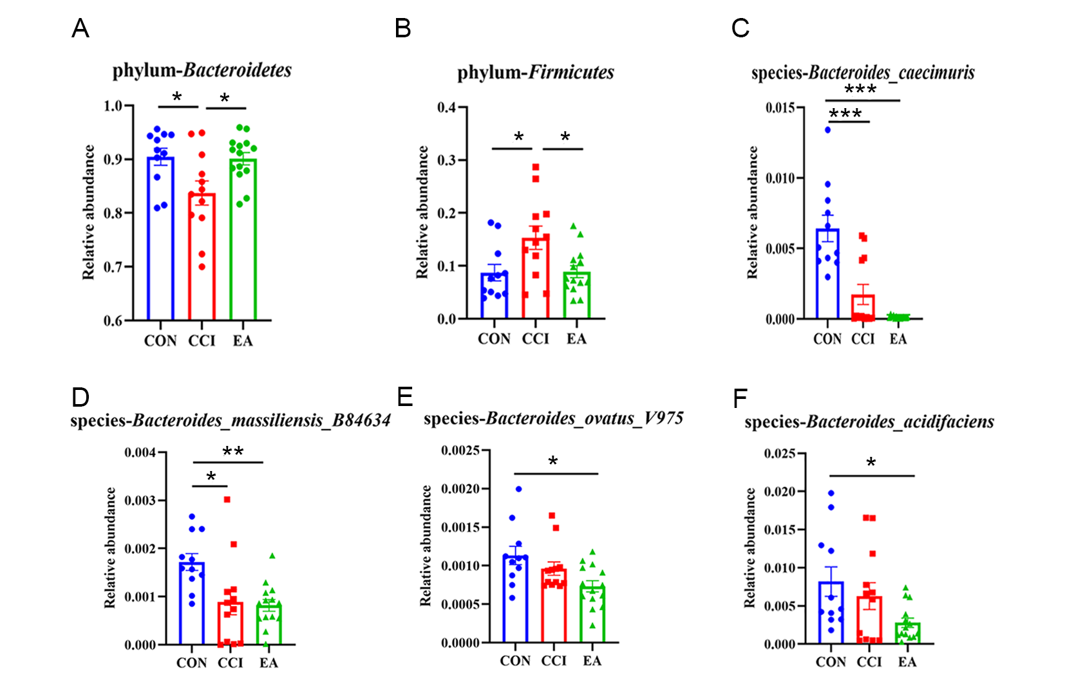
Supplementary Figure 1. (A-B) Phylum-level differences in relative abundance of Bacteroidetes and Firmicutes. (C-F) Species -level differences in relative abundance of Bacteroides_acidifaciens, Bacteroides_caecimuris, Bacteroides_massiliesis_B84634, Bacteroides_ovatus_V975. Data are mean ± standard error of the mean.
Notes: *P < 0.05, **P < 0.01, ***P < 0.001.

