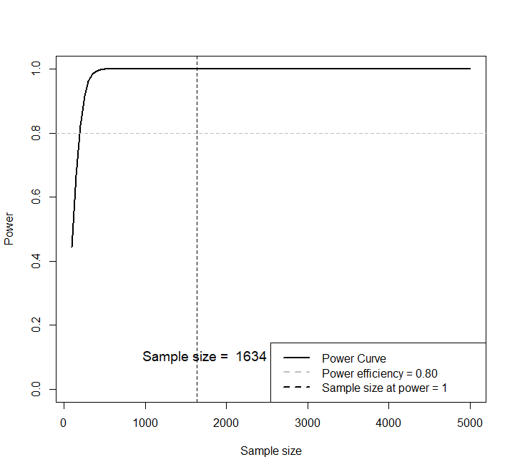

Appendix Figure 1. Relationship between sample size and power.

Appendix table 1. Lifetime Severe Traumatic Events Scale
Items | Questions | Options
1 | Death of a grandparent | Yes | No
2 | Death of father or mother | Yes | No
3 | Death of a sibling | Yes | No
4 | Suffered from a serious illness | Yes | No
5 | Natural disaster such as fire, flood, earthquake | Yes | No
6 | Been physically assaulted or attacked | Yes | No
7 | Witnessed someone else being seriously maimed or killed | Yes | No
8 | As a child, suffered physical abuse by a caregiver | Yes | No
9 | Suffered emotional/mental abuse by a foster parent when the child was a child | Yes | No
10 | Child has been neglected or ignored by his/her caregivers | Yes | No
11 | Sexism in the family | Yes | No
12 | Sexism in school | Yes | No
13 | School bullying (victim) | Yes | No
14 | Bullying in school (perpetrator) | Yes | No
15 | Being invited or asked to do sex-related activities | Yes | No
16 | Non-consensual kissing or hugging with sexual intent | Yes | No
17 | Non-consensual exposing or being exposed to sexual organs | Yes | No
18 | Non-consensual touching or being touched in a private area | Yes | No
19 | Non-consensual sexual intercourse | Yes | No
20 | Consensual sexual intercourse | Yes | No
21 | Been raped | Yes | No
22 | Adopted/fostered | Yes | No
23 | Left-behind children (both parents are away and not with them) | Yes | No

Appendix table 2. Comparison of characteristics between genetically provided and non-genetically provided samples among first-year university students
Variables | Total  Sample | Genetic Sample | Non-genetic sample | χ²/U | P
Variables | N=6985(%) | N1=4866(%) | N2=2119(%) | χ²/U | P
Age (M±SD) | 18.39(0.84) | 18.42(0.86) | 18.38(0.84) | -5.075ª | <0.001
Beck anxiety score (M±SD) | 25.11(6.26) | 25.03(6.23) | 25.14(6.27) | -2.369ª | 0.018
Beck depression score (M±SD) | 3.11(5.27) | 2.93(5.49) | 3.23(5.12) | -2.844ª | 0.004
Number of Adolescent Self-rating Life Events | 6.60 (4.14) | 6.68 (4.14) | 6.43 (4.14) | -2.436ª | 0.015
Number of Lifetime Severe Traumatic Events | 1.22 (1.24) | 1.22 (1.26) | 1.21 (1.18) | -0.535ª | 0.593
Sex
Male | 2750(39.4) | 1888(38.8) | 862(40.7) | 2.107 | 0.147
Female | 4235(60.6) | 2978(61.2) | 1257(59.3)
Only Child
No | 4258(61.5) | 3020(62.1) | 1238(60.3) | 1.892 | 0.177
Yes | 2661(38.5) | 1846(37.9) | 815(39.7)
City
Jining | 3884(55.6) | 2179(44.8) | 1705(80.5) | 761.384 | <0.001
Weifang | 747(10.7) | 646(13.3) | 101(4.8)
Rizhao | 2354(33.7) | 2041(41.9) | 313(14.8)
Major depressive disorder
No | 4751(97.6) | 1848(97.9) | 2903(97.5) | 0.601 | 0.438
Yes | 115(2.4) | 40(2.1) | 75(2.5)
Family functioning(M±SD)
Problem Solving | 2.14(0.42) | 2.17(0.48) | 2.12(0.37) | -2.506ª | 0.012
Communication | 2.11(0.39) | 2.13(0.38) | 2.10(0.39) | -0.875ª | 0.381
Roles | 2.17(0.28) | 2.18(0.30) | 2.16(0.27) | -0.590ª | 0.555
Affective Responsiveness | 2.20(0.44) | 2.21(0.42) | 2.18(0.46) | -0.138ª | 0.890
Affective Involvement | 2.04(0.41) | 2.06(0.45) | 2.03(0.39) | -1.667ª | 0.096
Behavior Control | 2.29(0.27) | 2.28(0.28) | 2.30(0.26) | -1.191ª | 0.234
General Functioning | 2.06(0.34) | 2.09(0.35) | 2.04(0.33) | -0.219ª | 0.827
ªMann-Whitney U test.

Appendix table 3. Correlation between PCDH9 rs9540720 genotype and family functioning in first year university students
Family functioning | Rs9540720 genotype | β* | t | P
Problem Solving | GG | 0.017 | 1.292 | 0.197
Problem Solving | AA | 0.001 | 0.073 | 0.942
Communication | GG | 0.007 | 0.568 | 0.570
Communication | AA | 0.000 | 0.025 | 0.980
Roles | GG | 0.006 | 0.758 | 0.448
Roles | AA | 0.004 | 0.358 | 0.720
Affective Responsiveness | GG | -0.001 | -0.086 | 0.931
Affective Responsiveness | AA | -0.015 | -0.888 | 0.375
Affective Involvement | GG | -0.004 | -0.316 | 0.752
Affective Involvement | AA | 0.021 | 1.302 | 0.193
Behavior Control | GG | -0.005 | -0.601 | 0.548
Behavior Control | AA | -0.009 | -0.842 | 0.400
General Functioning | GG | 0.005 | 0.522 | 0.601
General Functioning | AA | -0.007 | -0.543 | 0.587
*Adjusted by sex, age, city, beck anxiety score, beck depression score, number of adolescent self-rating life events, number of lifetime severe traumatic events.

