Table 1. The qPCR primer sequence used in this article.
Gene | Forward Primer | Reverse Primer
Ptgs2 (mouse) | TTCAACACACTCTATCACTGGC | AGAAGCGTTTGCGGTACTCAT
Ptgs2 (rat) | CCAACCTCTCCTACTACACC | CCTTATTTCCTTTCACACCCA
mt-Co1 (mouse) | ACTACTAACAGACCGCAACC | TGAAGCACGATGTCAAGG
mt-Nd1 (mouse) | GTTGGTCCATACGGCATTT | TTGTTTGGGCTACGGCTC
mt-Cytb (mouse) | TAGCAATCGTTCACCTCCTC | CTGGGTCTCCTAGTATGTCTGG
mt-Atp6 (mouse) | AACCGTCTCCATTCTTTC | ATAGTTGGGTAGTAGGTGTAA
Il6 (mouse) | TAGTCCTTCCTACCCCAATTTCC | TTGGTCCTTAGCCACTCCTTC
Tnfa (mouse) | CCCTCACACTCAGATCATCTTCT | GCTACGACGTGGGCTACAG
Il1b (mouse) | GCAACTGTTCCTGAACTCAACT | ATCTTTTGGGGTCCGTCAACT
Col1a1 (mouse) | GCTCCTCTTAGGGGCCACT | CCACGTCTCACCATTGGGG
Col3a1 (mouse) | CTGTAACATGGAAACTGGGGAAA | CCATAGCTGAACTGAAAACCACC

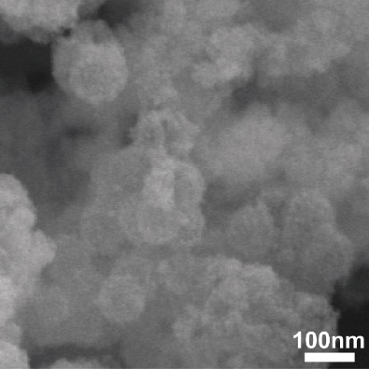
Figure S1. High Magnification SEM Image of Se@PSN.

Figure S2. Zeta Potential of Solid Se@SiO₂ and Se@PSN.

Figure S3. Multipoint Brunauer-Emmett-Teller (BET) Analysis of Se@PSN.

Figure S4. Hydrodynamic Size Distribution of Solid Se@SiO₂ and Se@PSN.

Figure S5. Effect of high-dose Se@PSN injection on the heart. A) Echocardiography images and EF and FS of mice injected with a high dose of Se@PSN into the myocardium at days 1 and 14 post-injection (n=3; ns, p > 0.05). B) Serum levels of cardiac injury markers in mice from the high-dose Se@PSN injection group compared to the control group (n=3; ns, p > 0.05).

Figure S6. Pearson Correlation Heatmap of Transcriptomic Data.

Figure S7. Heatmap of DEGs in the IR+Se@PSN Group Compared to the IR Group.

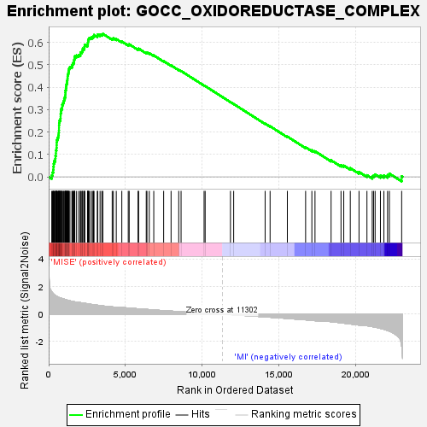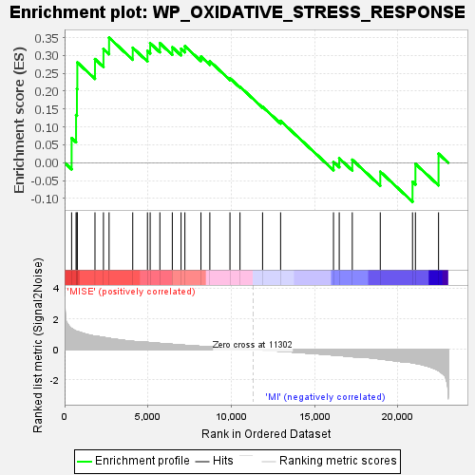
Figure S8. GSEA Plot of the Oxidoreductase and Oxidative Stress Pathway (IR+Se@PSN Group vs IR Group).

Figure S9. GPX4 and SLC7A11 Expression in H9c2 Cells from Control, Se@PSN, Erastin, Erastin+PSN and Erastin+Se@PSN Groups (n=4-5, *p < 0.05).

Figure S10. Relative mRNA Levels of Ptgs2 in H9c2 Cells from Different Groups (n=6, *p < 0.05).

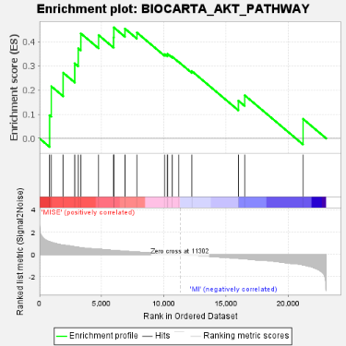
Figure S11. GSEA Plot of the Akt Pathway and Heatmap Illustrating Genes Related to the Akt Pathway in the IR+Se@PSN Group Compared to the IR Group.

Figure S12. p-Akt and p-GSK-3β Expression in H9c2 Cells from Control, Se@PSN, Erastin, Erastin+PSN, and Erastin+Se@PSN Groups (n=3, *p < 0.05).

Figure S13. PGC-1α Expression in Myocardium from Sham, Se@PSN, IR, IR+PSN and IR+Se@PSN Groups (n=3, *p < 0.05).

Figure S14. Apoptosis-Related Protein Expression in H9c2 Cells of Control, Se@PSN, HR and HR+Se@PSN Groups (n=5, *p < 0.05).

Figure S15. LV Vol;d and LV Vol;s of Mice from Different Groups at Day 14 Post-IR (n=5, *p < 0.05).
Figure S16. Relative mRNA Levels of Col1a1 and Col3a1 in Myocardial from Different Groups (n=3, *p < 0.05).

