Supplementary table 1

Factor 1  Confidence in information regarding the COVID-19 | Data on vaccination safety are often false.
Factor 1  Confidence in information regarding the COVID-19 | Immunizing children is harmful, and this is hidden by not being told.
Factor 1  Confidence in information regarding the COVID-19 | Pharmaceutical companies are hiding the side effects of the COVID-19 vaccines.
Factor 1  Confidence in information regarding the COVID-19 | Vaccines only serve pharmaceutical companies that want to get rich.
Factor 1  Confidence in information regarding the COVID-19 | Data on the effectiveness of vaccination are often false.
Factor 1  Confidence in information regarding the COVID-19 | I am afraid of the adverse effects of the COVID-19 vaccine.
Factor 1  Confidence in information regarding the COVID-19 | The vaccine was not studied enough before it was approved for vaccinating people.
Factor 2  Safety and efficacy of the COVID-19 vaccine | I don't think the COVID-19 vaccine is safe.
Factor 2  Safety and efficacy of the COVID-19 vaccine | I don't think it's important to get the COVID-19 vaccine to protect ourselves.
Factor 2  Safety and efficacy of the COVID-19 vaccine | I don't think it's important to get the COVID-19 vaccine to protect our family.
Factor 2  Safety and efficacy of the COVID-19 vaccine | I don't think it is important to make the COVID-19 vaccine to control the pandemic.
Factor 2  Safety and efficacy of the COVID-19 vaccine | I don't think the COVID-19 vaccine is effective.
Factor 2  Safety and efficacy of the COVID-19 vaccine | I don't think it's important to get vaccinated against COVID-19 to get back to normal life.
Factor 3  COVID-19 vaccination is a way of controlling the people | I believe that the COVID-19 vaccine is a way to control people.
 | I do not consider it acceptable to impose the anti-COVID-19 vaccination.

Supplementary table 1- presents the grouping of items into three distinct factors based on extracted themes.

Supplementary figure 1

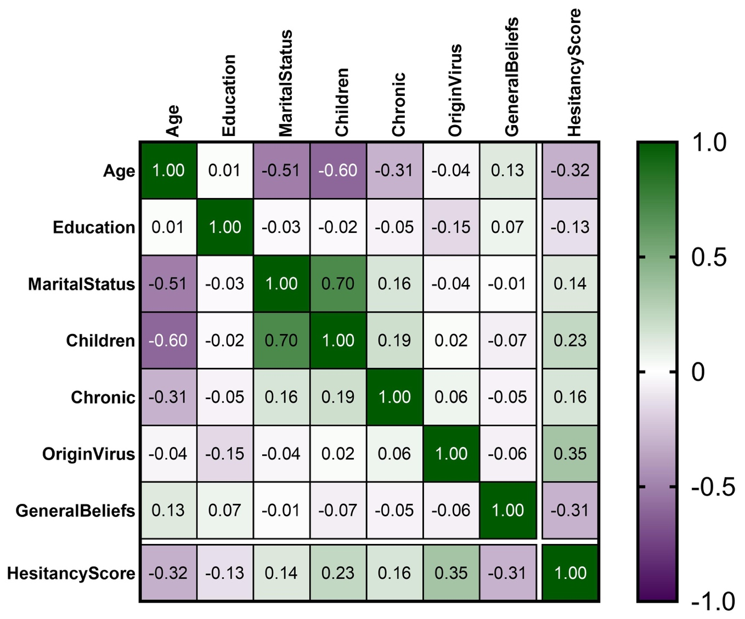

Supplementary figure 1. Heatmap correlation matrix of various factors influencing COVID-19 vaccine hesitancy. The color gradient ranges from green (positive correlation) to magenta (negative correlation). Each cell shows the correlation coefficient (rho) between the factors, with values labeled within the cells.

The variety of factors were found to be correlated with COVID-19 vaccine hesitancy, also as in Figure 4. Age of the participants influenced vaccine hesitancy, younger participants hesitate more than older participants (rho = -0.315, p-value < 0.0001). Education was a significant factor that influenced vaccine hesitancy, less educated participants were more hesitant (rho = -0.128, p-value = 0.041). Marital status was another significant factor, single or divorced participants were more hesitant in COVID-19 vaccination (rho = 0.136, p-value = 0.029). Having children was a factor that increased COVID-19 vaccine hesitancy (rho = 0.232, p-value < 0.0001). Participants with chronic diseases had higher COVID-19 vaccine hesitancy (rho = 0.157, p-value = 0.012). Lack of trust in the natural origin of the virus increased the level of hesitancy (rho = 0.353, p-value < 0.0001). General antivaccine beliefs decreased the level of hesitancy (rho = -0.305, p-value < 0.0001).

