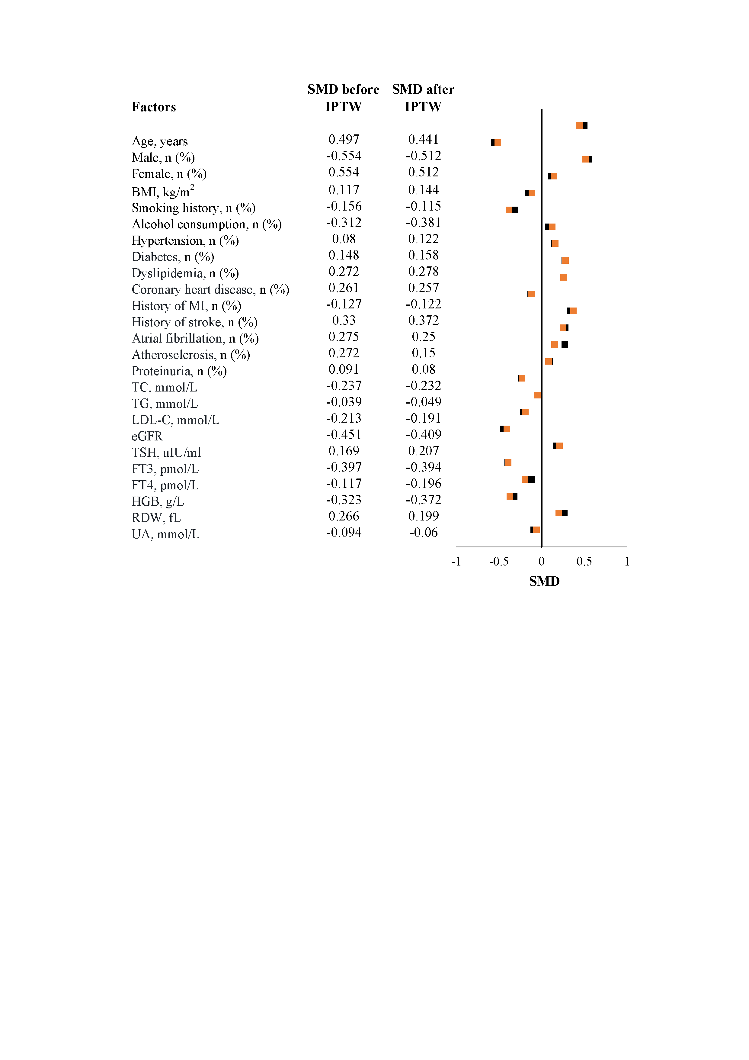

Supplementary Figure 1. Standardized mean difference (SMD) of baseline characteristics before and after propensity score inverse probability of treatment weighting (IPTW)
Black: SMD before IPTW; orange: SMD after IPTW

Supplementary Table 1. Patient characteristics by sex.
Variables | Overall  N=341 | Male  N=240 | Female  N=101 |  | P value
Left atrial enlargement, n(%) | 172(50.44) | 100(41.67) | 72(71.29) |  | <0.01
Age, years | 53.42±14.4 | 49.92±13.58 | 61.73±12.86 |  | <0.01
BMI, Kg/m2 | 28.91±4.46 | 29.2±4.44 | 28.24±4.45 |  | 0.07
BMI≥28, n(%) | 189(55.43) | 137(57.08) | 52(51.49) |  | 0.34
Smoking history, n(%) | 178(52.2) | 166(69.17) | 12(11.88) |  | <0.01
Alcohol consumption, n(%) | 129(37.83) | 125(52.08) | 4(3.96) |  | <0.01
Hypertension, n(%) | 284(83.28) | 200(83.33) | 84(83.17) |  | 0.97
Diabetes, n(%) | 119(34.9) | 79(32.92) | 40(39.6) |  | 0.24
Dyslipidemia, n(%) | 285(83.58) | 197(82.08) | 88(87.13) |  | 0.25
Coronary heart disease, n(%) | 119(34.9) | 78(32.5) | 41(40.59) |  | 0.15
History of MI, n(%) | 23(6.74) | 18(7.5) | 5(4.95) |  | 0.39
History of stroke, n(%) | 38(11.14) | 24(10) | 14(13.86) |  | 0.30
Atrial fibrillation, n(%) | 16(4.69) | 13(5.42) | 3(2.97) |  | 0.33
Atherosclerosis, n(%) | 273(80.06) | 185(77.08) | 88(87.13) |  | 0.03
Proteinuria, n(%) | 31(9.09) | 23(9.58) | 8(7.92) |  | 0.63
TC, mmol/L | 4.48±1.07 | 4.48±1.1 | 4.49±1.02 |  | 0.96
TG, mmol/L | 2.27±2.11 | 2.43±2.29 | 1.88±1.58 |  | 0.03
LDL-C, mmol/L | 2.65±0.93 | 2.67±0.96 | 2.63±0.88 |  | 0.73
eGFR | 92.13±21.07 | 94.71±20.41 | 85.99±21.45 |  | <0.01
TSH, uIU/ml | 1.83(1.31, 2.68) | 1.78(1.31, 2.48) | 2.12(1.29, 3.21) |  | 0.01
FT3, pmol/L | 4.8(4.4, 5.27) | 5(4.6, 5.4) | 4.4(4.1, 4.8) |  | <0.01
FT4, pmol/L | 16.4(15, 17.9) | 16.59(15.1, 18) | 15.8(14.8, 17.2) |  | 0.09
HGB, g/L | 142.89±17.89 | 149.03±15.96 | 128.32±13.2 |  | <0.01
RDW, fl | 41.79±3.75 | 41.8±4.04 | 41.78±2.95 |  | 0.97
UA, mmol/L | 401.77±108.8 | 424.23±108.25 | 348.4±90.31 |  | <0.01
EF, % | 66.14±5.5 | 66.13±5.27 | 66.15±6.02 |  | 0.98
LAD-ap,mm | 38.59±6.06 | 39.08±6.41 | 37.43±4.95 |  | 0.01
LVEDD, mm | 48.06±4.49 | 48.66±4.5 | 46.63±4.15 |  | <0.01
LV diastolic dysfunction, n (%) | 207(60.7) | 129(53.75) | 78(77.23) |  | <0.01
Mitral Regurgitation, n (%) |  |  |  |  | 0.15
none | 286(83.87) | 206(85.83) | 80(79.21)
mild | 47(13.78) | 28(11.67) | 19(18.81)
middle | 4(1.17) | 3(1.25) | 1(0.99)
severe | 1(0.29) | 0(0) |  | 1(0.99)
OAHI | 25.7(13.2, 45.5) | 29.3(16.15, 46.6) | 20.6(9.7, 34.9) |  | <0.01
OSAS |  |  |  |  | 0.01
none | 23(6.74) | 14(5.83) | 9(8.91)
mild | 69(20.23) | 41(17.08) | 28(27.72) |  | .
middle | 107(31.38) | 71(29.58) | 36(35.64) |  | .
severe | 142(41.64) | 114(47.5) | 28(27.72) |  | .
CAHI | 0.3(0, 1.4) | 0.4(0, 1.75) | 0.1(0, 0.7) |  | <0.01
CAHI≥5 | 33(9.68) | 24(10) | 9(8.91) |  | 0.76
AHI | 23.8(9.7, 44.9) | 31.6(17.15,51.25) | 21.6(10.9, 37.5) |  | <0.01
3%ODI | 23.8(9.7, 44.9) | 26.5(12.45, 46.7) | 17.6(6.9, 32.7) |  | <0.01
Mean SaO₂, % | 93.8±2.49 | 93.87±2.42 | 93.65±2.66 |  | 0.47
LSaO₂, % | 81.11±9.32 | 80.75±9.65 | 81.97±8.47 |  | 0.27
T90% | 2.8(0.3, 16.1) | 2.9(0.39, 16.75) | 1.7(0.2, 11.5) |  | 0.23
BMI, body mass index; MI, myocardial infarction; TG, Triglycerides; TC, Total cholesterol; LDL-C, Low-density lipoprotein cholesterol; eGFR, Estimated Glomerular Filtration Rate ; TSH, Thyroid Stimulating Hormone; FT3, Free Triiodothyronine; FT4, Free Thyroxine; HGB , Hemoglobin ; RDW, Red cell distribution; UA, Uric Acid ; AHI, apnea-hyponea index; CAHI, Central Apnea-Hypopnea Index; OAHI, Obstructive Apnea-Hypopnea Index; OSAs, obstructive sleep apnea severity; SaO₂,oxygen saturation of arterial blood hemoglobin; T90%,time with arterial oxygen saturation＜90%; LSaO₂, lowest blood oxygen saturation; 3%ODI, the number of oxygen desaturation events per hour with a desaturation of at least 3%; EF, ejection fraction; LAD-ap, Left Atrium Anterior-Posterior Diameter; LVEDD, left ventricular end diastolic diameter; LV, left ventricle.

Supplementary Table 2. VIF analysis
Factors | VIF
CSA | 1.27
Sex | 2.43
Age | 3.21
BMI | 1.42
Smoking history | 1.64
Alcohol consumption | 1.44
Hypertension | 1.24
Diabetes | 1.29
Dyslipidemia | 1.35
Coronary heart disease | 1.67
History of MI | 1.40
History of stroke | 1.30
Atrial fibrillation | 1.22
Peripheral arterial atherosclerosis | 1.50
Proteinuria | 1.37
TC | 4.07
eGFR | 2.24
FT3 | 1.75
HGB | 2.25
RDW | 3.47
EF | 1.25
LVEDD | 1.31
Mitral regurgitation | 1.33
Mean SaO₂ | 1.43
Severe OSAS | 1.44
CSA, central sleep apnea; BMI, body mass index; MI, myocardial infarction; TC, Total cholesterol; eGFR, Estimated Glomerular Filtration Rate; FT3, Free Triiodothyronine; HGB, Hemoglobin; RDW, Red cell distribution; SaO₂, oxygen saturation of arterial blood hemoglobin; EF, ejection fraction; LVEDD, left ventricular end diastolic diameter; OSAS, obstructive sleep apnea severity

Supplementary Table 3. Logistic regression analysis to explore odds ratios of CSA for left atrial enlargement adjusting for AHI and moderate-to severe OSAS
 | Sex | Model | OR (95% CI) | P value
before IPTW | Male | Model 4 | 1.54(0.49,4.84) | 0.46
 |  | Model 4x | 1.58(0.48,5.2) | 0.45
 |  | Model 4y | 1.54(0.49,4.86) | 0.46
 | Female | Model 4 | 1.17(0.11,12.38) | 0.90
 |  | Model 4x | 0.9(0.08,10.34) | 0.93
 |  | Model 4y | 1.15(0.11,12.48) | 0.91
after IPTW | Male | Model 4 | 4.54(1.45,14.2) | 0.01
 |  | Model 4x | 4.4(1.36,14.2) | 0.01
 |  | Model 4y | 4.57(1.47,14.24) | 0.01
 | Female | Model 4 | 3.99(0.19,82.06) | 0.37
 |  | Model 4x | 2.92(0.13,63.41) | 0.50
 |  | Model 4y | 3.34(0.17,67.21) | 0.43
IPTW: inverse probability of treatment weighting
Model 4: adjusting age, sex, BMI, smoking history, alcohol consumption, disease history, lab test (proteinuria, TC, eGFR, FT3, HGB, RDW), EF, LVEDD, mitral regurgitation, and sleep status (severe OSAS, mean SaO2)
Model 4x: adjusting age, sex, BMI, smoking history, alcohol consumption, disease history, lab test (proteinuria, TC, eGFR, FT3, HGB, RDW), EF, LVEDD, mitral regurgitation, and sleep status (mean SaO2), AHI (as continuous variable)
Model 4y: adjusting age, sex, BMI, smoking history, alcohol consumption, disease history, lab test (proteinuria, TC, eGFR, FT3, HGB, RDW), EF, LVEDD, mitral regurgitation, and sleep status (moderate-to-severe OSAS, mean SaO2).

