Supplementary Material

Supplementary Table 1: Biochemical phenotyping for the recruited population, stratified for Females and Males groups. Data are reported as Median [Interquartile Range - IQR].
 | T0 | T1 | T2
RBC (10⁹/l)
Males | 5.08 [4.85; 5.38] | 5.08 [4.86; 5.39] | 5.24 [4.44; 5.58]
Females | 4.5 [4.29; 4.76] | 4.48 [4.28; 4.59] | 4.55 [4.32; 4.83]
WBC (10¹²/l)
Males | 7.97 [6.35; 9.65] | 7.73 [6.58; 8.38] | 7.85 [7.08; 8.5]
Females | 6.75 [5.64; 8.05] | 6.59 [5.09; 7.8] | 7.05 [5.64; 7.9]
PLT (10⁹/l) | 247 [198; 278] | 239 [184; 263] | 235 [195.5; 281.5]
Glycaemia (mg/dl) | 93 [84; 107] | 91 [81.5; 105] | 92 [79; 97]
CRP (mg/l) | 0.145 [0.07; 0.42] | 0.14 [0.08; 0.25] | 0.17 [0.1; 0.26]
Ferritin (ng/ml)
Males | 105 [67; 155] | 167 [112; 241.5] | 163 [92; 291]
Females | 43 [22.25; 75.5] | 33 [13; 63] | 24 [10; 61]
AST (ng/ml)
Males | 22 [16; 24.5] | 24 [19.65; 26] | 20 [18; 27.5]
Females | 18 [15; 21.75] | 16 [15; 19] | 17 [15; 24]
ALT (ng/ml)
Males | 22 [16; 24.5] | 24 [20; 51] | 14 [13.5; 35.5]
Females | 17 [14.25; 21] | 17 [13; 20] | 15 [11; 19]
RBC: Red Blood Cells; WBC; White Blood Cells; PLT: Platelets; CRP: C-Reactive Protein; AST: Aspartate transaminase; ALT: Alanine transaminase.

Supplementary Table 2: Numeric Pain Scale Rate (NPRS) score. NPRS is reported as Mean ± Standard Deviation for the three time points. Mean Differences throughout times are reported as Mean (95% Confidence Interval). p<0.05 were considered statistically significant and represented in bold.
 | T0 | T1 | T2
NPRS | 8.12 ± 1.6 | 6.64 ± 1.93 | 5.08 ± 2.01
 |  | ΔT0-T1 | ΔT1-T2
Mean (95% CI) | - | 1.48 (0.82 – 2.13) | 1.55 (0.798 – 2.32)
p |  | <0.001 | <0.001
 |  |  | ΔT0-T2
Mean (95% CI) | - | - | 3.04 (2.35 – 3.73)
p |  |  | <0.001

Supplementary Table 3: APC screening for Cytokines, Chemokines and Growth factors at both T0 and T1. Results are indicated as median [IQR] and expressed as picograms/milliliters (pg/ml).
Marker | T0 APC | T1 APC | Paired  p | Fold Change
 |  |  |  | Est (95% CI) | p
IL-1β | 0.79 [0.57; 1.15] | 0.71 [0.57; 1.01] | 0.11 | 1.06 (0.72 – 1.39) | 0.737
IL-1ra | 206 [165; 293] | 206 [165; 260] | 0.121 | 0.92 (0.79 – 1.05) | 0.233
IL-2 | 3.04 [2.05; 4.72] | 2.55 [0.903; 6.96] | 0.713 | 1.16 (0.96 – 1.36) | 0.121
IL-4 | 2.43 [1.91; 3.2] | 2.68 [2.05; 3.40] | 0.789 | 1.16 (-0.17 – 2.50) | 0.755
IL-5 | 43.6 [43.6; 54] | 45.1 [29.9; 70.1] | 0.424 | 1.25 (0.99 – 1.51) | 0.056
IL-8 | 6.87 [5.88; 8.37] | 7.87 [5.88; 8.87] | 0.35 | 1.14 (0.81 – 1.91) | 0.136
IL-9 | 329 [284; 379] | 292 [274; 311] | 0.964 | 1.10 (0.92 – 1.29) | 0.259
IL-10 | 4.98 [3.51; 7.9] | 4.98 [4.12; 9.46] | 0.898 | 1.04 (0.95 – 1.12) | 0.421
IL-12 | 26.8 [17.3; 41] | 22.1 [14.9; 36.3] | 0.863 | 1.28 (0.90 – 1.66) | 0.144
IL-13 | 2.65 [2.16; 4.47] | 3.12 [2.16; 4.91] | 0.701 | 1.30 (0.83 – 1.77) | 0.205
IL-17 | 29.1 [25.7; 32.5] | 29.4 [23.5; 34.1] | 0.882 | 1.12 (0.85 – 1.38) | 0.378
Eotaxin | 49 [33.1; 65.7] | 41.2 [33.2; 58.2] | 0.982 | 1.07 (0.92 – 1.23) | 0.331
bFGF | 20.6 [16.8; 25.1] | 18.8 [16.8; 24.3] | 0.247 | 1.14 (0.99 – 1.30) | 0.063
G-CSF | 109 [87.9; 151] | 119 [93.2; 140] | 0.999 | 1.13 (0.92 – 1.34) | 0.215
GM-CSF | 3.51 [2.25; 5.18] | 3.8 [2.9; 5.05] | 0.757 | 1.06 (0.91 – 1.22) | 0.418
IFN-γ | 9.63 [8.07; 12.5] | 8.93 [8.24; 12.1] | 0.682 | 2.93 (-0.45 – 6.32) | 0.251
IP-10 | 230 [155; 332] | 168 [132; 246] | 0.782 | 1.06 (0.88 – 1.24) | 0.497
MCP-1 | 15.7 [12.6; 24.5] | 13 [10.2; 19.4] | 0.112 | 0.95 (0.81 – 1.10) | 0.491
MIP-1α | 1.73 [1.44; 2.12] | 1.86 [1.59; 1.99] | 0.915 | 1.09 (0.91 – 1.27) | 0.319
MIP-1β | 132 [108; 149] | 118 [103; 128] | 0.782 | 1.08 (0.93 – 1.24) | 0.274
PDGF | 423.22 [232.01; 688.56] | 331 [143;488] | 0.639 | 1.05 (0.95 – 1.14) | 0.325
RANTES | 2823 [2201; 4399] | 2367 [1836; 2532] | 0.221 | 1.03 (0.85 – 1.20) | 0.762
TNF-α | 140 [119; 174] | 121 [106; 132] | 0.925 | 1.03 (0.93 – 1.14) | 0.519
VEGF | 148 [68.7; 202] | 141 [96.5; 186] | 0.683 | 1.89 (0.66 – 3.11) | 0.147

Supplementary Table 4: Biometrical, biochemical and clinical phenotyping for early responders and poor early responders at T1. PB and APC cytokines are reported as pg/ml. p-values in bold denote statistical significance (p<0.05).
 | Poor Early Responders (n: 23) | Early Responders (n: 28) | p
Sex (Females) | 17 (73.91%) | 23 (82.14%) | 0.514
Age (years) | 67.7 ± 8.27 | 66.9 ± 11.7 | 0.778
Weight (Kg) | 78 [68; 88] | 77 [65; 80] | 0.159
Height (m) | 1.65 [1.60; 1.69] | 1.60 [1.59; 1.70] | 0.199
BMI (Kg/m²) | 27.3 [24.2; 32.4] | 28.1 [24.6; 30.9] | 0.919
Obese | 10 (43.48%) | 9 (32.14%) | 0.563
Diabetes | 4 (17.39%) | 5 (17.86%) | 0.999
Smoker | 6 (26.09%) | 10 (35.71%) | 0.552
T0 NPRS | 7.39 ± 1.48 | 8.71 ± 1.46 | 0.003
RBC (10⁹/l) | 4.73 [4.30; 5.01] | 4.61 [4.12; 4.96] | 0.356
WBC (10¹²/l) | 8.05 [6.57; 10.4] | 6.3 [5.33; 7.88] | 0.005
PLT (10⁹/l) | 248 [202; 275] | 244 [192; 290] | 0.655
PB MCP-1 | 11.83 [10.23; 16.46] | 20.16 [12.03; 25.52] | 0.012
APC PDGF | 274.9 [155.47; 446.52] | 486.6 [335.7; 688.56] | 0.009
APC RANTES | 2462 [2128; 3101] | 3554 [2375; 4888] | 0.023
APC VEGF | 139.65 [72.67; 163.4] | 171.06 [114.48; 235.79] | 0.027

Supplementary Table 5: Biometrical, Biochemical and Clinical phenotyping for Responders and Non-Responders at T2. Peripheral Blood and APC cytokines are reported as pg/ml. p-values in bold denote statistical significance (p<0.05).
 | Low Responders  (n: 12) | Mid Responders  (n: 23) | High Responders  (n: 16) | p
Sex (Females) | 10 (83.3%) | 15 (65.2%) | 15 (93.8%) | 0.092
Age (years) | 68 ± 12.3 | 65.82 ± 7.35 | 68.6 ± 12.3 | 0.679
Weight (Kg) | 79 [70.5; 85.75] | 80 [69; 83.5] | 70 [65; 73.5] | 0.095
Height (m) | 1.62 [1.6; 1.67] | 1.67 [1.6; 1.71] | 1.6 [1.6; 1.68] | 0.263
BMI (Kg/m²) | 29.24 [25.36; 33.45] | 29.43 [26.26; 31.05] | 26.44 [24.23; 27.73] | 0.183
Obese | 6 (50%) | 11 (47.8%) | 2 (12.5%) | 0.062
Diabetes | 4 (33.3%) | 3 (13%) | 2 (12.5%) | 0.265
Smoker | 2 (16.7%) | 9 (39.1%) | 4 (25%) | 0.344
T0 NPRS | 6.54 ± 1.34 | 8.46 ± 1.32 | 8.81 ± 1.39 | <0.001
RBC (10⁹/l) | 4.61 [4.26; 4.78] | 4.62 [4.28; 5.13] | 4.7 [4.39; 4.99] | 0.554
WBC (10¹²/l) | 9.09 [6.54; 10.31] | 7.65 [6.39; 8.48] | 6.15 [5.43; 6.78] | 0.015
PLT (10⁹/l) | 265 [250.25; 280.5] | 236.5 [202; 274.25] | 244 [186.5; 278.5] | 0.452
APC PDGF | 155.5 [141.1; 469.8] | 411.1 [281.6; 526.6] | 494 [340.9; 652.5] | 0.004

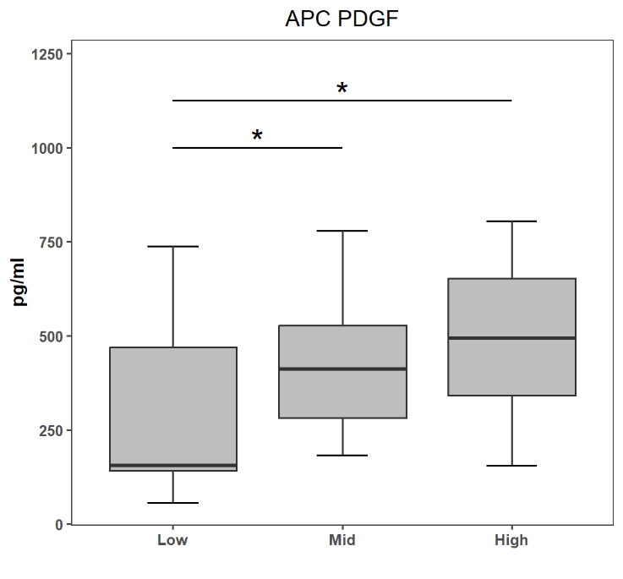

Supplementary Figure 1 – Soluble factors in APC in overall responders. Boxplots denote PDGF concentrations in APC at T0 for patients displaying Low, Mid and High response to therapy at T2 (as described in the text). PDGF concentration in APC is expressed as pg/ml. Asterisks denote statistical significance (*: p<0.05).

Supplementary Table 6: Biometrical, Biochemical and Clinical phenotyping for optimal responders and never responders through T1 and T2. PB and APC cytokines are reported as pg/ml. p-values in bold denote statistical significance (p<0.05).
 | Never Responders (n: 8) | Optimal Responder (n: 11) | p
Sex (Females, %) | F: 6 (75%) | F: 10 (90.91%) | 0.546
Age (years) | 66.25 ± 7.27 | 65.64 ± 12.08 | 0.806
Weight (Kg) | 79 [71.75; 94.25] | 72 [65.75; 79] | 0.163
Height (m) | 1.64 [1.62; 1.69] | 1.6 [1.53; 1.64] | 0.587
BMI (Kg/m²) | 30.48 [25.32; 34.28] | 28.51 [26.66; 30.5] | 0.485
Obese | 5 (62.5%) | 3 (30%) | 0.342
Diabetes | 2 (25%) | 1 (9.09%) | 0.546
Smoker | 1 (12.5%) | 2 (18.18%) | 0.999
T0 NPRS | 6.62 ± 1.41 | 9.05 ± 1.56 | 0.004
RBC (10⁹/l) | 4.42 [4.22; 4.75] | 4.5 [4.06; 4.9] | 0.707
WBC (10¹²/l) | 9.83 [9.22; 10.44] | 5.91 [4.84; 6.19] | 0.008
PLT (10⁹/l) | 248 [245; 257] | 205 [171; 258] | 0.571
APC MIP-1α | 2.12 [1.85; 2.22] | 1.59 [1.16; 1.79] | 0.033
APC PDGF | 189.79 [115.02; 400.77] | 467.86 [358.21; 670.54] | 0.027
APC VEGF | 76.67 [42.57; 152.43] | 181.74 [143.64; 238.35] | 0.032

