Supplementary Figures
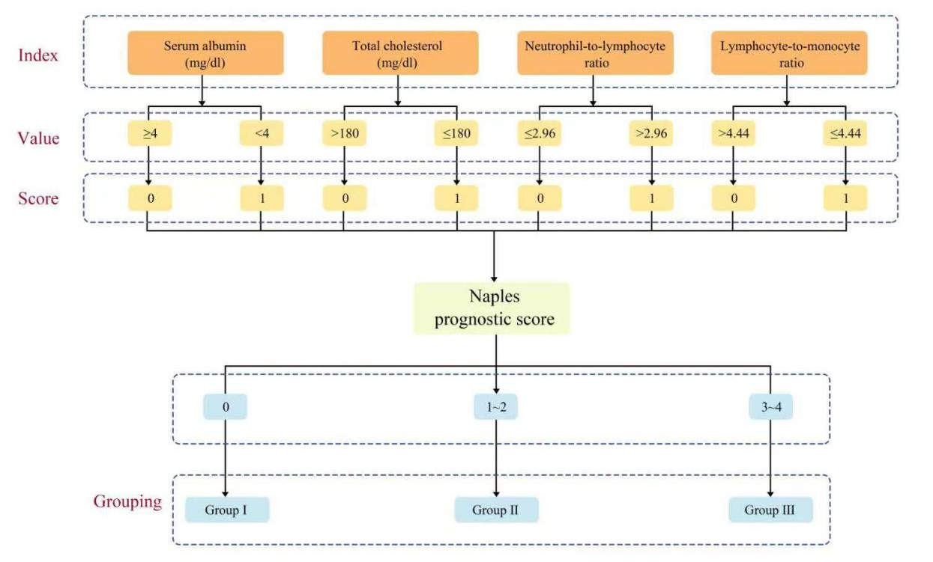Figure S1 The calculation formula and grouping method of Naples prognosis score.
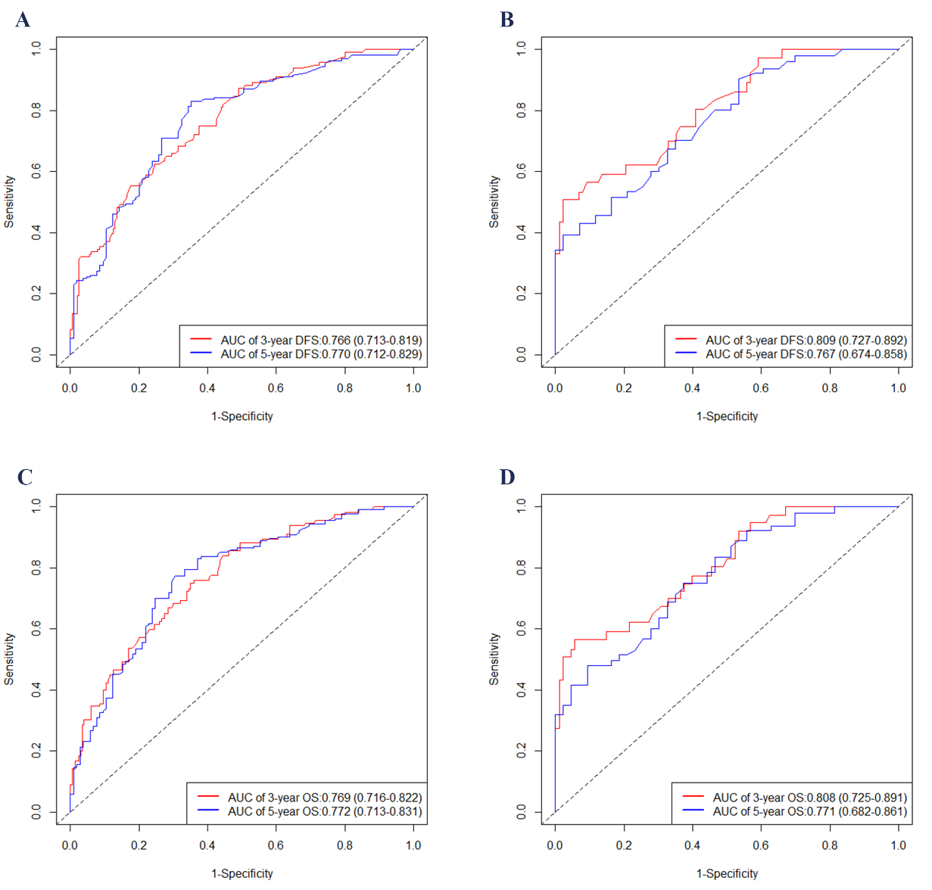
Figure S2 Time-dependent ROC curves for the two nomograms. AUC for predicting 3-, and 5-year DFS in the training (A) and validation (B) set; ROC curves corresponding to 3-, and 5-year OS in the training (C) and validation (D) cohort, respectively.
Abbreviations: AUC, area under curve; OS, overall survival; DFS, disease-free survival; ROC, receiver operating characteristic.
Supplementary Tables
Table S1 Calculation formulas in this study
Clinical index | Calculation formula
PLR | Platelet count / lymphocyte count
PAR | Platelet count / albumin (g/L)
NLR | Neutrophil count / lymphocyte count
LMR | Lymphocyte count / monocyte count
NPS | The following 4 conditions are awarded 1 point each if any are met, otherwise no points are awarded: serum albumin (mg/dL) ≥ 4, total cholesterol (mg/dL) > 180, NLR ≤ 2.96, and LMR > 4.44. The scores for the above 4 conditions are summed. The calculation range is 0-4 points.
PNI | Serum albumin (g/L) + (lymphocyte count ×5)
SII | Platelet count × NLR
SIS | Albumin < 40 g/L & LMR < 4.44 is scored as 2; Albumin ≥ 40 g/L or LMR ≥ 4.44 is scored as 1; Albumin ≥ 40 g/L & LMR ≥ 4.44 is scored as 0
BMI | Mass (kg) / height²(m²)
Abbreviation: BMI, body mass index; LMR, lymphocyte-monocyte ratio; NLR, neutrophil-to-lymphocyte ratio; NPS, Naples prognostic score; PLR, platelet-to-lymphocyte ratio; PNI, prognostic nutrition index; SII; systemic immune-inflammation index, SIS, systemic inflammation score.

Table S2 Calculation formula for age-adjusted Charlson comorbidity index
Scores | Clinical conditions
For comorbidities
1 | Cerebrovascular disease; Chronic pulmonary disease; Connective tissue disease; Congestive heart failure; Dementia; Diabetes; Mild liver disease; Myocardial infarction; Peripheral vascular disease; Ulcer disease
2 | Any tumor; Diabetes with endo organ damage; Hemiplegia; Leukemia; Lymphoma; Moderate or severe renal disease
3 | Moderate or severe liver disease
6 | Acquired immune deficiency syndrome; Metastatic solid tumor
For age
1 (up to 4 points) | Each decade over age 40 years

Table S3 Influence of adjuvant radiotherapy on DFS and OS in different subgroups.
Subgroups  (Total risk points) | Adjuvant radiotherapy |  | Chi-Square | P
Subgroups  (Total risk points) | No | Yes | Chi-Square | P
High risk group for DFS  (≥ 225.3) | n = 96 | n = 50 | 5.31 | 0.021
Medium risk group for DFS  (131.6-225.1) | n = 180 | n = 97 | 5.11 | 0.024
Low risk group for DFS  (≤ 131.3) | n = 101 | n = 52 | 2.36 | 0.120
High risk group for OS  (≥ 230.4) | n = 94 | n = 49 | 7.10 | 0.007
Medium risk group for OS  (150.1-230.0) | n = 140 | n = 78 | 4.36 | 0.037
Low risk group for OS  (≤ 150.3) | n = 143 | n = 72 | 1.38 | 0.240
Abbreviation: DFS, disease-free survival; OS: overall survival.

