Supporting Information
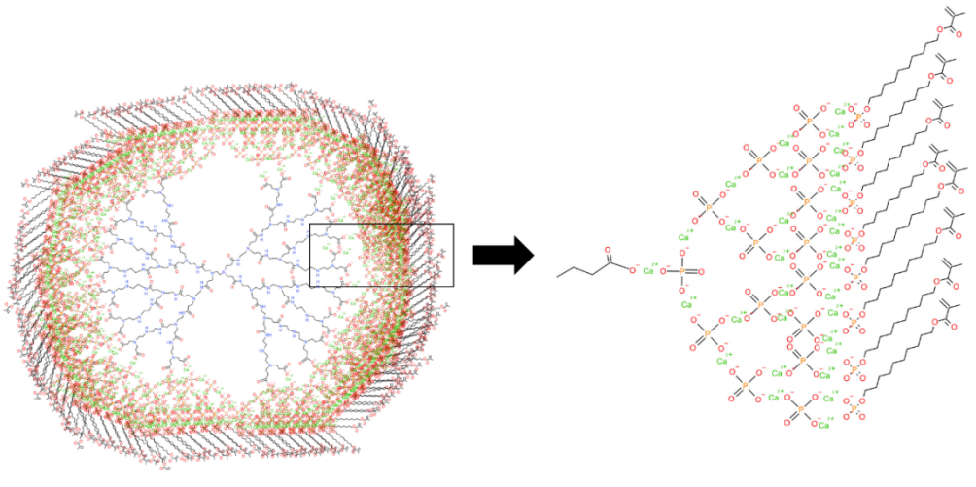
Fig.s1 The predicted structure schematic diagram of PAMAM-COOH/ACMP-MDP, the arrows indicate how each carboxyl terminal binds to calcium phosphate and MDP.

Fig.s2 TEM image of complete demineralized dentin tablet , no obvious deeply stained mineral residue was found.
Fig.s3 Comparison of particle size results among all groups showed that the particle size of PAMAM-COOH/ACMP-MDP had no significant change after 60 days of storage, and was smaller than that of PAMAM-COOH/ACMP (P<0.001). ***p < 0.001.

Fig.s4 (A) The depth of calcium ion infiltration into dentin tubules in each group. (B) The infiltration depth of the dentinal tubules in PAMAM-COOH/ACMP and PAMAM-COOH/ACMP-MDP groups was greater than that in ACMP group (***p < 0.001).
Fig.s5 The images in the left column were all low-power field of view (×2000), and the white box selection in the left column was enlarged (×25000) in the middle column, and the black box selection in the left column was enlarged (×25000) in the right column. (A1-A3) the blank group, the collagen web was thin and loose (arrow). (B1-B3) the ACMP group, the collagen fibers at the dentin tubule mouth were mineralized (arrow), and the collagen fibers became thicker and the space became smaller. However, there was no segmental thickening of the collagen fibers in the deep tubule (arrow). (C1-C3) the MDP group, There was a membrane-like adhesive layer on the surface of the collagen fiber network (arrow), and the collagen fiber network below the membrane layer shows no mineralization. (D1-D3) the PAMAM-COOH/ACMP group, (E1-E3) the PAMAM-COOH/ACMP-MDP group, In both of these groups, In both surface and deep dentin tubules, the collagen fibers were segmented and mineralized, and the interfiber space was smaller (arrow).

Fig.s6 After mineralization, the transverse lines of dentin collagen fibers disappeared, and deeply stained mineral particles were densely arranged along the longitudinal lines of the fibers, and mineral deposits were visible outside the fibers (arrow).

