Supplementary materials
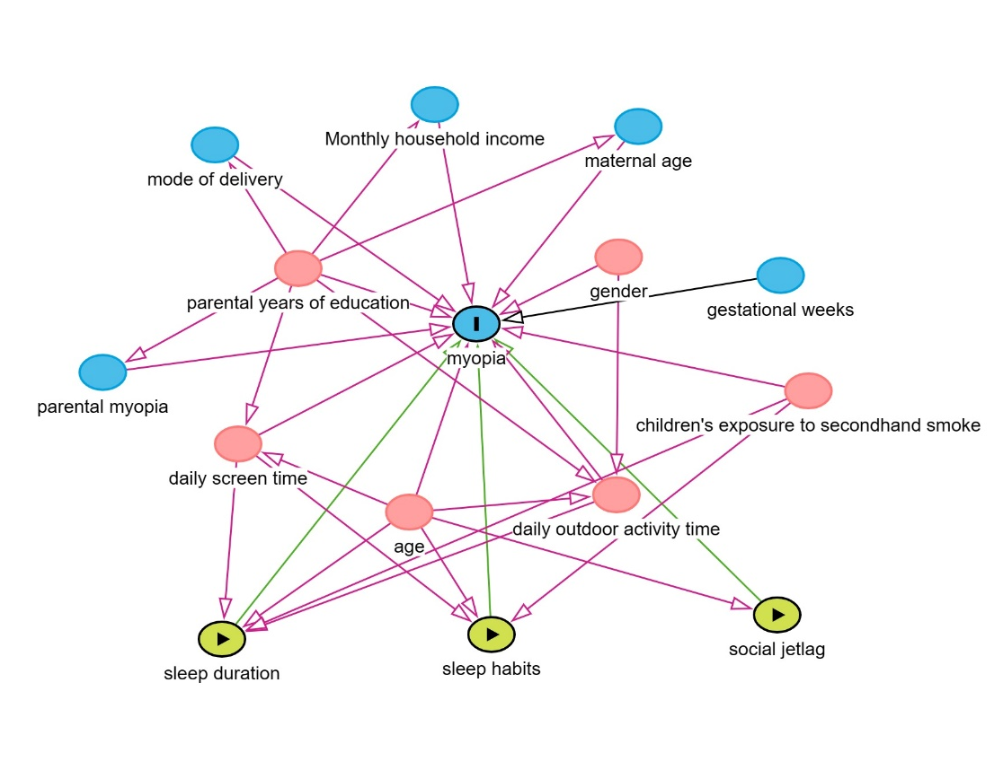
eFigure 1 Directed acyclic graph between sleep parameters variables and myopia as well as ocular biometric indices.

eTable 1 Classification of latent variable growth models for sleep duration
Class | AIC | BIC | aBIC | LMR-LRT | BLRT | Entropy | Categorical probability
1 | 14832.709 | 14864.827 | 14845.767 | — | — | — | —
2 | 14707.953 | 14761.484 | 14729.716 | 0.0000 | 0.0000 | 0.507 | 76.5%/23.5%
3 | 14673.734 | 14748.678 | 14704.203 | 0.0379 | 0.0000 | 0.616 | 69.1%/3.1%/27.8%
4 | 14647.272 | 14743.627 | 14686.445 | 0.3140 | 0.0000 | 0.598 | 49.8%/44.0%/3.3%/2.9%
Abbreviations: AIC, Akaike information criterion; BIC, Bayesian information criterion; a-BIC, sample-size adjusted BIC; LMR, Lo-Mendell-Rubin test; BLRT, bootstrapped likelihood-ratio test.

eTable 2 Classification of latent variable growth models for sleep habits
Class | AIC | BIC | aBIC | LMR-LRT | BLRT | Entropy | Categorical probability
1 | 30611.878 | 30643.997 | 30624.936 | — | — | — | —
2 | 30291.083 | 30344.613 | 30312.846 | 0.0278 | 0.0000 | 0.922 | 94.1%/5.9%
3 | 30110.255 | 30185.199 | 30140.724 | 0.1220 | 0.0000 | 0.932 | 92.0%/0.9%/7.1%
4 | 29969.173 | 30065.528 | 30008.346 | 0.0472 | 0.0000 | 0.952 | 91.9%/4.9%/2.2%/0.9%
Abbreviations: AIC, Akaike information criterion; BIC, Bayesian information criterion; a-BIC, sample-size adjusted BIC; LMR, Lo-Mendell-Rubin test; BLRT, bootstrapped likelihood-ratio test.

eTable 3 Classification of latent variable growth models for social jetlag
Class | AIC | BIC | aBIC | LMR-LRT | BLRT | Entropy | Categorical probability
1 | 6154.742 | 6186.861 | 6167.800 | — | — | — | —
2 | 5873.065 | 5926.596 | 5894.828 | 0.0945 | 0.0000 | 0.844 | 10.9%/89.1%
3 | 5664.272 | 5739.215 | 5694.740 | 0.0025 | 0.0000 | 0.835 | 82.3%/10.6%/7.1%
4 | 5584.821 | 5681.176 | 5623.994 | 0.2417 | 0.0000 | 0.800 | 15.0%/3.7%/75.5%/5.9%
Abbreviations: AIC, Akaike information criterion; BIC, Bayesian information criterion; a-BIC, sample-size adjusted BIC; LMR, Lo-Mendell-Rubin test; BLRT, bootstrapped likelihood-ratio test

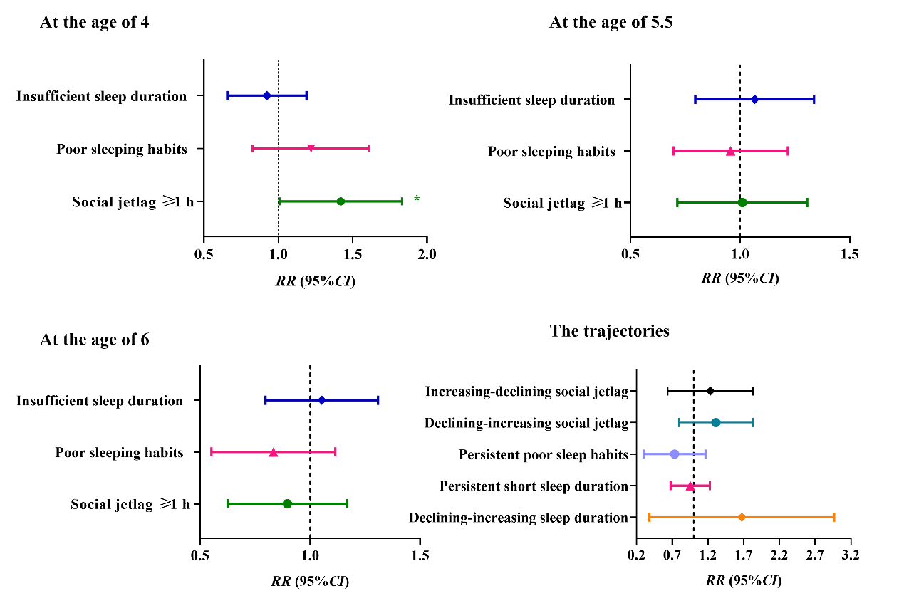
eFigure 2 Association of sleep parameters and their trajectories with myopia among school-aged children. The estimates were adjusted for children’s age, gender, parental myopia, mode of delivery, maternal age, gestational weeks, monthly household income, children's exposure to secondhand smoke, parental years of education, daily outdoor activity time, and daily screen time.
.

eTable 4 The linear mixed models of the associations of sleep parameters with myopia progression among school-aged children
Sleep parameters | SER(n=249) |  |  | AL(n=150)
Sleep parameters | β value（95%CI） | P value |  | β value（95%CI） | P value
At the age of 4
Sleep duration
Sufficient | Ref. |  |  | Ref.
Insufficient | -0.03 (-0.33~0.26) | 0.822 |  | -0.04 (-0.27~0.20) | 0.758
Sleep habits
Good | Ref. |  |  | Ref.
Poor | -0.57 (-0.94~-0.19) | 0.003 |  | 0.27 (-0.03~0.57) | 0.208
Social jetlag
<1 hour | Ref. |  |  | Ref.
≥1 hours | -0.49 (-0.80~-0.18) | 0.002 |  | 0.19 (-0.06~0.43) | 0.131
At the age of 5.5
Sleep duration
Sufficient | Ref. |  |  | Ref.
Insufficient | -0.23 (-0.50~0.03) | 0.082 |  | 0.15 (-0.06~0.36) | 0.427
Sleep habits
Good | Ref. |  |  | Ref.
Poor | 0.03 (-0.25~0.31) | 0.846 |  | 0.00 (-0.23~0.24) | 0.970
Social jetlag
<1 hour | Ref. |  |  | Ref.
≥1 hours | 0.16 (-0.16~0.49) | 0.316 |  | 0.16 (-0.10~0.42) | 0.229
At the age of 6
Sleep duration
Sufficient | Ref. |  |  | Ref.
Insufficient | 0.03 (-0.24~0.29) | 0.830 |  | 0.06 (-0.16~0.27) | 0.590
Sleep habits
Good | Ref. |  |  | Ref.
Poor | 0.06 (-0.31~0.42) | 0.766 |  | 0.00 (-0.30~0.31) | 0.979
Social jetlag
<1 hour | Ref. |  |  | Ref.
≥1 hours | 0.17 (-0.14~0.48) | 0.279 |  | -0.07 (-0.33~0.19) | 0.603
The trajectories of sleep duration
Persistent long sleep duration | Ref. |  |  | Ref.
Declining-increasing sleep duration | -0.04 (-0.76~0.68) | 0.914 |  | 0.35 (-0.22~0.91) | 0.228
Persistent short sleep duration | 0.38 (0.07~0.68) | 0.017 |  | 0.11 (-0.15~0.36) | 0.406
The trajectories of sleep habits
Persistent better sleep habits | Ref. |  |  | Ref.
Persistent poor sleep habits | 0.67 (0.04~1.31) | 0.038 |  | 0.14 (-0.30~0.58) | 0.525
The trajectories of social jetlag
Persistent low-level social jetlag | Ref. |  |  | Ref.
Declining-increasing social jetlag | -0.49 (-0.93~-0.06) | 0.027 |  | 0.59 (0.22~0.95) | 0.002
Increasing-declining social jetlag | -0.19 (-0.74~0.36) | 0.492 |  | 0.53(0.07~0.98) | 0.023
Note: Adjusting for children’s age, gender, parental myopia, mode of delivery, maternal age, gestational weeks, monthly household income, children's exposure to secondhand smoke, parental years of education, daily outdoor activity time, daily screen time.

