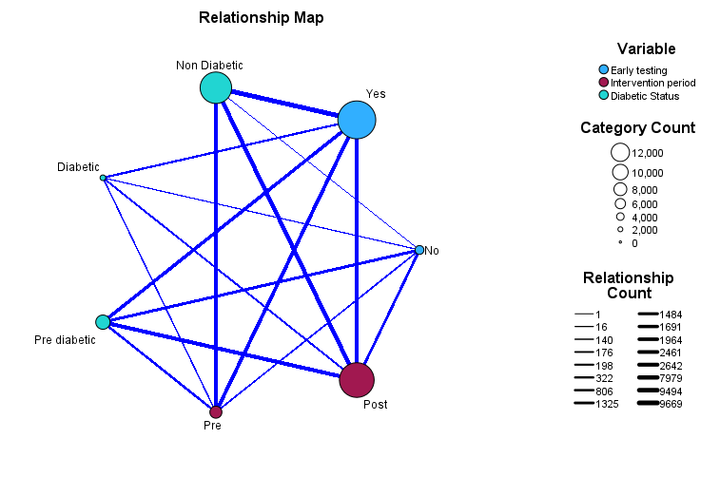
Supplementary figure 1: Relationship map of diabetic status, early testing, and intervention period

