Supplemental tables
Table S1. List of primers used for quantitative real‐time PCR
Homo sapiens
gene | forward (5'-3') | reverse (5'-3')
ACTA2 | GACAATGGCTCTGGGCTCTGTAA | TGTGCTTCGTCACCCACGTA
GAPDH | AGCCACATCGCTCAGACAC | GCCCAATACGACCAAATCC
COL1A1 | TGGCAAAGAAGGCGGCAAAGG | AGGAGCACCAGCAGGACCATC
Fibronectin | GCCACTGGAGTCTTTACCACA | CCTCGGTGTTGTAAGGTGGA
MMP2 | CACCTACACCAAGAACTTCCGTCTG | GTGCCAAGGTCAATGTCAGGAGAG
MMP14 | GCCTGCCTGCGTCCATCAAC | GCCTCATCAAACACCCAATGCTTG
Oryctolagus cuniculus
gene | forward (5'-3') | reverse (5'-3')
TGF-β1 | GGAACGGGCTCAACATCTACACAG | CCAGGTCCTTGCGGAAGTCAATG
SMAD7 | CAGCCGCCCTCGTCCTACTC | ACAGCAACACAGCCTCTTGACTTC
COL1A2 | CGGCGGTGGTTACGACTTTGG | TTGGGTCTGAGAGAAGGTGGTGAG
COL3A1 | GCGAGGTGCTGCTGGTGAAC | CAGGTGAGCCGTCTTTGCCATC
GAPDH | ACGACCACTTCGGCATTGTG | GCAGGGATGATGTTCTGGGC
IL-6 | AATTCCGCAAGCAAGGACAC | CAGTGGCTGAAGACGACCAC
COL1A1 | TGGCGAGCCTGGAGCTTCTG | GCTTCTCCGTCATCTCCGTTCTTG
MMP2 | TGGGAGCATGGAGACGGATACC | CTTCACACGGACCACTTGACCTTC
MMP9 | GTGAAGACGCAGACGGTGGATTC | GGTACTCACACGCCAGAAGAAGC

Supplementary Information 1
Hemolysis Test
The animal experiments in this study were approved by the Animal Care and Use Committee of Shanghai Sixth People’s Hospital (No. 2023-0517). Animal experiments were conducted in accordance with the ethical review of animal welfare for laboratory animals (GB/T 35892–2018). To assess the hemolytic rate of different samples, blood was collected from New Zealand rabbits. The blood was collected using citrate sodium anticoagulant tubes and diluted with PBS at a 4:5 (v/v) ratio. Then, 100 μL of the diluted anticoagulated rabbit blood was added to each centrifuge tube, followed by the addition of 1 mL of PBS, distilled water, AM extract, sEVs dilution, or P-AM-sEVs extract in separate tubes. PBS solution was used as the negative control and distilled water as the positive control. The tubes were incubated at 37°C for 2 hours, followed by centrifugation at 800 × g for 5 minutes to collect the supernatant. Then, 100 μL of the supernatant was added to each well of a 96-well plate, and the absorbance at 545 nm was measured using a microplate spectrophotometer (BioTek Instruments, USA). The hemolysis rate was determined as follows：
$$Hemolysis \left(\%\right)=\frac{OD-{OD}_{1}}{{OD}_{2}-{OD}_{1}}×100\%$$
OD, OD₁, and OD₂ represent the absorbance of the sample, the negative control group, and the positive control group, respectively.
Uptake of DiR-Labelled USC-sEVs in Vivo
The animal experiments in this study were approved by the Animal Care and Use Committee of Shanghai Sixth People’s Hospital (No. 2023-0517). Animal experiments were conducted in accordance with the ethical review of animal welfare for laboratory animals (GB/T 35892–2018). USC-sEVs were incubated with DiR dye (Yeasen, China) at 37°C for 30 minutes in the dark. Next, unbound dye was removed by ultracentrifugation twice at 100,000 × g for 70 minutes. The DiR-labeled USC-sEVs were then applied to the defect site in the sEVs and P-AM-sEVs groups. Seven days later, the rabbits were euthanized, and vaginal tissue was collected. The DiR fluorescence signal was detected using an in vivo fluorescence imaging system (Vieworks, Korea).

Supplementary figures
Figure S1. Zeta potential of USC-sEVs by ZetaView.

Figure S2. Representative images of DiR-labeled sEVs in the vaginal wall on Day 7. The colorful histogram on the right indicates the fluorescence intensity.

Figure S3. Hemolysis tests of each group. n= 3 per group.

Figure S4. P-AM-sEVs scaffolds reduced macrophage infiltration in rabbits on Day 7. (A) IF staining for CD68 after different treatments. Scale bar: 50 μm. (B) Quantification of IF staining for CD68. n= 3 per group. *, P < 0.05, compared with the PBS group; #, P < 0.05, compared with the AM group; %, P < 0.05, compared with the sEVs group.

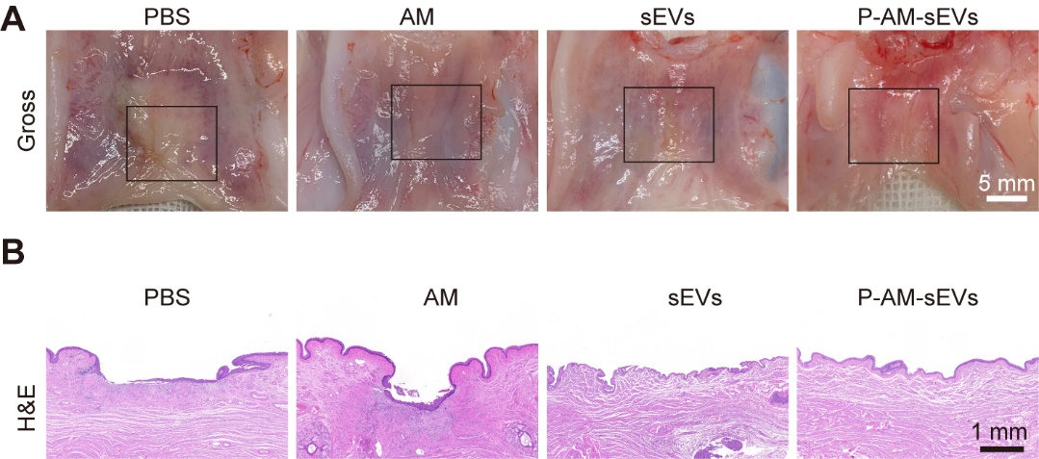
Figure S5. Gross observing and H&E staining of the rabbit vaginal wall on Day 28. (A) Representative images of vaginal mucosa defects subjected to different treatment. Scale bar: 5 mm. (B) H&E staining of vaginal mucosa defects in each group. Scale bar: 1 mm.

Figure S6. Picrosirius red staining of the rabbit vaginal wall on Day 28. (A) Bright-field images of Picrosirius red-stained sections from the different groups. Scale bar: 100 µm. (B, D) Images of Picrosirius red-stained sections under polarized light and quantification of the collagen I/III ratio in each group. Scale bar: 50 µm. (C, E) The orientation of collagen fibers in Picrosirius red-stained sections was quantified via Orientation J software. The color representation reflects the various fiber orientations. Scale bar: 100 µm. *, P < 0.05, compared with the PBS group; #, P < 0.05, compared with the AM group; %, P < 0.05, compared with the sEVs group.
Figure S7. The expression of collagen III of the rabbit vaginal wall on Day 28. (A) IHC staining for collagen III after different treatment. Scale bar: 100 μm. (B) Quantification of IHC staining for collagen III. n= 3 per group. *, P < 0.05, compared with the PBS group; #, P < 0.05, compared with the AM group; %, P < 0.05, compared with the sEVs group.

Figure S8. Images of the top 20 up- and down- regulated pathways of KEGG enrichment analysis.

Figure S9. Images of the top 30 up- and down- regulated terms of GO enrichment analysis.

