Supplementary material
Content
S1: | Further Methodological Descriptions  - Comment on included tables from DNPR  - Definition of time variables  - Comments on registration of time stamps in DNPR  - Comments on implementing the consensus-driven algorithm introduced by Gregersen et al
S2: | Supplementary Results
S3: | Variable description
S4: | List of ICD-10 codes for infections
S5: | Definition of rheumatic arthritis
S6: | References

S1: Further Methodological Descriptions
We used four different approaches for the results. Table S1.1 gives a quick overview of the three algorithms we implemented ourselves. Table S1.2 presents which modifications are needed for the algorithm to be applicable on the relevant registers. For evaluation of overlapping contacts across DNPR2 and DNPR3, we combined DNPR2 and DNPR3. This was important to avoid an excess number of contacts in the first half of 2019 where the DNPR3 was gradually introduced, and some contact information was transferred.
For all algorithms we only included the physical contacts from DNPR3.
Table S1.1: Algorithms, step by step
Approach 1: Validated algorithm (suggested by Skjøth et al)
- Use the validated algorithm to define each department as inpatient, outpatient, or emergency department.
- Combine all hospital contacts with ≤ 4 hours between.
- Identify the type of visit based on which hospital departments the patient had contact to during their visit. and hierarchically define each visit as outpatient > inpatient > emergency
Approach 2: Modified version recommended by Danish Ministry of Health and Elderly
- Combine all patient-hospital contacts with ≤ 4 hours between.
- If the first contact during a visit is acute, define the visit as emergency.
- Of the remaining contacts, define outpatients if the visit is < 12 h and inpatient if ≥ 12 h
Approach 3: Modified version recommended by the Danish Ministry of Health and Elderly combined with patient type on DNPR2
- Use Approach 2 on DNPR3
- Use the variables pattype and indm in DNPR2 to define the type of a contact. (see Table S3.1)
- Combine all overlapping contacts to a visit and hierarchically define each visit as outpatient > inpatient > emergency

Tabel S1.2: Modifications of algorithms needed for application on DNPR2 or DNPR3
Approach | DNPR2 | DNPR3
1 | None | None
2 | Timestamps filled out according to Skjøth et al | None
3 | None | None
4* | None | None
*Se comments later of modification specifically needed due to lack of data-availability.

Table S1.3 Overview of pros and cons of the algorithms
Approach | Algorithm | Pros | Cons
1 | Skjøth et al | - Based on department specific pattern  - In line with patient type from DNPR2  - A data responsible party could publish a department type list  - Validated | - Currently, require information from most of the DNPR  - A hierarchical definition of patient type is needed  - Time stamps must be defined if applied on DNPR2
2 and 3 | Ministry of Health and Elderly | - Only requires information on patient group of interest.  - Based on patient specific visit pattern | - Does not consider short term admissions  - For approach 3: the need for a hierarchical definition of hospital visits  - Time stamps must be defined if applied on DNPR2
4 | Gregersen et al | - Pre-coded algorithm available for SAS  - Based on consensus across clinicians  - Consider patient specific patter | - Require access to most of DNPR including psychiatry  - Time stamps must be defined if applied on DNPR2  - Department codes need update by April 2025, to continue to work

Comment on included tables from DNPR
DNPR is a group of registers that can be linked using a unique civil registration number given to all Danish residence upon birth or immigration. From the DNPR we included the raw data from the tables for administrative information for both private and public hospitals (t_adm) and visits (t_bes) for DNPR2 and the table for contacts (kontakter) and diagnoses (diagnoser) from DNPR3.^{1,2}
Definition of time variables
For both the Modified version of the algorithm suggested by the Danish Ministry of Health and Elderly and for the validated method suggested in Skjøth et al it was necessary to define the time of start and end of each contact if not available in DNPR2. We used the same approach as suggested by Skjøth et al.
For contacts to a public hospital in DNPR2, registration of end of contact was not mandatory for elective contact (Table S3.1). Further, if a patient had multiple outpatient contacts at the same hospital department as part of treating a single disease, the end date registered might be the date when the patient was considered fully treated, and thus falsely indicated that the patient stayed at the hospital for a long time. Therefore, we changed non-acute outpatients (pattype==2 and indm!=0, Table S3.1, for DNPR2), to start at 8:30am and end at 2:30pm on the day of contact start using the same strategy as in Skjøth et al.³
For all other contacts in DNPR2 date of discharge was mandatory, but registration of time (in hours) of discharge was voluntary until 2007. Thus, the remaining contacts (not included above) without a registered start and end time were set to start at 8:30am on the date of contact start, and end on 2:30pm on the day of contact end.
For private hospital contacts in DNPR2 no start or stop time was registered, and so we set the contact to start at 8:30am on the date of contact start and end at 2:30pm on the date of contact end. In DNPR3 all contacts had a registered timestamp.
Comments on registration of time stamps in DNPR
DNPR register is using local time when entering timestamp in the register. This means that twice a year (changing from summertime to wintertime or vice versa) a contact crossing 2am will look like a one hour longer or shorter contact. We have not accounted for this in any of the algorithms, assuming that it would not affect our result noticeably. As this information was obtained through contacting “Sundhedsdatastyrelsen” who is responsible for the DNPR register, we do not have any public reference on this. Further, to our knowledge there is no study validating the registered timestamps in DNPR, to identify if they are indeed registered when the patient leaves and enters a department, for this study we assumed that they were correctly entered.
Comments on implementing the consensus-driven algorithm introduced by Gregersen et al
Gregersen et al introduced a consensus-driven algorithm in November 2024 for defining hospital care episodes.⁴ The algorithm separate contacts in acute outpatient, elective outpatient, acute inpatient, and elective inpatients, with the aim of creating realistic hospital contact episodes in both DNPR2 and DNPR3. Gregersen et al also published the SAS code for their algorithm, which we implemented. However, we encountered the following problems.
- We did not have access to all relevant variables from the psychiatry
- We did not have access to the variables SHAK_AFD_ANS and SHAK_AFS_ANS in DNPR3
We solved 1) by simply omitting data from the psychiatry. However, as the algorithm uses this information to combine contacts, this would give us a slightly different result. We solved 2) by merging the data table lpr_f_kontakter from DNPR3 with the data table lpr_f_organisationer containing information on the different departments. From lpr_f_kontakter we used the variable SORENHED_ANS and linked it with the variable SORENHED in lpr_f_organisationer. Thus, we obtained the needed variables SHAK_AFD_ANS and SHAK_AFS_ANS. Unfortunately, SOR-codes created for new departments after April 2025 will not receive a SHAK-code.⁵ Thus, with time the algorithm will need to be updated to handle SOR-codes.
The data tables used for the consensus-driven algorithm differed from the data tables used in the three algorithms above. However, technically all algorithms could be updated to use all data tables if relevant. In the consensus-driven algorithm private hospital contacts, where omitted, while data tables for unfinished contacts was not included in the three approaches above. Due to the different data, the total number of observations in the consensus-driven algorithm is different from the other three approaches and is therefore not directly comparable.
The four patient types in the consensus-driven algorithm are more in line with how contacts are registered in DNPR, however not necessarily more in line with how patients are considered at the clinic. To present the result in a manner comparable with the three approaches above, we created three different figures. One where patients were categorized as inpatient or outpatient (comparable with the 12-hour method suggested by the Danish Ministry of Health and Elderly), one where all acute patients were categorized as emergency contacts (comparable to the modified version of the algorithm suggested by the Danish Ministry of Health and Elderly), and one where only acute outpatient were considered emergency contacts. These three figures are presented in supplementary result below.

S2: Supplementary Results
Figure S2.1: Number of types of all hospital visits per 1000 citizens using Skjøth’ s algorithm on the Danish National Patient Registry, combining overlapping contact.
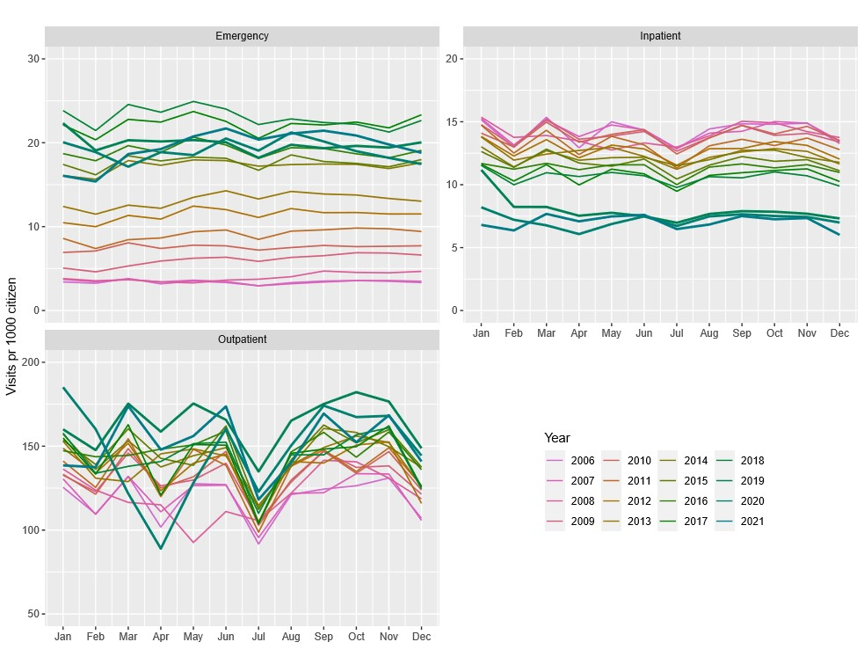

Figure S2.2: Number of types of hospital visit for patients with rheumatoid arthritis, per 1000 citizens using a modified version of the algorithm suggested by the Ministry of Health and Elderly on the Danish National Patient Registry.
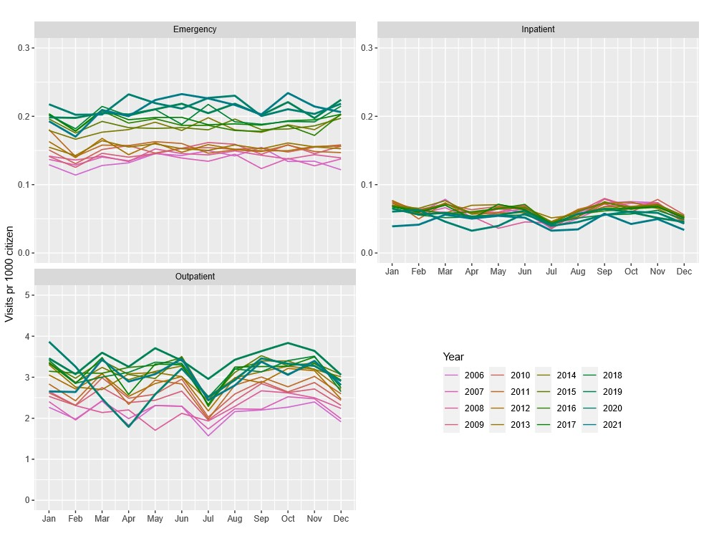

Figure S2.3: Number of types of hospital visits for patients with rheumatoid arthritis, per 1000 citizens using a modified version of the algorithm suggested by the Ministry of Health and Elderly on the Danish National Patient Registry version 3, and the patient type variables on the second version of the Danish National Patient Registry.
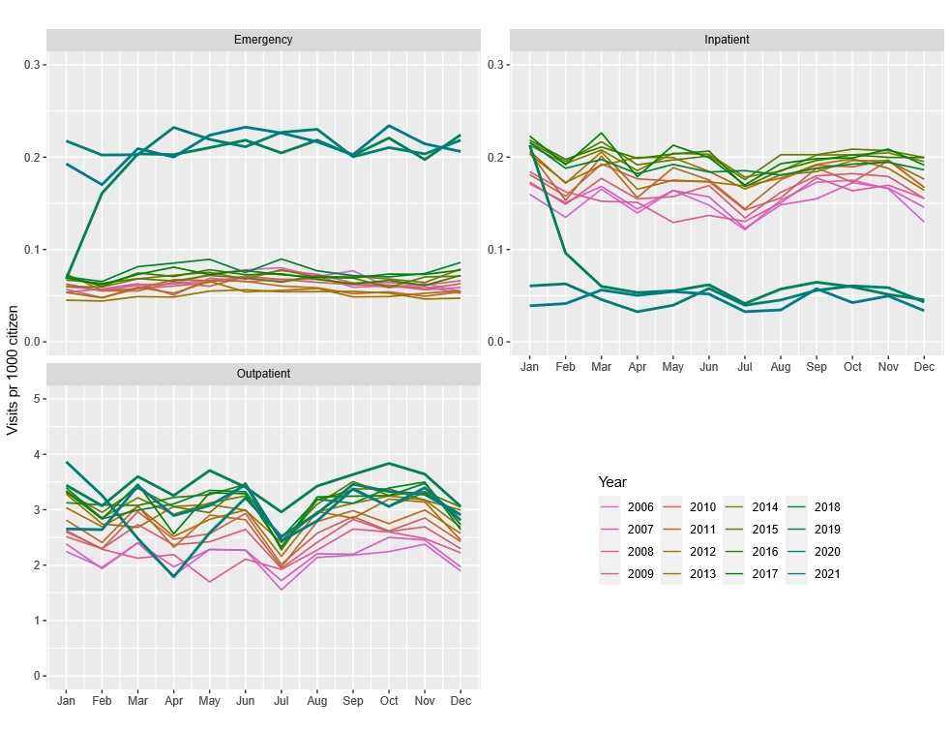

Figure S2.4: Number of types of hospital visits for patients with rheumatoid arthritis, per 1000 citizens using Skjøth’ s algorithm on the Danish National Patient Registry allowing four hours between contacts.
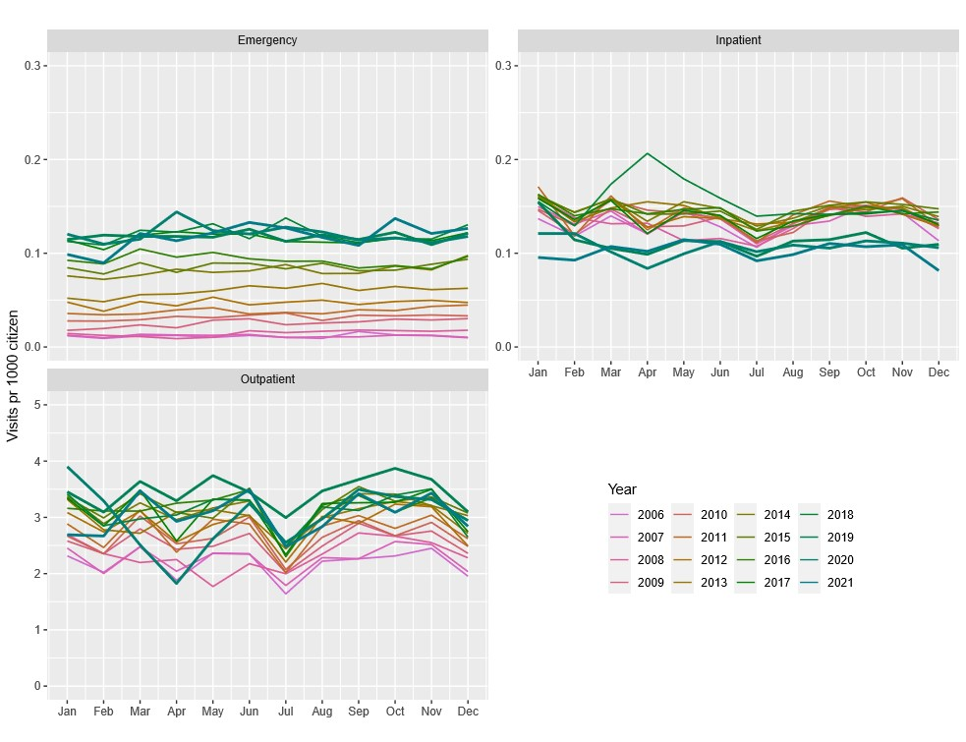

Figure S2.5: Number of types of hospital visits for hospital visits with a registered infection, per 1000 citizens using a modified version of the algorithm suggested by the Ministry of Health and Elderly on the Danish National Patient Registry.
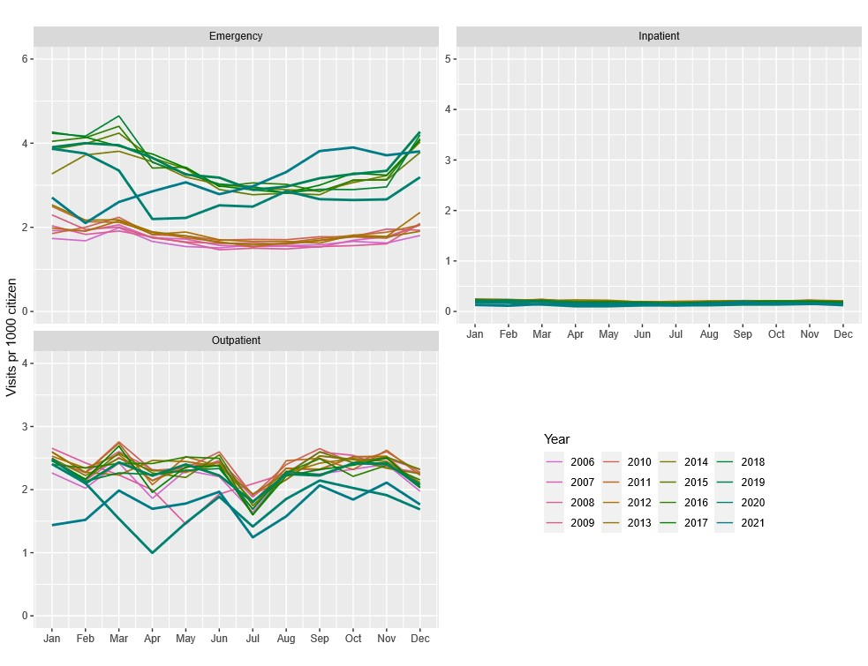

Figure S2.6: Number of types of hospital visits for hospital visits with a registered infection, per 1000 citizens using a modified version of the algorithm suggested by the Ministry of Health and Elderly on the Danish National Patient Registry version 3, and the patient type variables on the second version of the Danish National Patient Registry.
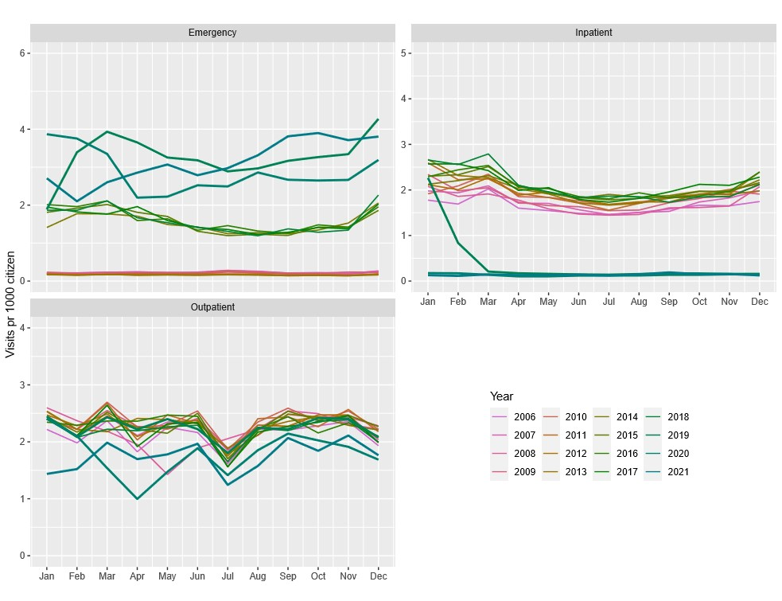

Figure S2.7: Number of types of hospital visits for hospital visits with a registered infection, per 1000 citizens using Skjøth’ s algorithm on the Danish National Patient Registry allowing four hours between contacts.
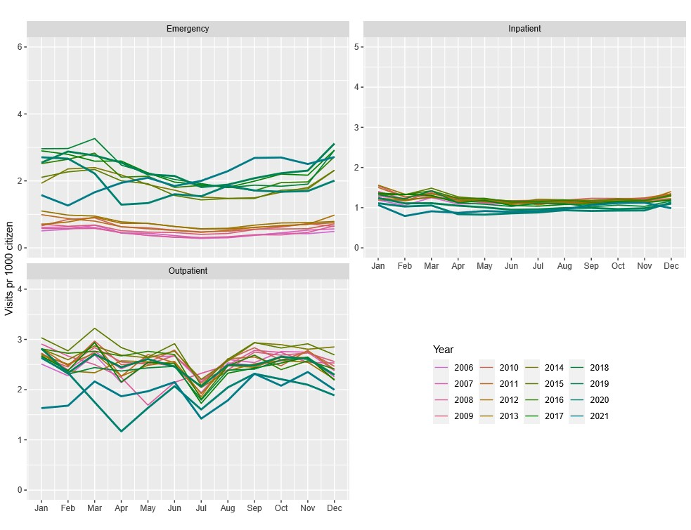

Figure S2.8: Number of types of hospital visits for hospital visits with a registered infection, per 1000 citizens using the algorithm suggested by the Ministry of Health and Elderly on the Danish National Patient Registry without introducing emergency contacts.
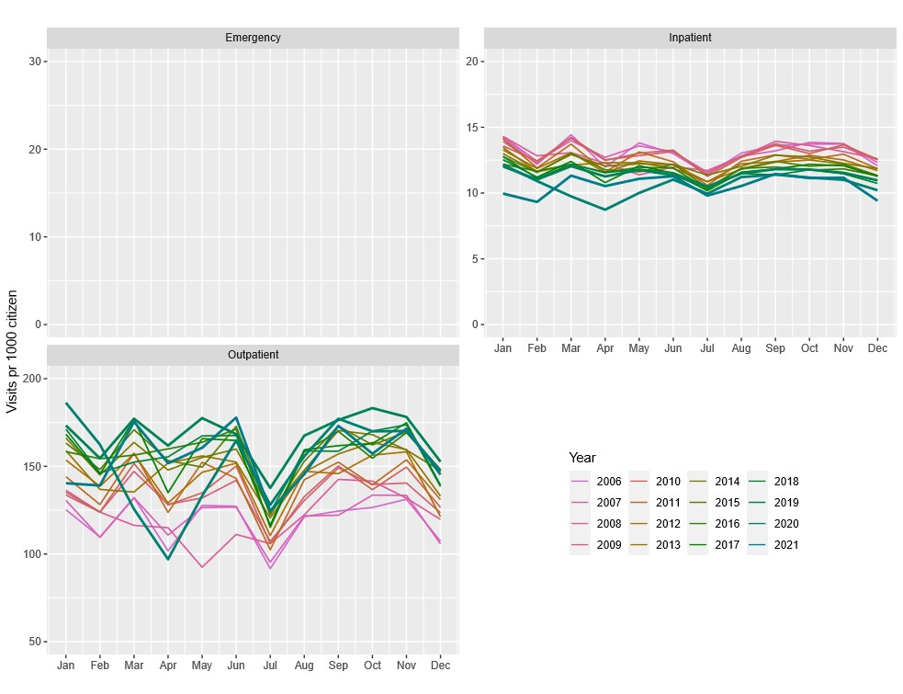

Table S2.1: Classification of hospital visits according to Approach 1 and 2.
All patients |  | Approach 2
 |  | Inpatient | Outpatient | Emergency
Approach 1 | Inpatient | 3 328 357 (2.0%) | 940 814 (0.6%) | 7 193 628 (4.2%)
Approach 1 | Outpatient | 756 370 (0.4%) | 139 927 717 (82.4%) | 6 396 664 (3.8%)
Approach 1 | Emergency | 260 003 (0.2%) | 373 570 (0.2%) | 10 731 445 (6.3%)

Table S2.2: Classification of hospital visits according to Approach 1 and 2.
Patients with an RA diagnose |  | Approach 2
 |  | Inpatient | Outpatient | Emergency
Approach 1 | Inpatient | 52 479 (1.6%) | 14 588 (0.4%) | 78 334 (2.4%)
Approach 1 | Outpatient | 9 390 (0.3%) | 3 054 135 (91.9%) | 38 951 (1.3%)
Approach 1 | Emergency | 2 233 (0.1%) | 2 517 (0.1%) | 70 173 (2.1%)

Table S2.3: Classification of hospital visits according to Approach 1 and 2.
Contacts with a diagnose of infection |  | Approach 2
 |  | Inpatient | Outpatient | Emergency
Approach 1 | Inpatient | 155 462 (2.9%) | 22 827 (0.4%) | 1 077 706 (19.9%)
Approach 1 | Outpatient | 34 566 (0.6%) | 2 368 185 (43.8%) | 259 237 (4.8%)
Approach 1 | Emergency | 8 280 (0.2%) | 23 245 (0.4%) | 1 452 793 (26.9%)

Table S2.4: Table of some clinical departments and how they were categorized using the algorithm suggested by Skjøth et al in DNPR2.
SHAK code* | Department name (Danish name) | Department type by algorithm
8001126 | Hobro same day surgeries  (Hobro kirurgisk sammedagsafd) | Outpatient
8001531 | Aalborg, orthopedic surgery inpatient department  (Aalborg Ortopædkirugisk senge afdeling) | Inpatient
8001539 | Aalborg, orthopedic outpatient department  (Aalborg Ortopdkirurgisk ambulatorie) | Outpatient
8001536 | Aalborg, orthopedic same day surgery  (Aalborg Ortopædkirurgisk sammedagskirurgi) | Outpatient
8001077 | Aalborg Rheumatology outpatient clinic  (Aalborg Reumatologisk ambulatorie) | Outpatient
8001071 | Aalborg Rheumatology department  (Aalborg Reumatologisk afsnit) | Inpatient
8001468 | Aalborg Receiving emergency patient.  (Aalborg skade modtageafdeling) | Emergency
8001469 | Aalborg Emergency Outpatient department  (Alborg skade ambulatorium) | Outpatient
*The SHAK codes are used to uniquely define the departments, and the specific departments can be found using searching on the codes in.⁶

Figure S2.9: Number of types of hospital visit per 1000 citizens using a modified version of the consensus-driven method by Gregersen et al., categorizing acute outpatients as emergency visits.
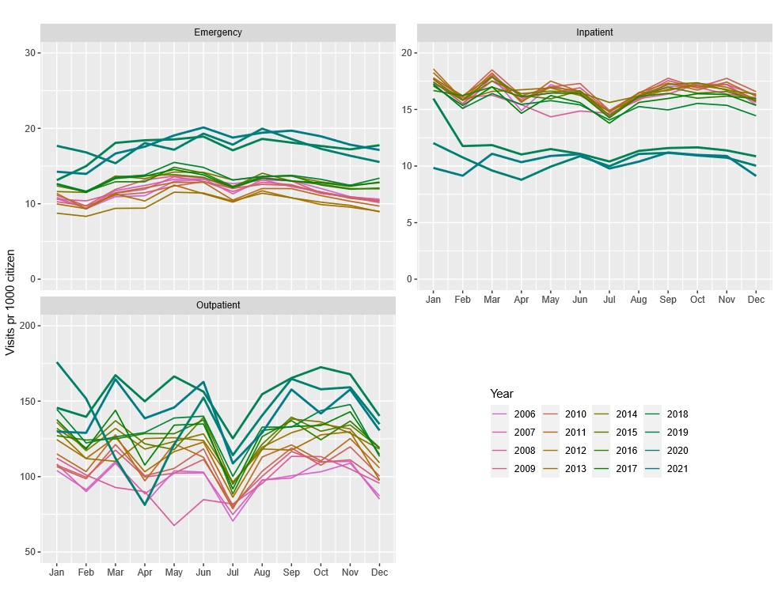

Figure S2.10: Number of types of hospital visit per 1000 citizens using a modified version of the consensus-driven method by Gregersen et al., categorizing all acute patients as emergency visits.
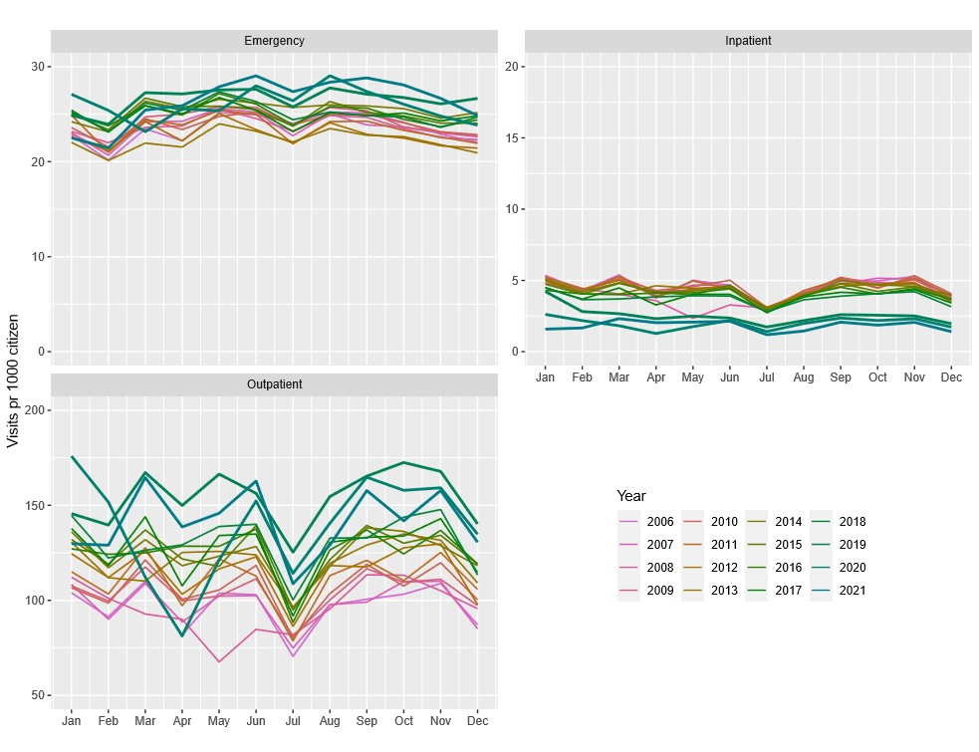

Figure S2.11 Number of types of hospital visit per 1000 citizens using a modified version of the consensus-driven method by Gregersen et al., categorizing only as outpatient and inpatient visits.
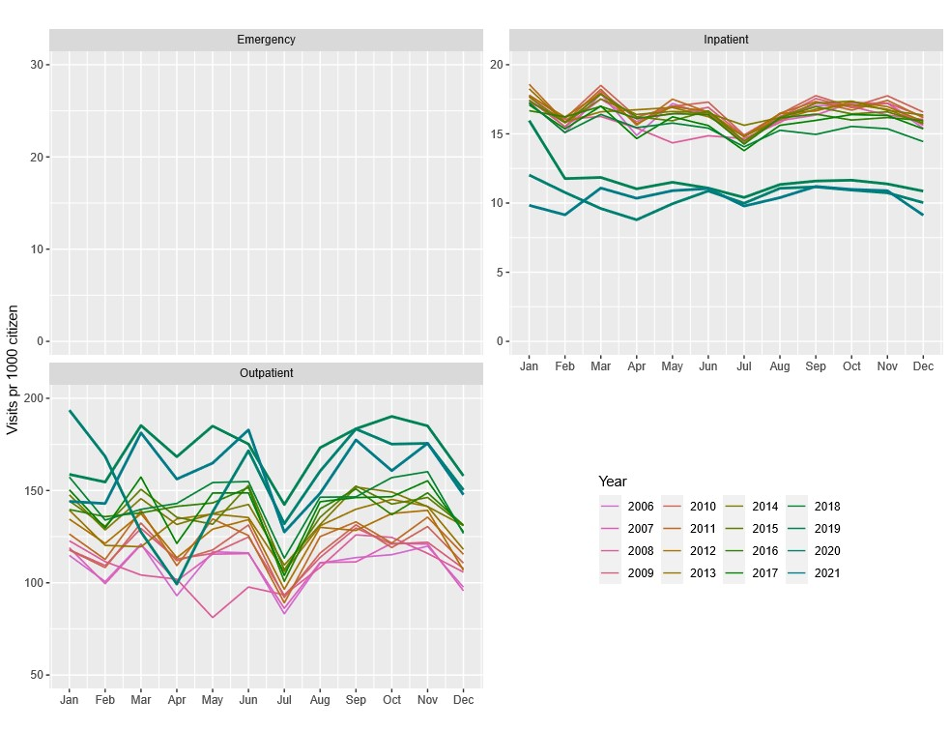

S3: Variable description
A short description of relevant information for variables used to determine admission status. Official descriptions can be found in:^{1,2,7}
Table S3.1: Short description of relevant variables used for approach 1 to 3.
 | Variable name | Description | Limits
DNPR2:
 | indm | Information on the priority of the contact, acute (1), elective (2).  Missing for some patients. | From 2005 to 2013 only filled out for inpatients (pattype=0).  From 2014 available for outpatients (pattype=2)
 | pattype | Indicate the patient type for the contact.  0: 24-hour patients  2: outpatients  3: emergency patients | From 2005 to 2013 emergency patients were registered as pattype=3  In 2014 emergency patients was registered as outpatients with indm=1.
 | inddto | Date of start of hospital contact.
 | uddto | Date for end of treatment. | For admissions started before 2015 the date is mandatory.  For elective admissions after 2015 it is volunteer.  For emergency contacts the date is mandatory.
 | indminut | Minute for contact. | Minute for contact to emergency room (2005-2013). Minute for start of admissions or outpatient contacts since 2005-2019.
 | indtime | Hour for start of contact
 | udtime | Hour for end of contact | Mandatory for outpatients and emergency patients since 2007. Otherwise not mandatory.
 | spec | Clinical specialty for contact. Used to exclude contacts from the psychiatry (50 and 52)
 | afd and sgh | Code for the clinical department. Combined for defining each unique clinical department
DNPR3
 | dato_start | Date for contacts start
 | dato_slut | Date for contact end
 | tidspunkt_start | Time stamp for contact start
 | tidspunkt_slut | Time stamp for contact end
 | hovedspeciale_ans | Used to exclude contact to psychiatry (hovedspeciale==”psykiatri”)
 | sorenhed_ans | Unique code for the clinical department.
 | Prioritet | Define the priority of the contact  acute (ATA1*), elective (ATA3)
 | Kontakttype | Identify if the contact is physical or electronic.  Physical contact (ALCA00)

S4: List of ICD-10 codes for infections
A00-A09, A15-A32, A34.9-A44, A46.9, A48-A49, A51-A53, A65.9, A66-A71, A75, A77, A78.9, A79-A89, A92-A99, B00.3, B00.4, B00.4A, B01-B07. B15-B20, B22-B27, B30, B33-B34, B37-B58, B60, B64.9, B65-B70, B75.9, B95-B99, D73.3, E32.1, G00-G02, G04.2, G05-G07, H00.0, H30, H44.0, H60.0-H60.3, H66, H70, H75.0, H94.0, I30.1, I33.0, I39, I40.0, I52, I68.1, I98.0-I98.1, J00-J06, J09-J18, J20-J22, J32, J34.0, J36-J37, J38.3C, J38.3D, J39.0-J39.1, J44.0, J85-J86, K04.4, K04.6-K04.7, K10.2, K11.3, K12.2, K14.0A, K23.0, K35, K57.0, K57.2, K57.4, K57.8, K61, K63.0, K65.0, K65.9, L02-L08, L30.3, M00-M01, M4.2-M46.5, M49.0, M49.2-M49.3, M60.0, M63.0-M63.2, M65.0-M65.1, M71.0-M71.2, M72.6, M86, M90.0-M90.2, N08.0, N10, N13.6, N15.1, N29.0-M29.1, N30.0, N30.8, N33.0, N34.0, N34.1, N34.2, N39.0, N41.2, N43.1, N45.0, N48.1-N48.2, N49, N61, N70, N71.0, N72, N73.2-N73.5, N73.8-N73.9, N74, N75.1, N76.0, N76.2, N77.0-N77.1, O23, O41.1, O75.3, O85-O86, O91, O98
S5: Definition of rheumatoid arthritis
To identify patients with rheumatoid arthritis we identified all patients registered in the nationwide Danish Rheumatology Quality Register (DANBIO) with an ICD-10 code of M05 or M06 (excluding M06_1) or ICD-8 code of 71209, 71210-71239 or 71259.⁸
S6: References
1. Sundhedsdatastyrelsen. Dokumentation af registre. 2016. Accessed September 2, 2024. https://www.esundhed.dk/Dokumentation/DocumentationExtended?id=5
2. Sundhedsdatastyrelsen. Vejledning til LPR3_F. December 18, 2023. Accessed June 6, 2024. https://sundhedsdatastyrelsen.dk/-/media/sds/filer/Forskerservice/Vejledning til LPR3_F
3. Skjøth F, Nielsen H, Bodilsen J. Validity of Algorithm for Classification of In-and Outpatient Hospital Contacts in the Danish National Patient Registry. Clin Epidemiol. Published online 2022:1561-1570.
4. Gregersen R, Fox Maule C, Bjørn Jensen C, et al. Algorithm for forming hospital care episodes by combining attendance contacts in the Danish National Patient Register: A methodological consensus-driven study. Scand J Public Health. 2024;(June):14034948241284712. doi:10.1177/14034948241284711
5. Sundhedsdatastyrelsen. SHAK-udfasning og klinisk administrativ attribut. 2024. Accessed November 14, 2024. https://sundhedsdatastyrelsen.dk/da/rammer-og-retningslinjer/organisationsregistrering/udfasning_shak
6. Sundhedsdatastyrelsen. SOR browser. Accessed September 4, 2024. https://sorbrowser.sundhedsdatastyrelsen.dk/
7. Sundhedsdatastyrelsen. Landspatientregisteret. 2021. Accessed September 4, 2024. https://www.dst.dk/Site/Dst/SingleFiles/GetArchiveFile.aspx?fi=7143686406&fo=0&ext=forskning
8. Ibfelt EH, Jensen DV, Hetland ML. The Danish nationwide clinical register for patients with rheumatoid arthritis: DANBIO. Clin Epidemiol. 2016;8:737. doi:10.2147

