Supplementary Material for:
A molecular signature of the ubiquitin-proteasome system for forecasting prognosis in thyroid carcinoma patients

Hong Zeng^{1,2,+}, Xitong Geng^{2,+}, Hao Wan^{3,+}, Xiaoyu Qu², Shengwei Tang², Ruiyu Zhang³, Minqin Zhou², Zichuan Yu², Jingying Pan³, Hao Zheng², Yanting Zhu², Shuhan Huang², Da Huang¹*

¹Second Afﬁliated Hospital of Nanchang University, Nanchang, Jiangxi Province, People’s Republic of China;
²Second College of Clinical Medicine, Nanchang university, Nanchang, Jiangxi Province, People’s Republic of China;
³First College of Clinical Medicine, Nanchang university, Nanchang, Jiangxi Province, People’s Republic of China;
⁺These authors contributed equally to this work

*Correspondence: Da Huang, Department of Thyroid surgery, Second Affiliated Hospital of Nanchang University, 1 Minde Road, Nanchang, Jiangxi Province, 330000, People’s Republic of China, E-mail: danmo0904@163.com.

This supplementary material includes 3 figures and 5 table.
Supplementary Figures: Supplementary Figure 1- Supplementary Figure 3.
Supplementary Tables: Supplementary Table 1- Supplementary Table 5.

Supplemental figures
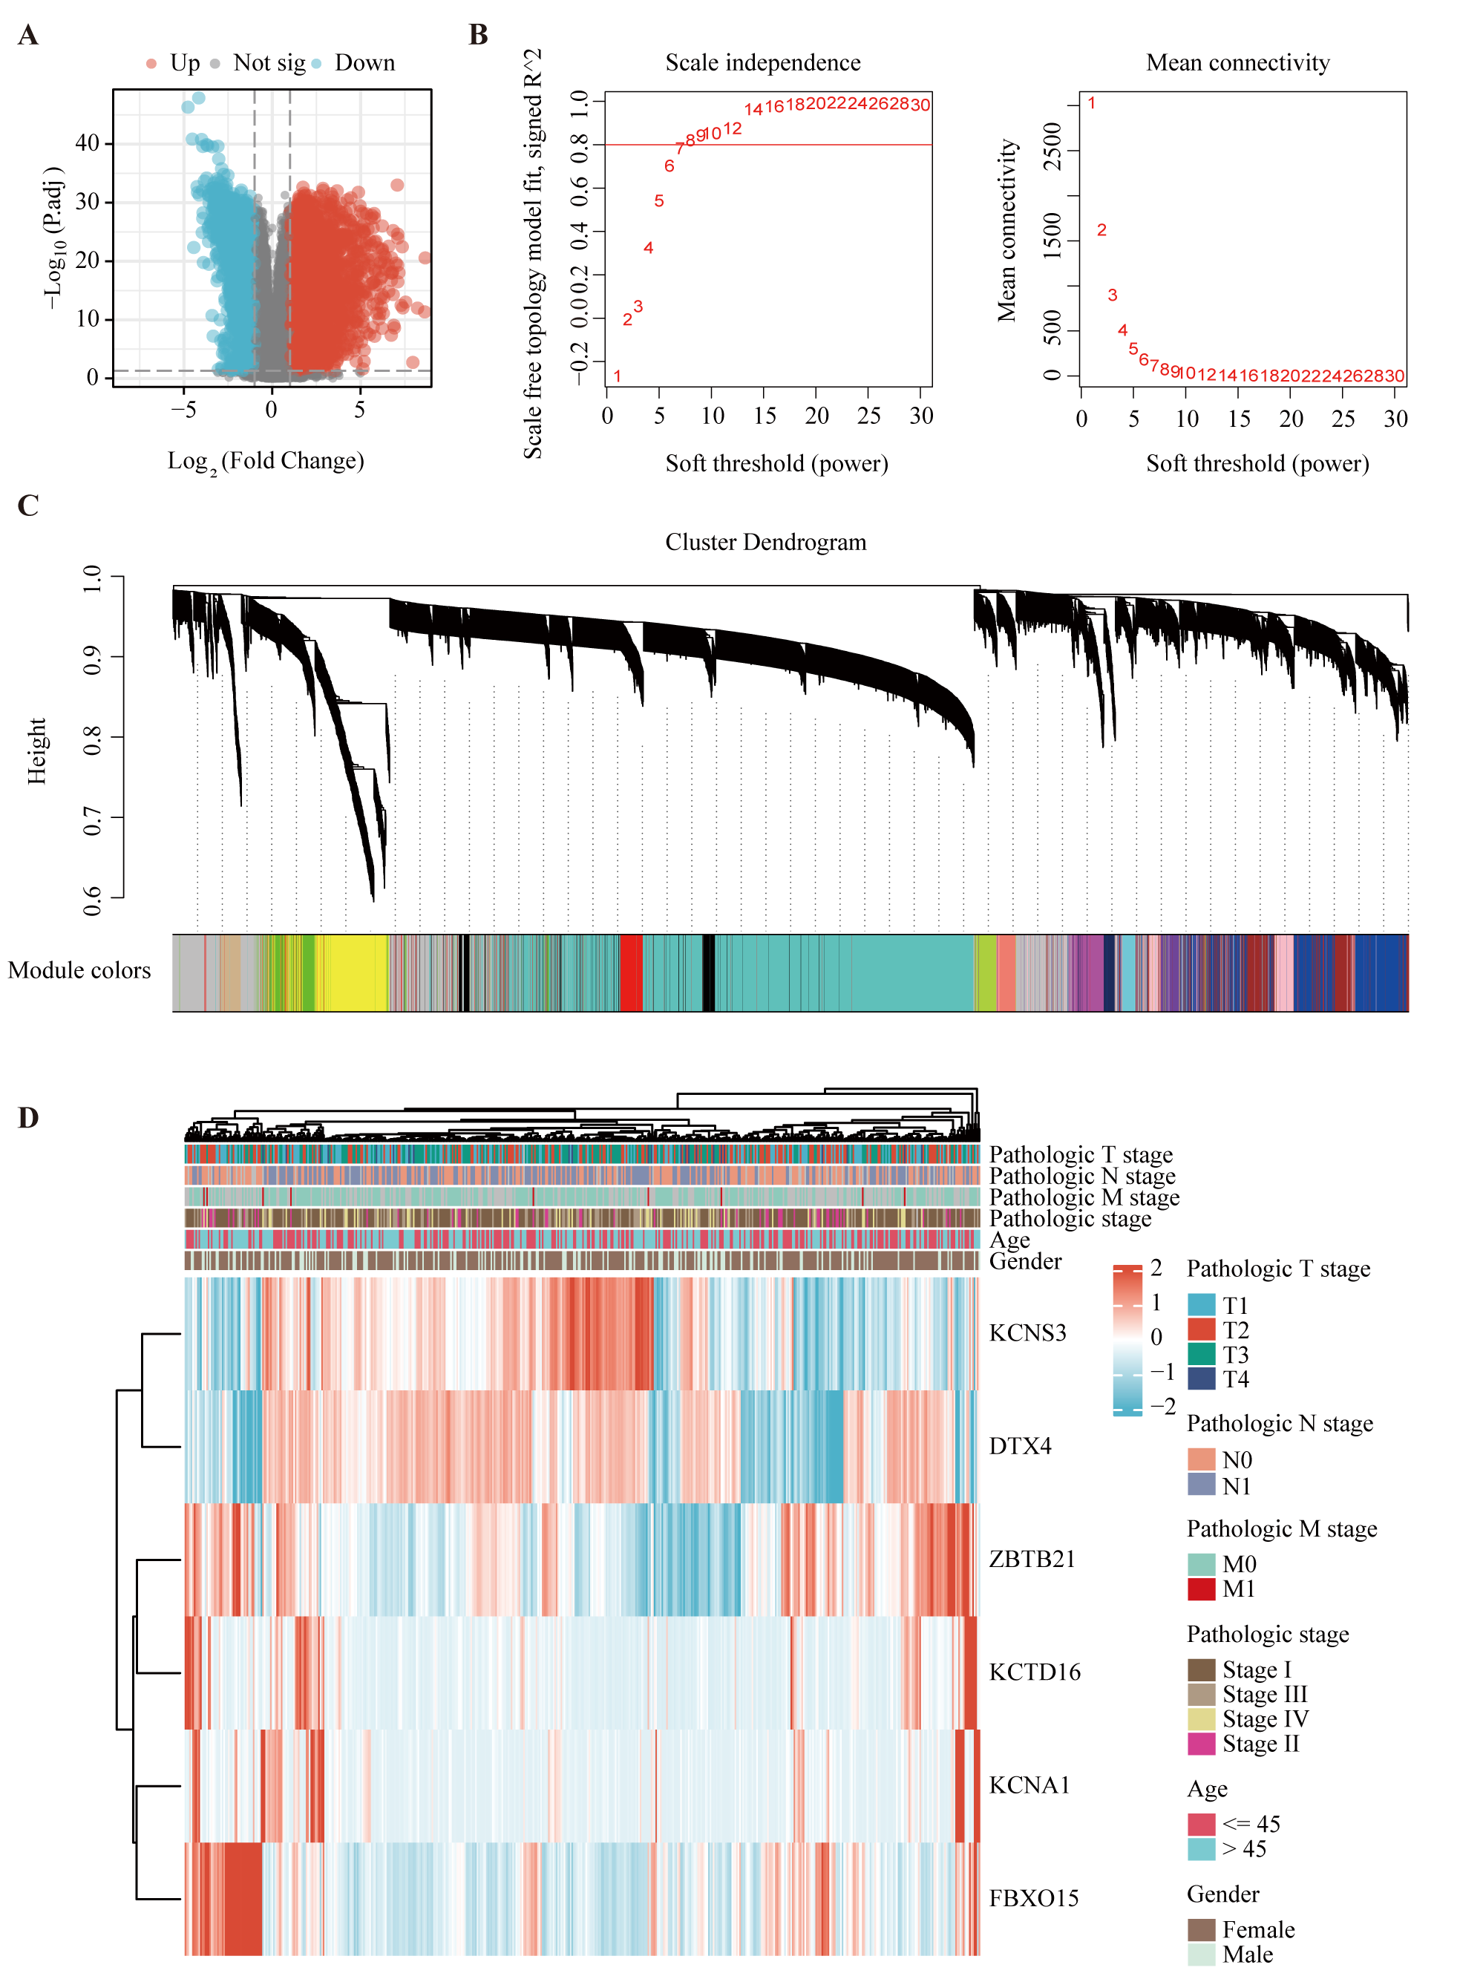
Supplemental figure 1. Identification of key genes. (A) Differentially expressed genes were identified from TCGA-THCA dataset. (B, C) WGCNA was utilized for consensus cluster analysis. (D) Relationship between six core genes and clinicopathological features.

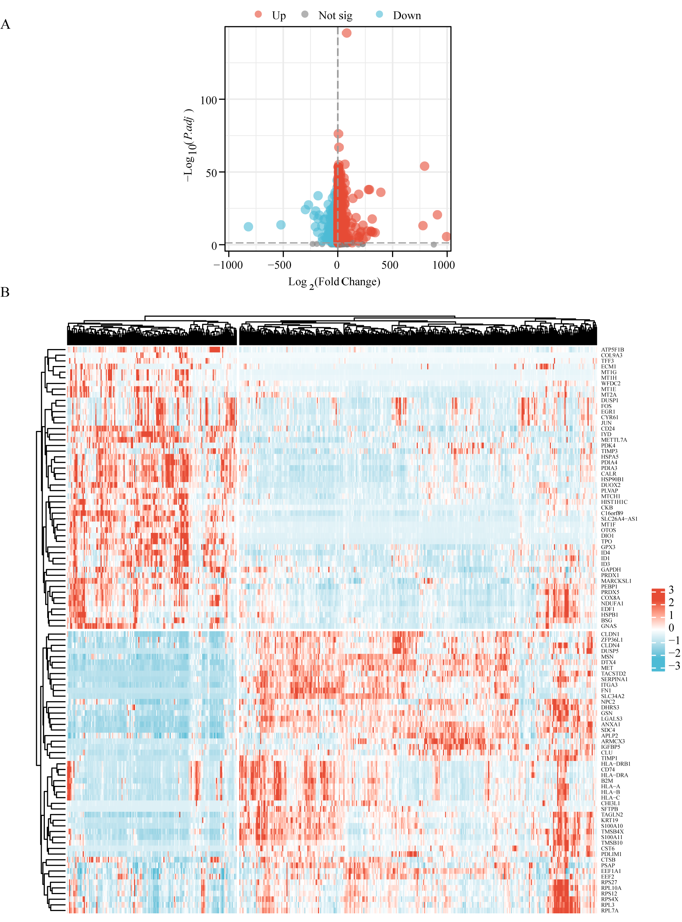
Supplemental figure 2. Identification of differentially expressed genes (DEGs) between high and low UPS-PMS group. (A) Volcano plot illustrating differentially expressed genes (DEGs) between the two isoforms(logFC >2, p < 0. 05). (B) Heatmap representation of the top 100 UPSPM-related DEGs (50 up-regulated,50 down-regulated) across two THCA subtypes.

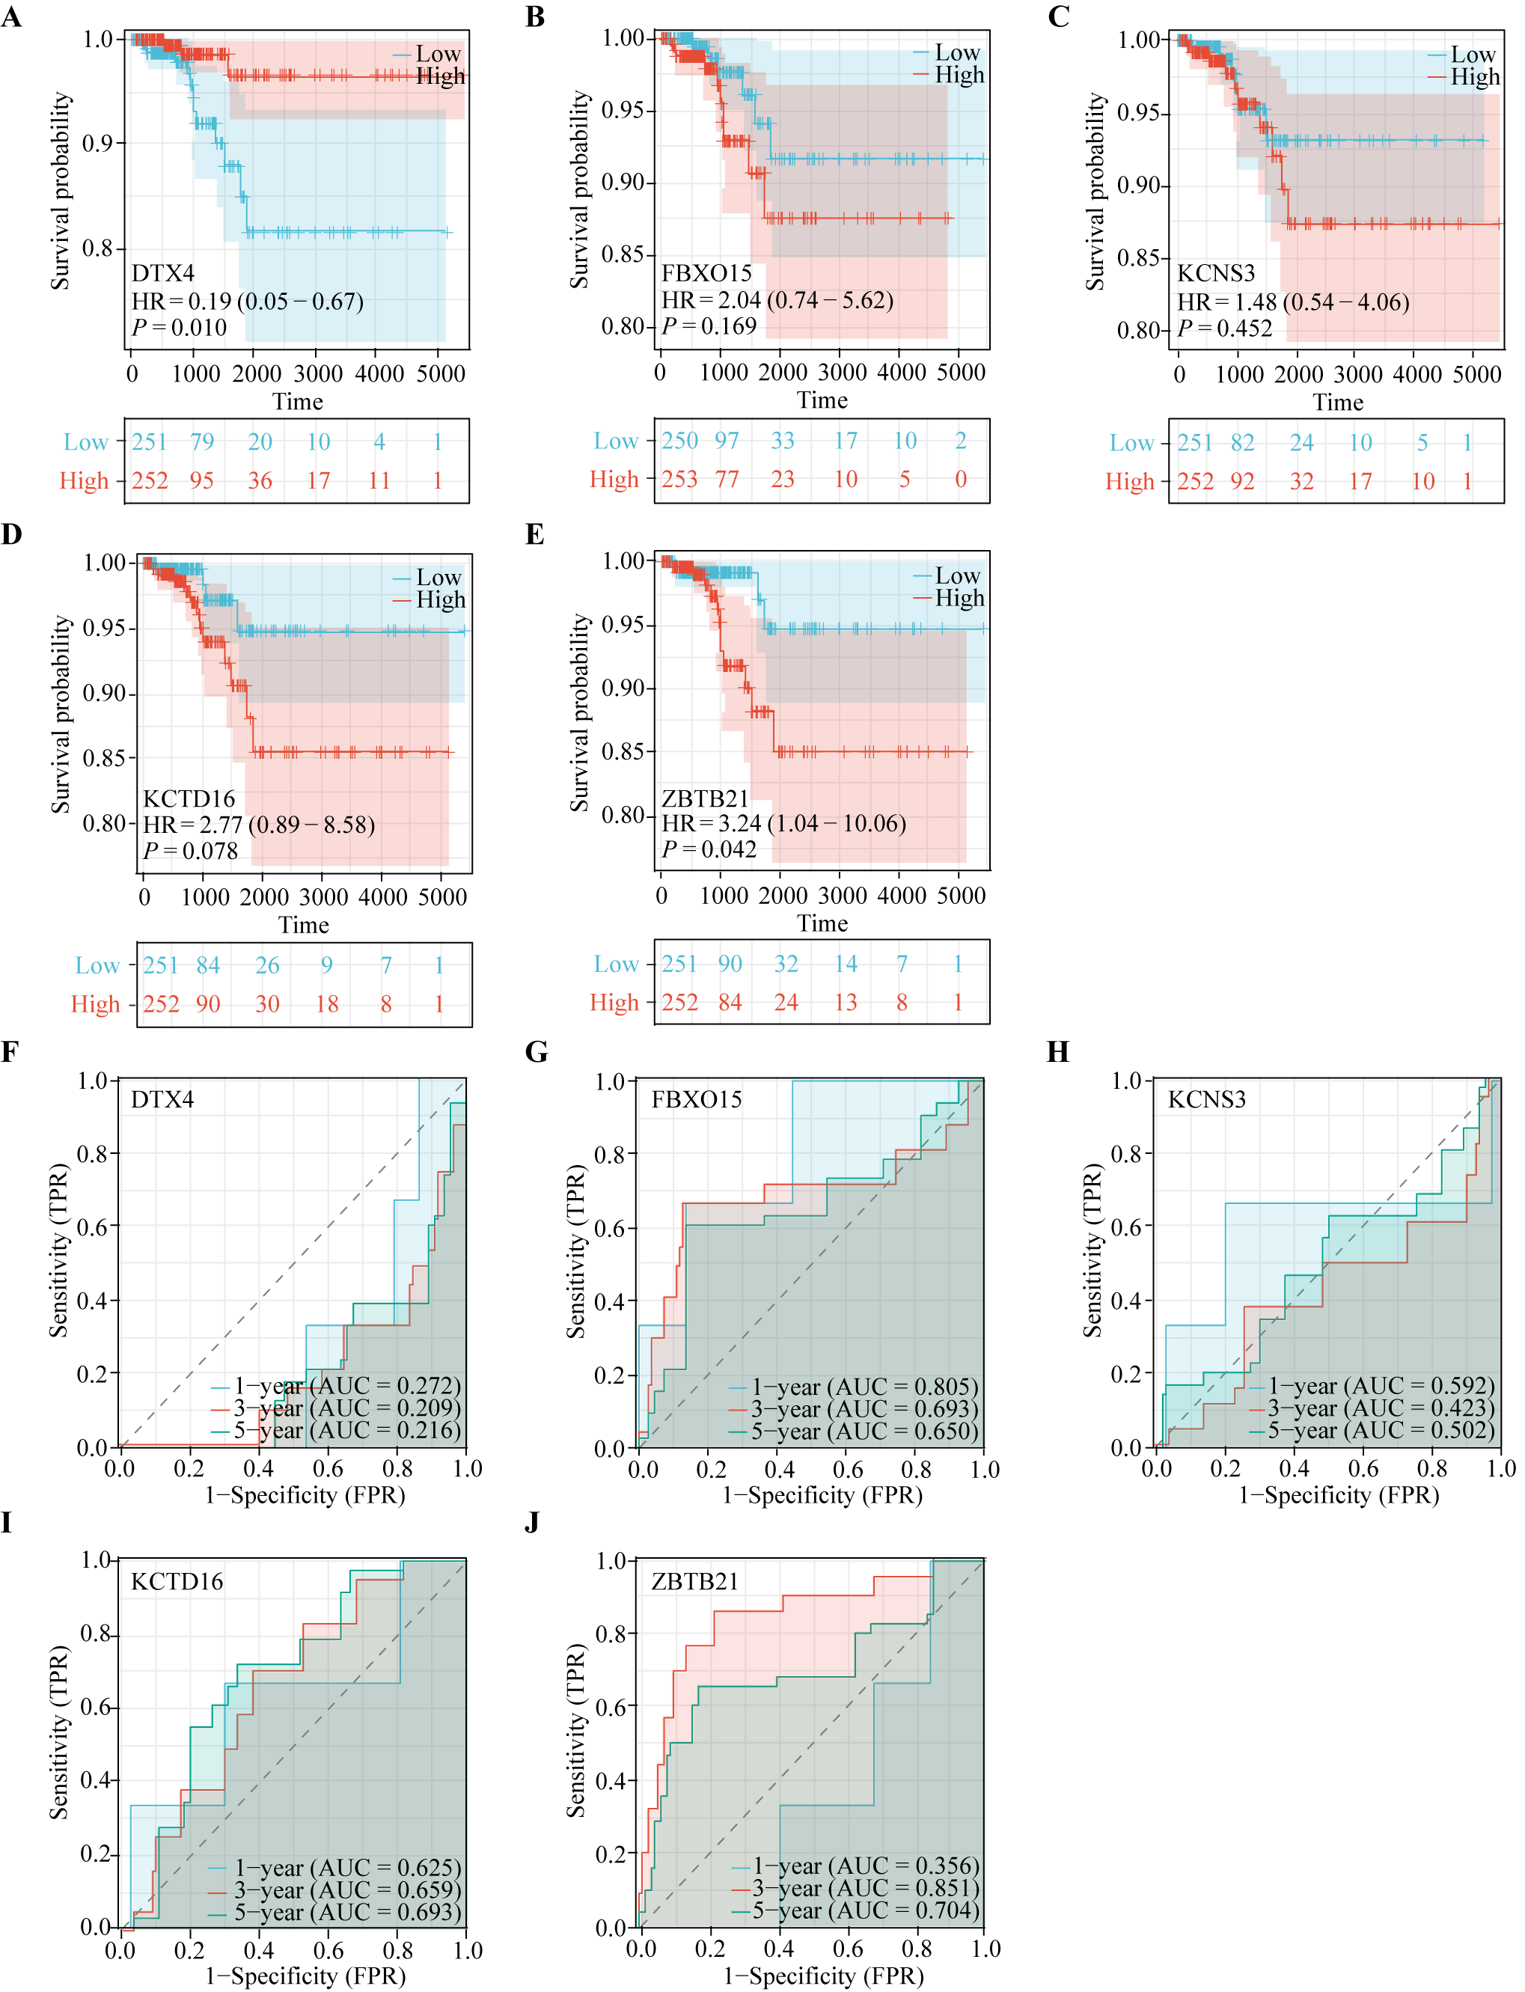Supplemental figure 3. The survival analysis of UPS-PM genes in THCA. (A-E) The survival analysis of (A) DTX4, (B) FBXO15, (C) KCNS3, (D) KCTD16, (E) ZBTB21, (F-J) The area under the curve of (F) DTX4, (G) FBXO15, (H) KCNS3, (I) KCTD16, (J) ZBTB21.

Supplementary Tables

Supplementary Table 1: The ubiquitin proteasome system related genes.
UPS system
UBE2QL1 | FBXL18 | PEX12 | TRIML1
ABTB2 | FBXL2 | PEX2 | TRIP12
ASB15 | FBXL20 | PHF7 | TTC3
BIRC7 | FBXL3 | PHRF1 | TULP4
BTBD11 | FBXL4 | PJA1 | UBE3A
DTX4 | FBXL5 | PJA2 | UBE3B
ENC1 | FBXL6 | PML | UBE3C
FBXO15 | FBXL7 | PPIL2 | UBE4A
FBXO17 | FBXL8 | PRPF19 | UBE4B
FBXO2 | FBXO10 | RAB40A | UBR1
FBXO30 | FBXO11 | RAB40AL | UBR2
FBXO41 | FBXO16 | RAB40B | UBR3
HECW1 | FBXO18 | RAB40C | UBR4
KBTBD8 | FBXO21 | RABGEF1 | UBR5
KCNA1 | FBXO22 | RAD18 | UHRF1
KCNA2 | FBXO24 | RAPSN | UHRF2
KCNA3 | FBXO25 | RBBP6 | UNK
KCNA6 | FBXO27 | RBCK1 | UNKL
KCND2 | FBXO28 | RBX1 | VHL
KCND3 | FBXO3 | RC3H1 | VPS11
KCNS3 | FBXO31 | RC3H2 | VPS18
KCNV1 | FBXO32 | RCBTB1 | VPS41
KCTD16 | FBXO33 | RCBTB2 | VPS8
KCTD4 | FBXO34 | RCHY1 | WDSUB1
KCTD7 | FBXO36 | RFFL | WHSC1
KCTD8 | FBXO38 | RFPL1 | WSB1
KLHL10 | FBXO4 | RFPL3 | WSB2
KLHL30 | FBXO40 | RFPL4B | WWP1
KLHL33 | FBXO42 | RFWD2 | WWP2
KLHL34 | FBXO44 | RFWD3 | XIAP
KLHL4 | FBXO45 | RHOBTB1 | ZBTB1
LONRF2 | FBXO46 | RHOBTB2 | ZBTB10
LONRF3 | FBXO5 | RING1 | ZBTB11
MARCH10 | FBXO6 | RLIM | ZBTB12
MARCH11 | FBXO7 | RNF10 | ZBTB17
MARCH4 | FBXO8 | RNF103 | ZBTB2
MEX3A | FBXO9 | RNF11 | ZBTB20
NEURL1 | FBXW11 | RNF111 | ZBTB22
PDZRN4 | FBXW2 | RNF112 | ZBTB24
RAG1 | FBXW4 | RNF113A | ZBTB25
RFPL4A | FBXW5 | RNF113B | ZBTB26
RHOBTB3 | FBXW7 | RNF114 | ZBTB3
RNF150 | FBXW8 | RNF115 | ZBTB32
RNF175 | G2E3 | RNF121 | ZBTB33
RNF183 | GAN | RNF122 | ZBTB37
RNF24 | GMCL1 | RNF123 | ZBTB38
RNF39 | GTF2H2 | RNF125 | ZBTB39
SH3RF1 | GZF1 | RNF126 | ZBTB4
SHPRH | HACE1 | RNF128 | ZBTB40
TRIM15 | HECTD1 | RNF13 | ZBTB41
TRIM36 | HECTD2 | RNF130 | ZBTB43
TRIM46 | HECTD3 | RNF133 | ZBTB44
TRIM47 | HECW2 | RNF135 | ZBTB45
TRIM54 | HERC1 | RNF138 | ZBTB46
TRIM58 | HERC2 | RNF139 | ZBTB48
TRIM63 | HERC3 | RNF14 | ZBTB49
UBOX5 | HERC4 | RNF141 | ZBTB5
ZBTB16 | HERC5 | RNF144A | ZBTB6
ZBTB21 | HERC6 | RNF144B | ZBTB7A
PSMA8 | HIC1 | RNF145 | ZBTB7B
PSMB11 | HIC2 | RNF146 | ZBTB7C
OTUD7A | HLTF | RNF148 | ZBTB8A
OTUD7B | HUWE1 | RNF149 | ZBTB9
PSMD14 | IBTK | RNF151 | ZFAND3
PSMD7 | IPP | RNF152 | ZFAND5
TNFAIP3 | ITCH | RNF157 | ZFAND6
USP17L2 | IVNS1ABP | LTN1 | ZBTB14
USP44 | KLHL41 | RNF165 | ZFPL1
USP49 | KBTBD11 | RNF166 | ZNF131
USP54 | KBTBD12 | RNF167 | ZBTB18
UBA1 | KBTBD2 | RNF168 | ZNF598
UBA2 | KBTBD3 | RNF169 | ZNF645
UBA3 | KBTBD4 | RNF17 | ZNRF1
UBA5 | KLHL40 | RNF170 | ZNRF2
UBA6 | KBTBD6 | RNF180 | ZNRF3
UBA7 | KBTBD7 | RNF181 | ZNRF4
ATG7 | KCNA10 | RNF182 | ZSWIM2
MOCS3 | KCNA4 | RNF185 | PSMA1
NAE1 | KCNA5 | RNF186 | PSMA2
SAE1 | KCNA7 | RNF187 | PSMA3
UBE2A | KCNB1 | RNF19A | PSMA4
UBE2B | KCNB2 | RNF19B | PSMA5
UBE2C | KCNC1 | RNF2 | PSMA6
UBE2D1 | KCNC2 | RNF20 | PSMA7
UBE2D2 | KCNC3 | RNF207 | PSMB1
UBE2D3 | KCNC4 | RNF208 | PSMB10
UBE2D4 | KCND1 | RNF212 | PSMB2
UBE2E1 | KCNG1 | RNF213 | PSMB3
UBE2E2 | KCNG3 | RNF214 | PSMB4
UBE2E3 | KCNRG | RNF215 | PSMB5
UBE2F | KCNS1 | RNF216 | PSMB6
UBE2G1 | KCNS2 | RNF217 | PSMB7
UBE2G2 | KCTD1 | RNF219 | PSMB8
UBE2H | KCTD10 | RNF220 | PSMB9
UBE2I | KCTD12 | RNF25 | PSMC1
UBE2J1 | KCTD13 | RNF26 | PSMC2
UBE2J2 | KCTD14 | RNF31 | PSMC3
UBE2K | KCTD15 | RNF32 | PSMC3IP
UBE2L3 | KCTD17 | RNF34 | PSMC4
UBE2L6 | KCTD2 | RNF38 | PSMC5
UBE2M | KCTD20 | RNF4 | PSMC6
UBE2N | KCTD21 | RNF40 | PSMD1
UBE2NL | KCTD3 | RNF41 | PSMD10
UBE2O | KCTD5 | RNF43 | PSMD11
UBE2Q1 | KCTD6 | RNF44 | PSMD12
UBE2Q2 | KCTD9 | RNF5 | PSMD13
UBE2R2 | KDM2A | RNF6 | PSMD2
UBE2S | KDM2B | RNF7 | PSMD3
UBE2T | KEAP1 | RNF8 | PSMD4
UBE2U | AREL1 | RNFT1 | PSMD5
UBE2V1 | KLHL42 | RSPRY1 | PSMD6
UBE2V2 | KLHL1 | SF3B3 | PSMD8
UBE2W | KLHL11 | SH3RF2 | PSMD9
UBE2Z | KLHL12 | SHKBP1 | PSME1
ATG10 | KLHL13 | SIAH1 | PSME2
ATG3 | KLHL14 | SIAH2 | PSME3
BIRC6 | KLHL15 | SKP2 | PSME4
CDC34 | KLHL17 | SMURF1 | PSMF1
ABTB1 | KLHL18 | SMURF2 | PSMG1
AMFR | KLHL20 | SOCS1 | PSMG2
ANAPC11 | KLHL21 | SOCS2 | PSMG3
ANKFY1 | KLHL22 | SOCS3 | PSMG4
ANKIB1 | KLHL23 | SOCS4 | POMP
ZFAND4 | KLHL24 | SOCS5 | KIAA0368
ARIH1 | KLHL25 | SOCS6 | ADRM1
ARIH2 | KLHL26 | SOCS7 | PAAF1
ARMC5 | KLHL28 | SPOP | ATXN3
ASB10 | KLHL29 | SPOPL | ATXN3L
ASB11 | KLHL3 | TRIM51 | BAP1
ASB13 | KLHL31 | SPSB1 | BRCC3
ASB14 | KLHL32 | SPSB2 | COPS5
ASB16 | KLHL36 | SPSB3 | COPS6
ASB17 | KLHL38 | SPSB4 | CYLD
ASB18 | KLHL5 | STUB1 | EIF3F
ASB2 | KLHL6 | SYVN1 | EIF3H
ASB3 | KLHL7 | TCEB3 | JOSD1
ASB4 | KLHL8 | TNFAIP1 | JOSD2
ASB5 | KLHL9 | TOPORS | MPND
ASB6 | KRT8 | TRAF2 | MYSM1
ASB7 | LGALS3BP | TRAF3 | OTUB1
ASB8 | LNX1 | TRAF4 | OTUB2
ASB9 | LNX2 | TRAF5 | OTUD1
ATRX | LONRF1 | TRAF6 | OTUD3
BACH1 | LRRC29 | TRAF7 | OTUD4
BACH2 | LRSAM1 | TRAIP | OTUD5
BARD1 | LZTR1 | TRIM10 | OTUD6A
BCL6 | MAP3K1 | TRIM11 | OTUD6B
BCL6B | MARCH1 | TRIM13 | PAN2
BFAR | MARCH2 | TRIM17 | PRPF8
BIRC2 | MARCH3 | TRIM2 | STAMBP
BIRC3 | MARCH5 | TRIM21 | STAMBPL1
BIRC8 | MARCH6 | TRIM22 | UCHL1
BMI1 | MARCH7 | TRIM23 | UCHL3
BRAP | MARCH8 | TRIM24 | UCHL5
BRCA1 | MARCH9 | TRIM25 | USP1
BTBD1 | MDM2 | TRIM26 | USP10
BTBD10 | MDM4 | TRIM27 | USP11
SLX4 | MEX3B | TRIM28 | USP12
BTBD17 | MEX3C | TRIM3 | USP13
BTBD2 | MEX3D | TRIM31 | USP14
BTBD3 | LINC00638 | TRIM32 | USP15
BTBD6 | MGRN1 | TRIM33 | USP16
BTBD7 | MIB1 | TRIM34 | USP17
BTBD8 | MIB2 | TRIM35 | USP17L6P
BTBD9 | MID1 | TRIM37 | USP18
BTRC | MID2 | TRIM38 | USP19
HECTD4 | MKRN1 | TRIM39 | USP2
IRF2BPL | MKRN2 | TRIM4 | USP20
CBL | MKRN3 | TRIM40 | USP21
CBLB | MNAT1 | TRIM41 | USP22
CBLC | MSL2 | TRIM42 | USP24
CBLL1 | MUL1 | TRIM43 | USP25
CCIN | MYCBP2 | TRIM45 | USP26
CCNB1IP1 | MYLIP | TRIM48 | USP27X
CCNF | MYNN | TRIM49 | USP28
CGRRF1 | NACC1 | TRIM5 | USP29
CHFR | NACC2 | TRIM50 | USP3
CISH | NEDD4 | TRIM52 | USP30
CNOT4 | NEDD4L | TRIM55 | USP31
CPSF1 | NEURL2 | TRIM56 | USP32
CUL9 | NEURL3 | TRIM59 | USP33
DCST1 | NFX1 | TRIM6 | USP34
DDB1 | NFXL1 | TRIM60 | USP35
DPF1 | NHLRC1 | TRIM61 | USP36
DTX1 | NOSIP | TRIM62 | USP37
DTX2 | NSMCE1 | TRIM64 | USP38
DTX3 | OSTM1 | TRIM65 | USP39
DTX3L | PARK2 | TRIM67 | USP4
DZIP3 | PATZ1 | TRIM68 | USP40
ECT2L | PCGF1 | TRIM69 | USP42
FANCL | PCGF2 | TRIM7 | USP43
FBXL12 | PCGF3 | TRIM72 | USP45
FBXL13 | PCGF5 | TRIM74 | USP46
FBXL14 | PCGF6 | TRIM77 | USP47
FBXL15 | PDZRN3 | TRIM8 | USP48
FBXL16 | PEX10 | TRIM9 | USP5
USP6 | USP8 | USPL1 | USP50
USP6NL | USP9X | VCPIP1 | USP51
USP7 | USP9Y | YOD1 | USP53
ZRANB1
Table legends
Supplementary Table 1: Based on previously published literature, 797 ubiquitin proteasome system related genes were collected.

Supplemental table 2. Gene Ontology (GO) & Kyoto Encyclopedia of Genes and Genomes (KEGG) Terminology Note for Figure 3C.
ONTOLOGY | ID | Description
BP | GO:0034976 | response to endoplasmic reticulum stress
BP | GO:0006979 | response to oxidative stress
BP | GO:0030433 | ubiquitin-dependent ERAD pathway
BP | GO:0070233 | negative regulation of T cell apoptotic process
BP | GO:0001837 | epithelial to mesenchymal transition
BP | GO:0002761 | regulation of myeloid leukocyte differentiation
BP | GO:0045638 | negative regulation of myeloid cell differentiation
BP | GO:0031398 | positive regulation of protein ubiquitination
CC | GO:0000835 | ER ubiquitin ligase complex
CC | GO:0000153 | cytoplasmic ubiquitin ligase complex
MF | GO:0140297 | DNA-binding transcription factor binding
MF | GO:0035259 | nuclear glucocorticoid receptor binding
MF | GO:0031625 | ubiquitin protein ligase binding
MF | GO:0005172 | vascular endothelial growth factor receptor binding
KEGG | hsa05415 | Diabetic cardiomyopathy
KEGG | hsa05012 | Parkinson disease
KEGG | hsa05010 | Alzheimer disease
KEGG | hsa04350 | TGF-beta signaling pathway
Table legends
Supplementary Table 2: The categories of GO and KEGG terms we used in Figure 3C, along with their specific descriptions.
.

Supplemental table 3. Gene Ontology (GO) & Kyoto Encyclopedia of Genes and Genomes (KEGG) Terminology Note for Figure 3D.
ONTOLOGY | ID | Description
BP | GO:0019882 | antigen processing and presentation
BP | GO:0002449 | lymphocyte mediated immunity
BP | GO:0031397 | negative regulation of protein ubiquitination
BP | GO:0051251 | positive regulation of lymphocyte activation
BP | GO:0019724 | B cell mediated immunity
BP | GO:0042098 | T cell proliferation
CC | GO:0005911 | cell-cell junction
CC | GO:0042611 | MHC protein complex
CC | GO:0000502 | proteasome complex
CC | GO:0019774 | proteasome core complex, beta-subunit complex
MF | GO:0044389 | ubiquitin-like protein ligase binding
MF | GO:0031625 | ubiquitin protein ligase binding
MF | GO:0042608 | T cell receptor binding
MF | GO:0055106 | ubiquitin-protein transferase regulator activity
KEGG | hsa04514 | Cell adhesion molecules
KEGG | hsa04612 | Antigen processing and presentation
KEGG | hsa04659 | Th17 cell differentiation
KEGG | hsa04658 | Th1 and Th2 cell differentiation
Table legends
Supplementary Table 3: The categories of GO and KEGG terms we used in Figure 3D, along with their specific descriptions.

Supplemental table 4. Gene Ontology (GO) & Kyoto Encyclopedia of Genes and Genomes (KEGG) Terminology Note for Figure 7A.
ONTOLOGY | ID | Description
BP | GO:0045785 | positive regulation of cell adhesion
BP | GO:0019882 | antigen processing and presentation
BP | GO:0007159 | leukocyte cell-cell adhesion
BP | GO:0045216 | cell-cell junction organization
BP | GO:0001819 | positive regulation of cytokine production
BP | GO:0019884 | antigen processing and presentation of exogenous antigen
BP | GO:0070661 | leukocyte proliferation
BP | GO:0050863 | regulation of T cell activation
BP | GO:0050867 | positive regulation of cell activation
BP | GO:0051251 | positive regulation of lymphocyte activation
BP | GO:0007249 | I-kappaB kinase/NF-kappaB signaling
BP | GO:0050870 | positive regulation of T cell activation
BP | GO:0032944 | regulation of mononuclear cell proliferation
BP | GO:0032943 | mononuclear cell proliferation
BP | GO:0002460 | adaptive immune response based on somatic recombination of immune receptors built from immunoglobulin superfamily domains
CC | GO:0005911 | cell-cell junction
CC | GO:0042611 | MHC protein complex
CC | GO:0005912 | adherens junction
MF | GO:0098631 | cell adhesion mediator activity
MF | GO:0044389 | ubiquitin-like protein ligase binding
MF | GO:0031625 | ubiquitin protein ligase binding
KEGG | hsa04530 | Tight junction
KEGG | hsa04514 | Cell adhesion molecules
KEGG | hsa04659 | Th17 cell differentiation
KEGG | hsa04670 | Leukocyte transendothelial migration
KEGG | hsa04612 | Antigen processing and presentation
KEGG | hsa04390 | Hippo signaling pathway
KEGG | hsa04210 | Apoptosis
Table legends
Supplementary Table 4: The categories of GO and KEGG terms we used in Figure 7A, along with their specific descriptions.

Supplemental table 5. Gene Ontology (GO) & Kyoto Encyclopedia of Genes and Genomes (KEGG) Terminology Note for Figure 7B.
ONTOLOGY | ID | Description
BP | GO:0034976 | response to endoplasmic reticulum stress
BP | GO:0006979 | response to oxidative stress
BP | GO:0030433 | ubiquitin-dependent ERAD pathway
BP | GO:0036503 | ERAD pathway
BP | GO:0034599 | cellular response to oxidative stress
BP | GO:2001242 | regulation of intrinsic apoptotic signaling pathway
BP | GO:0097193 | intrinsic apoptotic signaling pathway
BP | GO:0009060 | aerobic respiration
BP | GO:0006091 | generation of precursor metabolites and energy
BP | GO:0045333 | cellular respiration
BP | GO:0006119 | oxidative phosphorylation
MF | GO:0009055 | electron transfer activity
MF | GO:0015453 | oxidoreduction-driven active transmembrane transporter activity
MF | GO:0015078 | proton transmembrane transporter activity
MF | GO:0015399 | primary active transmembrane transporter activity
CC | GO:0098798 | mitochondrial protein-containing complex
CC | GO:0005743 | mitochondrial inner membrane
CC | GO:0098800 | inner mitochondrial membrane protein complex
CC | GO:0098803 | respiratory chain complex
KEGG | hsa05415 | Diabetic cardiomyopathy
KEGG | hsa05012 | Parkinson disease
KEGG | hsa05208 | Chemical carcinogenesis - reactive oxygen species
KEGG | hsa00190 | Oxidative phosphorylation
KEGG | hsa00020 | Citrate cycle (TCA cycle)
Table legends
Supplementary Table 5: The categories of GO and KEGG terms we used in Figure 7B, along with their specific descriptions.

