Figure S1. Flowchart of subject inclusion.
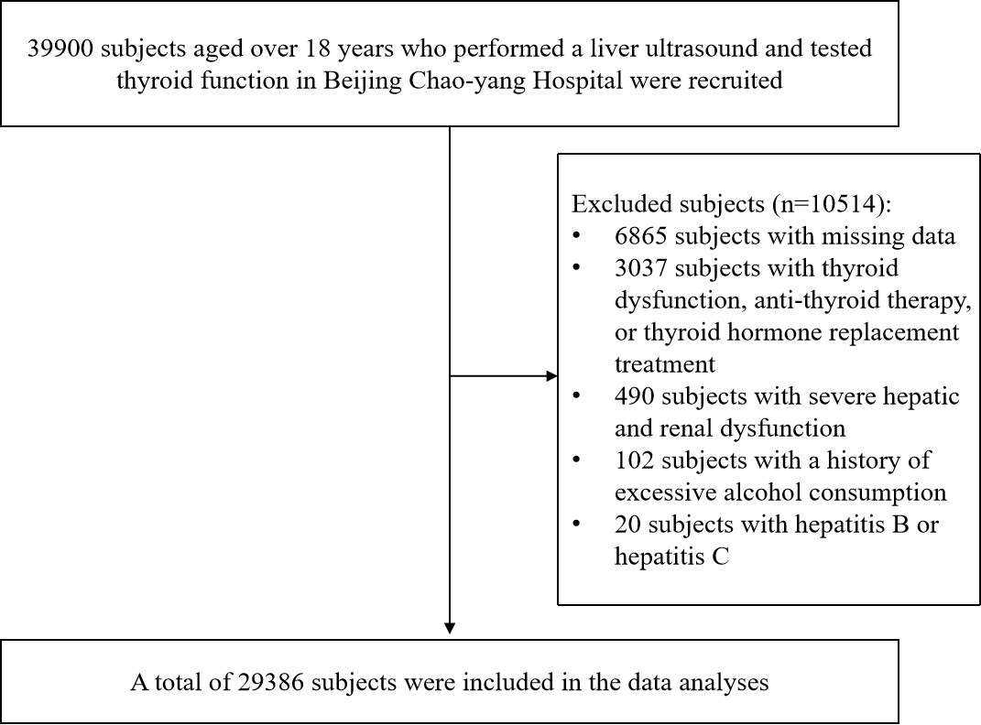
Table S1. The associations of thyroid hormone sensitivity and risks of NAFLD in males and females after adjusting age and BMI.
Parameters | Male (n=13576) |  | Female (n=15810)
Parameters | OR(95% CI) | P | OR(95% CI) | P
TFQI_{FT4}
Q1 | 1.00 |  | 1.00
Q2 | 0.98(0.87-1.11) | 0.758 | 1.13(0.98-1.31) | 0.095
Q3 | 1.05(0.94-1.18) | 0.398 | 1.17(1.01-1.36) | 0.041
Q4 | 0.99(0.88-1.11) | 0.866 | 1.22(1.04-1.42) | 0.015
TFQI_{FT3}
Q1 | 1.00 |  | 1.00
Q2 | 1.23(1.08-1.41) | 0.002 | 1.11(0.96-1.28) | 0.156
Q3 | 1.28(1.12-1.45) | <0.001 | 1.25(1.08-1.45) | 0.002
Q4 | 1.35(1.19-1.53) | <0.001 | 1.27(1.09-1.49) | 0.003
TSHI
Q1 | 1.00 |  | 1.00
Q2 | 1.05(0.94-1.18) | 0.421 | 1.20(1.03-1.39) | 0.020
Q3 | 0.96(0.85-1.07) | 0.441 | 1.12(0.96-1.30) | 0.142
Q4 | 0.99(0.89-1.11) | 0.913 | 1.18(1.01-1.38) | 0.035
TT4RI
Q1 | 1.00 |  | 1.00
Q2 | 1.01(0.90-1.12) | 0.925 | 1.06(0.91-1.24) | 0.476
Q3 | 0.94(0.84-1.05) | 0.289 | 1.05(0.90-1.23) | 0.533
Q4 | 0.97(0.86-1.08) | 0.548 | 1.12(0.96-1.30) | 0.147
TT3RI
Q1 | 1.00 |  | 1.00
Q2 | 1.12(1.00-1.25) | 0.055 | 1.01(0.87-1.18) | 0.882
Q3 | 0.96(0.85-1.07) | 0.437 | 1.10(0.94-1.28) | 0.236
Q4 | 1.10(0.98-1.23) | 0.115 | 1.10(0.95-1.28) | 0.198
FT3/FT4
Q1 | 1.00 |  | 1.00
Q2 | 1.17(1.03-1.32) | 0.013 | 1.06(0.91-1.23) | 0.451
Q3 | 1.24(1.10-1.39) | <0.001 | 1.07(0.92-1.24) | 0.402
Q4 | 1.30(1.16-1.46) | <0.001 | 1.23(1.05-1.43) | 0.009
Data was analyzed by multivariate logistic regression model.
NAFLD, non-alcoholic fatty liver disease; OR, odds ratio; CI, confidence interval; TFQI_{FT4}, thyroid feedback quartile-based index for FT4; TFQI_{FT3}, thyroid feedback quartile-based index for FT3; TSHI, TSH index; TT4RI, thyrotropin thyroxine resistance index; and TT3RI, thyrotropin triiodothyronine resistance index.

Table S2. The associations of thyroid hormone sensitivity and risks of NAFLD in non-obese and obese subjects after adjusting age and sex.
Parameters | Non-obesity (n=25208) |  | Obesity (n=4178)
Parameters | OR(95% CI) | P | OR(95% CI) | P
TFQI_{FT4}
Q1 | 1.00 |  | 1.00
Q2 | 1.06(0.97-1.17) | 0.216 | 1.08(0.88-1.33) | 0.473
Q3 | 1.14(1.04-1.25) | 0.007 | 1.16(0.94-1.42) | 0.169
Q4 | 1.10(1.00-1.21) | 0.043 | 1.17(0.95 -1.44) | 0.133
TFQI_{FT3}
Q1 | 1.00 |  | 1.00
Q2 | 1.29(1.17-1.42) | <0.001 | 1.19(0.96-1.49) | 0.120
Q3 | 1.42(1.29-1.57) | <0.001 | 1.56(1.25-1.95) | <0.001
Q4 | 1.56(1.42-1.72) | <0.001 | 1.64(1.32-2.05) | <0.001
TSHI
Q1 | 1.00 |  | 1.00
Q2 | 1.12(1.02-1.23) | 0.015 | 1.12(0.91-1.38) | 0.287
Q3 | 1.07(0.98-1.18) | 0.129 | 1.04(0.85-1.27) | 0.708
Q4 | 1.10(1.00-1.21) | 0.042 | 1.27(1.03-1.57) | 0.025
TT4RI
Q1 | 1.00 |  | 1.00
Q2 | 1.07(0.97-1.17) | 0.170 | 1.07(0.87-1.31) | 0.525
Q3 | 1.03(0.94-1.13) | 0.539 | 1.10(0.89-1.35) | 0.376
Q4 | 1.10(1.00-1.20) | 0.048 | 1.25(1.02-1.55) | 0.035
TT3RI
Q1 | 1.00 |  | 1.00
Q2 | 1.11(1.01-1.22) | 0.026 | 1.12(0.91-1.38) | 0.301
Q3 | 1.09(1.00-1.20) | 0.059 | 1.19(0.97-1.46) | 0.106
Q4 | 1.21(1.11-1.33) | <0.001 | 1.40(1.14-1.73) | 0.002
FT3/FT4
Q1 | 1.00 |  | 1.00
Q2 | 1.16(1.05-1.27) | 0.003 | 1.32(1.06-1.64) | 0.013
Q3 | 1.29(1.18-1.42) | <0.001 | 1.22(0.99-1.50) | 0.069
Q4 | 1.46(1.33-1.61) | <0.001 | 1.45(1.19-1.78) | <0.001
Data was analyzed by multivariate logistic regression model.
NAFLD, non-alcoholic fatty liver disease; OR, odds ratio; CI, confidence interval; TFQI_{FT4}, thyroid feedback quartile-based index for FT4; TFQI_{FT3}, thyroid feedback quartile-based index for FT3; TSHI, TSH index; TT4RI, thyrotropin thyroxine resistance index; and TT3RI, thyrotropin triiodothyronine resistance index.

