Supplementary Figure 1 Flow chart of participants' enrollment process in the prospective study.

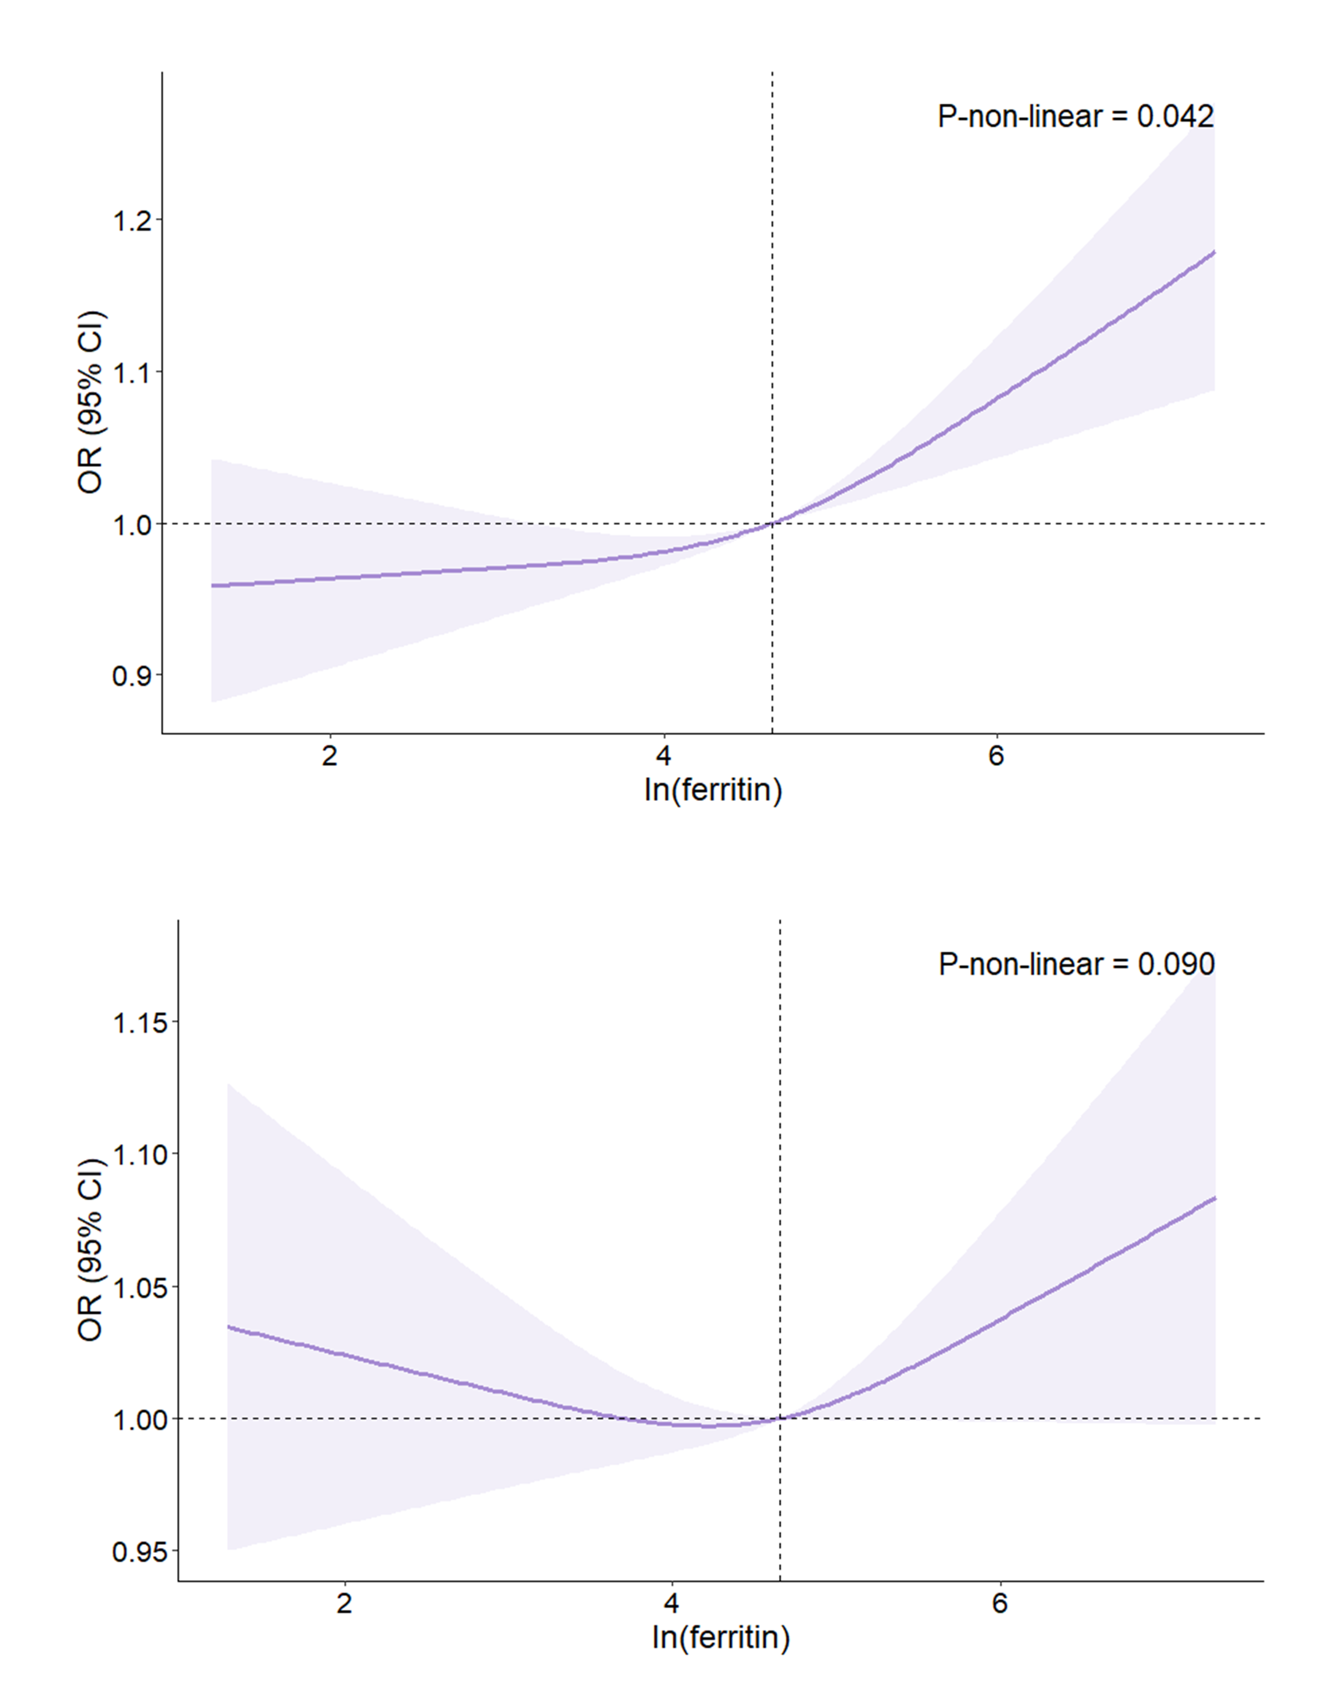
B
A
Supplementary Figure 2 Odds ratio of OSA according to ln-transformed ferritin levels in overweight/obese people. (A) No covariates. (B) Adjusted for Age, Gender, Race, BMI, and PIR.

Supplementary Figure 3 Predictive ability of Ferritin, HGB, WBC and CRP for OSA in four ROC curves.

Supplementary Figure 4 Kaplan-Meier curves across groups with different ferritin levels for all-cause mortality.

Supplementary Table 1 Characteristics of the study population according to OSA in the cross-sectional study.
Characteristic | Total, N = 4809 (100%) | No OSA, N = 2202 (46%) | OSA, N = 2607 (54%) | P-value
Age (years) |  |  |  | <0.001
20-40 years | 1,456 (34%) | 792 (39%) | 664 (30%)
40-60 years | 1,675 (37%) | 641 (33%) | 1,034 (41%)
60+ years | 1,678 (29%) | 769 (28%) | 909 (30%)
Gender, n (%) |  |  |  | <0.001
Female | 2,626 (53%) | 1,285 (58%) | 1,341 (49%)
Male | 2,183 (47%) | 917 (42%) | 1,266 (51%)
Race, n (%) |  |  |  | 0.700
Mexican American | 698 (9.6%) | 313 (9.7%) | 385 (9.5%)
Other Hispanic | 510 (7.1%) | 206 (6.5%) | 304 (7.6%)
Non-Hispanic White | 1,838 (66%) | 866 (66%) | 972 (65%)
Non-Hispanic Black | 1,230 (11%) | 568 (11%) | 662 (10%)
Other/multiracial | 533 (7.2%) | 249 (7.3%) | 284 (7.1%)
BMI |  |  |  | <0.001
Overweight (25-30 kg/m²) | 1,951 (41%) | 1,025 (49%) | 926 (35%)
Class I Obesity (30-35 kg/m²) | 1,406 (30%) | 648 (28%) | 758 (32%)
Class II Obesity (35-40 kg/m²) | 790 (16%) | 312 (13%) | 478 (18%)
Class III Obesity (≥40 kg/m²) | 662 (13%) | 217 (9.5%) | 445 (16%)
PIR, n (%) |  |  |  | 0.130
Low (<1.3) | 1,320 (18%) | 606 (17%) | 714 (19%)
Medium (1.3-3.5) | 1,925 (36%) | 859 (33%) | 1,066 (37%)
High (≥3.5) | 1,564 (46%) | 737 (49%) | 827 (44%)
Alcohol, n (%) | 2,123 (50%) | 950 (49%) | 1,173 (51%) | 0.500
Smoking, n (%) |  |  |  | <0.001
Former | 1,297 (29%) | 555 (26%) | 742 (31%)
Never | 2,691 (55%) | 1,307 (60%) | 1,384 (51%)
Now | 821 (16%) | 340 (14%) | 481 (18%)
Sedentary time, n (%) |  |  |  | 0.200
< 3 h/d | 719 (12%) | 356 (13%) | 363 (10%)
3-6 h/d | 1,784 (36%) | 820 (36%) | 964 (35%)
≥ 6 h/d | 2,306 (53%) | 1,026 (51%) | 1,280 (54%)
CVD, n (%) | 407 (7.0%) | 176 (6.7%) | 231 (7.3%) | 0.400
Diabetes, n (%) | 791 (13%) | 295 (11%) | 496 (15%) | <0.001
Hypertension, n (%) | 1,947 (36%) | 767 (30%) | 1,180 (40%) | <0.001
WBC (1000 cells/uL) | 7.20 (6.00, 8.70) | 7.10 (5.90, 8.60) | 7.40 (6.10, 8.80) | 0.01
HGB (g/dL) | 14.30 (13.30, 15.20) | 14.18 (13.30, 15.10) | 14.40 (13.40, 15.30) | 0.006
HCT (%) | 42.3 (39.7, 44.8) | 41.9 (39.5, 44.5) | 42.6 (40.0, 45.0) | 0.006
RDW (%) | 13.50 (13.00, 14.10) | 13.40 (13.00, 14.10) | 13.50 (13.00, 14.10) | 0.13
HDL (mg/dL) | 49 (41, 59) | 51 (42, 60) | 48 (40, 57) | <0.001
TC（mg/dL） | 186 (161, 214) | 184 (160, 213) | 188 (162, 216) | 0.11
CRP (mg/L) | 2.5 (1.1, 5.2) | 2.2 (1.0, 4.6) | 2.8 (1.1, 5.5) | 0.002
Total iron (mg/d) | 12 (9, 17) | 12 (8, 17) | 12 (9, 17) | 0.046
ln-ferritin | 4.66 (3.93, 5.26) | 4.52 (3.85, 5.17) | 4.75 (4.02, 5.35) | <0.001
Abbreviations: BMI: Body mass index; CVD: Cardiovascular disease; CRP: C-reactive protein; HCT: Hematocrit; HDL: High-Density Lipoprotein; HGB: Hemoglobin; ln-ferritin: ln-transformed ferritin; OSA: obstructive sleep apnea; RDW: Red cell distribution width; PIR: Family poverty income ratio; TC: Total Cholesterol; WBC: White blood cell.

Supplementary Table 2 Association between ferritin and three different definitions of OSA.
Variables |  | Question 1 |  |  | Question 2 |  |  | Question 3
Variables |  | OR (95% CI) | P-value |  | OR (95% CI) | P-value |  | OR (95% CI) | P-value
Q1 group |  | 1.15 (0.91, 1.45) | 0.200 |  | 1.16 (0.86, 1.58) | 0.300 |  | 1.03 (0.61, 1.75) | 0.900
Q2 group |  | Reference |  |  | Reference |  |  | Reference
Q3 group |  | 1.22 (0.92, 1.62) | 0.150 |  | 1.35 (1.06, 1.72) | 0.017 |  | 0.97 (0.56, 1.66) | 0.900
Q4 group |  | 1.31 (0.99, 1.73) | 0.056 |  | 1.63 (1.06, 2.49) | 0.028 |  | 0.90 (0.39, 2.06) | 0.800
P for trend |  | < 0.001 |  |  | 0.001 |  |  | 0.173
Question 1: “Do you snore for 3 or more nights per week?”.
Question 2: “Do you experience snorting, gasping, or stopping breathing for 3 or more nights per week?”.
Question 3: “Do you feel excessively sleepy during the day, ranging from 16 to 30 times per month, despite getting around 7 or more hours of sleep per night on weekdays or work nights?”.
All covariates in Model 2 were adjusted.

