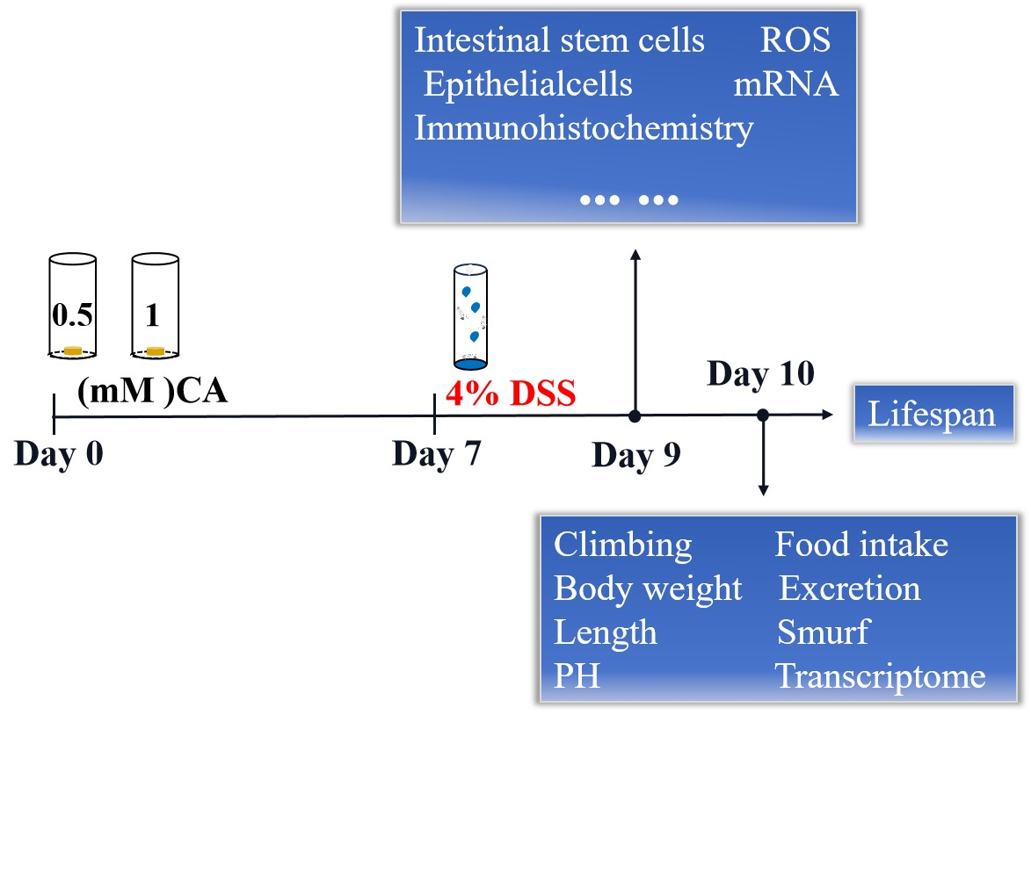
Supplementary Figure 1: Flowchart of Drosophila model construction.

