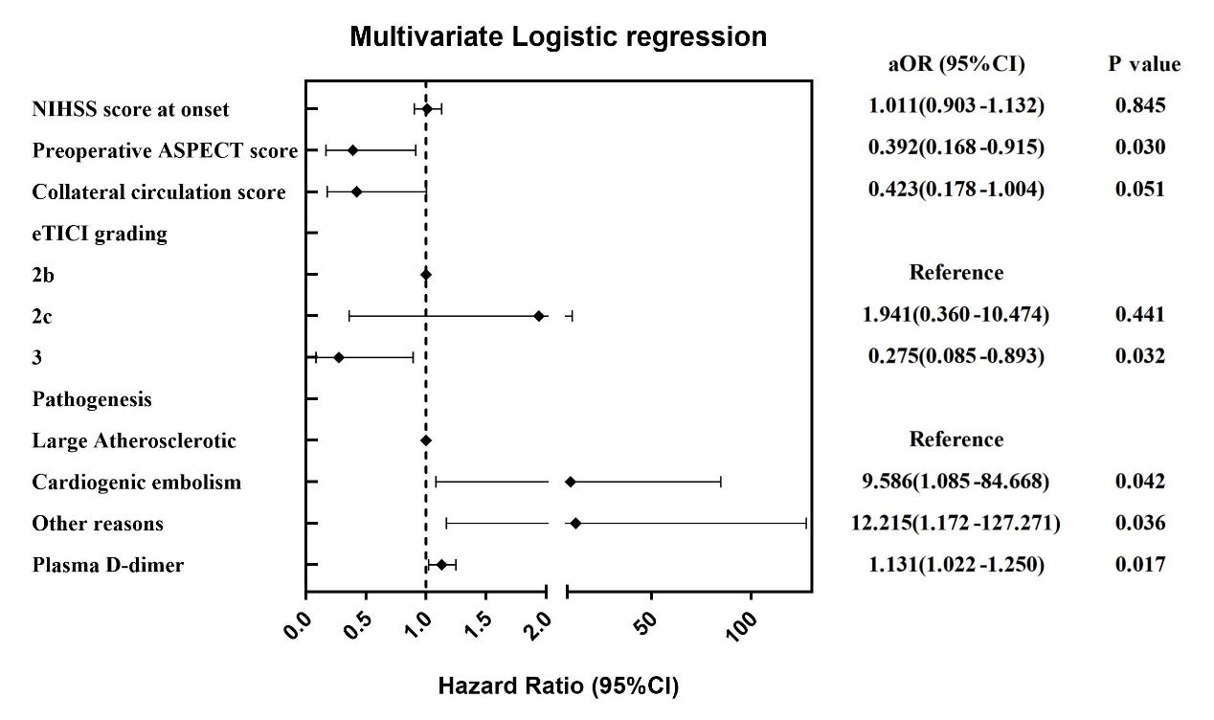
Supplementary Figure 1

Supplementary Figure 1: Forest plot of significant indicators in multivariate logistic regression analysis revealing corresponding hazard ratio of cerebral herniation of all indicators. The forest plot showed that for every 1mg/L increase in emergency preoperative plasma D-dimer, the risk of cerebral herniation increases 0.131 times.
NIHSS:National Institute of Health stroke scale; ASPECT:Alberta Stroke Program Early CT; eTICI:extended thrombolysis in cerebral infarction; CI: Confidence interval; AUC:Area under curve.

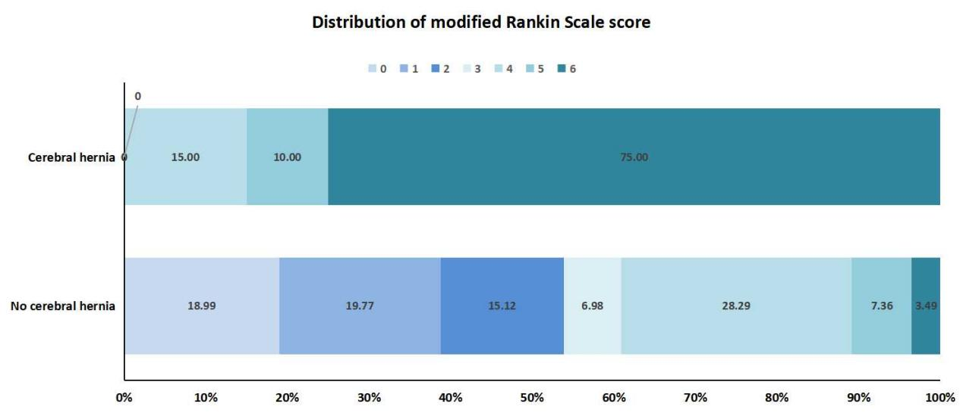
Supplementary Figure 2

Supplementary Figure 2: Distribution of mRS scores for patients with and without cerebral herniation at 3 months after mechanical thrombectomy. 3 months after mechanical thrombectomy, the proportion of mRS score ≤ 2 in patients with cerebral herniation was significantly lower than that in patients without cerebral herniation.
mRS: modified Rankin scale.

Supplementary Table 1: Baseline clinical data of patients with normal and elevated emergency preoperative plasma D-dimer levels with AIS due to anterior circulation occlusion of large blood vessels
Variables | All patients (n=278) | D-dimer normal (n=78) | D-dimer elevation (n=200) | P value
Age, years, (mean ± standard deviation) | 66.59±11.64 | 61.08±9.45 | 68.74±11.73 | ＜0.001
Gender, Male, n (%) | 184(66.19) | 58(74.36) | 126(63.00) | 0.072
Medical History
Hypertension, n (%) | 145(52.16) | 38(48.72) | 107(53.50) | 0.473
Diabetes, n (%) | 55(19.78) | 21(26.92) | 34(17.00) | 0.062
Cerebral infarction, n (%) | 41(14.75) | 15(19.23) | 26(13.00) | 0.188
Coronary heart disease, n (%) | 40(14.39) | 6(7.69) | 34(17.00) | 0.047
Atrial fibrillation, n (%) | 59(21.22) | 7(8.97) | 52(26.00) | 0.002
Smoking, n (%) | 110(39.57) | 37(47.44) | 73(36.50) | 0.094
Drinking, n (%) | 63(22.66) | 16(20.51) | 47(23.50) | 0.593
mRS score before onset, (mean ± standard deviation) | 0.10±0.42 | 0.08±0.35 | 0.12±0.45 | 0.485
The situation at the onset of stroke
NIHSS score at onset, median (IQR) | 12.00(10.00-16.00) | 11.00(8.75-14.00) | 13.00(10.00-16.00) | 0.012
Preoperative ASPECT score, median (IQR) | 7.00(7.00-9.00) | 8.00(7.00-9.00) | 7.00(7.00-8.00) | 0.011
Location of occluded blood vessels, n (%) |  |  |  | 0.031
M1 segment of middle cerebral artery | 125(44.96) | 38(48.72) | 87(43.50)
Middle cerebral artery M2 segment | 20(7.19) | 10(12.82) | 10(5.00)
Internal carotid artery | 38(13.67) | 10(12.82) | 28(14.00)
Anterior cerebral artery | 1(0.36) | 1(1.28) | 0(0)
Anterior circulation tandem lesion | 94(33.81) | 19(24.36) | 75(37.50)
Collateral circulation score of ASTIN/SIR, median (IQR) | 3.00(2.00-3.00) | 3.00(2.00-3.00) | 2.00(2.00-3.00) | 0.026
eTICI grading, n (%) |  |  |  | 0.875
2b | 59(21.22) | 15(19.23) | 44(22.00)
2c | 18(6.47) | 5(6.41) | 13(6.50)
3 | 201(72.30) | 58(74.36) | 143(71.50)
Pathogenesis, n (%) |  |  |  | 0.004
Atherosclerotic type | 121(43.53) | 40(51.28) | 81(40.50)
Cardiogenic embolism | 91(32.73) | 14(17.95) | 77(38.50)
Other causes | 66(23.74) | 24(30.77) | 42(21.00)
AIS:Acute ischemic stroke; mRS: modified Rankin scale; NIHSS:National Institute of Health stroke scale; ASPECT:Alberta Stroke Program Early CT; ASTIN/SIR:American Society of Interventional and Therapeutic Neuroradiology/Society of Interventional Radiology; eTICI:extended thrombolysis in cerebral infarction.

Supplementary Table 2: Univariate and multivariate logistic regression analysis of patients with elevated emergency preoperative plasma D-dimer levels
Variables | Univariate analysis |  |  |  | multivariate analysis
Variables | OR | 95%CI | P value |  | OR | 95%CI | P value
Age | 1.062 | 1.035-1.089 | ＜0.001 |  | 1.060 | 1.030-1.090 | ＜0.001
Coronary heart disease | 2.458 | 0.988-6.111 | 0.053
Atrial fibrillation | 3.564 | 1.541-8.241 | 0.003 |  | 1.841 | 0.580-5.837 | 0.300
NIHSS score at onset | 1.053 | 1.000-1.108 | 0.049 |  | 0.997 | 0.941-1.057 | 0.923
Preoperative ASPECT score | 0.761 | 0.612-0.946 | 0.014 |  | 0.819 | 0.606-1.107 | 0.194
Location of occluded blood vessels
M1 segment of middle cerebral artery | Reference
Middle cerebral artery M2 segment | 0.437 | 0.168-1.136 | 0.089
Internal carotid artery | 1.223 | 0.541-2.767 | 0.629
Anterior cerebral artery | 0.000 | 0.000-0.000 | 1.000
Anterior circulation tandem lesion | 1.724 | 0.917-3.242 | 0.091
Collateral circulation score of ASTIN/SIR | 0.705 | 0.510-0.976 | 0.035 |  | 0.880 | 0.571-1.357 | 0.564
Pathogenesis
Atherosclerotic type | Reference |  |  |  | Reference
Cardiogenic embolism | 2.716 | 1.371-5.382 | 0.004 |  | 1.428 | 0.558-3.658 | 0.458
Other causes | 0.864 | 0.461-1.620 | 0.649 |  | 1.290 | 0.636-2.617 | 0.481
NIHSS:National Institute of Health stroke scale; ASPECT:Alberta Stroke Program Early CT; ASTIN/SIR:American Society of Interventional and Therapeutic Neuroradiology/Society of Interventional Radiology; CI: Confidence interval.

