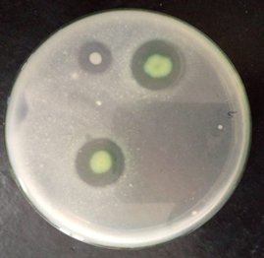
Figure S1: Skim milk agar plate: The halozones surrounding the colonies indicate the hydrolysis of skim milk by protease enzyme
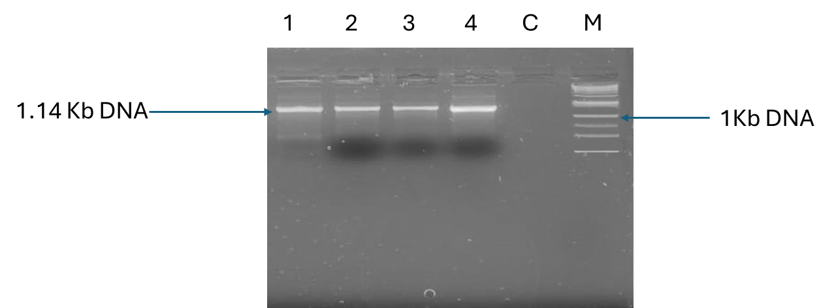
Figure S2: Amplification of Subtilisin gene from Bacillus haynesii (Lane 1-4: Subtilisin
carlsberg from four strains of Bacillus haynesii, Lane 5: Control and Lane 6: 100 bp marker)

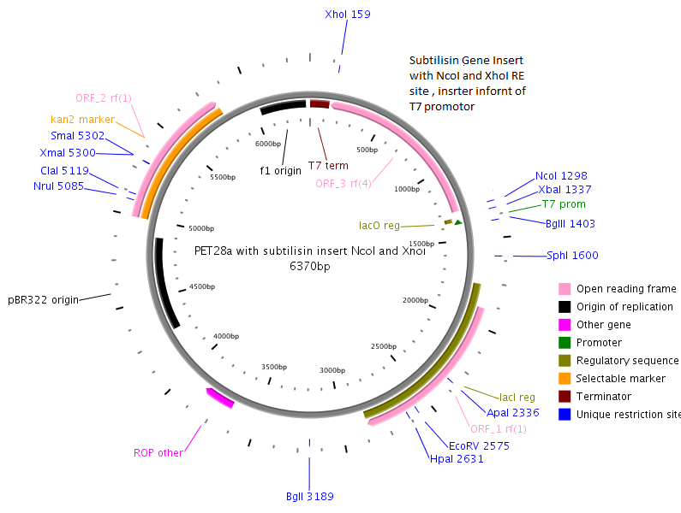
Subtilisin gene with NcoI & XhoI RE sites inserted after T7 Promotor

Figure S3: Plasmid Map of pET22 (a)+ vector with Subtilisin carlsberg

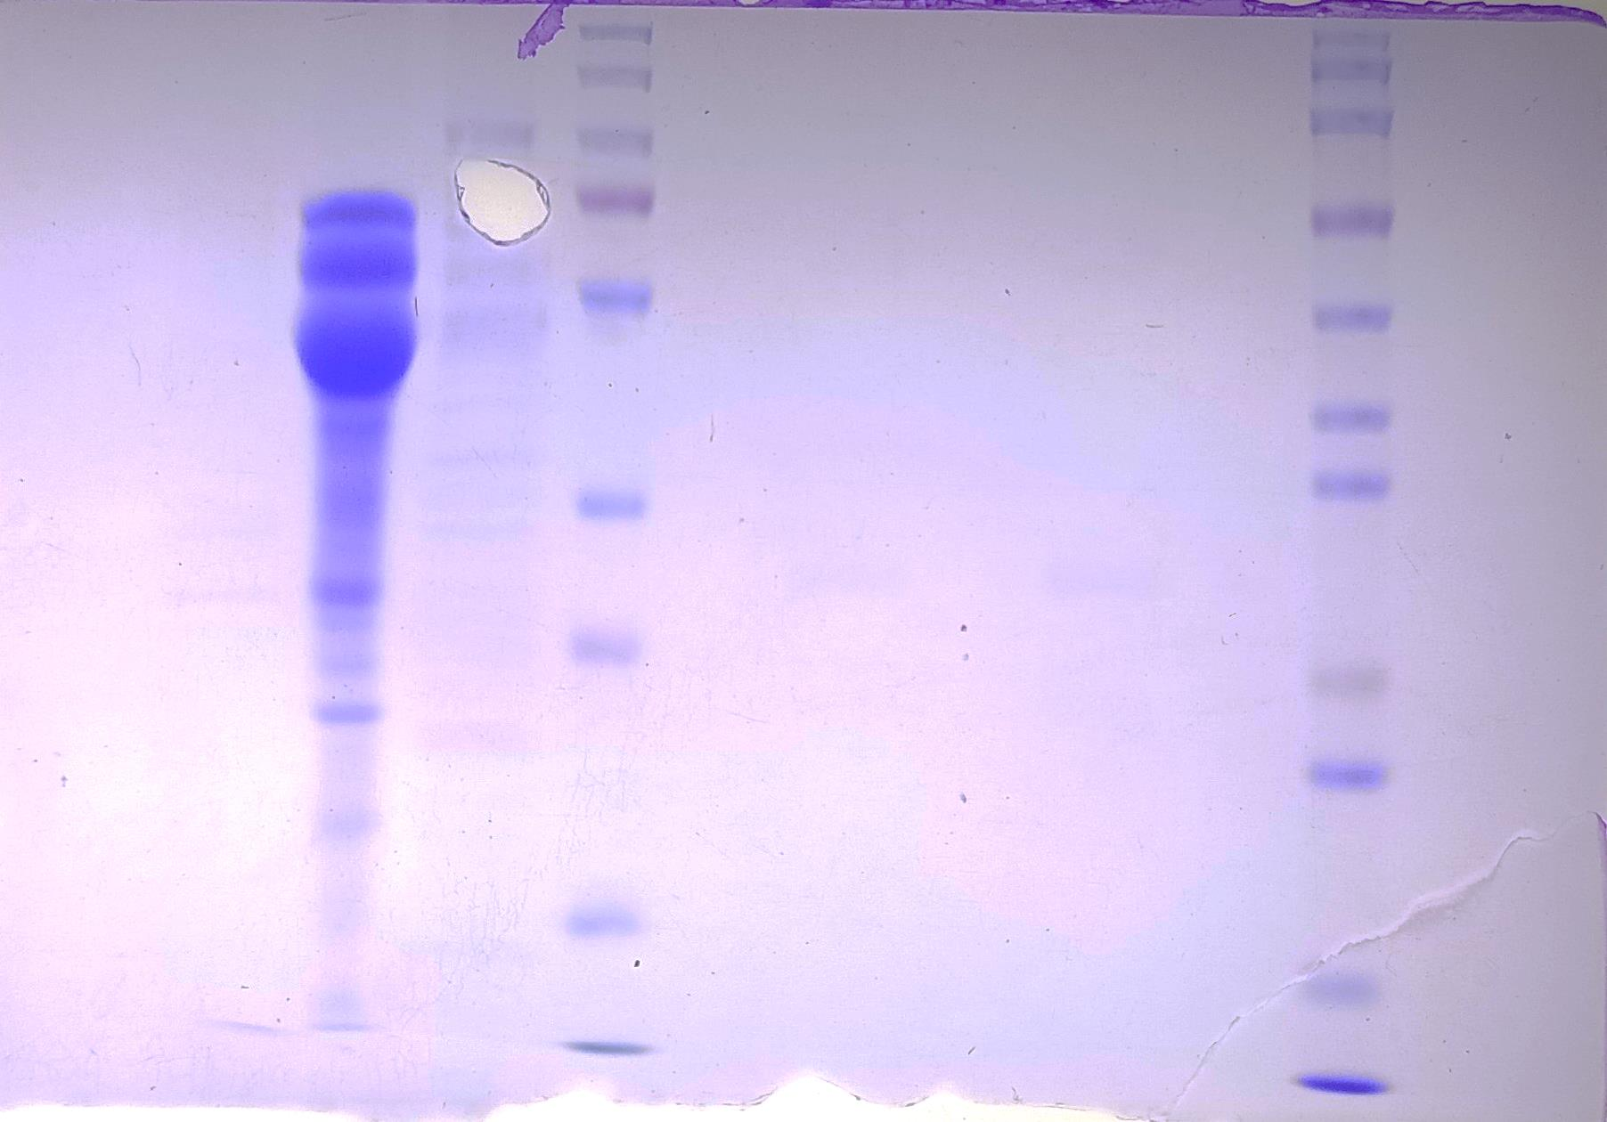
PageRuler E 15 μL E 20 μL E Zokeyo
150
70
50
35
25
100
40
20
15
70
55
35
100
130
15
25
E = Empty lane

Figure S4: SDS PAGE of subtilisin for the estimation it’s of molecular weight; The red arrow are used to show the bands of subtilisin. The first lane shows the bands of Page Ruler ladder, E shows empty lanes where no samples are loaded, 15 and 20 ul shows the concentration of protein loaded.
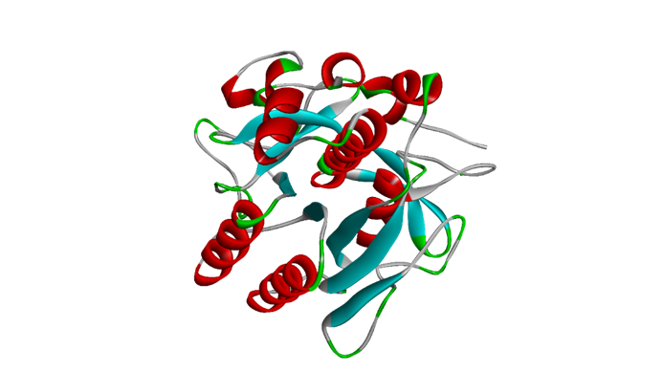
Figure S5: 3D structure model of the sequenced gene by homology modelling taking the coordinates of Subtilisin Carlsberg (PDB code: 1SBC)

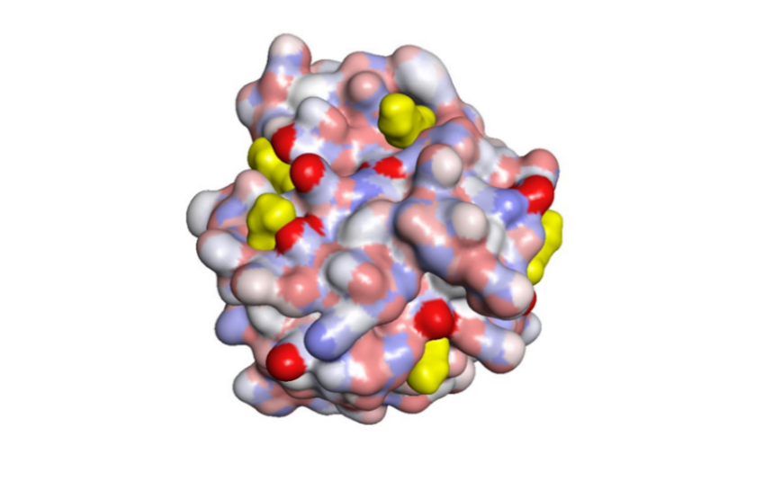
Figure S6: Surface of the selected model. Lysine residues located on the surface of the enzyme are coloured yellow.
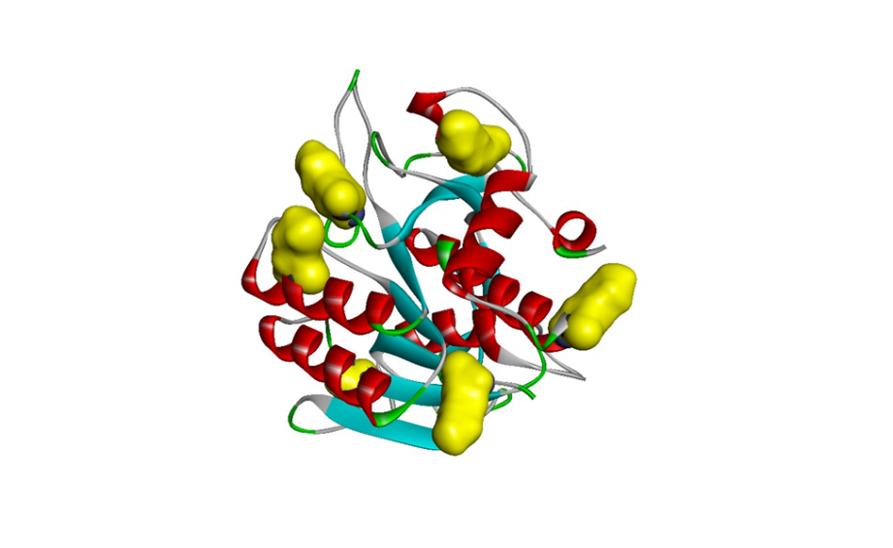
Figure S7: The selected model shown in cartoon representation. Lysine residues located on the surface of the enzyme are shown as yellow spheres.
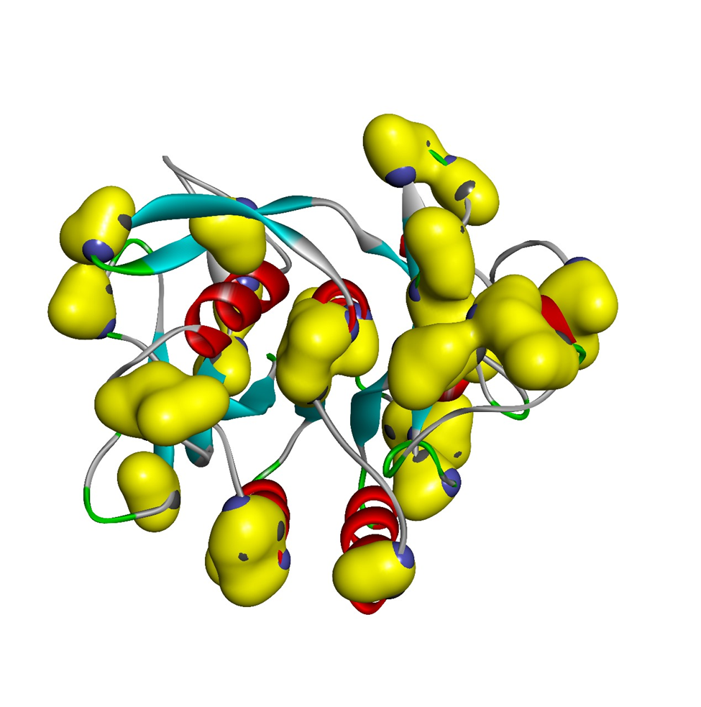
Figure S8: The selected model shown in cartoon representation. Serine residues in the enzyme are shown as yellow spheres.

