SUPPLEMENTARY FILE
Development of Solid Self-Nanoemulsifying Drug Delivery System of Rhein to improve biopharmaceutical performance: Physiochemical characterization, and Pharmacokinetic evaluation
Sachin Mashusudan More¹, Md Abdur Rashid², Rohini Kharwade³, Murtada Taha⁴, Yahya Alhamhoom², Gamal Osman Elhassan⁵, Purushottam Gangane³, Turky Omar Asar⁶, Ajay Pise⁷, Mohammed Kaleem^{1#}, Md Ali Mujtaba^{8,9*}
¹Department of Pharmacology, Dadasaheb Balpande College of Pharmacy, Rashtrasant Tukadoji Maharaj Nagpur University, Nagpur-440037, MH, India
²Department of Pharmaceutics, College of Pharmacy, King Khalid University, Abha, Saudi Arabia
³Department of Pharmaceutics, Dadasaheb Balpande College of Pharmacy, Rashtrasant Tukadoji Maharaj Nagpur University, Nagpur-440037, MH, India
⁴Department of Clinical Laboratory Science, Prince Sultan Military College of Health Sciences, Dhahran, Saudi Arabia
⁵Department of Pharmaceutics, College of Pharmacy, Qassim University, Buraidah, Saudi Arabia
⁶Department of Biology, College of Science and Arts at Alkamil, University of Jeddah, Jeddah, Saudi Arabia
⁷Department of Regulatory Affairs Dadasaheb Balpande College of Pharmacy, Rashtrasant Tukadoji Maharaj Nagpur University, Nagpur-440037, MH, India
⁸Department of Pharmaceutics, Faculty of Pharmacy, Northern Border University, Arar, Saudi Arabia
⁹Center for Health Research, Northern Border University, Arar, Saudi Arabia

1S) Validation of Bioanalytical method
- System Suitability
Six replicate injections of 10 μg Rhein + 1 μg diacerein (IS) solutions in plasma were conducted independently, and the chromatograms were obtained so that the system suitability test could be performed. Retention time, capacity factor, peak purity, symmetry, resolution, and the number of theoretical plates of analytes in spiked biological matrices were all evaluated to determine the suitability of the system, as shown in Table S1 and Fig. S1.
Table S1: Result of estimated parameters of an optimized method for resolution of rhein by HPLC chromatogram in plasma.
Bioactive | Diacerein | Rhein
Retention time (min) | 6.8 | 9.2
Area | 4156 | 42901
Height | 1706 | 3547
Tailing factor | 0.971 | 1.103
No. of theoretical plate (USP) | 10815 | 12762
HETP (USP) | 13.87 | 11.75
Peak purity index | 0.0942 | 0.0936
Resolution factor (USP) |  | 8.34  diacerein/rhein

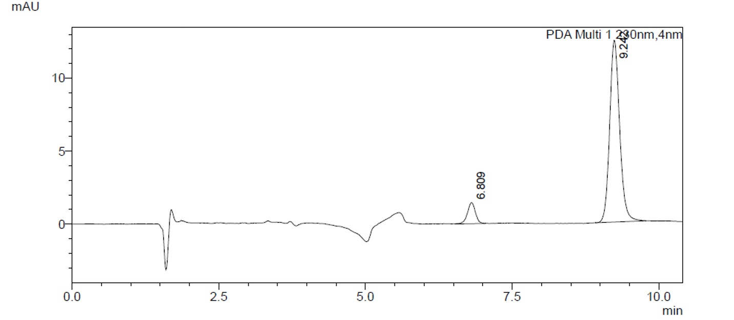

Fig. S1. Typical optimized HPLC chromatogram of rhein and diacerein (IS) by optimized method.
- Specificity
The interference biological matrices were compared to the rhein and IS to assess the specificity of the method. Additionally, the interference of the degradation products against the rhein, as illustrated in Fig. S2, was used to determine the specificity.

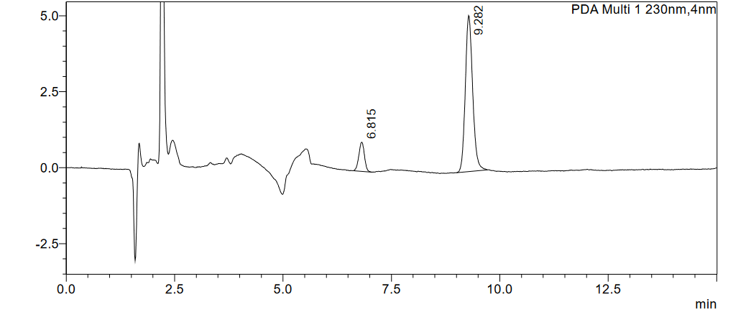

Fig. S2: Typical HPLC chromatogram of rhein and IS in plasma matrix

- Linearity study
The investigation on linearity was carried out throughout a range of concentrations of 1µg/ml-5 µg/ml in plasma. The linear regression analysis of the area ratio (analyte/internal standard) against concentration was plotted. The correlation coefficient (r²), which shall be 0.99 or higher, is an acceptability criterion for a calibration curve. The lower limit of quantification (LOQ) has a maximum permitted deviation of 20%, whereas the % coefficient of variation (% CV) of each standard concentration should fall within 15% of the nominal value.
% CV= (Standard Deviation /Mean) x 100
The chromatograms in plasma for the above concentrations were shown in Fig. S3a and S3b and the equation (y= 3.5337x+0.1825, R²=0.9928) of linearity was used to determine the concentration of rhein.
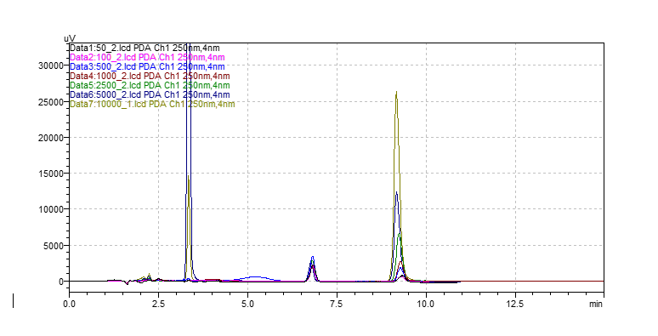
Fig. S3a: Typical HPLC overlay chromatograms of rhein for linearity in rat plasma.

Fig. S3b: Linearity curve of rhein for linearity in rat plasma
- Limit of detection (LOD) and Limit of quantification (LOQ)
Based on the signal-to-noise ratio, both the LOD and LOQ were calculated. The lowest concentration level that produced a height of the peak threefold the baseline noise was known as the detection limit. The lowest concentration level that yielded a peak height with a signal to noise ratio greater than ten percent was known as the quantification limit. The minimal amount of analyte in a sample that can be identified but occasionally quantified as a precise value is known as the detection limit of a particular analytical method. The detection limit (DL) may be expressed as (1)
DL=3.3 𝜎/𝑆 (1)
Where, σ = standard deviation of the response and S = slope of the calibration curve
The smallest quantity of analyte in a sample that can be quantitatively identified using proper accuracy and precision is known as the quantitation limit of an individual analytical method. For low concentrations of chemicals in sample matrices, the quantitation limit is a parameter of quantitative assays that is specifically utilized to detect contaminants and/or metabolite products. The formula for the quantitation limit (QL) is (2).
QL=10 𝜎/𝑆 (2)
The lower limit of quantification (LOQ) was 12 ng/ml and the lower limit of detection (LOD) was 7 ng/ml accordingly. It confirmed the optimized technique was very sensitive to quantifying the lowest concentration of rhein.
- Matrix effect and % recovery
The matrix effect and recovery study were carried out by taking 3 different concentrations i.e. low
0.05µg, middle 0.5µg, and high 5 µg. It was calculated by using the formula
The matrix effect of a biological sample at each level was calculated using equation (3)
Matrix effect = $\frac{ Peak area response of sample in absence of matrix ions }{Peak area response of sample in presence of matrix ions}$ x100 (3)
%Recovery of analyte at each level was calculated using equation (4)
%Recovery=$\frac{ Peak area response of sample in presence of pre-spiked matrix ions }{PPeak area response of sample in presence of post-spiked matrix ions}$x100 (4)
The % matrix effect ranged between 95% to 105% and % recovery of the extracted sample was found between 85-94%. At different concentration levels, Rhein showed reasonably high extraction efficacy as shown in Table S2. Consistently more than 90 % of the drug was extracted from the plasma matrix.
The extraction recovery and matrix effect for rhein in plasma samples at concentrations 0.05µg, 0.5µg, and 5 µg were 85.78-89.03% and 94.78-103.43% respectively. These data indicated that there were no significant matrix effects for rhein.

Table S2: % recovery and matrix effect of rhein determined in plasma
Rhein conc | Unextracted rhein AUC | Extracted pre-spiked Rhein AUC | Extracted post-spiked Rhein AUC | Recovery % | Matrix effect %
0.05 µg | 1589 | 1278 | 1409 | 89.03 | 97.03
0.5 µg | 7602 | 6109 | 6207 | 85.78 | 94.78
5 µg | 76142 | 66895 | 65832 | 86.52 | 103.43

- Precision and accuracy
The precision of the bioanalytical method was determined by assaying three concentration levels (low 0.05µg, middle 0.5µg, and high 5µg) and estimating standard deviation (SD) and relative standard deviation/ coefficient variation (CV). The intra-day and inter-day precision was determined by analyzing three samples at three different times and determining SD, and % CV as shown in Table S3.
The percentage coefficient of variation (% CV), which is used to measure precision, was determined using equation (5).
% CV = (Standard deviation /Mean) x 100 (5)
- Calculating the percentage coefficient of variation (% CV) of the findings acquired that same day allowed the determination of intra-day precision.
- Calculating the percentage coefficient of variation (% CV) of the outcomes gathered over a minimum of two days allowed for the determination of inter-day precision.
The accuracy is expressed as the nominal percentage of the concentration and was determined using equation (6).
% Nominal = (Measured concentration/Actual concentration) x 100 (6)
- The mean of the percentage nominal at every level was given after calculating the % nominal of the estimated concentration from the actual values for quality control samples at any concentration level evaluated in a single day. This allowed for a measurement of intra-day accuracy.
- The percentage nominal of the estimated concentration was derived from the actual value for quality control samples at every level studied across a minimum of two days to determine inter-day accuracy. The mean of the percentage nominal at every level was then noted.
Acceptance criteria:
- Accuracy: ± 15% of nominal concentrations; except ± 20% at LOQ.
- Precision: ± 15% CV, except ± 20% CV at LOQ
Table S3: Intra-day and inter-day precision and accuracy of Rhein determined by the bioanalytical method
Rhein Conc. | Intra-day (n=3) |  |  | Inter-day (n=3)
 | Precision |  | Accuracy | Precision |  | Accuracy
 | Mean | %CV | % | Mean | %CV | %
0.05 µg | 51.01±0.34 | 1.21 | 98.39 | 62.01±0.42 | 1.57 | 102.04%
0.5 µg | 521.62 ±0.24 | 2.36 | 99.87 | 619.62 ±0.51 | 3.01 | 104.12%
5 µg | 5027±0.41 | 3.78 | 98.03 | 6023±0.73 | 4.71 | 103.23%

