Table S1 Symptom clusters of patients with ECOPD determined by exploratory factor analysis
Symptom cluster | symptom | Loading
Symptom cluster | symptom | 1 | 2 | 3
Fatigue-activity symptom cluster | Fatigue | 0.822
Fatigue-activity symptom cluster | Decreased exercise tolerance | 0.792
Fatigue-activity symptom cluster | Activity restriction | 0.635
Fatigue-activity symptom cluster | Shortness of breath | 0.559
Nutrition-sleep symptom cluster | Loss of appetite |  | 0.811
Nutrition-sleep symptom cluster | Weight loss |  | 0.742
Nutrition-sleep symptom cluster | Insomnia |  | 0.750
Cough-sputum symptom cluster | Expectoration |  |  | 0.790
Cough-sputum symptom cluster | Cough |  |  | 0.775
Cough-sputum symptom cluster | Chest distress |  |  | 0.531
Variation |  | 35.419% | 14.444% | 10.597%
Cumulative variation |  | 35.419% | 49.863% | 60.461%

Table S2 Single-factor regression analysis results of different subgroups of patients with ECOPD
Variables | Overall  N=208 | class1  N=112 | class2  N=96 | OR | 95%CI | P
age, year |  |  |  |  |  | 0.501
<65 | 33 (15.9) | 16 (14.3) | 17 (17.7) | Reference | Reference
≥65 | 175 (84.1) | 96(85.7) | 79 (82.3) | 1.290 | 0.61-2.72
gender
male | 175 (84.1) | 91 (81.3) | 84 (87.5) | Reference | Reference
female | 33 (15.9) | 21 (18.8) | 12 (12.5) | 1.62 | 0.75-3.48 | 0.222
level of education |  |  |  |  |  | 0.744
illiteracy | 63 (30.3) | 35 (31.3) | 28 (29.2) | Reference | Reference
primary | 103 (49.5) | 52 (46.6) | 51 (53.1) | 0.82 | 0.43-1.53 | 0.526
junior middle school | 24 (11.5) | 12 (10.7) | 12 (12.5) | 0.80 | 0.31-2.05 | 0.642
high school and above | 18 (8.7) | 13 (11.6) | 5 (5.2) | 2.08 | 0.66-6.54 | 0.210
ECOPD severity grade
mild | 98 (47.1) | 49 (43.8) | 49 (51.0) | Reference | Reference
moderate | 39 (18.8) | 21 (18.8) | 18 (18.8) | 1.17 | 0.55-2.45 | 0.685
severe | 71 (34.1) | 42 (37.5) | 29 (30.2) | 1.45 | 0.78-2.68 | 0.239
history of frequent exacerbation
no | 150 (72.1) | 75 (67.0） | 75 (78.1) | Reference | Reference
yes | 58 (27.9) | 37 (33.0) | 21 (21.9) | 1.76 | 0.94-3.29 | 0.075
smoking
no | 92 (44.2) | 56 (50.0) | 36 (37.5) | Reference | Reference
yes | 116 (55.8) | 56 (50.0) | 60 (62.5) | 0.60 | 0.34-1.05 | 0.071
alcohol
no | 137 (65.9) | 77 (68.8) | 60 (62.5) | Reference | Reference
yes | 71 (34.1) | 35 (31.3) | 36 (37.5) | 0.76 | 0.43-1.35 | 0.344
occupational exposure
no | 176 (84.6) | 93 (83.0) | 83 (86.5) | Reference | Reference
yes | 32 (15.4) | 19 (17.0) | 13 (13.5) | 1.30 | 0.61-2.80 | 0.496
infection
no | 138 (66.3) | 68 (60.7) | 70 (72.9) | Reference | Reference
bacteria | 18 (8.7) | 12 (10.7) | 6 (6.3) | 2.06 | 0.73-5.80 | 0.172
fungus | 17 (8.2) | 11 (9.8) | 6(6.2) | 1.89 | 0.66-5.39 | 0.235
virus | 21 (10.1) | 11 (9.8) | 10 (10.4) | 1.13 | 0.45-2.84 | 0.791
mixed/indeterminate infection | 14 (6.7) | 10 (8.9) | 4 (4.2) | 2.57 | 0.77-8.60 | 0.125
ADL
≥60 | 135 (64.9) | 56 (50.0) | 79 (82.3) | Reference | Reference
＜60 | 73 (35.1) | 56(50.0) | 17 (17.7) | 4.65 | 2.45-8.83 | <0.001
allergy
no | 184 (88.5) | 99 (88.4) | 85 (88.5) | Reference | Reference
yes | 24 (11.5) | 13 (11.6) | 11 (11.5) | 1.01 | 0.43-2.38 | 0.973
hypertension, year
0 | 108 (51.9) | 58 (51.8) | 50 (52.1) | Reference | Reference
0-5 | 33 (15.9) | 17 (15.2) | 16 (16.7) | 0.92 | 0.42-2.00 | 0.826
＞5 | 67 (32.2) | 37 (33.0) | 30 (31.3) | 1.06 | 0.58-1.96 | 0.844
diabetes, year
0 | 178 (85.6) | 99 (88.4) | 79 (82.3) | Reference | Reference
0-5 | 12 (5.8) | 4 (3.6) | 8 (8.3) | 0.40 | 0.12-1.37 | 0.145
＞5 | 18 (8.7) | 9 (8.0) | 9 (9.4) | 0.80 | 0.30-2.11 | 0.648
COPD, year
0 | 22 (10.6) | 8 (7.1) | 14 (14.6) | Reference | Reference
0-5 | 64 (30.8) | 36 (32.1) | 26 (29.2) | 2.25 | 0.83-6.11 | 0.112
＞5 | 122 (58.7) | 68(60.7) | 53 (56.3) | 2.20 | 0.86-5.64 | 0.099
coronary heart disease, year
0 | 185 (88.9) | 95 (84.8) | 90 (93.8) | Reference | Reference
0-5 | 12 (5.8) | 7 (6.3) | 5 (5.2) | 1.33 | 0.41-4.33 | 0.640
＞5 | 11 (5.3) | 10 (8.9) | 1 (1.0) | 9.47 | 1.19-75.48 | 0.034
cerebrovascular disease, year
0 | 197(94.7) | 106(94.6) | 91(94.8) | Reference | Reference
0-5 | 8(3.8) | 4(3.6) | 4(4.2) | 0.86 | 0.21-3.53 | 0.833
＞5 | 3(1.5) | 2(1.8) | 1(1.0) | 1.72 | 0.15-19.25 | 0.661
pulmonary heart disease, year
0 | 190 (91.3) | 101 (90.2) | 89 (92.7) | Reference | Reference
0-5 | 15 (7.2) | 9 (8.0) | 6 (6.3) | 1.32 | 0.45-3.86 | 0.610
＞5 | 3 (1.4) | 2(1.8) | 1 (1.0) | 1.76 | 0.16-19.77 | 0.646
osteoporosis, year
0 | 198 (95.2) | 104(92.9) | 94 (97.9) | Reference | Reference
0-5 | 3 (1.4) | 2 (1.8) | 1 (1.0) | 1.81 | 0.16-20.26 | 0.631
＞5 | 7 (3.4) | 6 (5.4) | 1 (1.0) | 5.42 | 0.64-45.88 | 0.121
respiratory failure
no | 146 (70.2) | 76 (67.9) | 70 (72.9) | Reference | Reference
yes | 62 (29.8) | 36 (32.1) | 26 (27.1) | 1.28 | 0.70-2.32 | 0.427
COPD: Chronic Obstructive Pulmonary Disease; ADL: Activities of Daily Living Assessment; 95%CI: 95% Confidence Interval.
Table S3 Results of multiple-factor stepwise regression analysis of different subgroups of patients with ECOPD
Variables | Estimate | Std. Error | z value | P | OR | 95%CI
coronary heart disease, year
0 | Reference
0-5 | 0.190 | 0.642 | 0.296 | 0.767 | 1.209 | 0.344-4.482
＞5 | 2.130 | 1.082 | 1.969 | 0.049 | 8.040 | 1.456-159.454
ADL
≥60 | Reference
＜60 | 1.507 | 0.331 | 4.549 | <0.001 | 4.500 | 2.390-8.809
Adjust covariate: age. ADL: Activities of Daily Living assessment; 95%CI: 95% confidence interval.

Table S4 Results of Wilcoxon signed-rank test for auxiliary examinations in different subgroups.
variable | Class1(n=112), median[interquartile] | Class2(n=96), median[interquartile] | Z | P-value
temperature | 0 [0, 0] | 0 [0, 0] | -1.577 | 0.115
heart rate | 0 [0, 0] | 0 [0, 0] | -0.947 | 0.344
respiratory rate | 2 [2, 4] | 1 [1, 2] | -5.971 | <0.001
blood pressure | 0 [0, 1] | 0 [0, 1] | -0.742 | 0.458
BMI | 1 [0, 1] | 0 [0, 1] | -2.752 | 0.006
edema of lower limbs | 0 [0, 0.75] | 0 [0, 0] | -2.325 | 0.020
pressure Injury | 0 [0, 0] | 0 [0, 0] | -3.606 | <0.001
rale | 2[0, 2] | 0[0, 2] | -3.016 | 0.003
regular heart rate | 0[0, 0] | 0[0, 0] | -1.139 | 0.255
hemoglobin | 0 [0, 1] | 0 [0, 0] | -2.156 | 0.031
white blood cell | 0 [0, 4] | 0 [0, 4] | -0.139 | 0.889
neutrophilic granulocyte percentage | 4 [4, 4] | 4 [4, 4] | -1.073 | 0.283
eosinophils | 0 [0, 4] | 0 [0, 4] | -0.086 | 0.932
blood platelet | 0 [0, 0] | 0 [0, 0] | -1.997 | 0.046
albumin | 1 [0, 1.75] | 0 [0, 1] | -3.261 | 0.001
ALT | 0 [0, 0] | 0[0, 0] | -0.072 | 0.942
AST | 0 [0, 0] | 0 [0, 0] | -0.699 | 0.485
alkaline phosphatase | 0 [0, 0] | 0 [0, 0] | -0.573 | 0.567
γ-GT | 0 [0, 1] | 0 [0, 0] | -0.817 | 0.414
bilirubin | 0 [0, 0] | 0 [0, 0] | -1.611 | 0.107
BUN | 1 [0, 2] | 0 [0, 1] | -1.64 | 0.101
serum creatinine | 0 [0, 0] | 0 [0, 0] | -0.399 | 0.690
blood uric acid | 0 [0, 0] | 0 [0, 0] | -0.715 | 0.475
total cholesterol | 0 [0, 0] | 0 [0, 1] | -0.696 | 0.486
triglyceride | 0 [0, 1] | 0 [0, 0] | -0.362 | 0.718
HDL | 0 [0, 1] | 0 [0, 0] | -3.455 | 0.001
LDL | 1 [0, 1] | 1 [0, 2] | -0.715 | 0.475
Na | 0 [0, 0] | 0 [0, 0] | -1.819 | 0.069
K | 0 [0, 0] | 0 [0, 1] | -1.067 | 0.286
Cl | 0 [0, 4] | 0 [0, 0] | -3.502 | <0.001
Ca | 4 [4, 4] | 4 [0, 4] | -2.129 | 0.033
P | 0 [0, 4] | 0 [0, 4] | -0.287 | 0.774
Mg | 0 [0, 0] | 0 [0, 0] | -0.406 | 0.685
blood glucose | 1 [0, 4] | 1 [0, 4] | -1.016 | 0.310
Ph | 0 [0, 4] | 0 [0, 4] | -0.187 | 0.852
PaO₂ | 1 [0, 1] | 0.5 [0, 1] | -0.503 | 0.615
PaCO₂ | 4 [0, 4] | 4 [0, 4] | -0.508 | 0.611
SaO₂ | 0 [0, 1] | 0 [0, 1] | -0.185 | 0.853
tumor markers | 1 [1, 1] | 1 [0, 1] | -1.780 | 0.075
CRP | 1 [0,2] | 1 [0,2] | -2.107 | 0.035
PCT | 0 [0, 0] | 0 [0, 0] | -2.042 | 0.041
PT | 0 [0, 1] | 0 [0, 1] | -0.017 | 0.986
D-dimer | 4 [0, 4] | 4 [0, 4] | -1.628 | 0.103
pleural effusion | 0 [0,1] | 0 [0, 1] | -1.34 | 0.180
emphysema | 4 [4, 4] | 4 [4, 4] | -0.904 | 0.366
pleural thickening | 0 [0, 4] | 0 [0, 0] | -0.32 | 0.749
bullae of lung | 0 [0, 4] | 0 [0, 4] | -0.299 | 0.765
coronary artery calcium | 4 [0, 4] | 4 [0, 4] | -0.193 | 0.847
pulmonary arterial hypertension | 1 [0, 2] | 1 [0, 2] | -0.325 | 0.745
BMI: Body Mass Index; ALT: Alanine Aminotransferase; AST: Aspartate Aminotransferase; γ-GT: Gamma-Glutamyl Transferase; BUN: Blood Urea Nitrogen; HDL: High-Density Lipoprotein; LDL: Low-Density Lipoprotein; CRP: C-Reactive Protein; PCT: Procalcitonin; PT: Prothrombin Time

Table S5 Results of Wilcoxon rank sum test for outcomes in different subgroups
Outcome |  | Class 1, n=112 | Class 2, n=96 | Z | P-value
use of a noninvasive ventilator，n(%) |  | 46 (41.1%) | 27 (28.1%) | -1.946 | 0.052
sntibiotic, median [interquartile] | types, median [interquartile] | 1 [1, 2] | 1 [1, 1.75] | -2.547 | 0.011
sntibiotic, median [interquartile] | usage days, median [interquartile] | 7 [5, 9] | 6 [4, 7] | -3.501 | <0.001
days of glucocorticoid use, median [interquartile] |  | 3[0,7] | 0.5[0.5] | -1.896 | 0.058
inhaler | types, median [interquartile] | 3 [2,3] | 3 [2, 3] | -1.000 | 0.317
inhaler | usage days, median [interquartile] | 6 [4, 9] | 5 [3, 7] | -2.763 | 0.006
length of stay, median [interquartile] |  | 7.5 [6, 10] | 6 [5, 8] | -3.463 | 0.001
admitted in care unit (ICU)，n（%） |  | 29 (25.8%) | 14(14.5%) | -2.003 | 0.045
readmitted within 3 months，n（%） |  | 29 (25.8%) | 24 (25.0%) | -0.147 | 0.883
days of special care, median [interquartile] |  | 4.8 [0, 7.8] | 1.75 [0, 6] | -3.059 | 0.002
total cost of hospitalization, median [interquartile] |  | 14060.4 [10176.6, 222128.1] | 11154.3 [7695.9, 14677.1] | -3.757 | <0.001

Figure S1 Scree plot of symptom clusters in patients with ECOPD
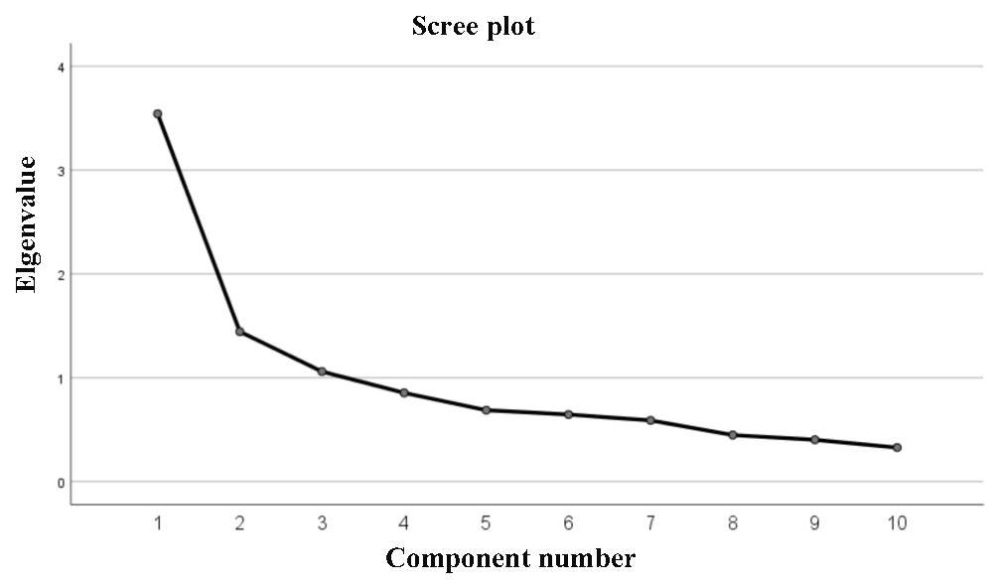

Figure S2 Accuracy estimation of edge weights in the symptom network of patients with ECOPD (A); Stability test of centrality indicators (B)
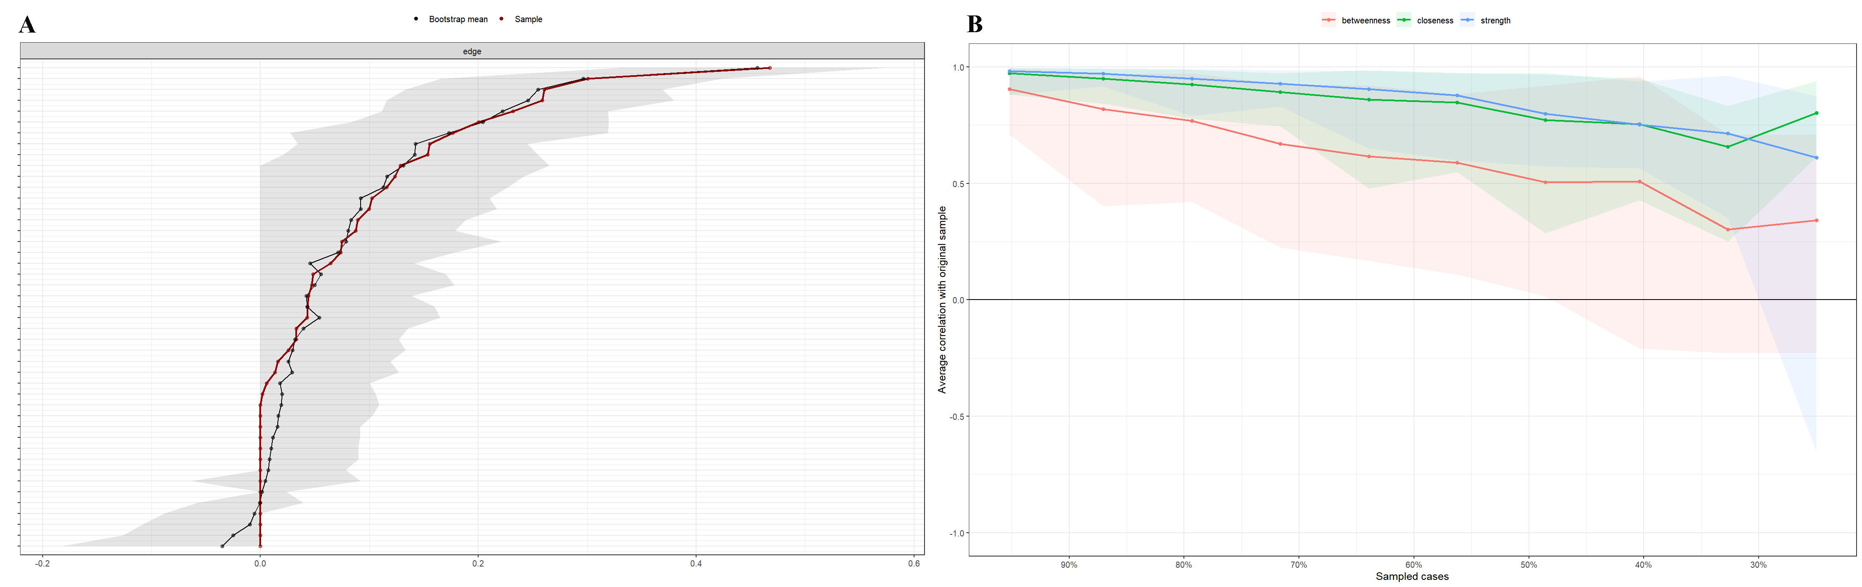

Figure S3 Stability test of centrality indicators of bridge symptoms in the symptom network of patients with ECOPD
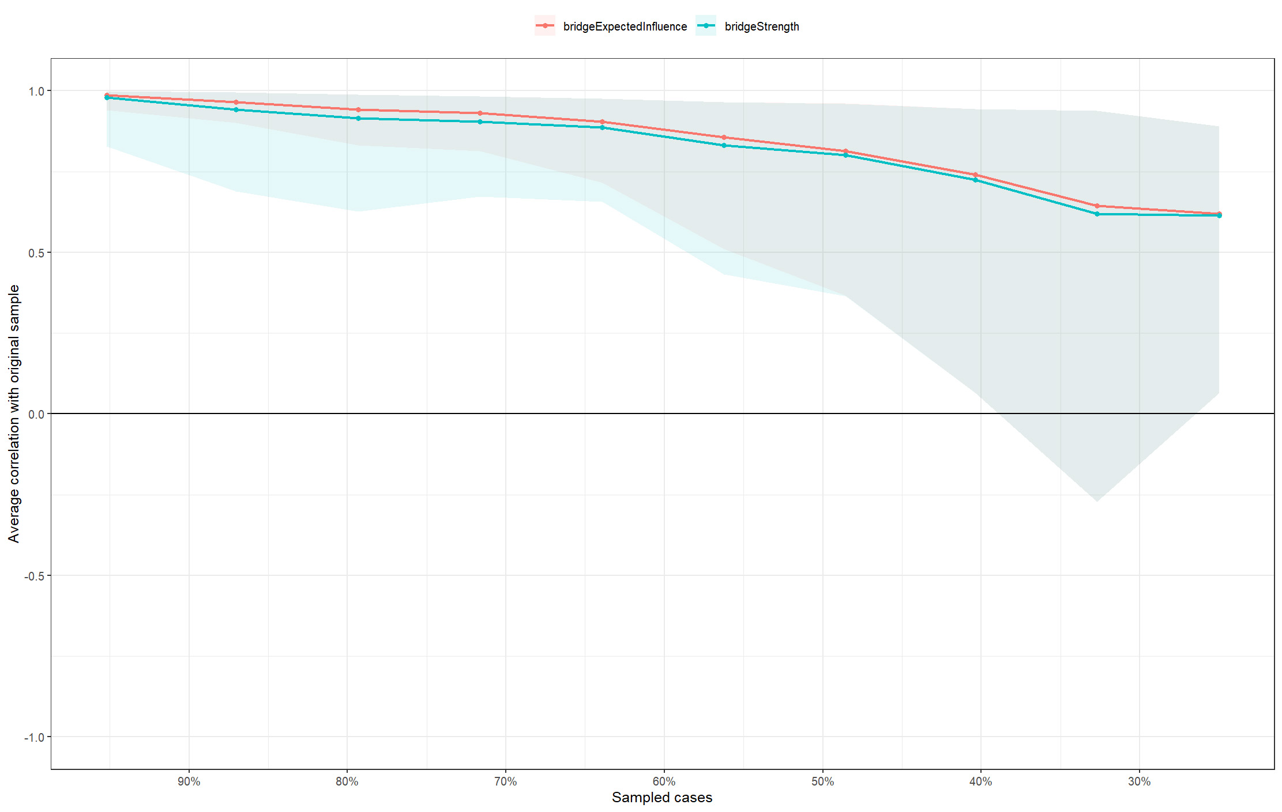
Figure S4 Correlation Heatmap between Severity of Symptoms in Different Subgroups and Auxiliary Examinations. (A-Class1) High-symptom group; (B-Class2) Low-symptom group.
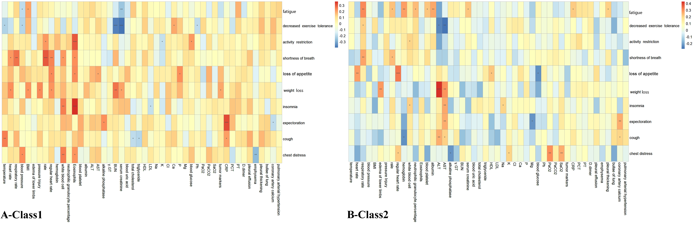
BMI: Body Mass Index; ALT: Alanine Aminotransferase; AST: Aspartate Aminotransferase; γ-GT: Gamma-Glutamyl Transferase; BUN: Blood Urea Nitrogen; HDL: High-Density Lipoprotein; LDL: Low-Density Lipoprotein; CRP: C-Reactive Protein; PCT: Procalcitonin; PT: Prothrombin Time; *p < 0.05, **p < 0.01，***p < 0.001.

