Supporting information

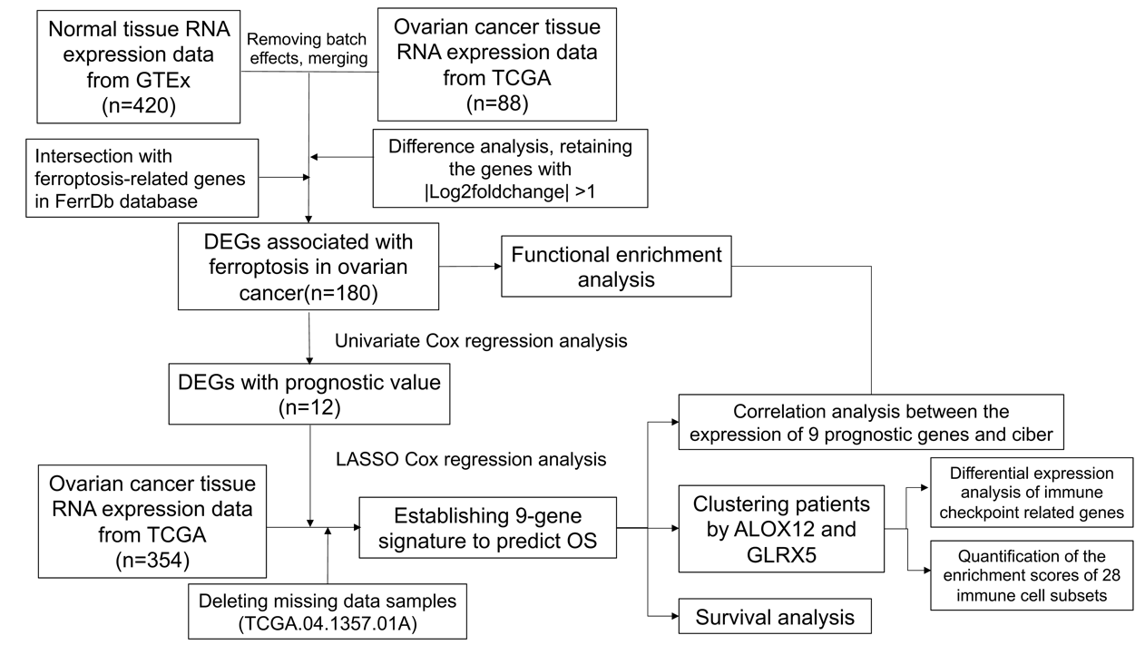
Supplementary Figure S1. The flowchart of our study.

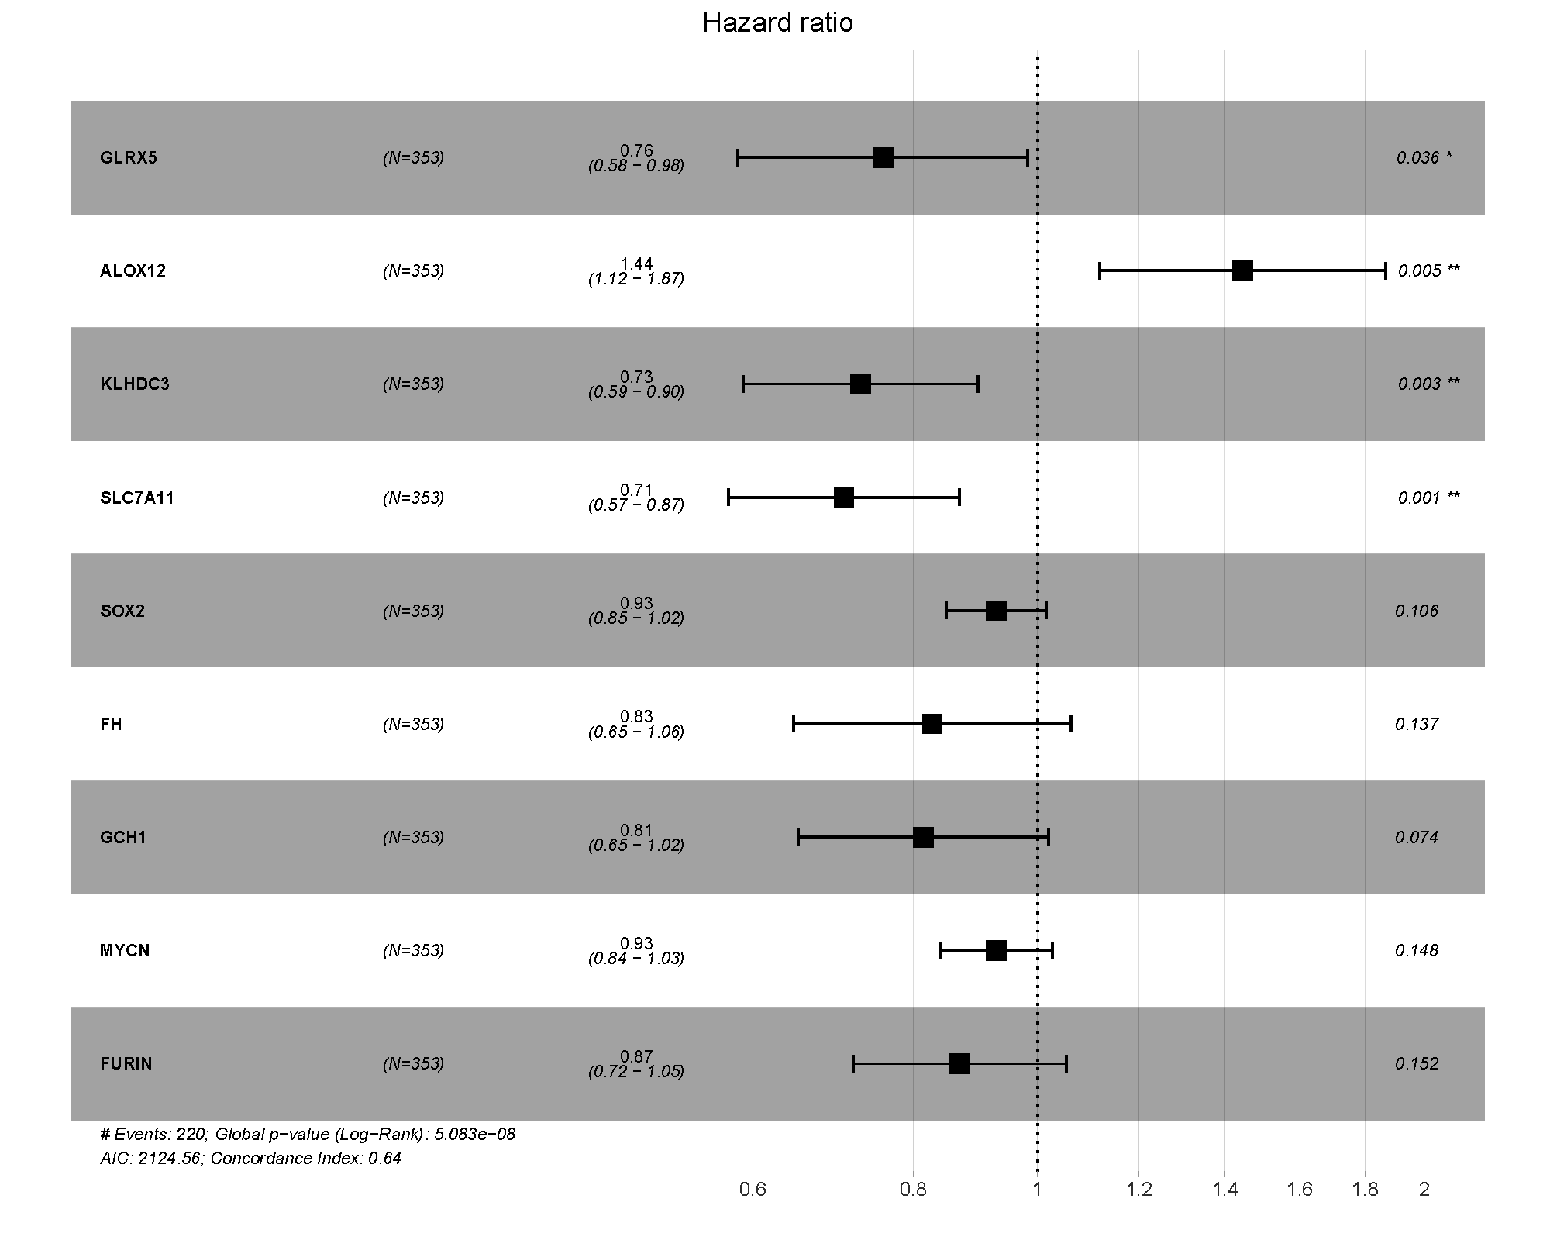
Supplementary Figure S2. The multivariate regression analysis forest plot showed a strong relationship between 9 prognostic ferroptosis-related genes and overall survival. * indicates P value < 0.05, ** indicates P value < 0.01.

Supplementary Table S1. Ferroptosis-related differentially expressed genes in ovarian cancer. Among all genes in the table, VDAC2 and IL6 can both drive and suppress the ferroptosis, so VDAC2 and IL6 belong to the driver column and also to the suppressor column.
Driver | Suppressor | Marker
PTPN6 | MUC1 | CHAC1
AQP5 | RRM2 | GPX4
CDKN2A | ETV4 | FTH1
CIRBP | CDH1 | HSPB1
MYB | KIF20A | TF
NRAS | PDK4 | TFRC
IDO1 | CP
CFL1 | LCN2
YTHDC2 | IDH2
AMN | GALNT14
ATM | TFAP2A
TSC1 | MT1G
BID | HCAR1
GABARAPL1 | PROM2
GRIA3 | NR4A1
CCDC6 | ARF6
SLC38A1 | VDR
NR1D1 | OTUB1
KLF2 | CA9
TRIM46 | TYRO3
CHAC1 | MGST1
MAP3K11 | ARNTL
DDR2 | NQO1
LPIN1 | CISD2
CTSB | PARP1
TFR2 | TERT
MIB2 | EZH2
IL1B | CDC25A
TRIM26 | CDKN1A
CPEB1 | COPZ1
CYBB | FNDC5
DCAF7 | PRDX6
CD82 | AKR1C1
MDM4 | SUV39H1
FBXW7 | MEF2C
LIFR | PARP12
MYCN | TXN
CDCA3 | TFAM
CDO1 | RICTOR
TNFAIP3 | PARP9
KEAP1 | TRIB2
ACVR1B | PARP6
ATG3 | GLRX5
PPARG | ABHD12
MMD | GPX4
ULK2 | SESN2
NCOA4 | PLA2G6
ALOX5 | SLC7A11
ULK1 | VDAC2
ALOXE3 | ADAMTS13
PEX10 | FTH1
SLC7A11 | NEDD4L
VDAC2 | FANCD2
LPCAT3 | AKT1S1
GSK3B | HELLS
FOXO4 | NT5DC2
TTPA | FH
NOX4 | PRDX1
SLC11A2 | PTPN18
SNCA | PML
PGD | MLST8
ZEB1 | HMOX1
SLC25A28 | KLHDC3
ALOX12B | CISD1
GSTZ1 | SLC16A1
HMOX1 | TP53
HDDC3 | FURIN
PEX2 | GDF15
TP53 | P4HB
KDM6B | PROK2
ACADSB | CAV1
LGMN | AKR1C2
MIB1 | HSPB1
MIOX | HSF1
KRAS | SOX2
CYGB | FTL
ADAM23 | TP63
PRKCA | ECH1
EPAS1 | PARP14
IFNG | MS4A15
TF | GCH1
FADS1 | RARRES2
NOX1 | NEDD4
ALOX12 | NOS2
TFRC | TF
EGR1 | FGF21
CYP4F8 | CD44
IL6 | ZFP36
FLT3 | TFRC
ALOX15 | IL6
IFNA13 | ADIPOQ
IFNA6 | GSTM1
LCE2C
IFNA5
IFNA21

