Supplementary Figure 1
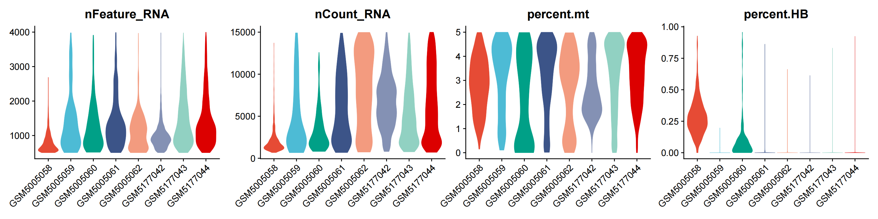
Violin Plots of Pre-Quality-Control Metrics (nFeature_RNA, nCount_RNA, percent.mt, percent.HB) for Individual Samples

Supplementary Figure 2

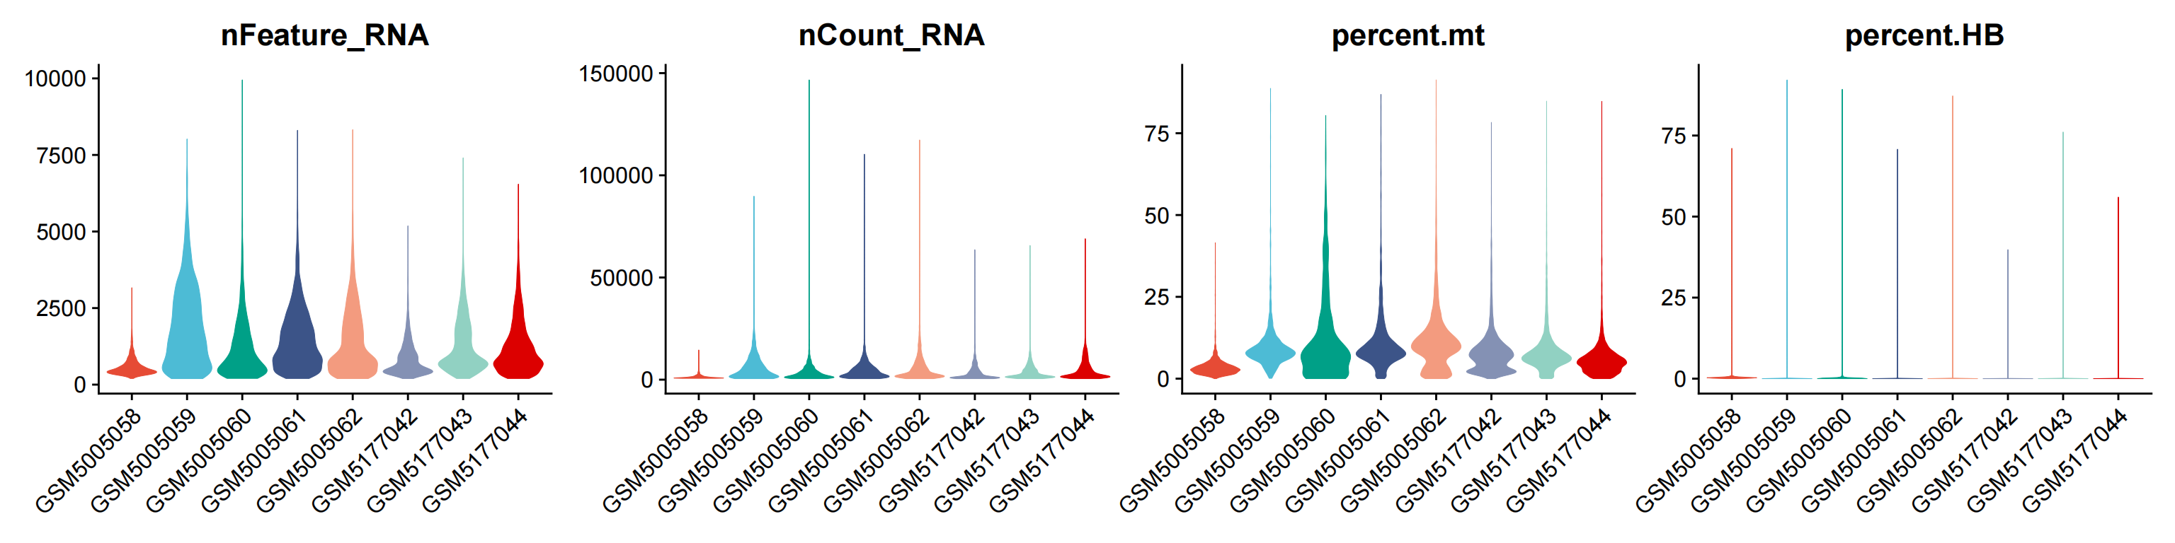
Extended Violin Plots of Post-Quality-Control Metrics for Additional Datasets (nFeature_RNA, nCount_RNA, percent.mt, percent.HB)

Supplementary Table 1

Gene Category | Gene Symbols
Macrophage-Associated Genes | SRGN, CTSS, LCP1, PLEK, LAPTM5, FTL, CD14, FCER1G, IL1B, C1QA, HLA-DMA, MMP9, RGS2, C1QC, G0S2, CXCL8, GZMB, C1QB, BCL2A1, HLA-DRA, CXCL3, PTGS2
Mitochondrial-Associated Genes | CYP24A1, FAHD1, PRDX4, GLDC, BNIP3, UNG, CBR3, UCP2, TMEM205, SLC25A43, ARMCX3, PDK1, BCL2A1, IFI27
Table 1. Differentially Expressed Macrophage- and Mitochondrial-Related Genes in Periodontitis

