Lactate ameliorates kainic acid-induced neuroinflammation and cognitive impairment via the chemokine signaling pathway in mice

Supplemental data

Supplemental figure 1. Cell viability of HT22 cells incubated with lactate at different concentrations (0, 1, 5, 10 and 20 mM) for 24 h (n=5 at each concentration). The data are presented as means ± SDs. Significance was determined by one-way ANOVA (****P<0.0001).

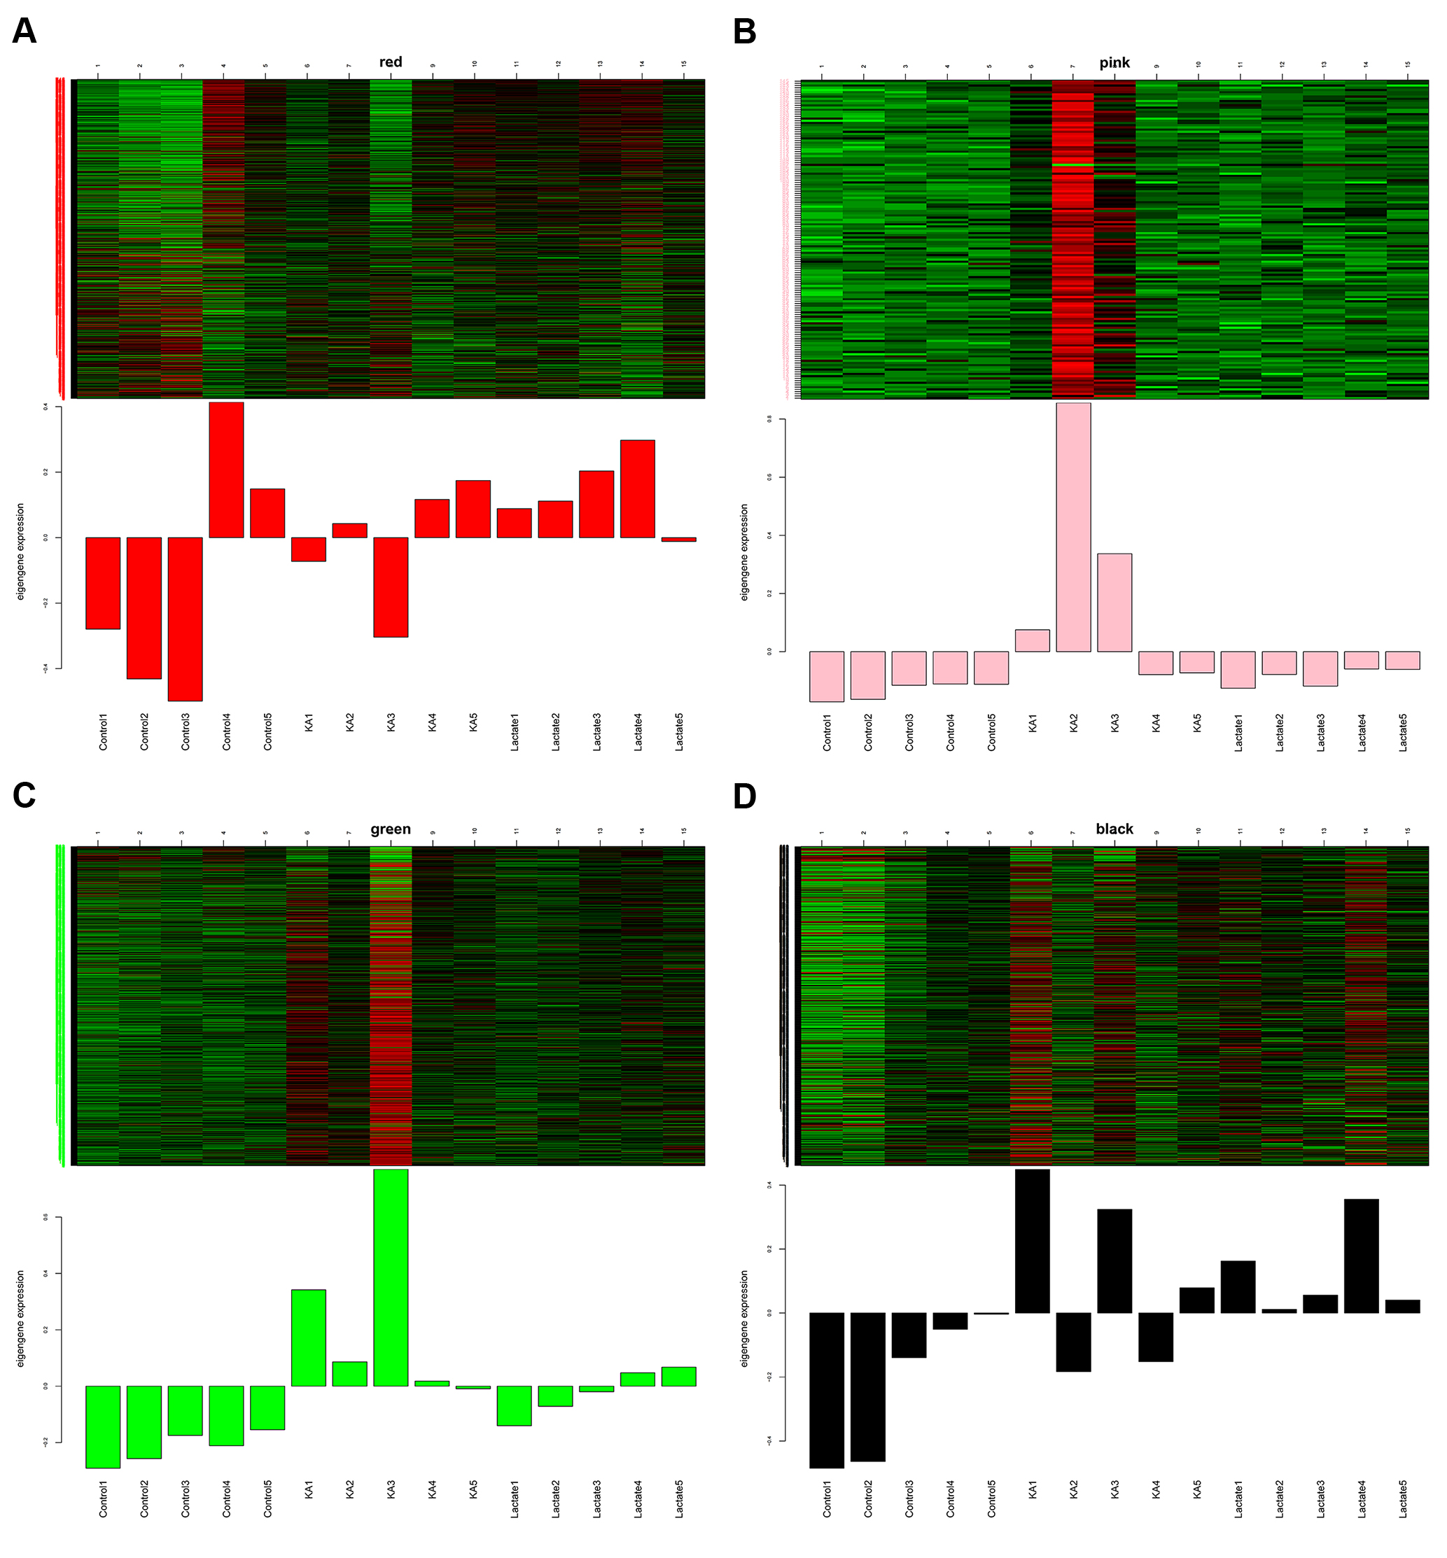
Supplemental figure 2. Heat maps and bar plots of eigengenes in red (A), pink (B), green (C) and black (D) modules.

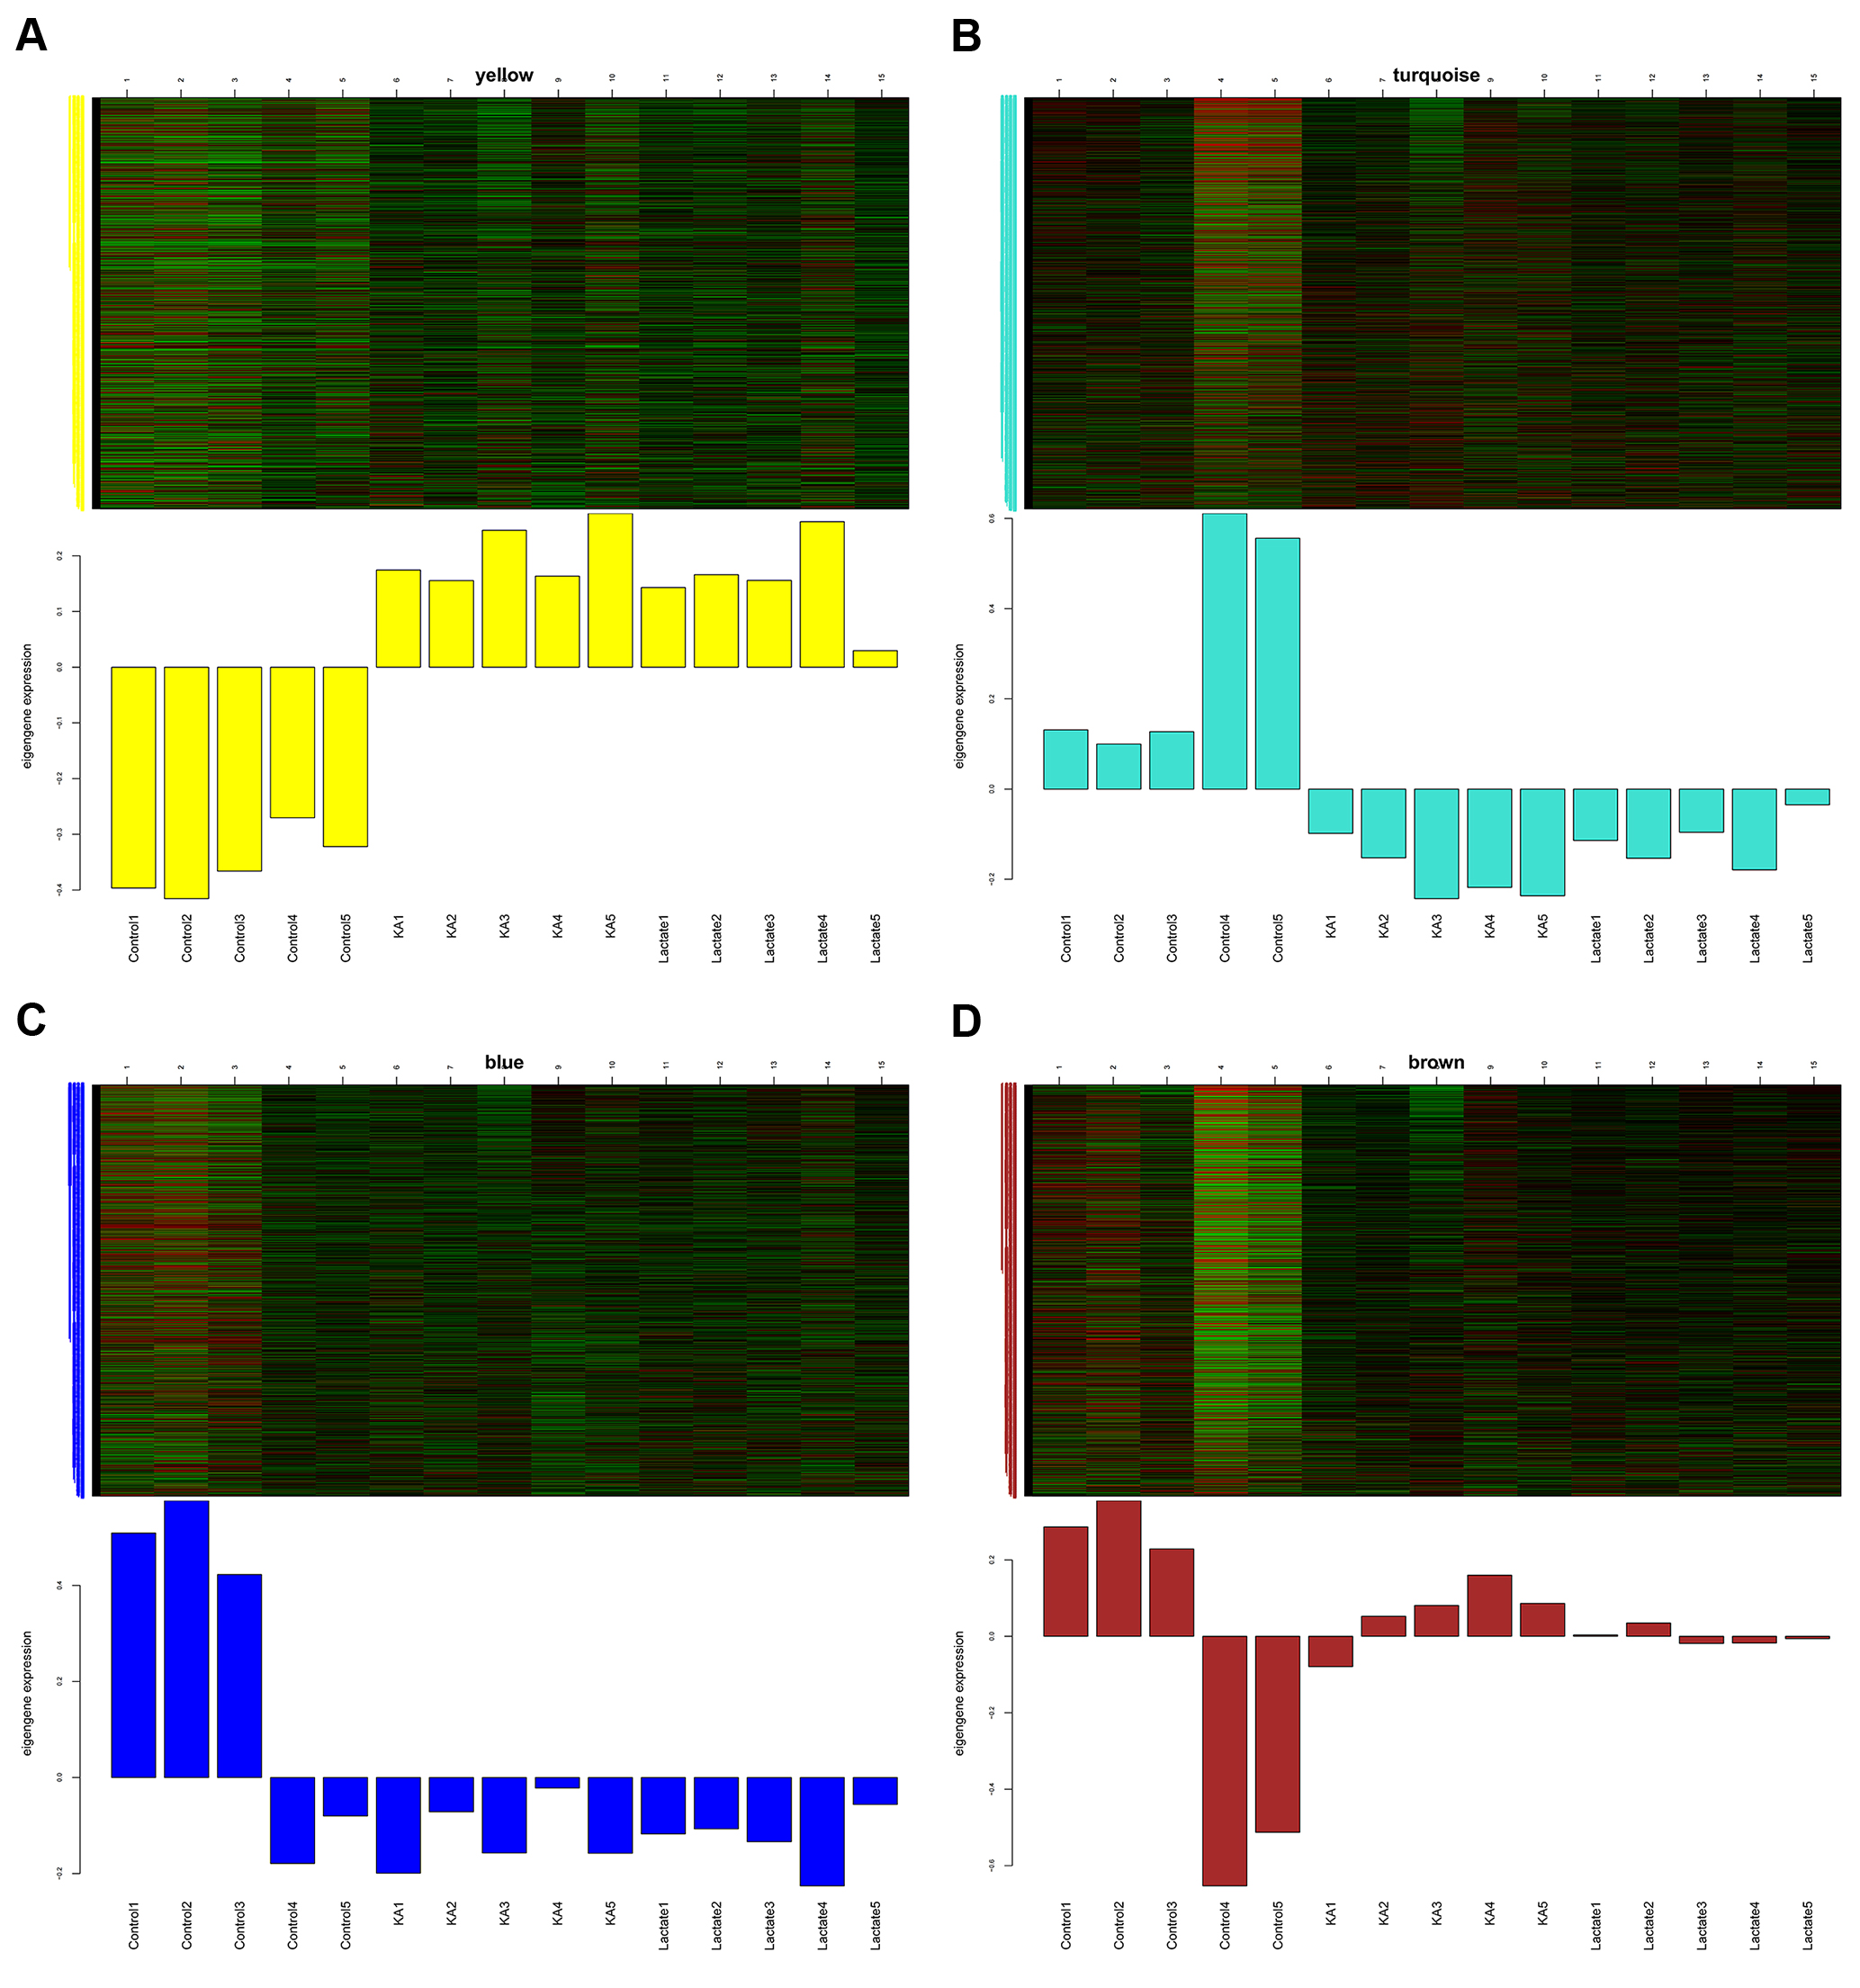
Supplemental figure 3. Heat maps and bar plots of eigengenes in yellow (A), turquoise (B), blue (C) and brown modules (D).

