Supplementary materials

Figure S1 Representative gating strategy of primary monocytes in isolate

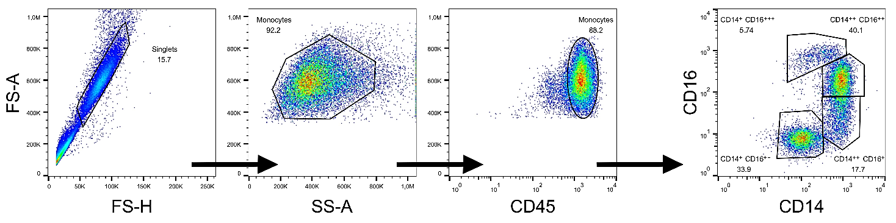
Figure S2 Representative gating strategy of primary monocytes after 24 h of incubation.

Figure S3 Viability and NLRP3 activity of THP1-null cells in the presence of TiO₂ without priming.
Notes: Viability was assessed by (A) LDH assay with Lysis buffer as 100% positive control and (B) WST-1 assay. (C) IL-1β was evaluated using reporter cell-based assays. Data were analyzed separately according to each corresponding control without TiO₂ treatment (RPMI and MDP) and are reported as median with interquartile range. *** p < 0.001, ** p < 0.01. Results were obtained from three independent experiments with three replicates each, n = 9.
Abbreviations: LDH, lactate dehydrogenase; WST-1, water-soluble tetrazolium salt; LB, lysis buffer; IL, interleukin; LPS, lipopolysaccharide; MDP, muramyl dipeptide; PC, positive control

Figure S4 Cytokines response of primary monocytes after 24 h of incubation with TiO_{2.}
Notes: (A) IL-6 and TNF-α released by monocytes were detected using HEK-Blue™ IL-6 and HEK-Dual TNF-α reporter cells (San Diego, CA, USA) according to the manufacturer’s instructions. HEK-Blue cells were cultured in DMEM supplemented with 10% heat-inactivated FBS_{LE}; 2 mM GlutaMAX, Normocin (100 μg/mL), and selective antibiotics 250x HEK selection and Zeocin, respectively. For experiments, cells were seeded in the 96-well plate at 5 × 10⁴ cells per well. 20 μL of supernatants from examined monocytes were added, and the samples in a final volume of 0.2 mL were incubated overnight at 37°C in a 5% CO₂. 20 μL of the supernatants were then transferred to 150 μL of QUANTI-Blue™ and the absorbance was measured in a Synergy HTX microplate reader at a wavelength of 630 nm. Data are reported as median with interquartile range. (B) IL-6 and TNF-αl were quantified by Human IL-6 Quantikine ELISA Kit and Human TNF-α Quantikine ELISA Kit (R&D Systems, Minneapolis, MN, USA), respectively. IL-10 was detected using Human IL-10 ELISA Kit, High Sensitivity (Thermo Fisher Scientific, USA). All assays were performed according to the manufacturer’s protocol. Samples were diluted 2-fold. Data are presented as a boxplot from min to max with all points.
Abbreviations: RPMI, negative control; MDP, muramyl dipeptide; IL, interleukin; TNF, tumor necrosis factor; A.c., positive assay control: recombinant rIL-6 and rTNF-α

Figure S5 Monocytes TiO₂-based IL-1β production after MDP priming.
Note: Monocytes were primed for 1 h or 3 h by MDP (5 µg/mL) and after careful washing by RPMI, cells were exposed to TiO₂ (120 µg/mL) for another 24 h. IL-1β in supernatants was evaluated using HEK-Blue IL-1β reporter cells. Results were obtained from two independent experiments/donors with three replicates each, n = 6. Data are reported as median with interquartile range with *** p < 0.01 and * p < 0.05 highlighting the statistical significance as compared to corresponding control without TiO₂.
Abbreviations: RPMI, negative control
Figure S6 Viability and NLRP3 activity of THP1-null cells in the presence of TiO₂ after priming.
Notes: Viability was assessed by (A) LDH assay with Lysis buffer as 100% positive control and (B) WST-1 assay. (C) IL-1β was evaluated using reporter cell-based assays. Results were obtained from three independent experiments with three replicates each, n = 9 and data were analyzed separately according to each corresponding control without TiO₂ treatment (RPMI and MDP) and are reported as median with interquartile range with *** p < 0.001, ** p < 0.01 highlighting the statistical significance as compared to corresponding control without TiO₂ (RPMI) and ##p < 0.01, ###p < 0.001 as compared to corresponding control without TiO₂ (MDP). (D) Cells were exposed to TiO₂, MDP, or their mixture for 24 h in the presence of the NOD2, NLRP3, their mixture, or AIM2 inhibitors GSK717, MCC950, GSK717+ MCC950 and A151, respectively. Results were obtained from two independent experiments with three replicates each, n = 6 and data are reported as median with interquartile range with *** p < 0.001 highlighting statistical significance compared to the unstimulated control (RPMI), and ###p < 0.001 highlighting statistical significance compared to the stimulated control without inhibitor.
Abbreviations: RPMI, negative control; MDP, muramyl dipeptide; LDH, lactate dehydrogenase; WST-1, water-soluble tetrazolium salt; LB, lysis buffer; IL, interleukin; LPS, lipopolysaccharide; PC, positive control

