Supplementary Material

Altered CD73-adenosine signaling linked to infection in patients undergoing hemodialysis
Fangfang Xiang^{1, 2, 3, 4}*,Zhen Zhang¹*, Yuxin Nie¹, Xuesen Cao¹, Yang Li¹, Xiaohong Chen¹, Shaomin Gong¹, Jianzhou Zou¹, Jie Teng¹，Xiaoqiang Ding^{1, 2, 3, 4}and Bo Shen^{1, 2, 3, 4}
¹Department of Nephrology, Zhongshan Hospital, Fudan University, Shanghai, China
²Shanghai Key Laboratory of Renal Disease and Blood Purification, Shanghai, China
³Shanghai Medical Center of Kidney, Shanghai, China.
⁴Shanghai Institute of Kidney and Dialysis, Shanghai, China
*These authors contributed equally

Correspondence: Bo Shen
No.180 Fenglin Road, Xuhui District, Shanghai,China
shen.bo@zs-hosptial.sh.cn

Methods
Cell preparation and flow cytometric analysis
Whole blood samples (100 μL) were obtained from K2-EDTA anticoagulant tubes and stained with an antibody cocktail obtained from Becton Dickinson (BD Biosciences, San Jose, CA, USA) or BioLegend (BL, San Diego, CA, USA). The cocktail contained antibodies against CD45 V500 (BD, clone HI30), CD3 BV421 (BD, clone UCHT1), CD73 FITC (BL, clone AD2), and CD39 APC (BL, clone A1). The samples were examined using a FACSLyric system (BD Biosciences, San Jose, CA, USA), and the data were analyzed using FlowJo Software, version 10.1 (BD Biosciences). The methods employed for the immunophenotyping and gating strategies are detailed in Figure S1.
Figure S1. Flow cytometry analysis to identify T cell subsets.

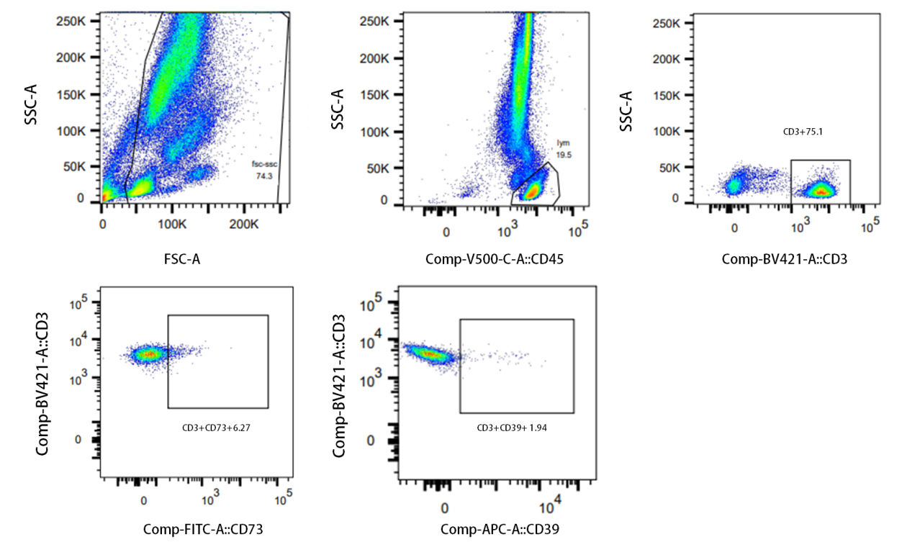

Animals and models of CKD and sepsis
Male Sprague Dawley rats (200 to 250g, 6-7 weeks old) were obtained from Shanghai SLAC Laboratory Anmimal CO., Ltd and maintained in a controlled temperature and humidity with adequate food and water supply.
CKD was induced by 5/6 nephrectomy (Nx). Anesthesia was induced by isoflurane. Laparotomy was performed to expose the left kidney followed by dissection of the adipose tissue and the renal capsule. Both poles were ligated approximately at the 1/3 position; then, the poles were excised. 12 weeks after the first operation, a total right nephrectomy was performed following the same steps described above, in which the right kidney was dissected. The adrenal gland was gently freed and placed back into the abdominal cavity. Following the ligation of the ureter and renal blood vessels, the right kidney was removed. Control animals were subjected to a sham operation, during of which the renal capsule was removed.
Sepsis was induced via cecal ligation and puncture (CLP). After isoflurane anesthesia, a 1.5-cm incision was made to expose the cecum to the abdominal portion. The cecum was ligated at 70% of its total length and perforated with a single puncture midway between the ligation point and tip of the cecum using a 20-gauge needle. Once the needle was removed, extrusion of fecal matter was confirmed. The cecum was returned to its original position and the abdominal incision was closed with sutures. In sham mice, no ligation of the cecum was performed; however, the treatment was administered identically. Antibiotics were not administered.

Blood test
Blood samples were collected via cardiac puncture at the conclusion. The blood samples were centrifuged and the sera were separated and stored at −80 °C. The concentrations of creatinine, urea nitrogen, C-reactive protein (CRP), and beta-2-microglobulin (β2-MG) were determined using enzyme-linked immunosorbent assay (ELISA) kits in accordance with the manufacturer’s instructions (Elabscience Biotechnology Co., Ltd., Wuhan, China). In addition, ELISA kits (MULTI SCIENCE, Shanghai, China) were used to quantify the levels of interleukin-1β (IL-1β), interleukin-2 (IL-2), interleukin-6 (IL-6), tumor necrosis factor-α (TNF-α), and interferon-γ (IFN-γ).

Quantitative reverse transcription polymerase chain reaction
Total RNA was extracted using TRIzol reagent (Invitrogen, Carlsbad, CA, USA), according to the manufacturer’s instructions. Reverse transcription was conducted and cDNA was prepared for amplification. The expression levels of the following genes were quantified: Rattus norvegicus ectonucleoside triphosphate diphosphohydrolase 1 (Entpd1), Rattus norvegicus5′ nucleotidase ecto (Nt5e), and Rattus norvegicus nuclear factor kappa B subunit 1 (Nfkb1). Quantification of the adenosine A2a receptor (Adora2a), adenosine A2B receptor (Adora2b), and purinergic receptor P2X 7 (P2rx7) in Rattus norvegicus was performed using an miRNA Assay Kit (Applied Biosystems, Foster City, CA, USA). Primer sequences are listed in Table S1.mRNA levels were calculated using the comparative cycle threshold (∆∆Ct) method. Relative expression levels were normalized to that of GAPDH.
Table S1. Primer sequences
Name | Forward primer | Reverse primer
Entpd1 | GGCCCAGGACATTCAGGTTT | GGCAGTGGCTGTTGTTGAAG
Nt5e | CACGTGTCCATGTGCATTGT | CCACATGGATTCCACCCACT
Nfkb1 | GATCCTTTCGGAACTGGGCA | GGTATGGGCCATCTGCTGTT
Adora2a | CCATCCCCTTCGCTATCACC | AAGCCATTGTACCGGAGTGG
Adora2b | TACAGACCCCCACCAACTACT | CCAAACCTTTATACCTGAGCGG
P2rx7 | GCGTGAATTACGGCACCATC | AGAACGAGTTCCCCTGCAAA

Indoxyl sulfate and p-cresyl sulfate measurement
Briefly, 100μL of plasma was added to 500μL of an internal standard protein precipitation solution (50 ng/mL hydrochlorothiazide in methanol for IS or 50ng/mL warfarin in methanol for PCS) to precipitate the proteins. Chromatographic separation was conducted on a Venusil XBP Phenyl column (100 × 2.1 mm, 5μm; Bonna-Agela Technologies Inc., Wilmington, DE, USA) with the column temperature maintained at 40 °C. Mobile phase A comprised 2mmol/L ammonium acetate in 0.1% formic acid (v/v). Mobile phase B comprised methanol (MeOH). The mobile phase (A : B = 30 : 70) was delivered at a flow rate of 0.35 mL/min. Mass spectrometric detection was conducted on an API 3000 triple quadrupole instrument (Applied Biosystems, Toronto, ON, Canada) in multiple reaction monitoring (MRM) mode with a spray voltage of -4200V. Data were processed using the Analyst 1.4.1 software package (Applied Biosystems, Toronto, ON, Canada).

Plasmatic quantification of nucleotides
Briefly, the serum sample was thawed on ice, and 50 μL of the sample was mixed with 110 μL methanol (containing 100 ng/mL adenosine-13C5). The mixture was vortexed for 30 s and subsequently centrifuged at 15,000 rpm and 4 °C for 15 min. Quality control samples were obtained by isometrically pooling all prepared samples. UHPLC-MS/MS analysis was conducted using an Agilent 1290 Infinity II UHPLC system with a 6470A Triple Quadrupole mass spectrometer (Santa Clara, CA, United States). The samples were injected onto a Waters UPLC BEH Amide column (100 mm × 2.1 mm, 1.7 μm) at a flow rate of 0.2 mL/min. The mobile phase comprised two solvents, A and B, which were mixed at a 90:10 ratio. Both solvents contained 10 mM ammonium acetate (pH9; regulated by ammonium hydroxide). Chromatographic separation was conducted using a gradient elution program: the initial mobile phase composition was 90% B for the first minute, followed by a gradient elution program comprising 90% B-85% B for 4 min, 85% B-80% B for 8 min, 80%B-65%B for 7 min, 65%B-40%B for 2 min, and 40%B for 2 min. The gradient was then returned to the initial composition after 17.1 minutes, and the analysis continued for a total of 20 min. The eluted analytes were ionized using an electrospray ionization source in positive mode (ESI+). The temperature of the source drying gas and sheath gas was set to 300°C. The flow rates of the source drying and sheath gases were set to 5 and 11 L/min, respectively. The nebulizer pressure was set at 45 psi and the capillary voltage was 4000 V. The optimized MRM transition (precursor > product), fragmentor, and collision energies were determined using the MRM. Agilent MassHunter software, version B.08.00, was used for instrument control and data acquisition.

Table S2.Demographic data of the study population.
Variable | Mean ± SD/median (interquartile range)
Age, years | 59.8 ±13.7
Time on HD, months | 56(22,105)
Male, % | 238(60.3%)
Diabetes mellitus, % | 103(26.1%)
CVD history, % | 154(39.0%)
Hypertension, % | 292(73.9%)
BMI, kg/m² | 21.9 ± 3.5
Kt/Vurea | 1.22 ± 0.23
Hemoglobin, g/L | 115.3 ± 15.3
White blood cell, ×10⁹/L | 6.40 ± 1.98
Lymphocytes, ×10⁹/L | 1.1 ± 0.4
Albumin, g/L | 39.8 ± 3.3
Prealbumin, mg/L | 306.0 ± 73.2
Creatinine, μmol/L | 980.1 ± 276.0
Uric acid, mmol/L | 438.0 ± 90.7
Calcium, mmol/L | 2.28 ± 0.23
Phosphorus, mmol/L | 2.19 ± 0.68
Total cholesterol, mmol/L | 3.88 ± 1.02
Triglyceride, mmol/L | 1.64(1.09,2.52)
LDL-C, mmol/L | 2.04 ± 0.83
HDL-C, mmol/L | 0.97 ± 0.32
Homocysteine, μmol/L | 30.3 (22.7, 43.2)
NT-proBNP, pg/mL | 4229.0 (1912.3, 9868.0)
iPTH, pg/mL | 283.0 (185.5, 446.5)
Ferritin, pg/mL | 161.5 (73.1, 341.0)
hsCRP, mg/L | 4.0 (1.3,12.2)
TNF-α, pg/mL | 18.0 (15.2, 21.1)
sIL-2R, U/mL | 1184.3 ± 458.5
IL-6, pg/mL | 4.3 (2.3, 7.8)
BMI: Body mass index; CMV: cytomegalovirus; CVD: cardiovascular disease; HD: hemodialysis; HDL-C: high-density lipoprotein cholesterol; hsCRP: high-sensitivity C-reactive protein; IL-6: interleukin 6; iPTH: intact parathyroid hormone; LDL-C: low-density lipoprotein cholesterol; NT-proBNP: N-terminal pro-brain natriuretic peptide; SD: standard deviation; sIL-2R: soluble interleukin-2 receptor; TNF-α: tumor necrosis factor-α.

