Supplementary Tables
Supplementary Table S1. The instrumental SNP variables for CVD on COPD
chr | position | rsid | standardized beta | PVE | F
1 | 3395467 | rs883678 | 0.008276375 | 6.85E-05 | 31.080
1 | 55293465 | rs17414716 | -0.009255238 | 8.57E-05 | 38.866
1 | 56487792 | rs61772590 | 0.008422456 | 7.09E-05 | 32.187
1 | 109272258 | rs4970834 | -0.008097015 | 6.56E-05 | 29.747
1 | 222746406 | rs2378606 | 0.008297982 | 6.89E-05 | 31.242
2 | 43459068 | rs2046916 | -0.008665539 | 7.51E-05 | 34.071
2 | 62663087 | rs1872790 | 0.008245739 | 6.80E-05 | 30.850
2 | 202779814 | rs56193304 | 0.008248337 | 6.80E-05 | 30.870
2 | 217820904 | rs2571434 | -0.008136501 | 6.62E-05 | 30.038
3 | 138352059 | rs13324341 | 0.008261904 | 6.83E-05 | 30.971
4 | 121511765 | rs11939834 | 0.008118614 | 6.59E-05 | 29.906
4 | 145401038 | rs11100877 | 0.008128264 | 6.61E-05 | 29.977
4 | 147117893 | rs4835377 | -0.010728095 | 0.000115079 | 52.221
4 | 147508331 | rs139452637 | 0.011200862 | 0.000125443 | 56.925
5 | 108753488 | rs6873068 | -0.008094515 | 6.55E-05 | 29.729
5 | 123335782 | rs9799914 | -0.008799264 | 7.74E-05 | 35.131
5 | 143122624 | rs11167804 | 0.00848107 | 7.19E-05 | 32.636
6 | 12912920 | rs9381494 | 0.009101772 | 8.28E-05 | 37.588
6 | 36676721 | rs3829964 | -0.009536384 | 9.09E-05 | 41.263
6 | 133905009 | rs162185 | -0.009468406 | 8.96E-05 | 40.677
6 | 160187772 | rs16891156 | 0.01054258 | 0.000111133 | 50.430
6 | 160289819 | rs3127580 | 0.009133424 | 8.34E-05 | 37.850
6 | 160424003 | rs12209391 | 0.009197076 | 8.46E-05 | 38.379
7 | 19006554 | rs6963129 | 0.008456016 | 7.15E-05 | 32.444
7 | 106773623 | rs2392929 | 0.008386239 | 7.03E-05 | 31.910
7 | 150993088 | rs3918226 | 0.010773785 | 0.000116061 | 52.666
8 | 20009934 | rs11986942 | -0.008416121 | 7.08E-05 | 32.138
8 | 22198046 | rs4072420 | 0.008665719 | 7.51E-05 | 34.073
9 | 21790756 | rs1542076 | -0.008486574 | 7.20E-05 | 32.679
9 | 21973858 | rs13288666 | 0.008536055 | 7.29E-05 | 33.061
10 | 43994981 | rs4948592 | 0.010128076 | 0.000102567 | 46.543
10 | 89249122 | rs2250644 | 0.008577954 | 7.36E-05 | 33.386
10 | 98263602 | rs55917128 | -0.008220187 | 6.76E-05 | 30.659
11 | 9301806 | rs4537761 | 0.008138704 | 6.62E-05 | 30.054
11 | 116778201 | rs964184 | -0.008669904 | 7.52E-05 | 34.106
12 | 20740118 | rs2037154 | 0.008398327 | 7.05E-05 | 32.002
12 | 111741667 | rs4766897 | -0.009684138 | 9.38E-05 | 42.552
13 | 110152462 | rs650724 | -0.010267696 | 0.000105414 | 47.835
13 | 110340843 | rs7335876 | 0.009387276 | 8.81E-05 | 39.983
14 | 99668969 | rs12436072 | 0.008358199 | 6.99E-05 | 31.697
14 | 99853261 | rs72710004 | 0.008296556 | 6.88E-05 | 31.232
14 | 99956525 | rs7143424 | 0.009131632 | 8.34E-05 | 37.835
15 | 78778753 | rs12913260 | -0.010697566 | 0.000114425 | 51.924
15 | 78847028 | rs56225615 | 0.009993284 | 9.99E-05 | 45.312
15 | 89358116 | rs7180160 | -0.008384423 | 7.03E-05 | 31.897
15 | 90877710 | rs2071410 | 0.008216709 | 6.75E-05 | 30.633
16 | 75283677 | rs59686216 | 0.008959106 | 8.03E-05 | 36.419
17 | 2215212 | rs148183711 | 0.009586069 | 9.19E-05 | 41.694
18 | 48989546 | rs9945890 | 0.008163913 | 6.66E-05 | 30.241
19 | 11155010 | rs10423196 | -0.008639514 | 7.46E-05 | 33.867
19 | 18479133 | rs11670056 | 0.008295744 | 6.88E-05 | 31.225
19 | 44919589 | rs56131196 | 0.010173622 | 0.000103492 | 46.962
20 | 34624251 | rs6142206 | 0.008565686 | 7.34E-05 | 33.291
20 | 59148075 | rs6026728 | 0.008670498 | 7.52E-05 | 34.110
21 | 34240460 | rs146711790 | 0.008403587 | 7.06E-05 | 32.043
Abbreviations: SNP, single nucleotide polymorphism; Chr, chromosome; CVD, cardiovascular disease; COPD, chronic obstructive pulmonary disease; beta, effect size; PVE, the proportion of variance explained by individual SNP.

Supplementary Table S2. The instrumental SNP variables for T2DM on COPD
chr | position | rsid | standardized beta | PVE | F
1 | 39568233 | rs58302493 | 0.009028123 | 8.15E-05 | 34.227
1 | 109604699 | rs17024258 | 0.009247379 | 8.55E-05 | 35.910
1 | 119894128 | rs35273427 | 0.008419797 | 7.09E-05 | 29.770
1 | 150712010 | rs116279971 | -0.008585703 | 7.37E-05 | 30.955
1 | 213972388 | rs340882 | 0.008916188 | 7.95E-05 | 33.384
1 | 219619710 | rs12133396 | -0.008422666 | 7.09E-05 | 29.790
1 | 229537208 | rs348330 | -0.009076028 | 8.24E-05 | 34.591
2 | 651365 | rs2867113 | -0.008848698 | 7.83E-05 | 32.880
2 | 27348981 | rs112796438 | 0.008533714 | 7.28E-05 | 30.581
2 | 58967099 | rs12713390 | -0.008690253 | 7.55E-05 | 31.713
2 | 59071023 | rs112789204 | -0.008440966 | 7.12E-05 | 29.920
2 | 60359572 | rs243018 | 0.010696521 | 0.000114402 | 48.046
2 | 164875154 | rs34357955 | 0.008924664 | 7.96E-05 | 33.447
2 | 184132693 | rs2369204 | 0.00849613 | 7.22E-05 | 30.312
2 | 226001510 | rs6760762 | -0.009343102 | 8.73E-05 | 36.657
3 | 12102136 | rs146058284 | -0.01017782 | 0.000103577 | 43.499
3 | 12371840 | rs2120825 | -0.009277722 | 8.61E-05 | 36.146
3 | 12409339 | rs147667955 | 0.00858265 | 7.37E-05 | 30.933
3 | 23182126 | rs55767896 | 0.008460593 | 7.16E-05 | 30.059
3 | 23453005 | rs7610906 | -0.010013477 | 0.000100259 | 42.106
3 | 42827724 | rs7653015 | 0.008509582 | 7.24E-05 | 30.408
3 | 47843463 | rs319694 | 0.008470158 | 7.17E-05 | 30.127
3 | 123303582 | rs4072921 | -0.008511094 | 7.24E-05 | 30.419
3 | 132034453 | rs2178385 | 0.008862998 | 7.85E-05 | 32.986
3 | 138009942 | rs3755752 | 0.008627895 | 7.44E-05 | 31.260
3 | 185761945 | rs6789741 | 0.009482193 | 8.99E-05 | 37.756
3 | 186960148 | rs6444188 | 0.00868311 | 7.54E-05 | 31.661
4 | 6302559 | rs1046319 | 0.01411538 | 0.000199204 | 83.668
4 | 45315141 | rs76699792 | 0.009440289 | 8.91E-05 | 37.424
4 | 84436245 | rs962305 | 0.008795769 | 7.74E-05 | 32.488
4 | 95244385 | rs35780120 | 0.008912265 | 7.94E-05 | 33.354
4 | 102764018 | rs223485 | -0.009055966 | 8.20E-05 | 34.438
4 | 152599323 | rs6813195 | -0.008514619 | 7.25E-05 | 30.444
4 | 184805394 | rs4862423 | 0.008941902 | 8.00E-05 | 33.576
5 | 14764073 | rs258217 | -0.009256876 | 8.57E-05 | 35.983
5 | 77131486 | rs6878122 | -0.008829733 | 7.80E-05 | 32.739
5 | 102698908 | rs74566838 | 0.010621356 | 0.0001128 | 47.373
5 | 134537882 | rs329126 | 0.008691536 | 7.55E-05 | 31.722
6 | 7231610 | rs9379084 | -0.010667666 | 0.000113786 | 47.787
6 | 20585270 | rs191604770 | 0.009177085 | 8.42E-05 | 35.366
6 | 21092344 | rs7762964 | -0.00943376 | 8.90E-05 | 37.372
6 | 31346466 | rs7453967 | 0.010105488 | 0.00010211 | 42.883
6 | 33113855 | rs11751659 | -0.010444366 | 0.000109073 | 45.808
6 | 43858944 | rs9472144 | 0.009085335 | 8.25E-05 | 34.662
6 | 107112196 | rs1665901 | -0.008898049 | 7.92E-05 | 33.248
6 | 117675468 | rs80196932 | -0.008573085 | 7.35E-05 | 30.864
6 | 127079620 | rs2800719 | -0.008681852 | 7.54E-05 | 31.652
6 | 131629658 | rs3843995 | 0.009144904 | 8.36E-05 | 35.118
7 | 14999874 | rs1002061 | -0.00873614 | 7.63E-05 | 32.049
7 | 28156794 | rs849135 | -0.012749113 | 0.000162513 | 68.255
7 | 44192179 | rs2971669 | 0.009205754 | 8.47E-05 | 35.587
7 | 45322488 | rs12702134 | -0.008416944 | 7.08E-05 | 29.750
7 | 73409331 | rs42128 | 0.008726875 | 7.62E-05 | 31.981
7 | 74781899 | rs800980 | -0.008553356 | 7.32E-05 | 30.722
7 | 102319364 | rs79356898 | 0.008484147 | 7.20E-05 | 30.227
7 | 102982217 | rs73714541 | -0.009695904 | 9.40E-05 | 39.478
7 | 130750422 | rs287621 | -0.009249826 | 8.56E-05 | 35.929
7 | 150840547 | rs62492368 | 0.008629876 | 7.45E-05 | 31.274
7 | 157128326 | rs6459732 | -0.00912071 | 8.32E-05 | 34.933
8 | 41577898 | rs62509769 | -0.01011811 | 0.000102365 | 42.991
8 | 94955610 | rs481887 | 0.009365946 | 8.77E-05 | 36.836
8 | 115673262 | rs2205256 | -0.009464829 | 8.96E-05 | 37.618
8 | 127699497 | rs17772814 | -0.009502457 | 9.03E-05 | 37.918
9 | 21457673 | rs140262850 | -0.008577967 | 7.36E-05 | 30.899
9 | 22020494 | rs490005 | -0.009362771 | 8.77E-05 | 36.811
9 | 22128710 | rs12347779 | 0.009844548 | 9.69E-05 | 40.697
9 | 79290675 | rs17791513 | -0.009040177 | 8.17E-05 | 34.318
9 | 81696885 | rs9410573 | -0.00922722 | 8.51E-05 | 35.753
9 | 98728784 | rs380857 | -0.008712936 | 7.59E-05 | 31.879
9 | 101108180 | rs7019003 | 0.008801299 | 7.75E-05 | 32.529
9 | 117657603 | rs1041293 | 0.008830793 | 7.80E-05 | 32.747
9 | 133278431 | rs651007 | -0.008780362 | 7.71E-05 | 32.374
9 | 136362314 | rs3829109 | -0.009698009 | 9.40E-05 | 39.495
10 | 12281465 | rs7069060 | 0.012703143 | 0.000161343 | 67.764
10 | 68069886 | rs10997925 | 0.008525634 | 7.27E-05 | 30.523
10 | 68632336 | rs190611672 | 0.008686723 | 7.55E-05 | 31.687
10 | 69294953 | rs36007468 | 0.008571819 | 7.35E-05 | 30.855
10 | 79182874 | rs12571751 | -0.008757785 | 7.67E-05 | 32.208
10 | 97332009 | rs945189 | -0.008947537 | 8.01E-05 | 33.619
10 | 112900284 | rs184953419 | -0.012727529 | 0.000161963 | 68.024
10 | 113061202 | rs4918788 | 0.008651277 | 7.48E-05 | 31.429
10 | 113603905 | rs58315919 | 0.008637519 | 7.46E-05 | 31.329
10 | 114468384 | rs55651341 | -0.008738939 | 7.64E-05 | 32.069
11 | 983626 | rs78721871 | 0.009164289 | 8.40E-05 | 35.267
11 | 2705955 | rs86392 | 0.009075201 | 8.24E-05 | 34.585
11 | 2887524 | rs445084 | 0.00924632 | 8.55E-05 | 35.901
11 | 17385085 | rs10766395 | -0.01064819 | 0.000113371 | 47.613
11 | 47559884 | rs117677903 | 0.008457025 | 7.15E-05 | 30.034
11 | 69201348 | rs10792030 | -0.008666751 | 7.51E-05 | 31.542
11 | 72816182 | rs138454321 | -0.008501891 | 7.23E-05 | 30.353
11 | 92973009 | rs7951037 | 0.011514048 | 0.000132555 | 55.671
11 | 128170915 | rs10893827 | -0.009586817 | 9.19E-05 | 38.594
12 | 942701 | rs12581771 | 0.008488397 | 7.20E-05 | 30.257
12 | 4052829 | rs147663909 | -0.016244801 | 0.000263823 | 110.816
12 | 4218982 | rs11063044 | -0.012379719 | 0.000153234 | 64.357
12 | 4294710 | rs3217893 | -0.012903131 | 0.000166463 | 69.914
12 | 6630331 | rs35104374 | -0.009167273 | 8.40E-05 | 35.290
12 | 27802138 | rs71274822 | -0.008510999 | 7.24E-05 | 30.418
12 | 49847230 | rs11169176 | 0.008821002 | 7.78E-05 | 32.675
12 | 65782920 | rs73131951 | 0.009461671 | 8.95E-05 | 37.593
12 | 71117527 | rs1705219 | -0.010390924 | 0.000107959 | 45.340
12 | 97456812 | rs76369685 | -0.008996644 | 8.09E-05 | 33.989
12 | 108224853 | rs3764002 | -0.008413429 | 7.08E-05 | 29.725
12 | 120631398 | rs4767921 | 0.008840322 | 7.81E-05 | 32.818
12 | 121524144 | rs28644184 | 0.010562566 | 0.000111555 | 46.850
12 | 124055244 | rs825458 | 0.009002072 | 8.10E-05 | 34.030
13 | 32980449 | rs2858980 | -0.008632369 | 7.45E-05 | 31.292
13 | 50519978 | rs9316500 | -0.011709272 | 0.000137088 | 57.575
13 | 80136687 | rs112373019 | 0.010596682 | 0.000112277 | 47.153
14 | 29622926 | rs4981713 | 0.00843252 | 7.11E-05 | 29.860
14 | 32823537 | rs2239647 | -0.00878354 | 7.71E-05 | 32.398
14 | 69083247 | rs11158782 | 0.008956042 | 8.02E-05 | 33.683
14 | 79466480 | rs111908763 | 0.008501391 | 7.23E-05 | 30.350
14 | 100788835 | rs73347525 | -0.010038678 | 0.000100765 | 42.318
15 | 38779738 | rs11857063 | 0.008469967 | 7.17E-05 | 30.126
15 | 62090956 | rs4502156 | -0.009736769 | 9.48E-05 | 39.811
15 | 77431061 | rs34981488 | 0.009269418 | 8.59E-05 | 36.081
15 | 77894125 | rs28593679 | 0.008682401 | 7.54E-05 | 31.656
15 | 89880061 | rs4932265 | -0.009307806 | 8.66E-05 | 36.380
16 | 53793267 | rs9931494 | 0.025538139 | 0.00065177 | 273.875
16 | 68771331 | rs117300597 | -0.00842395 | 7.10E-05 | 29.799
16 | 75249167 | rs60879082 | -0.009182935 | 8.43E-05 | 35.411
16 | 77182924 | rs76568663 | 0.008785405 | 7.72E-05 | 32.411
16 | 81484939 | rs898969 | -0.009054295 | 8.20E-05 | 34.426
16 | 89309922 | rs3096301 | 0.008821384 | 7.78E-05 | 32.677
17 | 4332680 | rs12453940 | 0.009071898 | 8.23E-05 | 34.560
17 | 7580597 | rs9896688 | 0.008923467 | 7.96E-05 | 33.438
17 | 37687414 | rs3110641 | -0.010076285 | 0.000101521 | 42.636
17 | 37733029 | rs7405776 | 0.009570233 | 9.16E-05 | 38.461
17 | 49046061 | rs4643373 | -0.00906789 | 8.22E-05 | 34.529
17 | 68148261 | rs7215687 | 0.009432432 | 8.90E-05 | 37.361
18 | 23585116 | rs1788781 | -0.009658913 | 9.33E-05 | 39.177
18 | 42335329 | rs9947788 | 0.008826304 | 7.79E-05 | 32.714
18 | 55254216 | rs62092441 | 0.009256276 | 8.57E-05 | 35.979
18 | 59216087 | rs7243357 | -0.01048198 | 0.00010986 | 46.138
19 | 7911644 | rs2303700 | -0.009560566 | 9.14E-05 | 38.383
19 | 18698105 | rs7258722 | -0.009461937 | 8.95E-05 | 37.595
19 | 19285807 | rs188247550 | 0.010344407 | 0.000106995 | 44.935
19 | 44919589 | rs56131196 | -0.009259274 | 8.57E-05 | 36.002
19 | 45685222 | rs67600353 | 0.00925475 | 8.56E-05 | 35.967
20 | 43531056 | rs41303935 | 0.008611207 | 7.41E-05 | 31.139
20 | 43730254 | rs13038394 | 0.009463946 | 8.96E-05 | 37.611
20 | 43995985 | rs4513351 | -0.009692538 | 9.39E-05 | 39.450
20 | 44107267 | rs11696553 | 0.009387738 | 8.81E-05 | 37.008
20 | 58545284 | rs76780157 | -0.009240975 | 8.54E-05 | 35.860
21 | 33274112 | rs28741377 | -0.008574472 | 7.35E-05 | 30.874
22 | 29996549 | rs200607773 | -0.009801651 | 9.61E-05 | 40.343
Abbreviations: SNP, single nucleotide polymorphism; Chr, chromosome; T2DM, type 2 diabetes mellitus; COPD, chronic obstructive pulmonary disease; beta, effect size; PVE, the proportion of variance explained by individual SNP.

Supplementary Table S3. The instrumental SNP variables for HTN on COPD
chr | position | rsid | standardized beta | PVE | F
1 | 3409348 | rs2493298 | 0.008888701 | 7.90E-05 | 35.843
1 | 6648399 | rs12137106 | -0.008132281 | 6.61E-05 | 30.002
1 | 10727481 | rs518789 | -0.013137593 | 0.000172566 | 78.299
1 | 11745326 | rs17875989 | -0.010427414 | 0.000108719 | 49.326
1 | 24902816 | rs111283598 | 0.008946944 | 8.00E-05 | 36.314
1 | 25018519 | rs11249242 | -0.00865213 | 7.49E-05 | 33.960
1 | 26767665 | rs34502618 | 0.009054782 | 8.20E-05 | 37.195
1 | 39484408 | rs1775654 | 0.008318996 | 6.92E-05 | 31.395
1 | 56487792 | rs61772590 | 0.008528385 | 7.27E-05 | 32.996
1 | 88661204 | rs10493817 | 0.008513493 | 7.25E-05 | 32.881
1 | 112513136 | rs58118553 | 0.019855576 | 0.000394088 | 178.850
1 | 115283548 | rs57748895 | 0.008468967 | 7.17E-05 | 32.538
1 | 150740618 | rs112274066 | -0.008280609 | 6.86E-05 | 31.106
1 | 156240766 | rs12090516 | 0.008428879 | 7.10E-05 | 32.230
1 | 176195729 | rs12755507 | -0.008315845 | 6.91E-05 | 31.372
1 | 228001535 | rs73110722 | -0.008926139 | 7.97E-05 | 36.145
1 | 230730977 | rs57268081 | 0.011772089 | 0.000138563 | 62.868
2 | 25265950 | rs7578575 | 0.008868253 | 7.86E-05 | 35.678
2 | 26730982 | rs1631026 | 0.009131483 | 8.34E-05 | 37.827
2 | 37011373 | rs6753260 | -0.008663004 | 7.50E-05 | 34.046
2 | 42907831 | rs56276825 | -0.008576021 | 7.35E-05 | 33.365
2 | 43477937 | rs12185693 | -0.008175184 | 6.68E-05 | 30.319
2 | 69064324 | rs57716909 | -0.008156112 | 6.65E-05 | 30.178
2 | 158557222 | rs7568220 | -0.008946097 | 8.00E-05 | 36.307
2 | 161614459 | rs62187654 | -0.00941994 | 8.87E-05 | 40.255
2 | 163560391 | rs143246952 | 0.009207288 | 8.48E-05 | 38.458
2 | 179817826 | rs56388438 | -0.008102835 | 6.57E-05 | 29.785
2 | 180635546 | rs6756509 | 0.009993718 | 9.99E-05 | 45.308
2 | 181238244 | rs10180754 | -0.009368696 | 8.78E-05 | 39.818
2 | 206492632 | rs1921667 | -0.008226496 | 6.77E-05 | 30.701
2 | 226334547 | rs10195178 | 0.008767989 | 7.69E-05 | 34.876
3 | 11576994 | rs2077507 | -0.008268937 | 6.84E-05 | 31.019
3 | 14870061 | rs13064931 | -0.009824336 | 9.65E-05 | 43.786
3 | 27450659 | rs12632305 | -0.009860965 | 9.72E-05 | 44.113
3 | 39546046 | rs1996097 | -0.008779712 | 7.71E-05 | 34.969
3 | 49700521 | rs35620248 | -0.008455964 | 7.15E-05 | 32.438
3 | 53666677 | rs3821856 | -0.008285507 | 6.86E-05 | 31.143
3 | 101812911 | rs73143875 | -0.008111063 | 6.58E-05 | 29.846
3 | 134133660 | rs4324466 | 0.009507865 | 9.04E-05 | 41.010
3 | 158513429 | rs200290953 | 0.008645949 | 7.47E-05 | 33.912
3 | 160650203 | rs1920656 | -0.008131229 | 6.61E-05 | 29.994
3 | 169373465 | rs1273886 | 0.008352655 | 6.98E-05 | 31.650
4 | 25407216 | rs34811474 | -0.008649874 | 7.48E-05 | 33.943
4 | 26813819 | rs68041310 | -0.008697634 | 7.56E-05 | 34.318
4 | 38357696 | rs6819003 | -0.008163819 | 6.66E-05 | 30.235
4 | 55597656 | rs28435401 | 0.008421893 | 7.09E-05 | 32.177
4 | 80214918 | rs77993782 | 0.008672178 | 7.52E-05 | 34.118
4 | 85782942 | rs4693737 | 0.008273879 | 6.85E-05 | 31.056
4 | 94976218 | rs6846665 | -0.008400102 | 7.06E-05 | 32.011
4 | 110504739 | rs13134008 | -0.009187819 | 8.44E-05 | 38.296
4 | 123901239 | rs6845345 | -0.008751996 | 7.66E-05 | 34.749
4 | 137543688 | rs7439567 | 0.008281761 | 6.86E-05 | 31.115
4 | 143264803 | rs542555 | -0.009240731 | 8.54E-05 | 38.738
4 | 147544147 | rs5344 | -0.009386945 | 8.81E-05 | 39.974
4 | 155547124 | rs7670965 | -0.008468359 | 7.17E-05 | 32.533
4 | 155778484 | rs3796570 | -0.009356743 | 8.75E-05 | 39.717
5 | 3717793 | rs7731095 | 0.009044618 | 8.18E-05 | 37.111
5 | 32672157 | rs62369471 | 0.008774338 | 7.70E-05 | 34.926
5 | 61974134 | rs192730324 | 0.011674718 | 0.00013628 | 61.833
5 | 66995542 | rs4286632 | -0.009151931 | 8.38E-05 | 37.997
5 | 91120575 | rs1808084 | -0.008593979 | 7.39E-05 | 33.505
5 | 96865876 | rs2617442 | -0.008787759 | 7.72E-05 | 35.033
5 | 114785497 | rs289032 | -0.0084375 | 7.12E-05 | 32.296
5 | 123075641 | rs6893466 | -0.00819588 | 6.72E-05 | 30.473
5 | 128415854 | rs186685 | -0.011632632 | 0.0001353 | 61.388
5 | 133176190 | rs6596110 | -0.00816581 | 6.67E-05 | 30.250
5 | 148487916 | rs10076060 | 0.00887622 | 7.88E-05 | 35.742
5 | 157996805 | rs7720047 | 0.009792134 | 9.59E-05 | 43.499
5 | 158664361 | rs1276674 | -0.009648826 | 9.31E-05 | 42.235
5 | 170978805 | rs35975806 | 0.008731159 | 7.62E-05 | 34.583
6 | 8905804 | rs4431477 | -0.008307762 | 6.90E-05 | 31.311
6 | 25863422 | rs17271121 | 0.01055182 | 0.000111328 | 50.510
6 | 31345435 | rs9265884 | 0.009699004 | 9.41E-05 | 42.676
6 | 32107786 | rs429150 | 0.008334917 | 6.95E-05 | 31.516
6 | 43367017 | rs9394948 | -0.009756413 | 9.52E-05 | 43.182
6 | 50678971 | rs147222641 | -0.008936667 | 7.99E-05 | 36.231
6 | 51537676 | rs62461275 | 0.008187827 | 6.70E-05 | 30.413
6 | 79143023 | rs956550 | -0.008212682 | 6.74E-05 | 30.598
6 | 125758786 | rs13193692 | -0.008977429 | 8.06E-05 | 36.562
6 | 126054435 | rs1268119 | 0.008621342 | 7.43E-05 | 33.719
6 | 127006198 | rs6913010 | 0.008581171 | 7.36E-05 | 33.405
6 | 142828906 | rs9373363 | -0.00914296 | 8.36E-05 | 37.923
6 | 150672165 | rs117973853 | -0.012659491 | 0.000160237 | 72.704
6 | 165765479 | rs186211987 | -0.00916539 | 8.40E-05 | 38.109
7 | 1931590 | rs61409925 | -0.009466391 | 8.96E-05 | 40.653
7 | 2479597 | rs73283443 | -0.008519288 | 7.26E-05 | 32.925
7 | 7228615 | rs6944243 | 0.008833034 | 7.80E-05 | 35.395
7 | 26362887 | rs2699808 | -0.010258204 | 0.000105219 | 47.738
7 | 27414093 | rs929243 | -0.009162571 | 8.39E-05 | 38.085
7 | 27659556 | rs42086 | 0.008522381 | 7.26E-05 | 32.949
7 | 70303247 | rs8180850 | 0.008149649 | 6.64E-05 | 30.130
7 | 76911094 | rs2258770 | -0.008212537 | 6.74E-05 | 30.597
7 | 106674178 | rs150515606 | 0.008103128 | 6.57E-05 | 29.787
7 | 116759077 | rs10215153 | 0.008302507 | 6.89E-05 | 31.271
7 | 131625100 | rs148378832 | 0.009007136 | 8.11E-05 | 36.804
7 | 149483564 | rs35704166 | -0.008205715 | 6.73E-05 | 30.546
7 | 150379067 | rs57274670 | -0.010100902 | 0.000102018 | 46.286
7 | 150998638 | rs1549758 | -0.008759216 | 7.67E-05 | 34.806
7 | 156518725 | rs7794928 | -0.008375866 | 7.02E-05 | 31.826
8 | 9730164 | rs11785923 | -0.008126438 | 6.60E-05 | 29.959
8 | 11493711 | rs1382568 | -0.010963534 | 0.000120184 | 54.529
8 | 30979628 | rs2543617 | -0.00869053 | 7.55E-05 | 34.262
8 | 75861613 | rs10504597 | -0.008346684 | 6.97E-05 | 31.605
8 | 94961588 | rs574183 | 0.009190367 | 8.45E-05 | 38.317
8 | 104880496 | rs71506363 | -0.009853276 | 9.71E-05 | 44.044
8 | 128366357 | rs11785859 | -0.008107144 | 6.57E-05 | 29.817
8 | 141316866 | rs56352120 | 0.008144874 | 6.63E-05 | 30.095
8 | 142856700 | rs28524031 | -0.008118603 | 6.59E-05 | 29.901
9 | 22115027 | rs2383206 | 0.010187625 | 0.000103777 | 47.084
9 | 34577650 | rs147372328 | 0.008580469 | 7.36E-05 | 33.400
9 | 35921638 | rs111497848 | -0.008645986 | 7.47E-05 | 33.912
9 | 110003602 | rs10816916 | -0.008465575 | 7.17E-05 | 32.512
9 | 126894544 | rs74767468 | 0.008808246 | 7.76E-05 | 35.197
9 | 133730336 | rs72761174 | -0.011215292 | 0.000125767 | 57.062
9 | 133845428 | rs2510258 | 0.008201988 | 6.73E-05 | 30.518
10 | 18159919 | rs10764327 | 0.008712735 | 7.59E-05 | 34.438
10 | 18392730 | rs11014012 | -0.009466455 | 8.96E-05 | 40.654
10 | 21301937 | rs142904042 | -0.008103633 | 6.57E-05 | 29.791
10 | 61792840 | rs72831369 | -0.010391175 | 0.000107965 | 48.984
10 | 62793174 | rs1848797 | -0.008816718 | 7.77E-05 | 35.265
10 | 67907117 | rs200029654 | 0.00822576 | 6.77E-05 | 30.696
10 | 77842646 | rs1248670 | 0.008206593 | 6.73E-05 | 30.553
10 | 80444944 | rs11202930 | -0.008841528 | 7.82E-05 | 35.463
10 | 94189675 | rs11187808 | 0.009055589 | 8.20E-05 | 37.201
10 | 102760520 | rs12571643 | -0.01035913 | 0.0001073 | 48.682
10 | 104032781 | rs41302703 | 0.010104221 | 0.000102085 | 46.316
10 | 105529474 | rs12762222 | 0.008216997 | 6.75E-05 | 30.630
10 | 114082538 | rs7076871 | 0.008285291 | 6.86E-05 | 31.142
10 | 114269306 | rs142248545 | -0.010127248 | 0.00010255 | 46.527
11 | 1831984 | rs80150773 | 0.010082506 | 0.000101646 | 46.117
11 | 1866301 | rs74047621 | -0.013860954 | 0.000192089 | 87.159
11 | 9748015 | rs415895 | 0.008927027 | 7.97E-05 | 36.153
11 | 13221291 | rs7943572 | 0.008236505 | 6.78E-05 | 30.776
11 | 27461715 | rs10835183 | -0.011033442 | 0.000121722 | 55.226
11 | 28620834 | rs10767734 | -0.008547625 | 7.31E-05 | 33.145
11 | 30957524 | rs163868 | -0.008146782 | 6.64E-05 | 30.109
11 | 32369989 | rs11031751 | 0.00811948 | 6.59E-05 | 29.908
11 | 47433036 | rs4357651 | 0.00872085 | 7.60E-05 | 34.502
11 | 47654618 | rs7107356 | 0.009923725 | 9.85E-05 | 44.676
11 | 58672693 | rs35094231 | -0.008322083 | 6.93E-05 | 31.419
11 | 61495644 | rs11605791 | -0.011431705 | 0.000130667 | 59.285
11 | 65727740 | rs11227279 | 0.008510828 | 7.24E-05 | 32.860
11 | 69286465 | rs11602680 | -0.00816982 | 6.67E-05 | 30.280
11 | 100769143 | rs3901516 | 0.009176657 | 8.42E-05 | 38.203
11 | 116863430 | rs718847 | -0.008467933 | 7.17E-05 | 32.530
11 | 119924424 | rs576764 | 0.009161103 | 8.39E-05 | 38.073
11 | 122628424 | rs34636990 | 0.008326872 | 6.93E-05 | 31.455
12 | 12674830 | rs10743998 | 0.008218445 | 6.75E-05 | 30.641
12 | 15302993 | rs10466855 | 0.008822284 | 7.78E-05 | 35.309
12 | 17272569 | rs76926573 | -0.009101339 | 8.28E-05 | 37.578
12 | 20215335 | rs60691990 | -0.01100417 | 0.000121077 | 54.934
12 | 26143321 | rs6487532 | 0.00833983 | 6.95E-05 | 31.553
12 | 50256274 | rs2160994 | -0.008747853 | 7.65E-05 | 34.716
12 | 53117596 | rs7302769 | 0.008628495 | 7.44E-05 | 33.775
12 | 53746148 | rs7133633 | -0.008905211 | 7.93E-05 | 35.976
12 | 53982480 | rs12422555 | 0.008412133 | 7.08E-05 | 32.102
12 | 69290748 | rs11177581 | -0.009138222 | 8.35E-05 | 37.883
12 | 89719404 | rs4842679 | 0.010681663 | 0.000114085 | 51.761
12 | 111535554 | rs597808 | -0.018115162 | 0.000328051 | 148.871
12 | 115115310 | rs35441 | -0.012617527 | 0.000159176 | 72.223
13 | 21719978 | rs483071 | 0.01086925 | 0.000118126 | 53.595
13 | 29580212 | rs3803266 | -0.009291186 | 8.63E-05 | 39.162
13 | 71790579 | rs93177 | 0.00838842 | 7.04E-05 | 31.922
13 | 71919784 | rs9542774 | -0.008560105 | 7.33E-05 | 33.242
13 | 114228821 | rs10083257 | 0.008372372 | 7.01E-05 | 31.800
14 | 68502267 | rs8010430 | -0.008403364 | 7.06E-05 | 32.035
14 | 98112646 | rs17096452 | 0.008151665 | 6.64E-05 | 30.145
14 | 103487329 | rs55859054 | -0.009051527 | 8.19E-05 | 37.168
15 | 31383649 | rs79622589 | -0.010343928 | 0.000106985 | 48.540
15 | 41278103 | rs77807473 | 0.008530075 | 7.28E-05 | 33.009
15 | 65508518 | rs3784448 | -0.008556532 | 7.32E-05 | 33.214
15 | 67784145 | rs8025526 | -0.008164762 | 6.67E-05 | 30.242
15 | 69390577 | rs117539635 | -0.008203403 | 6.73E-05 | 30.529
15 | 73336736 | rs112515238 | -0.008452192 | 7.14E-05 | 32.409
15 | 80776252 | rs941984 | 0.008205495 | 6.73E-05 | 30.545
15 | 89480327 | rs17807723 | -0.008127031 | 6.60E-05 | 29.963
15 | 90864764 | rs7497418 | 0.011945401 | 0.000142672 | 64.733
16 | 1188875 | rs117177120 | 0.008613129 | 7.42E-05 | 33.655
16 | 20381010 | rs77924615 | -0.008813126 | 7.77E-05 | 35.236
16 | 51723331 | rs34869093 | 0.008218611 | 6.75E-05 | 30.642
16 | 53793267 | rs9931494 | 0.017654175 | 0.000311572 | 141.390
16 | 66904920 | rs8062688 | 0.008272454 | 6.84E-05 | 31.045
16 | 75283677 | rs59686216 | 0.008488548 | 7.21E-05 | 32.688
16 | 81486161 | rs2317241 | -0.008228654 | 6.77E-05 | 30.717
16 | 81570014 | rs12925980 | 0.008753705 | 7.66E-05 | 34.762
16 | 88255940 | rs61235349 | 0.008119783 | 6.59E-05 | 29.910
17 | 6608749 | rs9912456 | 0.00830033 | 6.89E-05 | 31.255
17 | 7271578 | rs4796392 | -0.010661861 | 0.000113662 | 51.569
17 | 7557200 | rs3803798 | -0.008519672 | 7.26E-05 | 32.928
17 | 45060402 | rs6503412 | -0.00851668 | 7.25E-05 | 32.905
17 | 48794984 | rs9901447 | -0.008435417 | 7.12E-05 | 32.280
17 | 61209908 | rs11655511 | -0.008351163 | 6.97E-05 | 31.639
17 | 61391581 | rs3785837 | 0.0094177 | 8.87E-05 | 40.236
17 | 63470201 | rs8077276 | -0.009527847 | 9.08E-05 | 41.183
17 | 63508699 | rs55668739 | -0.008566126 | 7.34E-05 | 33.288
17 | 77310785 | rs67735271 | -0.009097165 | 8.28E-05 | 37.544
18 | 23534953 | rs1788823 | -0.008480871 | 7.19E-05 | 32.629
18 | 25312350 | rs34326525 | 0.009182096 | 8.43E-05 | 38.248
18 | 43377623 | rs75082984 | -0.008112874 | 6.58E-05 | 29.859
18 | 50647106 | rs17742463 | -0.008094767 | 6.55E-05 | 29.726
19 | 1857298 | rs10411759 | -0.008698934 | 7.57E-05 | 34.329
19 | 2177626 | rs55678414 | 0.008322988 | 6.93E-05 | 31.426
19 | 11363659 | rs8108707 | 0.008835175 | 7.81E-05 | 35.412
19 | 12314455 | rs17001926 | 0.008231841 | 6.78E-05 | 30.741
19 | 12403482 | rs7245860 | -0.010474467 | 0.000109702 | 49.772
19 | 17043995 | rs12459970 | 0.009953407 | 9.91E-05 | 44.944
19 | 21707537 | rs6511285 | 0.00825718 | 6.82E-05 | 30.931
19 | 46284488 | rs2005873 | -0.008548719 | 7.31E-05 | 33.153
19 | 50377070 | rs376510895 | -0.008633352 | 7.45E-05 | 33.813
20 | 8650980 | rs8118986 | -0.008331685 | 6.94E-05 | 31.491
20 | 10848600 | rs6074192 | 0.009371779 | 8.78E-05 | 39.845
20 | 10954766 | rs767087 | 0.008202559 | 6.73E-05 | 30.523
20 | 32315811 | rs17123165 | 0.008322025 | 6.93E-05 | 31.418
20 | 41313876 | rs142391093 | -0.008116691 | 6.59E-05 | 29.887
20 | 48826887 | rs2004772 | -0.008330175 | 6.94E-05 | 31.480
20 | 51512459 | rs6021262 | -0.008542794 | 7.30E-05 | 33.107
20 | 58953224 | rs6026615 | -0.008333009 | 6.94E-05 | 31.501
20 | 59148075 | rs6026728 | 0.024847051 | 0.000616994 | 280.075
20 | 59268848 | rs4812068 | -0.008579745 | 7.36E-05 | 33.394
20 | 63849655 | rs2427541 | -0.010641009 | 0.000113218 | 51.368
21 | 15205839 | rs1997595 | 0.009048693 | 8.19E-05 | 37.145
21 | 32298829 | rs2298359 | -0.008183713 | 6.70E-05 | 30.383
21 | 43323826 | rs28655204 | 0.008205175 | 6.73E-05 | 30.542
22 | 28862563 | rs10154819 | 0.008195597 | 6.72E-05 | 30.471
Abbreviations: SNP, single nucleotide polymorphism; Chr, chromosome; HTN, hypertension; COPD, chronic obstructive pulmonary disease; beta, effect size; PVE, the proportion of variance explained by individual SNP.

Supplementary Table S4. The instrumental SNP variables for COPD on CVD
chr | position | rsid | standardized beta | PVE | F
1 | 34293885 | rs2180744 | -0.00807073 | 6.51E-05 | 23.527
1 | 114466659 | rs72691846 | 0.007692002 | 5.92E-05 | 21.371
2 | 18005607 | rs67180931 | -0.007969496 | 6.35E-05 | 22.940
2 | 135962446 | rs76396935 | -0.008059533 | 6.50E-05 | 23.462
2 | 161560869 | rs1451826 | 0.007967195 | 6.35E-05 | 22.927
2 | 226507271 | rs61677583 | 0.00763921 | 5.84E-05 | 21.078
3 | 8114846 | rs3916090 | -0.008046116 | 6.47E-05 | 23.383
3 | 49584243 | rs11130204 | -0.007755054 | 6.01E-05 | 21.722
3 | 151319088 | rs7620281 | -0.007644308 | 5.84E-05 | 21.106
4 | 184824352 | rs13130260 | -0.007871652 | 6.20E-05 | 22.380
5 | 124683175 | rs2678201 | -0.008225567 | 6.77E-05 | 24.438
5 | 168247646 | rs924874 | -0.007734257 | 5.98E-05 | 21.606
6 | 30818348 | rs139507938 | -0.007632264 | 5.82E-05 | 21.040
6 | 32028149 | rs1150758 | 0.008435477 | 7.12E-05 | 25.701
6 | 32545392 | rs35511257 | 0.007744032 | 6.00E-05 | 21.661
6 | 32593566 | rs9271726 | 0.013841498 | 0.00019155 | 69.200
6 | 67540960 | rs34323376 | 0.008174833 | 6.68E-05 | 24.138
8 | 129262797 | rs113636706 | 0.008308696 | 6.90E-05 | 24.935
9 | 6213387 | rs928413 | -0.008220126 | 6.76E-05 | 24.406
10 | 78757740 | rs3781159 | 0.008037352 | 6.46E-05 | 23.333
11 | 61623140 | rs174601 | -0.008722448 | 7.61E-05 | 27.480
12 | 5147891 | rs73036753 | -0.007758345 | 6.02E-05 | 21.741
13 | 43285999 | rs7326405 | 0.00772857 | 5.97E-05 | 21.574
16 | 90020861 | rs7195043 | -0.007710487 | 5.94E-05 | 21.473
17 | 37814080 | rs1877031 | -0.00810111 | 6.56E-05 | 23.704
20 | 12184534 | rs56403683 | -0.007648913 | 5.85E-05 | 21.132
21 | 21213559 | rs2825862 | -0.007873486 | 6.20E-05 | 22.391
21 | 38127227 | rs13050215 | -0.007868588 | 6.19E-05 | 22.363
Abbreviations: SNP, single nucleotide polymorphism; Chr, chromosome; COPD, chronic obstructive pulmonary disease; CVD, cardiovascular disease; beta, effect size; PVE, the proportion of variance explained by individual SNP.

Supplementary Table S5. The instrumental SNP variables for COPD on T2DM
chr | position | rsid | standardized beta | PVE | F
1 | 34293885 | rs2180744 | -0.00807073 | 6.51E-05 | 23.527
1 | 114466659 | rs72691846 | 0.007692002 | 5.92E-05 | 21.371
2 | 18005607 | rs67180931 | -0.007969496 | 6.35E-05 | 22.940
2 | 135962446 | rs76396935 | -0.008059533 | 6.50E-05 | 23.462
2 | 161560869 | rs1451826 | 0.007967195 | 6.35E-05 | 22.927
2 | 226507271 | rs61677583 | 0.00763921 | 5.84E-05 | 21.078
3 | 8114846 | rs3916090 | -0.008046116 | 6.47E-05 | 23.383
3 | 49584243 | rs11130204 | -0.007755054 | 6.01E-05 | 21.722
3 | 151319088 | rs7620281 | -0.007644308 | 5.84E-05 | 21.106
4 | 184824352 | rs13130260 | -0.007871652 | 6.20E-05 | 22.380
5 | 124683175 | rs2678201 | -0.008225567 | 6.77E-05 | 24.438
5 | 168247646 | rs924874 | -0.007734257 | 5.98E-05 | 21.606
6 | 30818348 | rs139507938 | -0.007632264 | 5.82E-05 | 21.040
6 | 32545392 | rs35511257 | 0.007744032 | 6.00E-05 | 21.661
6 | 67540960 | rs34323376 | 0.008174833 | 6.68E-05 | 24.138
8 | 129262797 | rs113636706 | 0.008308696 | 6.90E-05 | 24.935
9 | 6213387 | rs928413 | -0.008220126 | 6.76E-05 | 24.406
10 | 78757740 | rs3781159 | 0.008037352 | 6.46E-05 | 23.333
12 | 5147891 | rs73036753 | -0.007758345 | 6.02E-05 | 21.741
13 | 43285999 | rs7326405 | 0.00772857 | 5.97E-05 | 21.574
17 | 37814080 | rs1877031 | -0.00810111 | 6.56E-05 | 23.704
20 | 12184534 | rs56403683 | -0.007648913 | 5.85E-05 | 21.132
21 | 21213559 | rs2825862 | -0.007873486 | 6.20E-05 | 22.391
21 | 38127227 | rs13050215 | -0.007868588 | 6.19E-05 | 22.363
Abbreviations: SNP, single nucleotide polymorphism; Chr, chromosome; COPD, chronic obstructive pulmonary disease; T2DM, type 2 diabetes mellitus; beta, effect size; PVE, the proportion of variance explained by individual SNP.

Supplementary Table S6. The instrumental SNP variables for COPD on HTN
chr | position | rsid | standardized beta | PVE | F
1 | 34293885 | rs2180744 | -0.00807073 | 6.51E-05 | 23.527
1 | 114466659 | rs72691846 | 0.007692002 | 5.92E-05 | 21.371
2 | 18005607 | rs67180931 | -0.007969496 | 6.35E-05 | 22.940
2 | 135962446 | rs76396935 | -0.008059533 | 6.50E-05 | 23.462
2 | 161560869 | rs1451826 | 0.007967195 | 6.35E-05 | 22.927
2 | 226507271 | rs61677583 | 0.00763921 | 5.84E-05 | 21.078
3 | 8114846 | rs3916090 | -0.008046116 | 6.47E-05 | 23.383
3 | 49584243 | rs11130204 | -0.007755054 | 6.01E-05 | 21.722
3 | 151319088 | rs7620281 | -0.007644308 | 5.84E-05 | 21.106
4 | 184824352 | rs13130260 | -0.007871652 | 6.20E-05 | 22.380
5 | 124683175 | rs2678201 | -0.008225567 | 6.77E-05 | 24.438
5 | 168247646 | rs924874 | -0.007734257 | 5.98E-05 | 21.606
6 | 30818348 | rs139507938 | -0.007632264 | 5.82E-05 | 21.040
6 | 32028149 | rs1150758 | 0.008435477 | 7.12E-05 | 25.701
6 | 32545392 | rs35511257 | 0.007744032 | 6.00E-05 | 21.661
6 | 67540960 | rs34323376 | 0.008174833 | 6.68E-05 | 24.138
6 | 128046713 | rs564461 | -0.007800239 | 6.08E-05 | 21.976
8 | 129262797 | rs113636706 | 0.008308696 | 6.90E-05 | 24.935
9 | 6213387 | rs928413 | -0.008220126 | 6.76E-05 | 24.406
10 | 78757740 | rs3781159 | 0.008037352 | 6.46E-05 | 23.333
11 | 61623140 | rs174601 | -0.008722448 | 7.61E-05 | 27.480
12 | 5147891 | rs73036753 | -0.007758345 | 6.02E-05 | 21.741
13 | 43285999 | rs7326405 | 0.00772857 | 5.97E-05 | 21.574
16 | 90020861 | rs7195043 | -0.007710487 | 5.94E-05 | 21.473
17 | 37814080 | rs1877031 | -0.00810111 | 6.56E-05 | 23.704
20 | 12184534 | rs56403683 | -0.007648913 | 5.85E-05 | 21.132
21 | 21213559 | rs2825862 | -0.007873486 | 6.20E-05 | 22.391
21 | 38127227 | rs13050215 | -0.007868588 | 6.19E-05 | 22.363
Abbreviations: SNP, single nucleotide polymorphism; Chr, chromosome; COPD, chronic obstructive pulmonary disease; HTN, hypertension; beta, effect size; PVE, the proportion of variance explained by individual SNP.

Supplementary Figures

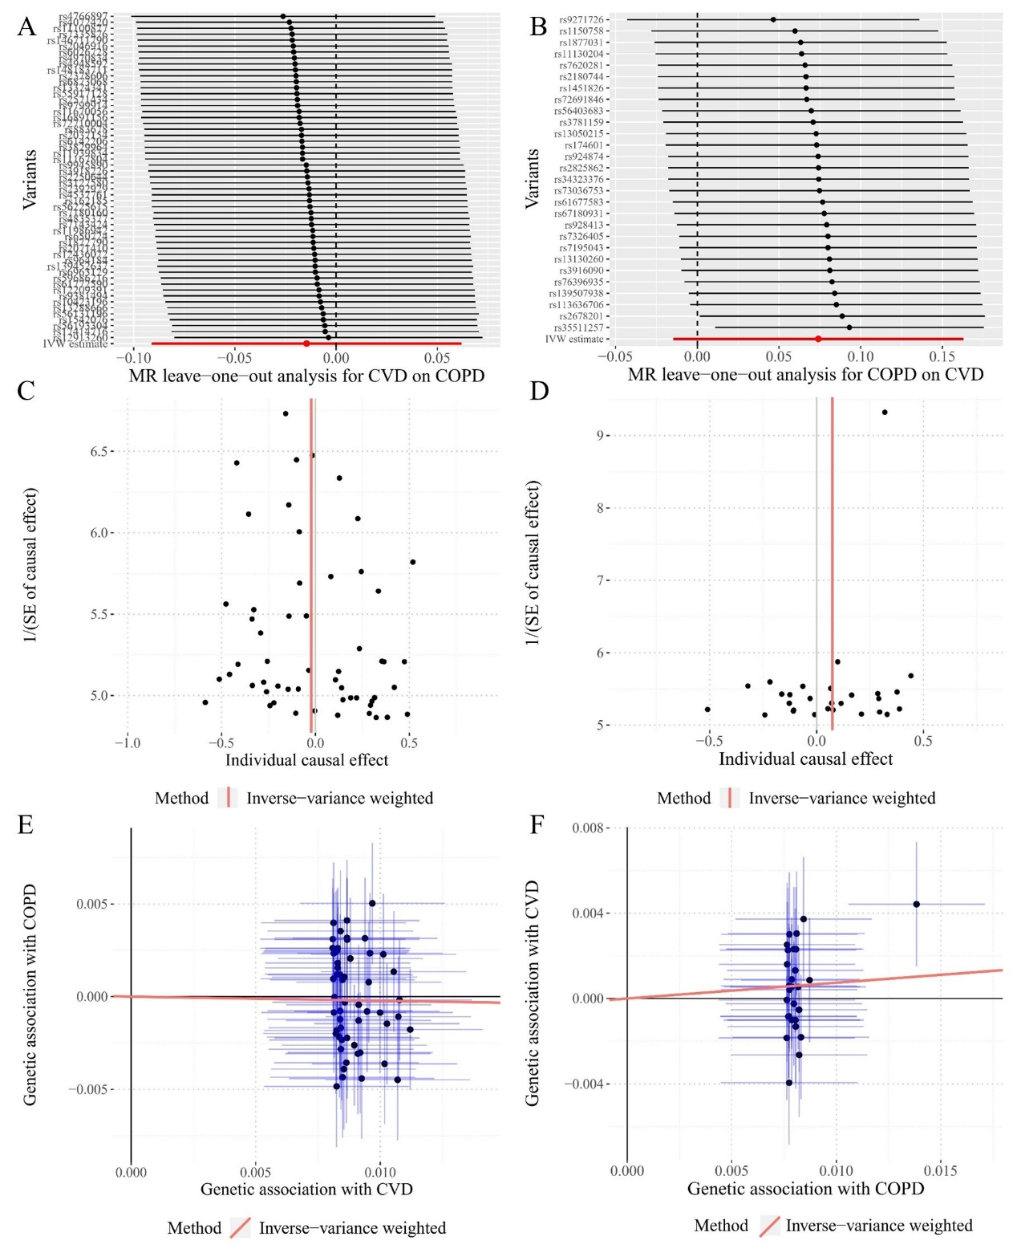
Figure S1 Diagnostic plots for the two-sample Mendelian randomization analysis between COPD and CVD. A. MR leave-one-out analysis for CVD on COPD; B. MR leave-one-out analysis for COPD on CVD; C. Funnel plot for CVD on COPD; D. Funnel plot for COPD on CVD; E. Scatter plot for CVD on COPD. F. Scatter plot for COPD on CVD.

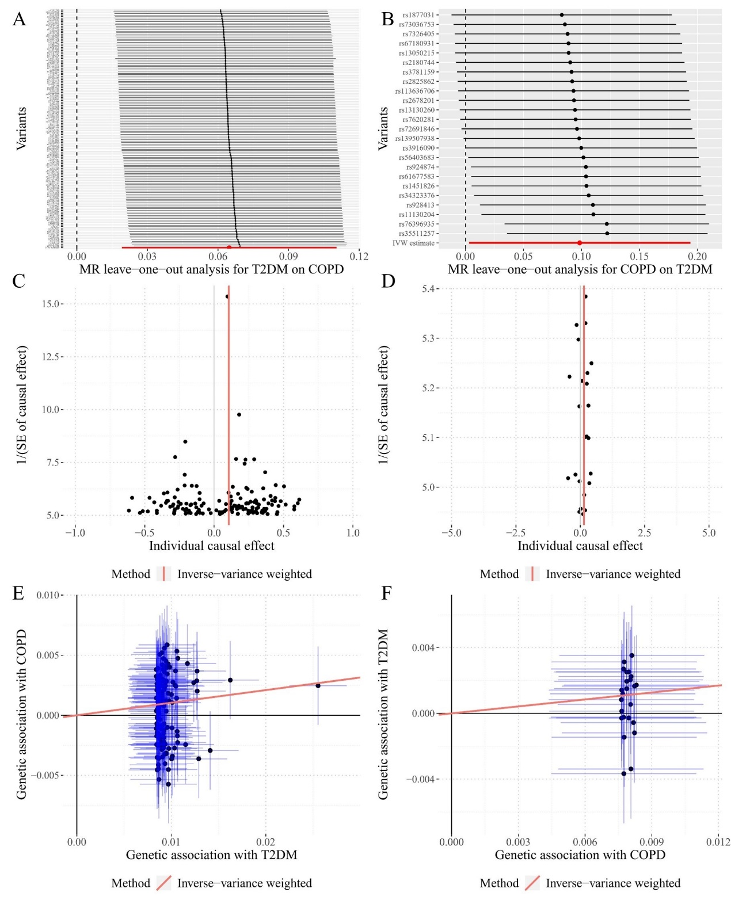
Figure S2 Diagnostic plots for the two-sample Mendelian randomization analysis between COPD and T2DM. A. MR leave-one-out analysis for T2DM on COPD; B. MR leave-one-out analysis for COPD on T2DM; C. Funnel plot for T2DM on COPD; D. Funnel plot for COPD on T2DM; E. Scatter plot for T2DM on COPD. F. Scatter plot for COPD on T2DM.

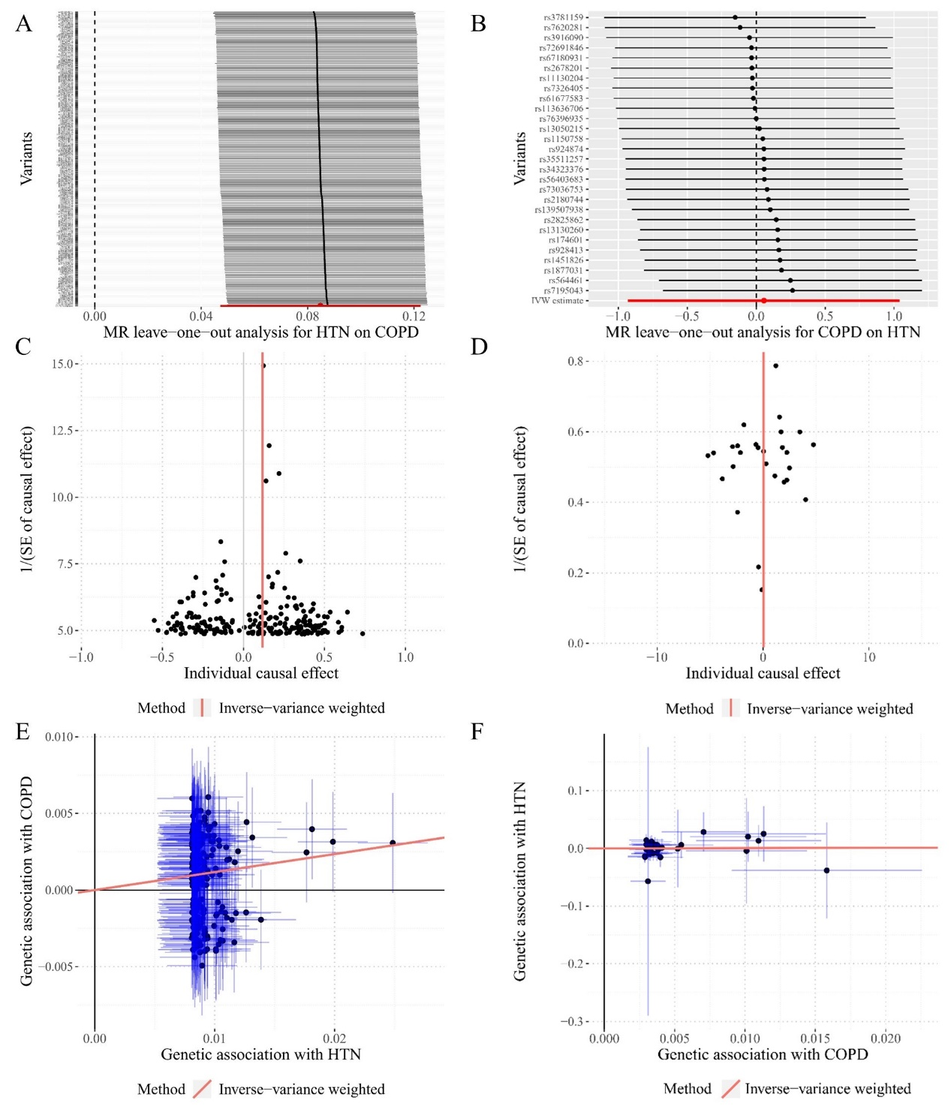
Figure S3 Diagnostic plots for the two-sample Mendelian randomization analysis between COPD and HTN. A. MR leave-one-out analysis for HTN on COPD; B. MR leave-one-out analysis for COPD on HTN; C. Funnel plot for HTN on COPD; D. Funnel plot for COPD on HTN; E. Scatter plot for HTN on COPD. F. Scatter plot for COPD on HTN.

