Supplementary material to the article Frequency of exacerbations of chronic obstructive pulmonary disease associated with the long-term exposure to air pollution in the AIREPOC cohort
Selection
Included
Eligible

Identification

Identificación entificación
Patients COPD- E
(n = 722)

Patients with COPD -E
(n = 382)
One COPD-E (n = 262)
Two COPD-E (n = 148)
Three COPD-E (n = 90)
More than four COPD-E (n = 80)
Figure S1. Patient selection flowchart from the AIREPOC Program patient cohort, Fundación Neumológica Colombiana, 2018–2021, Bogotá D.C.

Figure S2 The spatial distribution of PM_{2.5} ug/m³ and NO₂ ug/m³ exposure for each patient in the AIREPOC program from 2018 to 2021
PM_{2.5} ug/m³ NO₂ ug/m³
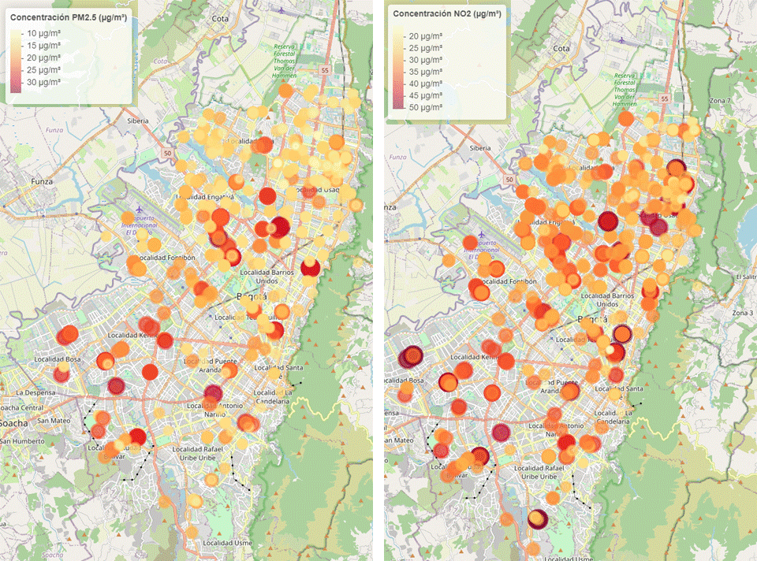
Table S1 Variables associated with the number of COPD exacerbations in the zero-truncated negative binomial regression model by gender

 | PM_{2.5} ≥ 15 µg/m3 |  |  |  |  |  |  |  |  |  | NO₂ ≥ 25 µg/m3
 | Males |  |  | Value of P | Women |  |  | Value of P | Males |  |  | Value of P | Women |  |  | Value of P
Contaminant | 0.81 | 0.60 | 1.09 | 0.000 | 0.93 | 0.71 | 1.22 | 0.161 | 1.57 | 1.05 | 2.35 | 0.027 | 1.09 | 0.80 | 1.48 | 0.564
Grade B | 0.97 | 0.66 | 1.43 | 0.895 | 0.73 | 0.50 | 1.06 | 0.112 | 0.97 | 0.65 | 1.41 | 0.836 | 0.71 | 0.49 | 1.04 | 0.071
Grade C | 1.79 | 1.17 | 2.74 | 0.004 | 1.45 | 0.90 | 2.33 | 0.201 | 1.88 | 1.23 | 2.88 | 0.003 | 1.21 | 0.81 | 1.77 | 0.179
Grade D | 2.26 | 1.53 | 3.34 | 0.000 | 1.37 | 0.95 | 1.97 | 0.087 | 2.21 | 1.49 | 3.26 | 0.000 | 1.33 | 0.83 | 2.15 | 0.126
Depression | 1.01 | 0.98 | 1.03 | 0.652 | 1.01 | 0.98 | 1.03 | 0.429 | 1.01 | 0.97 | 1.03 | 0.648 | 1.01 | 0.98 | 1.03 | 0.415
FEV1 pre bronchodilator | 1.12 | 0.88 | 1.42 | 0.447 | 0.88 | 0.62 | 1.23 | 0.458 | 1.11 | 0.87 | 1.40 | 0.425 | 0.91 | 0.64 | 1.26 | 0.493
Relative humidity | 0.81 | 0.75 | 0.87 | 0.000 | 0.95 | 0.89 | 1.01 | 0.457 | 0.83 | 0.78 | 0.89 | 0.000 | 0.96 | 0.90 | 1.02 | 0.890
Solar radiation | 1.01 | 1.004 | 1.02 | 0.047 | 1.01 | 1.004 | 1.018* | 0.034 | 1.01 | 1.01 | 1.02 | 0.004 | 1.01 | 1.004 | 1.02 | 0.000
Abbreviations:
IDR: Incidence density
CI: Confidence intervals
FEV₁ pre bronchodilator: Forced Expiratory Volume in the first-second pre bronchodilator.

Table S2 Goodness-of-fit of zero-truncated negative binomial models

Indexes | PM_{2.5} |  | NO₂
 | Males | Women | Males | Women
Log-Likelihood | -377.638 | -269.9512 | -375.9986 | -269.8811
AIC | 775.276 | 559.9025 | 771.9973 | 559.7622
Collinearity | No | No | No | No
RMSE | 18.624 | 462.600 | 18.299 | 466.80

Abbreviations:
AIC: Akaike information criterion
RMSE: Root mean square Error

