Highly stable antitumor silver-lipid nanoparticles optimized for targeted therapy

Ammar Darwish¹, Nikolett Sándor¹, Imre Szenti², Tamás Marosvölgyi³, Kata Juhász¹, Andrea Rónavári², Edi Kachal², Bence Kutus⁴, Zoltán Kónya², Zsolt Balogi¹

¹Institute of Biochemistry and Medical Chemistry, Medical School, University of Pécs, Hungary
²Department of Applied and Environmental Chemistry, University of Szeged, Hungary
³Institute of Bioanalysis, Medical School, University of Pécs, Hungary
⁴Department of Molecular and Analytical Chemistry, University of Szeged, Hungary

correspondence to Dr. Zsolt Balogi, email: zsolt.balogi@aok.pte.hu

Supplementary data
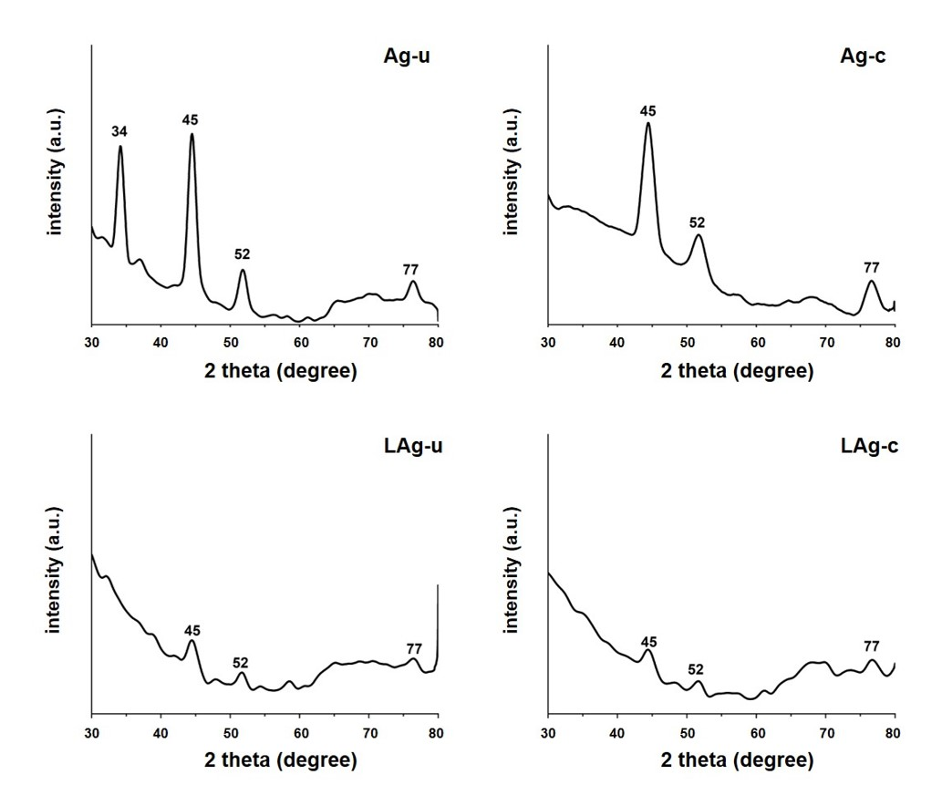
Supplementary Figure 1 X-ray diffraction patterns of free AgNPs and PC/PG/SM-LAgs of different types.

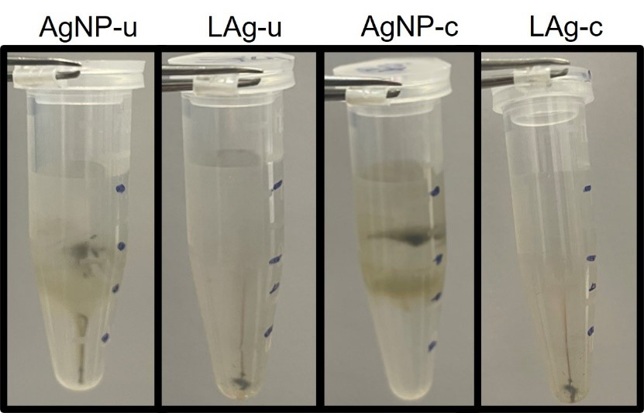

Supplementary Figure 2 Differential DGC profiles of free AgNPs and PC-LAgs of different types.
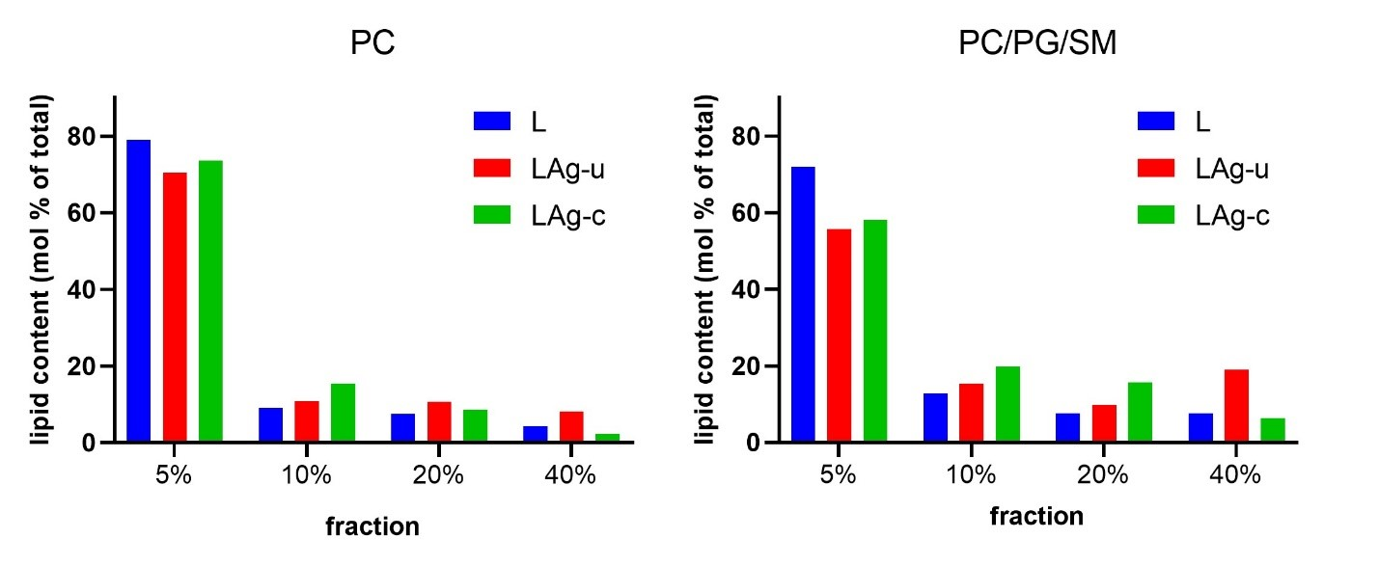

Supplementary Figure 3 Lipid content shift in the DGC fractions of LAgs. Purified empty liposomes (L) (PC and PC/PG/SM) and corresponding LAgs were fractionated by DGC, followed by collection and lipid content analysis of each fraction. Lipid content of fractions is displayed as mol % of the total lipid amount based on fatty acid determination.

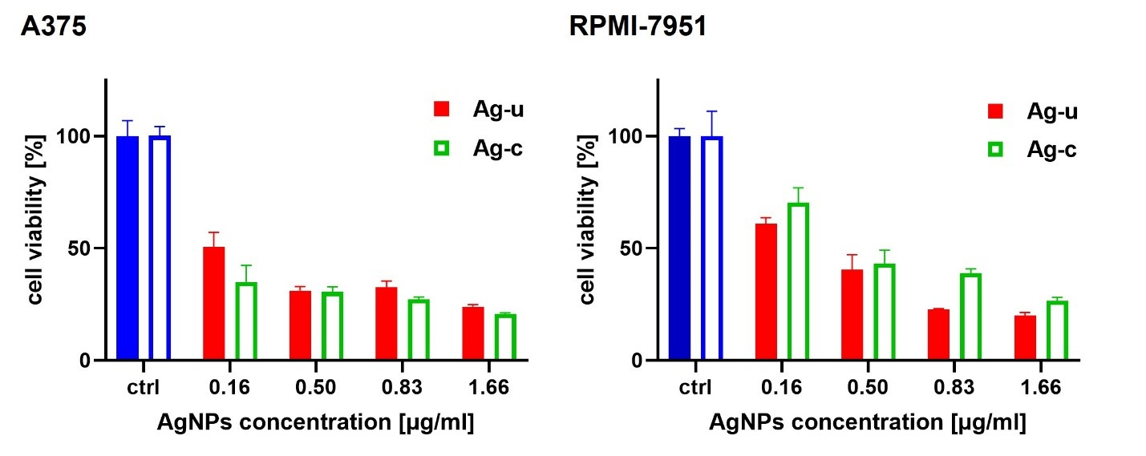
Supplementary Figure 4 Concentration-dependent effect of free AgNPs on the viability of melanoma cells. Viability of A375 and RPMI-7951 cells was measured by MTT assay upon exposure to free AgNPs for 48 h. Based on ICP-MS measurements of purified vs. unpurified samples, 0.5 μg/ml AgNP levels are considered equivalent to the AgNP levels in LAgs (30 % EE). Note: n = 6.

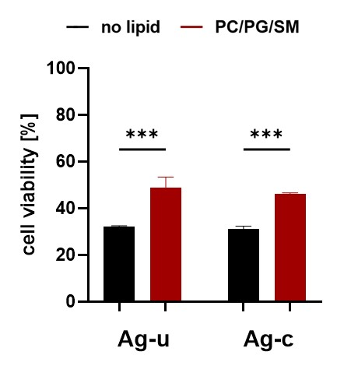
Supplementary Figure 5 Cell viability of HEK-293 cells measured by MTT assay upon 48 h exposure to LAgs, data are expressed as relative to those of untreated control (AgNPs) or empty liposomes (LAgs). Note: n = 6, and ***p < 0.001.

