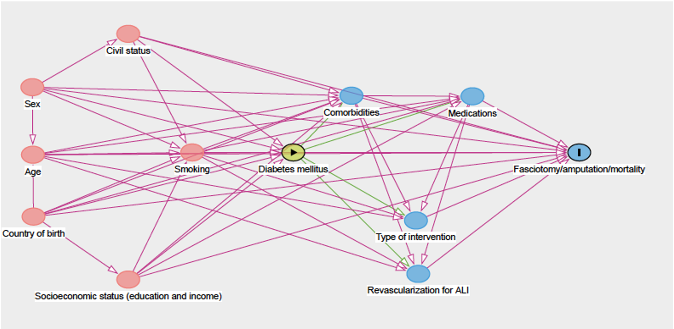
Supplementary Figure S1: Directed acyclic graph over potential interactions between variables. Variables in pink could be potential confounders.

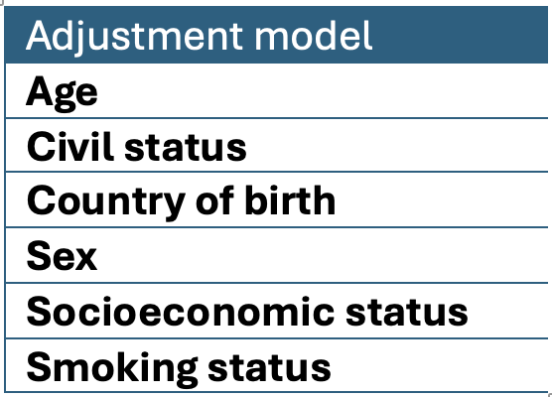
Supplementary Figure S2: Variables included in the model used to adjust the multivariable analyses.

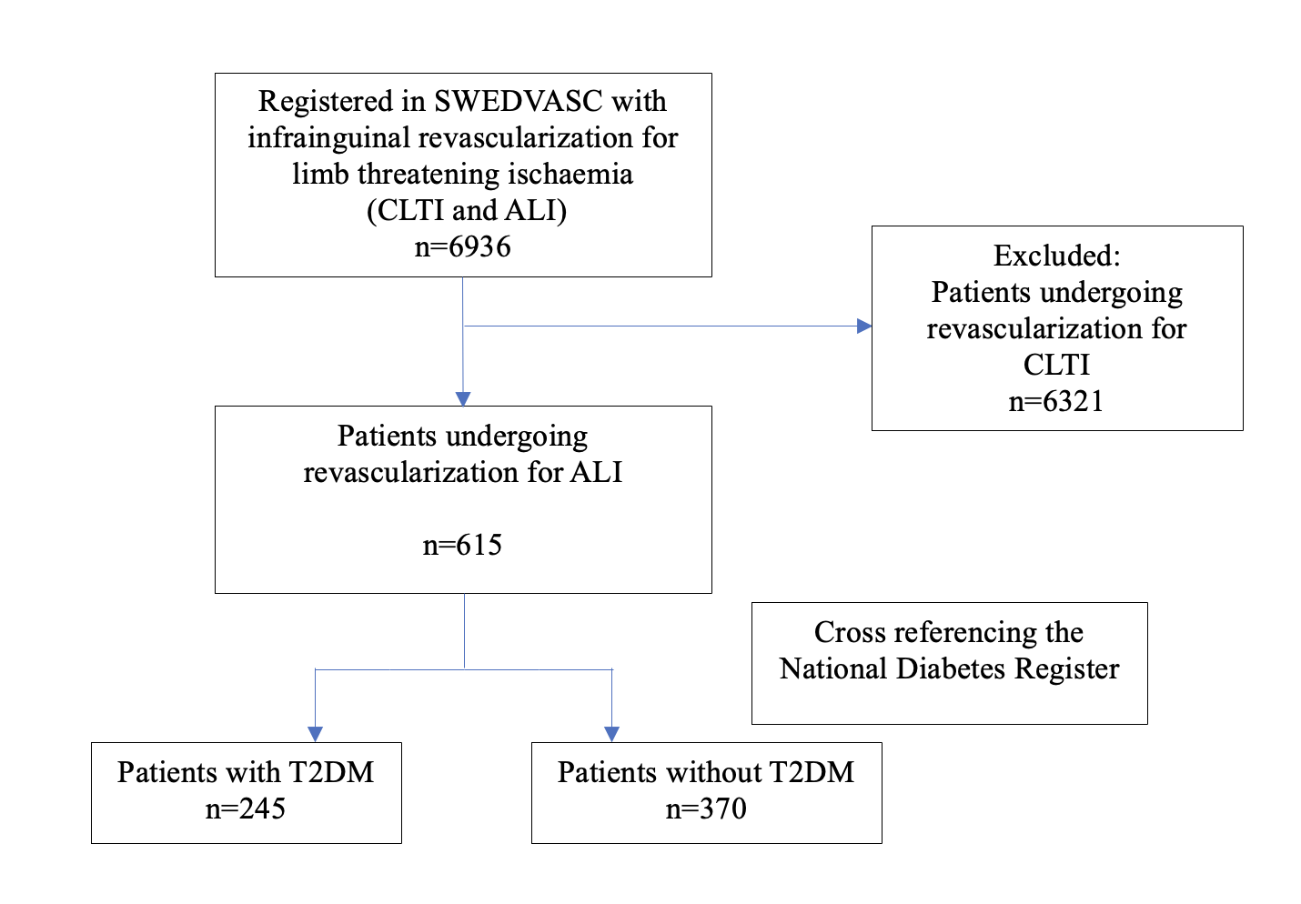

Supplementary Figure S3. Flow chart describing the patient selection of patients who had undergone revascularization for acute lower limb ischemia, with or without type 2 diabetes mellitus, by cross-referencing two national registries.

Supplementary Table S1.
STROBE Statement—checklist of items that should be included in reports of observational studies

 | Item No. | Recommendation | Page  No. | Relevant text from manuscript
Title and abstract | 1 | (a) Indicate the study’s design with a commonly used term in the title or the abstract | 1-2 | Title, abstract
Title and abstract | 1 | (b) Provide in the abstract an informative and balanced summary of what was done and what was found | 2 | Abstract
Introduction
Background/rationale | 2 | Explain the scientific background and rationale for the investigation being reported | 4 | Introduction: paragraph 1-2
Objectives | 3 | State specific objectives, including any prespecified hypotheses | 4 | Introduction: paragraph 3
Methods
Study design | 4 | Present key elements of study design early in the paper | 5 | Methods: “Study design and setting”
Setting | 5 | Describe the setting, locations, and relevant dates, including periods of recruitment, exposure, follow-up, and data collection | 5 | Methods: “Study design and setting”
Participants | 6 | (a) Cohort study—Give the eligibility criteria, and the sources and methods of selection of participants. Describe methods of follow-up  Case-control study—Give the eligibility criteria, and the sources and methods of case ascertainment and control selection. Give the rationale for the choice of cases and controls  Cross-sectional study—Give the eligibility criteria, and the sources and methods of selection of participants | 6 | Methods: “Sample Selection”
Participants | 6 | (b) Cohort study—For matched studies, give matching criteria and number of exposed and unexposed  Case-control study—For matched studies, give matching criteria and the number of controls per case
Variables | 7 | Clearly define all outcomes, exposures, predictors, potential confounders, and effect modifiers. Give diagnostic criteria, if applicable | 7-8 | Methods: “Variables”
Data sources/ measurement | 8* | For each variable of interest, give sources of data and details of methods of assessment (measurement). Describe comparability of assessment methods if there is more than one group | 7 | Methods: “Data Collection and registries”
Bias | 9 | Describe any efforts to address potential sources of bias | 14-15 | Discussion: “Strengths and limitations
Study size | 10 | Explain how the study size was arrived at | 6 | Methods: “Sample Selection”
Continued on next page
Quantitative variables | 11 | Explain how quantitative variables were handled in the analyses. If applicable, describe which groupings were chosen and why | 8-9 | Methods: “Statistical Methods”
Statistical methods | 12 | (a) Describe all statistical methods, including those used to control for confounding | 8-9 | Methods: “Statistical Methods”
Statistical methods | 12 | (b) Describe any methods used to examine subgroups and interactions | 8-9 | Methods: “Statistical Methods”
Statistical methods | 12 | (c) Explain how missing data were addressed | 8-9 | Methods: “Statistical Methods”
Statistical methods | 12 | (d) Cohort study—If applicable, explain how loss to follow-up was addressed  Case-control study—If applicable, explain how matching of cases and controls was addressed  Cross-sectional study—If applicable, describe analytical methods taking account of sampling strategy | 8-9 | Methods: “Statistical Methods”
Statistical methods | 12 | (e) Describe any sensitivity analyses | 8-9 | Methods: “Statistical Methods”
Results
Participants | 13* | (a) Report numbers of individuals at each stage of study—eg numbers potentially eligible, examined for eligibility, confirmed eligible, included in the study, completing follow-up, and analysed | 10 | Results: “Study Cohort”
Participants | 13* | (b) Give reasons for non-participation at each stage | 10 | Results: “Study Cohort”
Participants | 13* | (c) Consider use of a flow diagram | 28 | Supplementary Figure S3
Descriptive data | 14* | (a) Give characteristics of study participants (eg demographic, clinical, social) and information on exposures and potential confounders | 20-21 | Table 1-2
Descriptive data | 14* | (b) Indicate number of participants with missing data for each variable of interest | 20-22 | Table 1-3
Descriptive data | 14* | (c) Cohort study—Summarise follow-up time (eg, average and total amount) | - | -
Outcome data | 15* | Cohort study—Report numbers of outcome events or summary measures over time | 22 | Table 3
Outcome data | 15* | Case-control study—Report numbers in each exposure category, or summary measures of exposure
Outcome data | 15* | Cross-sectional study—Report numbers of outcome events or summary measures
Main results | 16 | (a) Give unadjusted estimates and, if applicable, confounder-adjusted estimates and their precision (eg, 95% confidence interval). Make clear which confounders were adjusted for and why they were included | 22 | Table 3
Main results | 16 | (b) Report category boundaries when continuous variables were categorized
Main results | 16 | (c) If relevant, consider translating estimates of relative risk into absolute risk for a meaningful time period
Continued on next page
Other analyses | 17 | Report other analyses done—eg analyses of subgroups and interactions, and sensitivity analyses | 22 | Table 3
Discussion
Key results | 18 | Summarise key results with reference to study objectives | 12 | Discussion: Paragraph 1
Limitations | 19 | Discuss limitations of the study, taking into account sources of potential bias or imprecision. Discuss both direction and magnitude of any potential bias | 14 | Discussion: “Strengths and limitations”
Interpretation | 20 | Give a cautious overall interpretation of results considering objectives, limitations, multiplicity of analyses, results from similar studies, and other relevant evidence | 15 | Discussion: “Conclusions”
Generalisability | 21 | Discuss the generalisability (external validity) of the study results | 15 | Discussion: “Generalizability”
Other information
Funding | 22 | Give the source of funding and the role of the funders for the present study and, if applicable, for the original study on which the present article is based | 16 | Discussion: “Funding”

*Give information separately for cases and controls in case-control studies and, if applicable, for exposed and unexposed groups in cohort and cross-sectional studies.

Note: An Explanation and Elaboration article discusses each checklist item and gives methodological background and published examples of transparent reporting. The STROBE checklist is best used in conjunction with this article (freely available on the Web sites of PLoS Medicine at http://www.plosmedicine.org/, Annals of Internal Medicine at http://www.annals.org/, and Epidemiology at http://www.epidem.com/). Information on the STROBE Initiative is available at www.strobe-statement.org.

Supplementary Table S2. HbA1C levels and anti-diabetic medication use in the T2DM-group
 | T2DM % (n=245)
Mean HbA1C levels (mmol/mol) n=165 | 61.46 (SD: 15.32)
Any anti-diabetic medication | 211 (86.1%)
Metformin | 78 (31.8%)
HbA1C: Hemoglobin A1C, SD: Standard deviation, T2DM: Type 2 diabetes mellitus

