Supporting information
Ahn et al

Viral mimetic bacterial outer membrane vesicles for targeting angiotensin-converting enzyme 2
Gna Ahn^{1,2}*
Hyo-Won Yoon¹*
Ju Hwan Jeong^{3,4}*
Yang-Hoon Kim¹*
Woo-Ri Shin^{1,5,6}
Min-Suk Song³
Ji-Young Ahn¹
*These authors contributed equally to this work

¹Department of Microbiology, Chungbuk National University, Cheongju, Republic of Korea; ²Center for Ecology and Environmental Toxicology, Chungbuk National University, Cheongju, Republic of Korea; ³Department of Microbiology, College of Medicine and Medical Research Institute, Chungbuk National University, Cheongju, Republic of Korea; ⁴Korea Research Institute of Bioscience and Biotechnology, Jeongeup, Republic of Korea; ⁵Department of Bioengineering, University of Pennsylvania, Philadelphia, USA; ⁶Department of Animal Bioscience & Integrated Biotechnology, Gyeongsang National University, Jinju, Republic of Korea

Correspondence: Ji-Young Ahn (Phone: +82-43-261-2301, E-mail: jyahn@chungbuk.ac.kr)
Co-correspondence: Min-Suk Song (Phone: +82-43-261-3778, E-mail: songminsuk@chungbuk.ac.kr)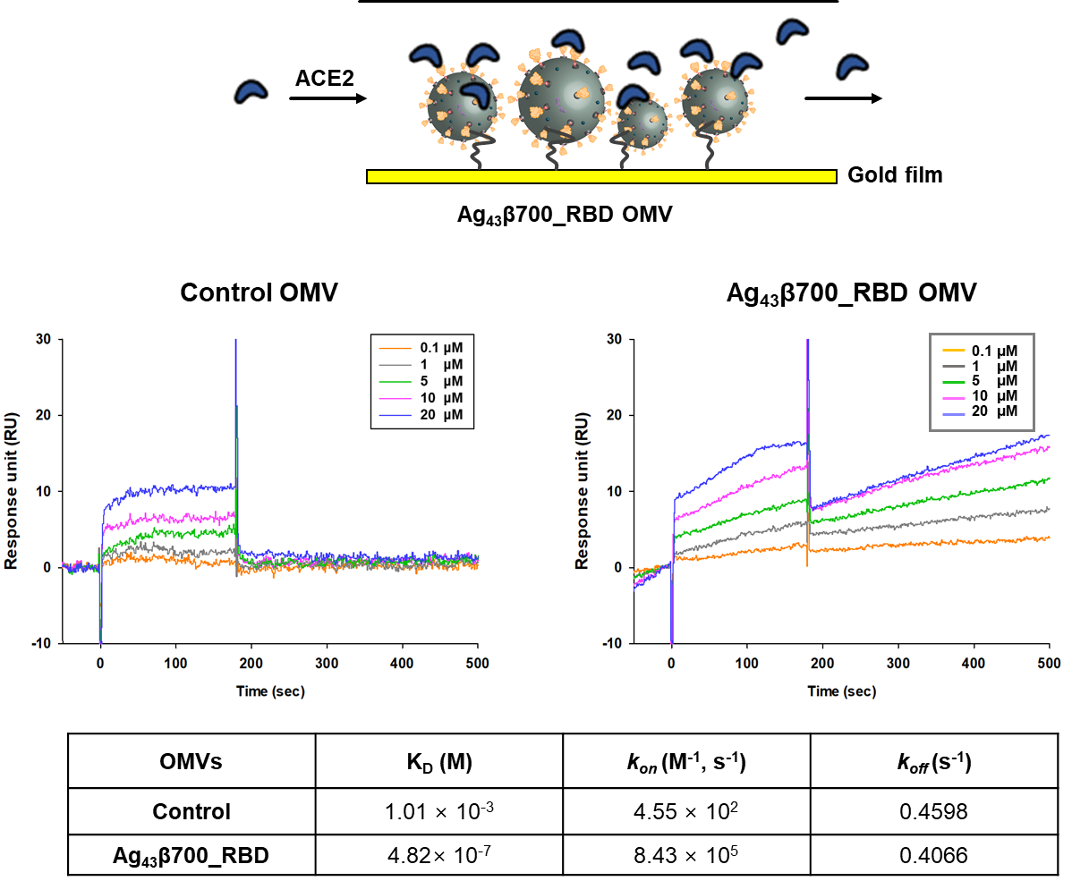

Supplementary Figure S1. Evaluation of binding affinity of Ag43β700_RBD OMVs to hACE2 using surface plasmon resonance. Both control and Ag43β700_RBD OMVs were immobilised to a sensor chip L1 (Cytiva, Sweden) and soluble hACE2 was injected at the indicated concentrations in a single-cycle kinetics experiment. Kinetics fitting curve (sensogram) of Ag43β700_RBD (left) and control (right) OMVs were constructed. The binding affinity KD, as well as kinetic parameters k_{on} and k_{off} of Ag43β700_RBD and control OMVs were calculated. The KD of Ag43β700-RBD-OMVs with recombinant hACE2 (RayBiotech, USA) was measured using surface plasmon resonance with a Biacore X100 system containing a sensor chip L1. The running buffer used was 10 mM Tris-HCl pH 8.0, while the regeneration buffer used was 40 mM n-octyl β-D-glucopyranoside (OG). The Ag43β700_RBD/non-induction OMVs were diluted in 10 mM Tris-HCl to a final concentration of 2.4×10¹¹ particles/mL. The surface of the sensor chip L1 was pre-treated with 40 mM OG and the nanoparticle sample was then injected at a flow rate of 10 µL/min. After the sensogram flattened out, various concentrations of hACE2 (0, 0.1, 1, 5, 10, and 20 μM) in 10 mM Tris-HCl were injected over the flow cell at a flow rate of 10 µL/min. Following each binding step using ACE2, the sensor chip was regenerated using 40 mM OG buffer. The Κ_{D} of the OMV–ACE2 complexes were determined using BIAevaluation software.
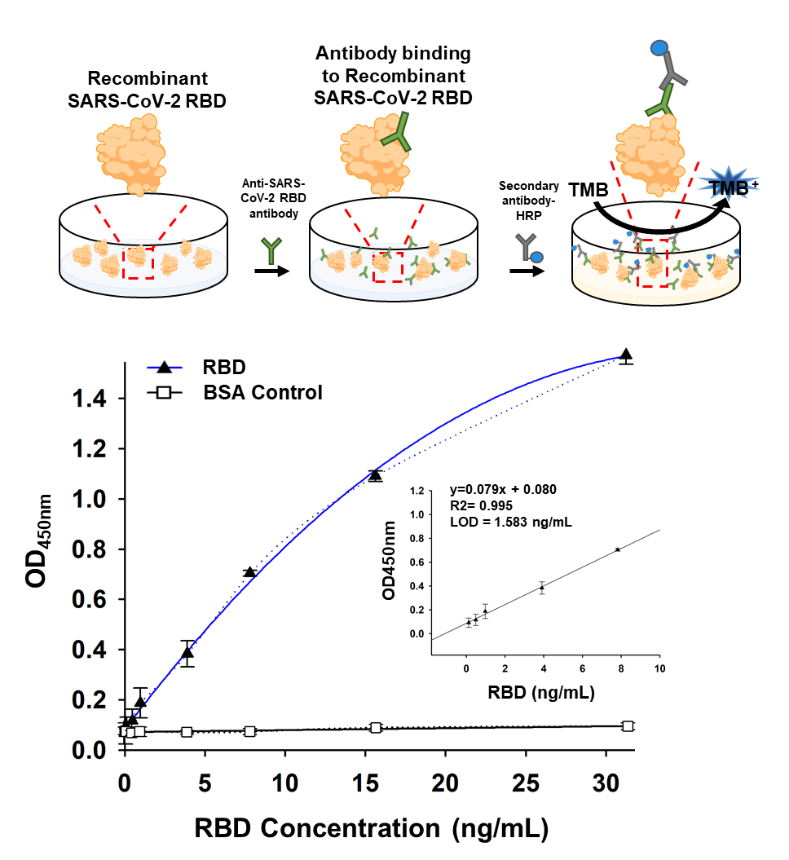

Supplementary Figure S2. Recombinant RBD-based indirect ELISA platform to identify anti-SARS-CoV-2 spike RBD antibodies. RBD proteins were bound to the surface of 96-well plates.

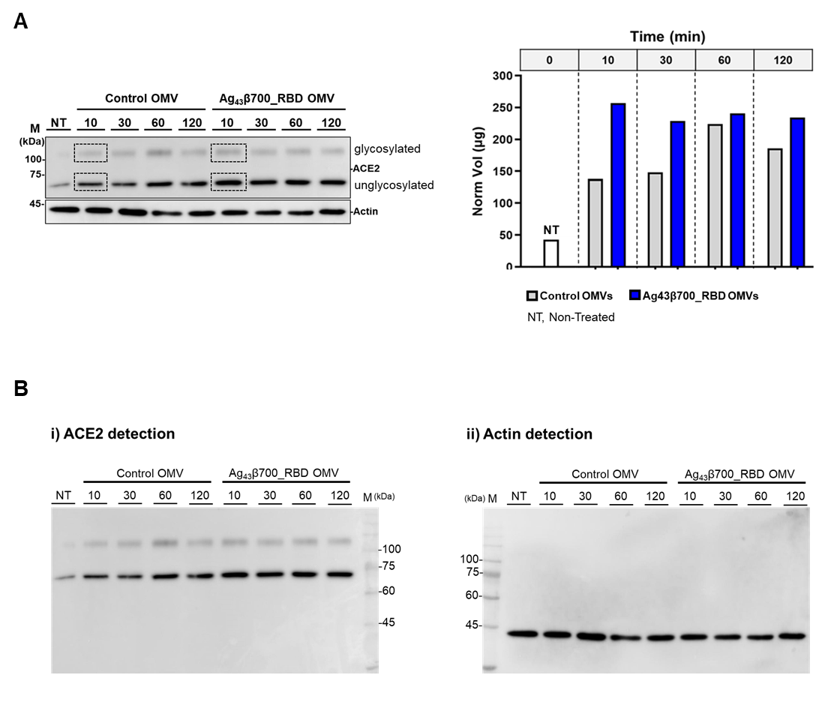
Supplementary Figure S3. Western blot analysis of ACE2 expression in the total cell lysate of Vero E6 cells. A. ACE2 expression in Vero E6 cells treated with control OMVs and RBD-OMVs for 10, 30, 60, and 120 min (left). Relative normalised volume (Norm Vol) measured using Amersham software (Cytiva, USA) (right). Two bands of approximately 70 and 20 kDa were detected, corresponding to the unglycosylated and glycosylated forms of ACE2, respectively. B. Raw file of western blot

Supplementary Table 1. Primers used in the study
Primer name | Primer sequence (5′–3′)
Ag43 cloning
Ag43_F |  | ATGAAACGACATCTGAATACCTGCTAC
Ag43_R |  | TCAGAAGGTCACATTCAGTGTGGC
1BamHIC_SP_F |  | GGATCCCATGAAACGACATCTGAATACCTG
53SP_FLAG_R |  | ATCCTTGTAATCAGCCAGCACCGGGA
HindⅢ_700_Ag43_F |  | AAGCTTCTGCGCAGTGAAAATGCTTAT
XhoⅠ_1038_Ag43_R |  | CTCGAGTCAGAAGGTCACATTCAGT
HindⅢ_G4S_R2 |  | AAGCTTAGAACCACCACCACCAGAACCACCA
SARS-CoV-2 Recombinant RBD Cloning
SARS2_S_F |  | ATGTTTGTTTTTCTTGTTTTATTGCCAC
SARS2_S_R |  | TTATGTGTAATGTAATTTGACTCCTTTG
RBD_SP_F |  | CCGGTGCTGGCTAATATTACAAACTTGTGCCCT
RBD_R |  | AACAGTTGCTGGTGCATGTAGAAGTTC
RBD_6H_R |  | CCACCGTGATGGTGGTGATGGTGAACAGTTGCTGGTGC  ATGT
SP_RBD_ R_F |  | TCCCGGTGCTGGCTAATATTACAAACTTGTGCCCT
SP_RBD_F |  | GGATCCCATGAAACGACATCTGAATACCTG
R_RBD 6H_AAGCTT |  | AAGCTTCGTGATGGTGGTGATGGTGAACAGTTG

All primers were synthesized from cosmogenetech (Seoul, Republic of Korea).

