Supplementary materials
Supplementary Tables 2
Table S1. Piecewise regression model of post-induction fecal calprotectin (per 100 units) for predicting long-term endoscopic remission in the discovery cohort 2
Table S2. Subgroup analyses for the associations between FC index† and long-term outcomes stratified by sex and age in the discovery cohort 3
Table S3. Subgroup analyses for the associations between FC index† and long-term outcomes stratified by smoking history and TNF antagonist exposure history in the discovery cohort 6
Table S4. Sensitivity analyses for the association between FC index† and redefined disease clearance‡ 9
Table S5. Receiver operating characteristic curve analysis for predicting long-term outcomes in the validation cohort 10
Table S6. Subgroup analyses for the associations between FC index† and long-term outcomes stratified by sex and age in the validation cohort 11
Table S7. Subgroup analyses for the associations between FC index† and long-term outcomes stratified by smoking history and TNF antagonist exposure history in the validation cohort 13
Supplementary Figures 15
Figure S1. The flow chart of participant recruitment. 15
Figure S2. Sensitivity analyses using restricted cubic spline curves with three knots in the discovery cohort. 16
Figure S3. Sensitivity analyses using restricted cubic spline curves with five knots in the discovery cohort. 17
Figure S4. Sensitivity analyses for the nonlinear association between fecal calprotectin and redefined disease clearance. 18
Figure S5. Restricted cubic spline for the nonlinear associations between fecal calprotectin and long-term outcomes in the validation cohort. 19
Figure S6. Sensitivity analyses using restricted cubic spline curves with three and five knots in the validation cohort. 20

Supplementary Tables

Table S1. Piecewise regression model of post-induction fecal calprotectin (per 100 units) for predicting long-term endoscopic remission in the discovery cohort
Model | OR (95% CI) | P value
FC <1st inflection point†
Unadjusted model | 0.55 (0.28, 1.08) | 0.09
Model 1 | 0.55 (0.28, 1.08) | 0.08
Model 2 | 0.55 (0.28, 1.07) | 0.08
Model 3 | 0.56 (0.28, 1.10) | 0.09
1st inflection point ≤ FC <2nd inflection point‡
Unadjusted model | 0.86 (0.76, 0.97) | 0.02
Model 1 | 0.86 (0.76, 0.97) | 0.02
Model 2 | 0.86 (0.76, 0.98) | 0.02
Model 3 | 0.87 (0.77, 0.98) | 0.03
FC ≥ 2nd inflection point
Unadjusted model | 1.01 (1.00, 1.02) | 0.05
Model 1 | 1.01 (1.00, 1.02) | 0.05
Model 2 | 1.01 (1.00, 1.02) | 0.05
Model 3 | 1.01 (1.00, 1.02) | 0.05
†The 1st inflection point was estimated at 176, 172, 176, and 176 μg/g in the unadjusted model, Model 1, Model 2 and Model 3, respectively.
‡The 2nd inflection point was estimated at 1256, 1262,1298, and 1265 μg/g in the unadjusted model, Model 1, Model 2 and Model 3, respectively.
Model 1 was adjusted for sex and age. Model 2 was adjusted for covariates in Model 1 plus disease duration, smoking history, and previous exposure of tumor necrosis factor antagonist. Model 3 was adjusted covariates in Model 2 plus treatment allocations, concomitant corticosteroid uses at baseline, baseline partial Mayo score, and baseline Mayo endoscopy score.
CI, confidence interval; FC, fecal calprotectin; OR, odds ratio.

Table S2. Subgroup analyses for the associations between FC index† and long-term outcomes stratified by sex and age in the discovery cohort
FC index | Stratified by age |  |  |  |  |  | Stratified by sex
FC index | Age<40 years old |  | Age≥40 years old |  | P for interaction |  | Male |  | Female |  | P for interaction
FC index | OR [95% CI] | P value | OR [95% CI] | P value | P for interaction |  | OR [95% CI] | P value | OR [95% CI] | P value | P for interaction
Endoscopic remission
0 | Reference | / | Reference | / |  |  | Reference | / | Reference | /
1 | 0.42 [0.19, 0.90] | 0.03 | 0.49 [0.22, 1.05] | 0.07 | 0.81 |  | 0.42 [0.18, 0.90] | 0.03 | 0.50 [0.22, 1.09] | 0.09 | 0.75
2 | 0.24 [0.10, 0.52] | 0.001 | 0.15 [0.05, 0.37] | <0.001 | 0.50 |  | 0.23 [0.10, 0.48] | <0.001 | 0.15 [0.05, 0.40] | <0.001 | 0.56
3 | 0.12 [0.05, 0.28] | <0.001 | 0.17 [0.07, 0.36] | <0.001 | 0.62 |  | 0.13 [0.06, 0.28] | <0.001 | 0.16 [0.06, 0.40] | <0.001 | 0.76
P for trend |  | <0.001 |  | <0.001 | 0.88 |  |  | <0.001 |  | <0.001 | 0.96
Endoscopic improvement
0 | Reference | / | Reference | / |  |  | Reference | / | Reference | /
1 | 0.31 [0.15, 0.64] | 0.002 | 0.46 [0.22, 0.98] | 0.045 | 0.45 |  | 0.31 [0.15, 0.65] | 0.002 | 0.46 [0.22, 0.97] | 0.04 | 0.48
2 | 0.23 [0.11, 0.46] | <0.001 | 0.22 [0.10, 0.44] | <0.001 | 0.90 |  | 0.19 [0.10, 0.38] | <0.001 | 0.27 [0.12, 0.57] | 0.001 | 0.54
3 | 0.07 [0.03, 0.15] | <0.001 | 0.17 [0.08, 0.32] | <0.001 | 0.10 |  | 0.11 [0.06, 0.20] | <0.001 | 0.11 [0.05, 0.25] | <0.001 | 0.97
P for trend |  | <0.001 |  | <0.001 | 0.20 |  |  | <0.001 |  | <0.001 | 0.88
Clinical remission
0 | Reference | / | Reference | / |  |  | Reference | / | Reference | /
1 | 0.27 [0.13, 0.57] | 0.001 | 0.54 [0.25, 1.17] | 0.11 | 0.21 |  | 0.34 [0.16, 0.74] | 0.006 | 0.45 [0.21, 0.95] | 0.04 | 0.63
2 | 0.33 [0.16, 0.66] | 0.002 | 0.25 [0.12, 0.49] | <0.001 | 0.58 |  | 0.22 [0.11, 0.43] | <0.001 | 0.40 [0.19, 0.83] | 0.02 | 0.26
3 | 0.11 [0.06, 0.22] | <0.001 | 0.24 [0.12, 0.45] | <0.001 | 0.13 |  | 0.12 [0.06, 0.22] | <0.001 | 0.28 [0.13, 0.57] | 0.001 | 0.09
P for trend |  | <0.001 |  | <0.001 | 0.31 |  |  | <0.001 |  | 0.001 | 0.07
Histologic remission
0 | Reference | / | Reference | / |  |  | Reference | / | Reference | /
1 | 0.29 [0.12, 0.65] | 0.004 | 0.34 [0.13, 0.80] | 0.02 | 0.21 |  | 0.27 [0.10, 0.63] | 0.004 | 0.37 [0.15, 0.84] | 0.02 | 0.63
2 | 0.13 [0.05, 0.32] | <0.001 | 0.18 [0.06, 0.45] | 0.001 | 0.58 |  | 0.14 [0.05, 0.33] | <0.001 | 0.17 [0.05, 0.45] | 0.001 | 0.78
3 | 0.06 [0.02, 0.16] | <0.001 | 0.10 [0.03, 0.26] | <0.001 | 0.13 |  | 0.07 [0.02, 0.17] | <0.001 | 0.08 [0.02, 0.26] | <0.001 | 0.82
P for trend |  | <0.001 |  | <0.001 | 0.49 |  |  | <0.001 |  | <0.001 | 0.74
Histologic improvement
0 | Reference | / | Reference | / |  |  | Reference | / | Reference | /
1 | 0.25 [0.11, 0.52] | <0.001 | 0.46 [0.22, 0.94] | 0.04 | 0.25 |  | 0.35 [0.16, 0.72] | 0.005 | 0.35 [0.16, 0.74] | 0.007 | 0.98
2 | 0.16 [0.08, 0.33] | <0.001 | 0.36 [0.18, 0.71] | 0.004 | 0.12 |  | 0.22 [0.11, 0.41] | <0.001 | 0.29 [0.14, 0.61] | 0.001 | 0.56
3 | 0.10 [0.05, 0.20] | <0.001 | 0.16 [0.08, 0.31] | <0.001 | 0.34 |  | 0.10 [0.05, 0.19] | <0.001 | 0.18 [0.08, 0.37] | <0.001 | 0.28
P for trend |  | <0.001 |  | <0.001 | 0.25 |  |  | <0.001 |  | <0.001 | 0.25
Disease clearance
0 | Reference | / | Reference | / |  |  | Reference | / | Reference | /
1 | 0.49 [0.17, 1.23] | 0.15 | 0.16 [0.01, 0.83] | 0.08 | 0.33 |  | 0.30 [0.07, 0.93] | 0.06 | 0.49 [0.13, 1.52] | 0.25 | 0.58
2 | 0.23 [0.06, 0.64] | 0.01 | N/A | >0.99 | >0.99 |  | 0.12 [0.02, 0.44] | 0.006 | 0.23 [0.03, 0.88] | 0.06 | 0.58
3 | 0.04 [0.00, 0.19] | 0.002 | N/A | >0.99 | 0.99 |  | N/A | 0.99 | 0.09 [0.01, 0.50] | 0.03 | 0.99
P for trend |  | <0.001 |  | 0.02 | 0.17 |  |  | <0.001 |  | 0.004 | 0.20
†FC index of 0 to 3 represents FC levels of <180, 180-500, 500-1300, and ≥1300 μg/g, respectively.
CI, confidence interval; FC, fecal calprotectin; N/A, not available; OR, odds ratio.

Table S3. Subgroup analyses for the associations between FC index† and long-term outcomes stratified by smoking history and TNF antagonist exposure history in the discovery cohort
FC index | Stratified by smoking history |  |  |  |  |  | Stratified by TNF antagonists exposure history
FC index | No |  | Yes |  | P for interaction |  | No |  | Yes |  | P for interaction
FC index | OR [95% CI] | P value | OR [95% CI] | P value | P for interaction |  | OR [95% CI] | P value | OR [95% CI] | P value | P for interaction
Endoscopic remission
0 | Reference | / | Reference | / |  |  | Reference | / | Reference | /
1 | 0.47 [0.24, 0.90] | 0.03 | 0.45 [0.16, 1.20] | 0.116 | 0.93 |  | 0.35 [0.19, 0.63] | 0.001 | 2.08 [0.48, 9.02] | 0.32 | 0.03
2 | 0.25 [0.11, 0.50] | <0.001 | 0.12 [0.03, 0.34] | <0.001 | 0.28 |  | 0.17 [0.08, 0.33] | <0.001 | 0.43 [0.10, 1.60] | 0.22 | 0.22
3 | 0.24 [0.12, 0.46] | <0.001 | 0.03 [0.01, 0.12] | <0.001 | 0.02 |  | 0.17 [0.09, 0.30] | <0.001 | N/A | >0.99 | 0.98
P for trend |  | <0.001 |  | <0.001 | 0.01 |  |  | <0.001 |  | 0.002 | 0.70
Endoscopic improvement
0 | Reference | / | Reference | / |  |  | Reference | / | Reference | /
1 | 0.37 [0.20, 0.68] | 0.001 | 0.42 [0.15, 1.18] | 0.10 | 0.82 |  | 0.33 [0.19, 0.58] | <0.001 | 0.78 [0.19, 3.29] | 0.73 | 0.27
2 | 0.24 [0.13, 0.43] | <0.001 | 0.19 [0.07, 0.46] | <0.001 | 0.65 |  | 0.22 [0.12, 0.38] | <0.001 | 0.27 [0.09, 0.81] | 0.02 | 0.74
3 | 0.14 [0.08, 0.25] | <0.001 | 0.07 [0.02, 0.16] | <0.001 | 0.18 |  | 0.11 [0.06, 0.18] | <0.001 | 0.16 [0.05, 0.48] | 0.002 | 0.56
P for trend |  | <0.001 |  | <0.001 | 0.17 |  |  | <0.001 |  | 0.001 | 0.67
Clinical remission
0 | Reference | / | Reference | / |  |  | Reference | / | Reference | /
1 | 0.39 [0.21, 0.73] | 0.003 | 0.36 [0.13, 1.01] | 0.05 | 0.88 |  | 0.32 [0.18, 0.57] | <0.001 | 0.97 [0.23, 4.47] | 0.97 | 0.16
2 | 0.33 [0.18, 0.59] | <0.001 | 0.20 [0.08, 0.50] | 0.001 | 0.38 |  | 0.28 [0.16, 0.49] | <0.001 | 0.37 [0.12, 1.05] | 0.07 | 0.65
3 | 0.20 [0.11, 0.34] | <0.001 | 0.12 [0.05, 0.27] | <0.001 | 0.32 |  | 0.17 [0.10, 0.28] | <0.001 | 0.19 [0.06, 0.54] | 0.003 | 0.86
P for trend |  | <0.001 |  | <0.001 | 0.26 |  |  | <0.001 |  | 0.002 | 0.95
Histologic remission
0 | Reference | / | Reference | / |  |  | Reference | / | Reference | /
1 | 0.22 [0.09, 0.48] | <0.001 | 0.61 [0.22, 1.61] | 0.32 | 0.12 |  | 0.29 [0.14, 0.54] | <0.001 | 0.52 [0.07, 2.55] | 0.45 | 0.53
2 | 0.17 [0.07, 0.37] | <0.001 | 0.12 [0.03, 0.38] | 0.001 | 0.62 |  | 0.15 [0.07, 0.31] | <0.001 | 0.19 [0.03, 0.82] | 0.05 | 0.83
3 | 0.10 [0.04, 0.22] | <0.001 | 0.04 [0.01, 0.16] | <0.001 | 0.38 |  | 0.08 [0.03, 0.16] | <0.001 | 0.07 [0.00, 0.43] | 0.02 | 0.96
P for trend |  | <0.001 |  | <0.001 | 0.48 |  |  | <0.001 |  | 0.003 | 0.88
Histologic improvement
0 | Reference | / | Reference | / |  |  | Reference | / | Reference | /
1 | 0.31 [0.16, 0.57] | <0.001 | 0.45 [0.17, 1.24] | 0.12 | 0.52 |  | 0.33 [0.18, 0.57] | <0.001 | 0.42 [0.10, 1.70] | 0.22 | 0.75
2 | 0.29 [0.16, 0.52] | <0.001 | 0.16 [0.06, 0.39] | <0.001 | 0.28 |  | 0.26 [0.15, 0.45] | <0.001 | 0.21 [0.07, 0.63] | 0.006 | 0.74
3 | 0.14 [0.08, 0.25] | <0.001 | 0.11 [0.05, 0.25] | <0.001 | 0.66 |  | 0.13 [0.08, 0.22] | <0.001 | 0.13 [0.04, 0.40] | <0.001 | 0.95
P for trend |  | <0.001 |  | <0.001 | 0.42 |  |  | <0.001 |  | <0.001 | 0.91
Disease clearance
0 | Reference | / | Reference | / |  |  | Reference | / | Reference | /
1 | 0.41 [0.13, 1.05] | 0.08 | 0.32 | 0.16 | 0.81 |  | 0.25 [0.08, 0.62] | 0.006 | N/A | 0.16 | 0.02
2 | 0.19 [0.04, 0.56] | 0.008 | 0.11 | 0.04 | 0.68 |  | 0.13 [0.03, 0.39] | 0.001 | N/A | 0.98 | 0.19
3 | 0.05 [0.00, 0.22] | 0.003 | N/A | 0.99 | 0.99 |  | 0.03 [0.00, 0.14] | 0.001 | N/A | >0.99 | >0.99
P for trend |  | <0.001 |  | 0.002 | 0.43 |  |  | <0.001 |  | 0.31 | 0.17
†FC index of 0 to 3 represents FC levels of <180, 180-500, 500-1300, and ≥1300 μg/g, respectively.
CI, confidence interval; FC, fecal calprotectin; N/A, not available; OR, odds ratio.

Table S4. Subgroup analyses for the associations between FC index† and long-term outcomes stratified by biologics in the discovery cohort
FC index | Stratified by biologics
FC index | Vedolizumab |  | Adalimumab |  | P for interaction
FC index | OR [95% CI] | P value | OR [95% CI] | P value | P for interaction
Endoscopic remission
0 | Reference | / | Reference | /
1 | 0.50 [0.24, 0.98] | 0.047 | 0.37 [0.13, 0.90] | 0.036 | 0.609
2 | 0.26 [0.12, 0.54] | <0.001 | 0.10 [0.02, 0.29] | <0.001 | 0.175
3 | 0.14 [0.05, 0.32] | <0.001 | 0.16 [0.07, 0.35] | <0.001 | 0.847
P for trend |  | <0.001 |  | <0.001 | 0.813
Endoscopic improvement
0 | Reference | / | Reference | /
1 | 0.48 [0.24, 0.98] | 0.043 | 0.23 [0.10, 0.53] | 0.001 | 0.192
2 | 0.22 [0.11, 0.42] | <0.001 | 0.23 [0.10, 0.48] | <0.001 | 0.926
3 | 0.11 [0.05, 0.23] | <0.001 | 0.13 [0.06, 0.25] | <0.001 | 0.815
P for trend |  | <0.001 |  | <0.001 | 0.644
Clinical remission
0 | Reference | / | Reference | /
1 | 0.28 [0.13, 0.59] | 0.001 | 0.47 [0.21, 1.05] | 0.065 | 0.349
2 | 0.21 [0.10, 0.43] | <0.001 | 0.37 [0.18, 0.75] | 0.006 | 0.292
3 | 0.10 [0.05, 0.21] | <0.001 | 0.27 [0.15, 0.51] | <0.001 | 0.044
P for trend |  | <0.001 |  | <0.001 | 0.052
Histological remission
0 | Reference | / | Reference | /
1 | 0.33 [0.16, 0.66] | 0.002 | N/A | / | 0.982
2 | 0.10 [0.04, 0.22] | 60.001 | 0.29 [0.08, 0.84] | 0.035 | 0.135
3 | 0.10 [0.04, 0.23] | <0.001 | 0.03 [0.00, 0.17] | 0.001 | 0.341
P for trend |  | <0.001 |  | <0.001 | 0.794
Histological improvement
0 | Reference | / | Reference | /
1 | 0.32 [0.16, 0.64] | 0.002 | 0.30 [0.12, 0.68] | 0.005 | 0.898
2 | 0.19 [0.10, 0.38] | <0.001 | 0.30 [0.14, 0.62] | 0.001 | 0.383
3 | 0.10 [0.05, 0.21] | <0.001 | 0.17 [0.09, 0.33] | <0.001 | 0.3
P for trend |  | <0.001 |  | <0.001 | 0.228
Disease clearance
0 | Reference | / | Reference | /
1 | 0.41 [0.15, 0.95] |  | N/A | / | 0.993
2 | 0.14 [0.03, 0.41] | 0.002 | 0.25 [0.01, 1.51] | 0.203 | 0.634
3 | N/A | 0.983 | 0.13 [0.01, 0.77] | 0.059 | 0.99
P for trend |  | <0.001 |  | 0.039 | 0.358
†FC index of 0 to 3 represents FC levels of <180, 180-500, 500-1300, and ≥1300 μg/g, respectively.
CI, confidence interval; FC, fecal calprotectin; N/A, not available; OR, odds ratio.

Table S5. Sensitivity analyses for the associations between FC index constructed using the unrounded cutoff values and long-term outcomes
FC index | Unadjusted model |  | Model 1† |  | Model 2‡ |  | Model 3§
FC index | OR [95% CI] | P value | OR [95% CI] | P value | OR [95% CI] | P value | OR [95% CI] | P value
Endoscopic remission
<176 μg/g | Reference | / | Reference | / | Reference | / | Reference | /
176–486 μg/g | 0.39 [0.22, 0.67] | 0.001 | 0.39 [0.22, 0.68] | 0.001 | 0.39 [0.22, 0.68] | 0.001 | 0.38 [0.21, 0.68] | 0.001
486–1265 μg/g | 0.21 [0.11, 0.38] | <0.001 | 0.21 [0.11, 0.38] | <0.001 | 0.22 [0.12, 0.40] | <0.001 | 0.23 [0.12, 0.42] | <0.001
≥1265 μg/g | 0.14 [0.07, 0.24] | <0.001 | 0.14 [0.07, 0.24] | <0.001 | 0.14 [0.07, 0.24] | <0.001 | 0.16 [0.08, 0.28] | <0.001
P for trend |  | <0.001 |  | <0.001 |  | <0.001 |  | <0.001
Endoscopic improvement
<176 μg/g | Reference | / | Reference | / | Reference | / | Reference | /
176–486 μg/g | 0.35 [0.21, 0.59] | <0.001 | 0.35 [0.21, 0.59] | <0.001 | 0.35 [0.20, 0.59] | <0.001 | 0.34 [0.19, 0.58] | <0.001
486–1265 μg/g | 0.24 [0.14, 0.39] | <0.001 | 0.24 [0.14, 0.39] | <0.001 | 0.25 [0.15, 0.40] | <0.001 | 0.26 [0.15, 0.43] | <0.001
≥1265 μg/g | 0.11 [0.06, 0.18] | <0.001 | 0.11 [0.06, 0.18] | <0.001 | 0.11 [0.06, 0.18] | <0.001 | 0.12 [0.07, 0.20] | <0.001
P for trend |  | <0.001 |  | <0.001 |  | <0.001 |  | <0.001
Clinical remission
<176 μg/g | Reference | / | Reference | / | Reference | / | Reference | /
176–486 μg/g | 0.35 [0.20, 0.60] | <0.001 | 0.35 [0.20, 0.60] | <0.001 | 0.34 [0.20, 0.59] | <0.001 | 0.33 [0.19, 0.57] | <0.001
486–1265 μg/g | 0.29 [0.18, 0.48] | <0.001 | 0.29 [0.18, 0.48] | <0.001 | 0.31 [0.19, 0.51] | <0.001 | 0.32 [0.19, 0.53] | <0.001
≥1265 μg/g | 0.16 [0.10, 0.25] | <0.001 | 0.16 [0.10, 0.25] | <0.001 | 0.16 [0.10, 0.26] | <0.001 | 0.18 [0.11, 0.29] | <0.001
P for trend |  | <0.001 |  | <0.001 |  | <0.001 |  | <0.001
Histological remission
<176 μg/g | Reference | / | Reference | / | Reference | / | Reference | /
176–486 μg/g | 0.33 [0.18, 0.60] | <0.001 | 0.34 [0.18, 0.61] | <0.001 | 0.34 [0.18, 0.61] | <0.001 | 0.29 [0.15, 0.56] | <0.001
486–1265 μg/g | 0.15 [0.07, 0.28] | <0.001 | 0.15 [0.07, 0.28] | <0.001 | 0.15 [0.07, 0.29] | <0.001 | 0.13 [0.06, 0.26] | <0.001
≥1265 μg/g | 0.07 [0.03, 0.15] | <0.001 | 0.07 [0.03, 0.15] | <0.001 | 0.07 [0.03, 0.15] | <0.001 | 0.08 [0.04, 0.18] | <0.001
P for trend |  | <0.001 |  | <0.001 |  | <0.001 |  | <0.001
Histological improvement
<176 μg/g | Reference | / | Reference | / | Reference | / | Reference | /
176–486 μg/g | 0.32 [0.19, 0.53] | <0.001 | 0.32 [0.19, 0.54] | <0.001 | 0.32 [0.18, 0.54] | <0.001 | 0.30 [0.17, 0.51] | <0.001
486–1265 μg/g | 0.26 [0.16, 0.42] | <0.001 | 0.26 [0.16, 0.42] | <0.001 | 0.27 [0.16, 0.44] | <0.001 | 0.27 [0.16, 0.44] | <0.001
≥1265 μg/g | 0.12 [0.08, 0.20] | <0.001 | 0.12 [0.08, 0.20] | <0.001 | 0.12 [0.08, 0.20] | <0.001 | 0.14 [0.08, 0.23] | <0.001
P for trend |  | <0.001 |  | <0.001 |  | <0.001 |  | <0.001
Disease clearance
<176 μg/g | Reference | / | Reference | / | Reference | / | Reference | /
176–486 μg/g | 0.36 [0.14, 0.81] | 0.02 | 0.37 [0.14, 0.83] | 0.025 | 0.36 [0.14, 0.82] | 0.023 | 0.37 [0.13, 0.90] | 0.037
486–1265 μg/g | 0.15 [0.04, 0.40] | 0.001 | 0.14 [0.04, 0.36] | <0.001 | 0.15 [0.04, 0.39] | <0.001 | 0.12 [0.03, 0.35] | <0.001
≥1265 μg/g | 0.03 [0.00, 0.12] | <0.001 | 0.02 [0.00, 0.11] | <0.001 | 0.02 [0.00, 0.11] | <0.001 | 0.03 [0.00, 0.15] | 0.001
P for trend |  | <0.001 |  | <0.001 |  | <0.001 |  | <0.001
†Model 1 was adjusted for sex and age.
‡Model 2 was adjusted for covariates in Model 1 plus disease duration, smoking history, and previous exposure of tumor necrosis factor antagonist.
§Model 3 was adjusted covariates in Model 2 plus treatment allocations, concomitant corticosteroid uses at baseline, baseline partial Mayo score, and baseline.
CI, confidence interval; FC, fecal calprotectin; OR, odds ratio.

Table S6. Sensitivity analyses of the accuracy of FC index constructed using unrounded cutoff values† ​​on the prediction of long-term outcomes
Long-term outcome | Area under the receiver operator characteristic curve  [95% confidence interval]
Endoscopic remission | 0.7116 [0.6641, 0.7592]
Endoscopic improvement | 0.7248 [0.6833, 0.7663]
Clinical remission | 0.6872 [0.6444, 0.7299]
Histological remission | 0.7553 [0.7111, 0.7996]
Histological improvement | 0.7125 [0.6709, 0.7542]
Disease clearance | 0.7676 [0.7159, 0.8194]
†Unrounded cutoff values referred to 176, 486, and 1265 μg/g.

Table S7. Sensitivity analyses for the association between FC index† and redefined disease clearance‡
FC index | Unadjusted model |  | Model 1§ |  | Model 2¶ |  | Model 3^{V}
FC index | OR [95% CI] | P value | OR [95% CI] | P value | OR [95% CI] | P value | OR [95% CI] | P value
0 | Reference | / | Reference | / | Reference | / | Reference | /
1 | 0.33 [0.15, 0.69] | 0.005 | 0.35 [0.15, 0.72] | 0.007 | 0.34 [0.15, 0.72] | 0.007 | 0.34 [0.14, 0.75] | 0.01
2 | 0.14 [0.05, 0.32] | <0.001 | 0.13 [0.04, 0.31] | <0.001 | 0.14 [0.05, 0.34] | <0.001 | 0.13 [0.04, 0.32] | <0.001
3 | 0.06 [0.01, 0.16] | <0.001 | 0.05 [0.01, 0.15] | <0.001 | 0.05 [0.01, 0.15] | <0.001 | 0.07 [0.02, 0.22] | <0.001
P for trend |  | <0.001 |  | <0.001 |  | <0.001 |  | <0.001
†FC index of 0 to 3 represents FC levels of <180, 180-500, 500-1300, and ≥1300 μg/g, respectively.
‡Disease clearance was defined as the simultaneous achievement of clinical, endoscopic, and histological remission.
§Model 1 was adjusted for sex and age.
¶Model 2 was adjusted for covariates in Model 1 plus disease duration, smoking history, and previous exposure of tumor necrosis factor antagonist.
^{V}Model 3 was adjusted covariates in Model 2 plus treatment allocations, concomitant corticosteroid uses at baseline, baseline partial Mayo score, and baseline Mayo endoscopy score.
CI, confidence interval; FC, fecal calprotectin; OR, odds ratio.

Table S8. Receiver operating characteristic curve analysis for predicting long-term outcomes in the validation cohort
Variables | AUC [95% CI] | P value†
Endoscopic remission
FC index | 0.6824 [0.63, 0.7347] | /
Continuous FC | 0.6892 [0.6343, 0.7441] | 0.44
Dichotomous FC
cutoff value =250 μg/g | 0.6284 [0.5752, 0.6816] | <0.001
cutoff value =125 μg/g | 0.6162 [0.5636, 0.6688] | 0.001
cutoff value =100 μg/g | 0.6103 [0.559, 0.6616] | 0.002
Endoscopic improvement
FC index | 0.7041 [0.6601, 0.7482] | /
Continuous FC | 0.7103 [0.6648, 0.7558] | 0.36
Dichotomous FC
cutoff value =250 μg/g | 0.6416 [0.5989, 0.6843] | <0.001
cutoff value =125 μg/g | 0.6429 [0.6031, 0.6826] | <0.001
cutoff value =100 μg/g | 0.6342 [0.596, 0.6724] | <0.001
Clinical remission
FC index | 0.6885 [0.6429, 0.734] | /
Continuous FC | 0.693 [0.6459, 0.7401] | 0.52
Dichotomous FC
cutoff value =250 μg/g | 0.6326 [0.5883, 0.6769] | <0.001
cutoff value =125 μg/g | 0.6069 [0.5657, 0.6481] | <0.001
cutoff value =100 μg/g | 0.6059 [0.5664, 0.6455] | <0.001
†P value <0.05 was considered as statistically significant difference between the receiver operating characteristic curve of FC index and that of another variable.
AUC, area under the receiver operator characteristic curve; FC, fecal calprotectin; CI: confidence interval.

Table S9. Subgroup analyses for the associations between FC index† and long-term outcomes stratified by sex and age in the validation cohort
FC index | Stratified by age |  |  |  |  |  | Stratified by sex
FC index | Age <40 years old |  | Age ≥40 years old |  | P for interaction |  | Male |  | Female |  | P for interaction
FC index | OR [95% CI] | P value | OR [95% CI] | P value | P for interaction |  | OR [95% CI] | P value | OR [95% CI] | P value | P for interaction
Endoscopic remission
0 | Reference | / | Reference | / |  |  | Reference | / | Reference | /
1 | 0.55 [0.24, 1.20] | 0.14 | 0.55 [0.24, 1.20] | 0.14 | 0.56 |  | 0.59 [0.27, 1.26] | 0.18 | 0.35 [0.14, 0.80] | 0.02 | 0.37
2 | 0.46 [0.19, 1.02] | 0.06 | 0.46 [0.19, 1.02] | 0.06 | 0.38 |  | 0.37 [0.15, 0.81] | 0.02 | 0.33 [0.14, 0.74] | 0.009 | 0.88
3 | 0.09 [0.01, 0.33] | 0.002 | 0.09 [0.01, 0.33] | 0.002 | 0.84 |  | 0.10 [0.01, 0.34] | 0.002 | 0.10 [0.02, 0.32] | <0.001 | 0.92
P for trend |  | <0.001 |  | <0.001 | 0.65 |  |  | <0.001 |  | <0.001 | 0.88
Endoscopic improvement
0 | Reference | / | Reference | / |  |  | Reference | / | Reference | /
1 | 0.42 [0.21, 0.84] | 0.02 | 0.42 [0.21, 0.84] | 0.02 | 0.51 |  | 0.32 [0.16, 0.61] | 0.001 | 0.43 [0.20, 0.89] | 0.03 | 0.56
2 | 0.34 [0.17, 0.67] | 0.002 | 0.34 [0.17, 0.67] | 0.002 | 0.28 |  | 0.30 [0.16, 0.57] | <0.001 | 0.20 [0.09, 0.43] | <0.001 | 0.43
3 | 0.07 [0.02, 0.18] | <0.001 | 0.07 [0.02, 0.18] | <0.001 | 0.29 |  | 0.13 [0.05, 0.27] | <0.001 | 0.09 [0.03, 0.22] | <0.001 | 0.59
P for trend |  | <0.001 |  | <0.001 | 0.82 |  |  | <0.001 |  | <0.001 | 0.88
Clinical remission |  |  |  |  |  |  |  |  |  |  | 0.39
0 | Reference | / | Reference | / |  |  | Reference | / | Reference | / | 0.77
1 | 0.63 [0.31, 1.26] | 0.20 | 0.63 [0.31, 1.26] | 0.20 | 0.33 |  | 0.39 [0.20, 0.75] | 0.005 | 0.67 [0.31, 1.41] | 0.29 | 0.29
2 | 0.47 [0.23, 0.94] | 0.04 | 0.47 [0.23, 0.94] | 0.04 | 0.16 |  | 0.29 [0.15, 0.57] | <0.001 | 0.39 [0.18, 0.81] | 0.01 | 0.59
3 | 0.07 [0.02, 0.21] | <0.001 | 0.07 [0.02, 0.21] | <0.001 | 0.30 |  | 0.11 [0.04, 0.26] | <0.001 | 0.12 [0.04, 0.31] | <0.001 | 0.90
P for trend |  | <0.001 |  | <0.001 | >0.99 |  |  | <0.001 |  | <0.001 | 0.77
†FC index of 0 to 3 represents FC levels of <180, 180-500, 500-1300, and ≥1300 μg/g, respectively.
CI, confidence interval; CR, clinical remission; EI, endoscopic improvement; ER, endoscopic remission; FC, fecal calprotectin; OR, odds ratio.

Table S10. Subgroup analyses for the associations between FC index† and long-term outcomes stratified by smoking history and TNF antagonist exposure history in the validation cohort
FC index | Stratified by smoking history |  |  |  |  |  | Stratified by TNF antagonist exposure history
FC index | No |  | Yes |  | P for interaction |  | No |  | Yes |  | P for interaction
FC index | OR [95% CI] | P value | OR [95% CI] | P value | P for interaction |  | OR [95% CI] | P value | OR [95% CI] | P value | P for interaction
Endoscopic remission
0 | Reference | / | Reference | / |  |  | Reference | / | Reference | /
1 | 0.49 [0.23, 1.01] | 0.06 | 0.41 [0.16, 1.00] | 0.06 | 0.76 |  | 0.59 [0.24, 1.39] | 0.23 | 0.59 [0.24, 1.39] | 0.23 | 0.47
2 | 0.41 [0.20, 0.81] | 0.01 | 0.25 [0.08, 0.68] | 0.01 | 0.46 |  | 0.20 [0.06, 0.54] | 0.003 | 0.20 [0.06, 0.54] | 0.003 | 0.15
3 | 0.10 [0.02, 0.30] | <0.001 | 0.10 [0.02, 0.38] | 0.003 | >0.99 |  | 0.15 [0.04, 0.45] | 0.002 | 0.15 [0.04, 0.45] | 0.002 | 0.32
P for trend |  | <0.001 |  | <0.001 | 0.58 |  |  | <0.001 |  | <0.001 | 0.72
Endoscopic improvement
0 | Reference | / | Reference | / |  |  | Reference | / | Reference | /
1 | 0.30 [0.16, 0.57] | <0.001 | 0.47 [0.21, 1.01] | 0.06 | 0.40 |  | 0.49 [0.22, 1.06] | 0.07 | 0.49 [0.22, 1.06] | 0.07 | 0.41
2 | 0.23 [0.12, 0.41] | <0.001 | 0.29 [0.12, 0.67] | 0.004 | 0.62 |  | 0.28 [0.12, 0.61] | 0.002 | 0.28 [0.12, 0.61] | 0.002 | 0.97
3 | 0.07 [0.03, 0.17] | <0.001 | 0.19 [0.07, 0.46] | 0.001 | 0.16 |  | 0.13 [0.05, 0.33] | <0.001 | 0.13 [0.05, 0.33] | <0.001 | 0.84
P for trend |  | <0.001 |  | <0.001 | 0.23 |  |  | <0.001 |  | <0.001 | 0.90
Clinical remission
0 | Reference | / | Reference | / |  |  | Reference | / | Reference | /
1 | 0.45 [0.24, 0.85] | 0.01 | 0.58 [0.25, 1.29] | 0.18 | 0.65 |  | 0.54 [0.24, 1.19] | 0.13 | 0.54 [0.24, 1.19] | 0.13 | 0.86
2 | 0.31 [0.17, 0.57] | <0.001 | 0.35 [0.14, 0.83] | 0.02 | 0.84 |  | 0.28 [0.12, 0.63] | 0.003 | 0.28 [0.12, 0.63] | 0.003 | 0.49
3 | 0.08 [0.03, 0.19] | <0.001 | 0.20 [0.07, 0.53] | 0.002 | 0.19 |  | 0.15 [0.05, 0.36] | <0.001 | 0.15 [0.05, 0.36] | <0.001 | 0.71
P for trend |  | <0.001 |  | 0.001 | 0.32 |  |  | <0.001 |  | <0.001 | 0.84
†FC index of 0 to 3 represents FC levels of <180, 180-500, 500-1300, and ≥1300 μg/g, respectively.
CI, confidence interval; FC, fecal calprotectin; OR, odds ratio.

Supplementary Figures
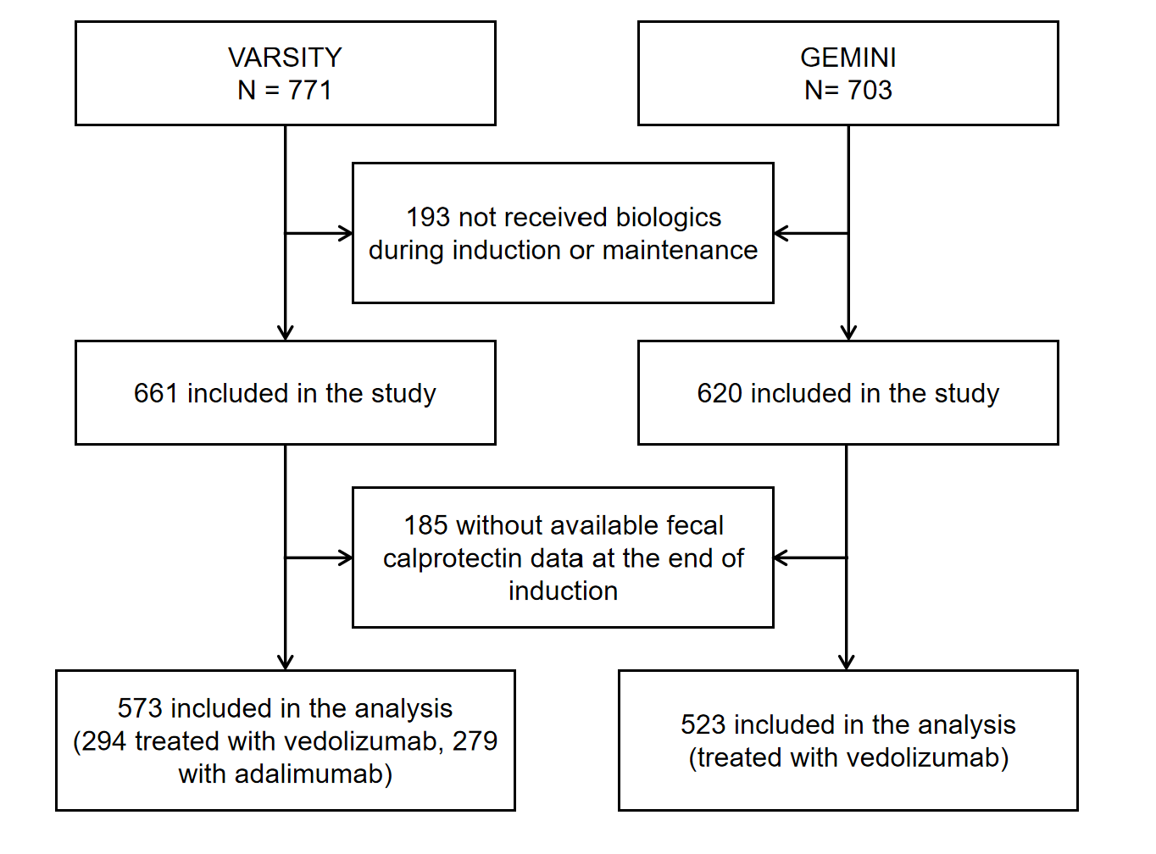

Figure S1. The flow chart of participant recruitment.

Figure S2. Sensitivity analyses using restricted cubic spline curves with three knots in the discovery cohort.
(a) for endoscopic remission; (b) for endoscopic improvement; (c) for clinical remission; (d) for histologic remission; (e) for histologic improvement; (f) for disease clearance. Spline curves represent odds ratios adjusted for age, sex, disease duration, smoking history, previous exposure of tumor necrosis factor antagonist, treatment allocations, concomitant corticosteroid use at baseline, baseline partial Mayo score, and baseline Mayo endoscopy score. The blue solid lines are fitted based on logistic regression models, with 95% confidence intervals indicated by the shaded areas. The reference point, that is, the median of fecal calcitonin levels, is represented by a pink vertical line, with three knots set at the 10th, 50th, and 90th percentiles.

Figure S3. Sensitivity analyses using restricted cubic spline curves with five knots in the discovery cohort.
(a) for endoscopic remission; (b) for endoscopic improvement; (c) for clinical remission; (d) for histologic remission; (e) for histologic improvement; (f) for disease clearance. To better present the curve, the part of the curve with fecal calprotectin >7000 μg/g (poor convergence) was omitted in (f). Spline curves represent odds ratios adjusted for age, sex, disease duration, smoking history, previous exposure of tumor necrosis factor antagonist, treatment allocations, concomitant corticosteroid use at baseline, baseline partial Mayo score, and baseline Mayo endoscopy score. The blue solid lines are fitted based on logistic regression models, with 95% confidence intervals indicated by the shaded areas. The reference point, that is, the median of fecal calcitonin levels, is represented by a pink vertical line, with five knots set at the 5th, 27.5th, 50th, 75.5th, and 95th percentiles.

Figure S4. Sensitivity analyses for the nonlinear association between fecal calprotectin and redefined disease clearance.
(a-c) Restricted cubic spline curves with three knots (10th, 50th, and 90th percentiles), four knots (5th, 35th, 65th, and 95th percentiles), and five knots (5th, 27.5th, 50th, 75.5th, and 95th percentiles). Disease clearance was defined as the simultaneous achievement of clinical, endoscopic, and histological remission. Spline curves represent odds ratios adjusted for age, sex, disease duration, smoking history, previous exposure of tumor necrosis factor antagonist, treatment allocations, concomitant corticosteroid use at baseline, baseline partial Mayo score, and baseline Mayo endoscopy score. The blue solid lines are fitted based on logistic regression models, with 95% confidence intervals indicated by the shaded areas. The reference point, that is, the median of fecal calcitonin levels, is represented by a pink vertical line.
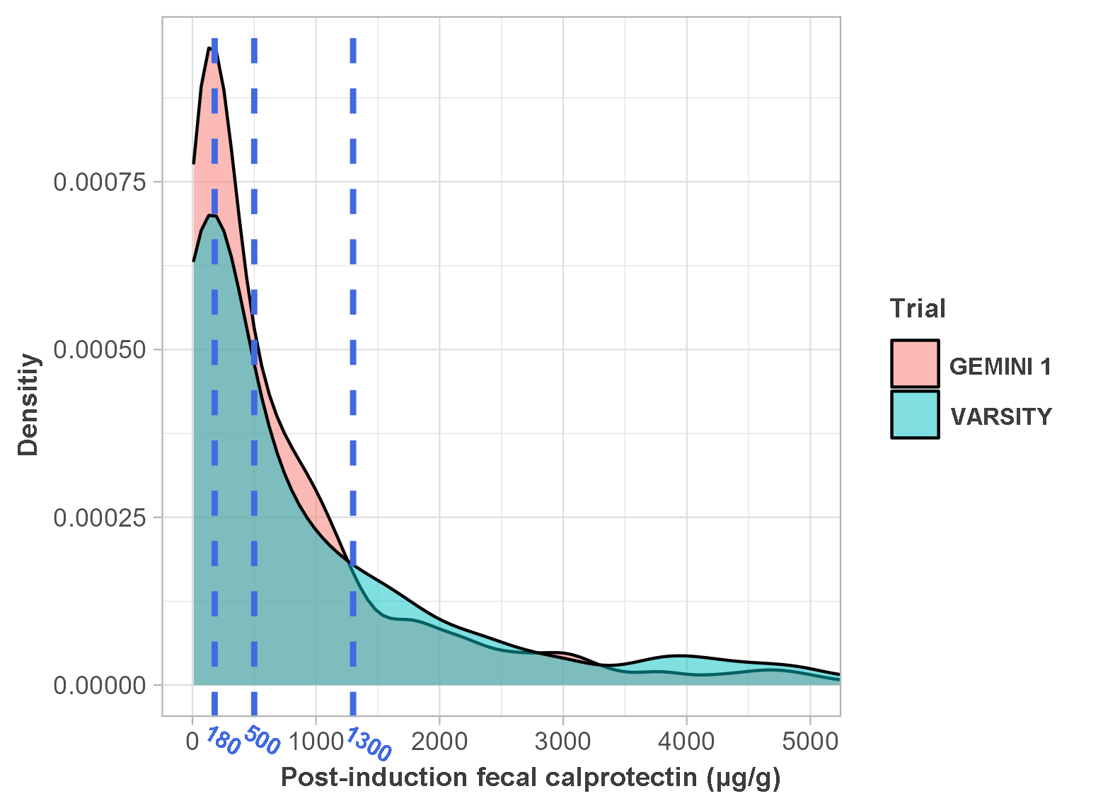

Figure S5. Density plot of post-induction fecal calprotectin levels and the selection of cutoff values.

Figure S6. Restricted cubic spline for the nonlinear associations between fecal calprotectin and long-term outcomes in the validation cohort.
(a) for endoscopic remission; (b) for endoscopic improvement; (c) for clinical remission. Spline curves represent odds ratios adjusted for age, sex, disease duration, smoking history, previous exposure of tumor necrosis factor antagonist, treatment allocations, concomitant corticosteroid use at baseline, baseline partial Mayo score, and baseline Mayo endoscopy score. The blue solid lines are fitted based on logistic regression models, with 95% confidence intervals indicated by the shaded areas. The reference point, that is, the median of fecal calcitonin levels, is represented by a pink vertical line, with four knots set at the 5th, 35th, 65th, and 95th percentiles.

Figure S7. Sensitivity analyses using restricted cubic spline curves with three and five knots in the validation cohort.
(a-c) Restricted cubic spline curves with three knots set at the 10th, 50th, and 90th percentiles of fecal calprotectin for endoscopic remission, endoscopic improvement, and clinical remission, respectively. (d-f) Restricted cubic spline curves with three knots five knots set at the 5th, 27.5th, 50th, 75.5th, and 95th percentiles of fecal calprotectin for endoscopic remission, endoscopic improvement, and clinical remission, respectively. Spline curves represent odds ratios adjusted for age, sex, disease duration, smoking history, previous exposure of tumor necrosis factor antagonist, treatment allocations, concomitant corticosteroid use at baseline, baseline partial Mayo score, and baseline Mayo endoscopy score. The blue solid lines are fitted based on logistic regression models, with 95% confidence intervals indicated by the shaded areas. The reference point, that is, the median of fecal calcitonin levels, is represented by a pink vertical line.

