Supplementary materials

Supplementary Figure 1 TGA curves of CeO₂@IN NPs
Supplementary Figure 2 H&E staining image of colon from colitis mice, which show high CT signals at 12 h post-administration of CeO₂@IN NPs. Scale bars, 200 µm.
Supplementary Figure 3 Representative CT images of mice in CeO₂@IN NPs group at 12 h following oral administration during the whole treatment period
Supplementary Figure 4 H&E stain of the major organs from C57BL/6 mice receiving CeO₂@IN treatment at 14-days. Scales bars, 100 µm.
Supplementary Figure 5 ICP-MS analysis of Ce contents in various organs (A) and feces (B) of C57BL/6 mice at 24h following oral administration of CeO₂@IN NPs. Healthy C57BL/6 mice treated with PBS served as a control.

Supplementary Figure 1.

Supplementary Figure 2.

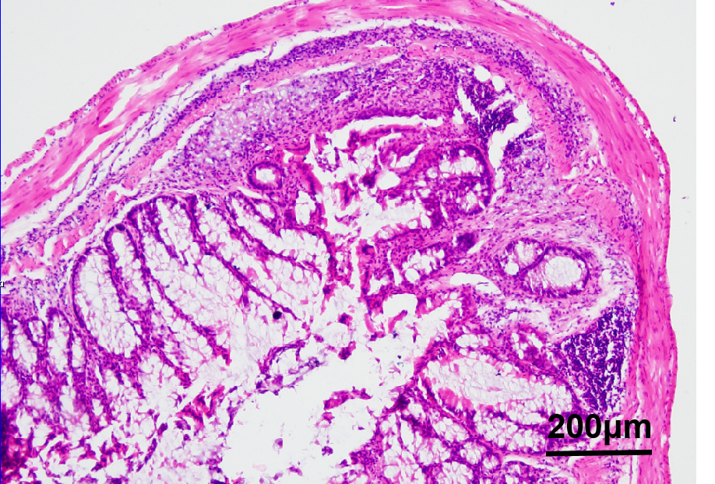
.

Supplementary Figure 3.

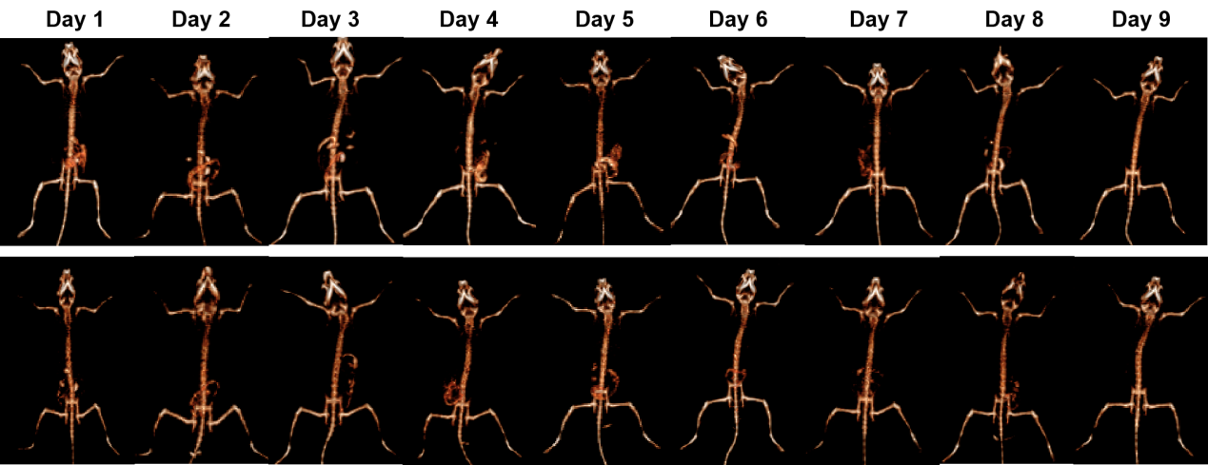

Supplementary Figure 4.

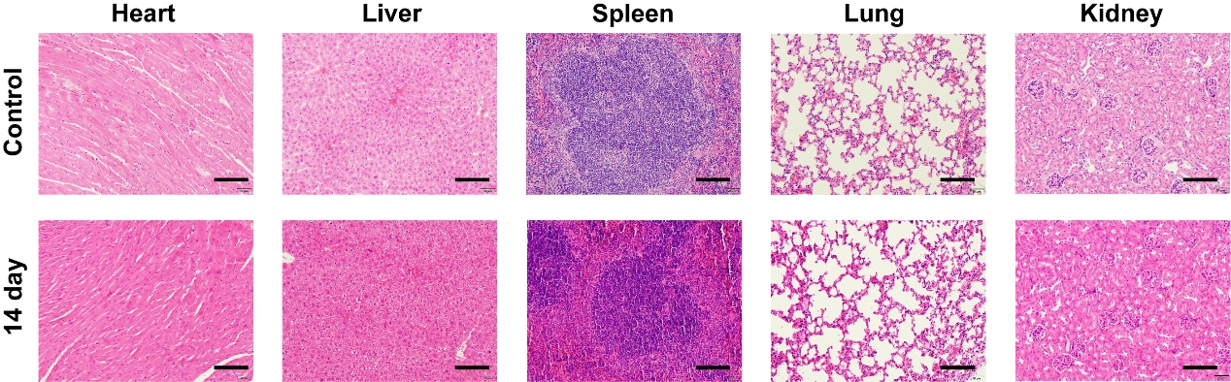

Supplementary Figure 5.

