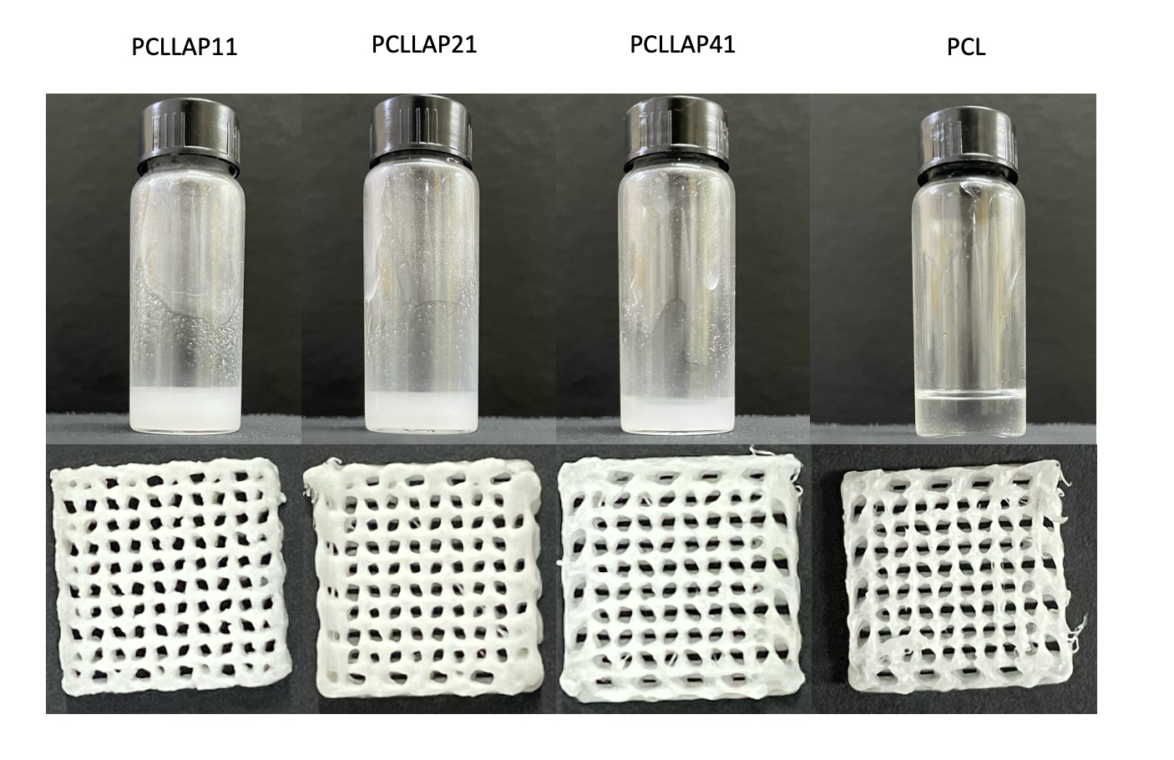
Figure S1. Visual aspect of the inks used for printing the scaffolds and the scaffolds obtained from each group.

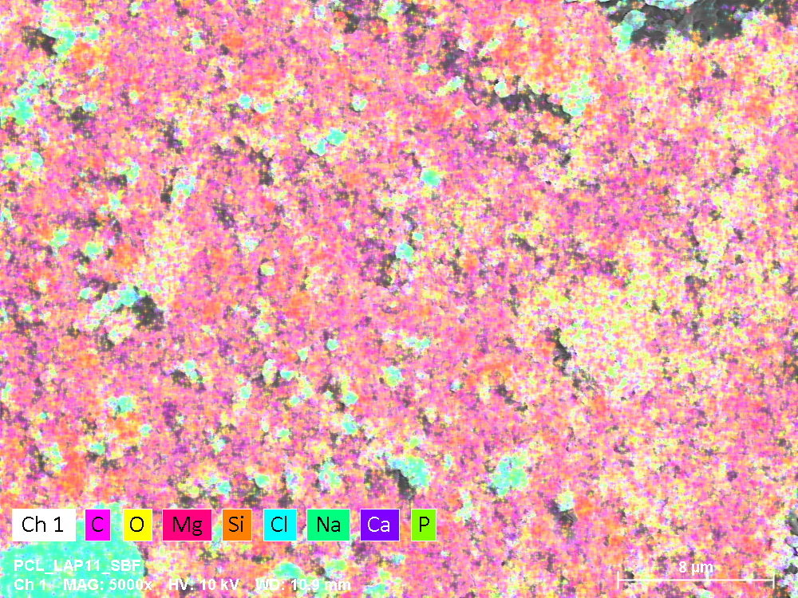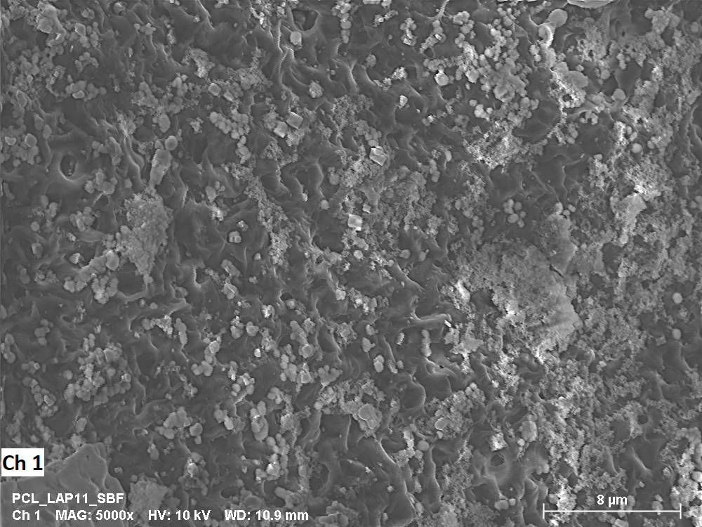
Figure S2. EDS mapping collecting from the SEM image of PCLLAP11 group

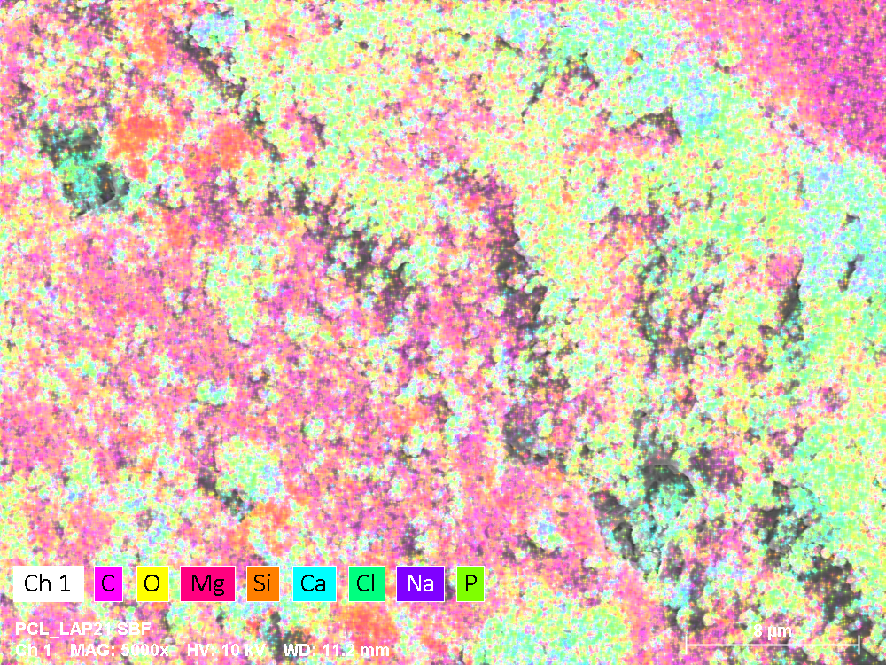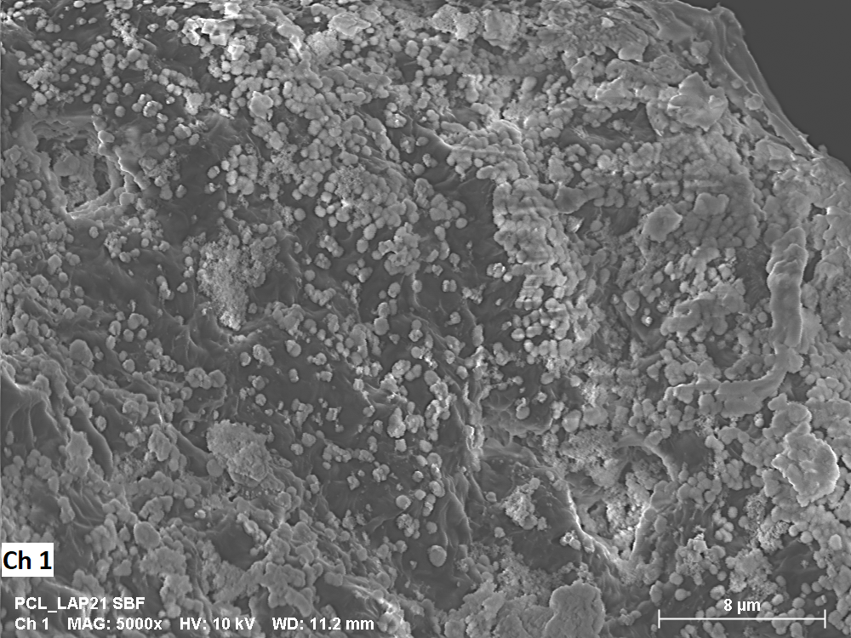
Figure S3. EDS mapping collecting from the SEM image of PCLLAP21 group

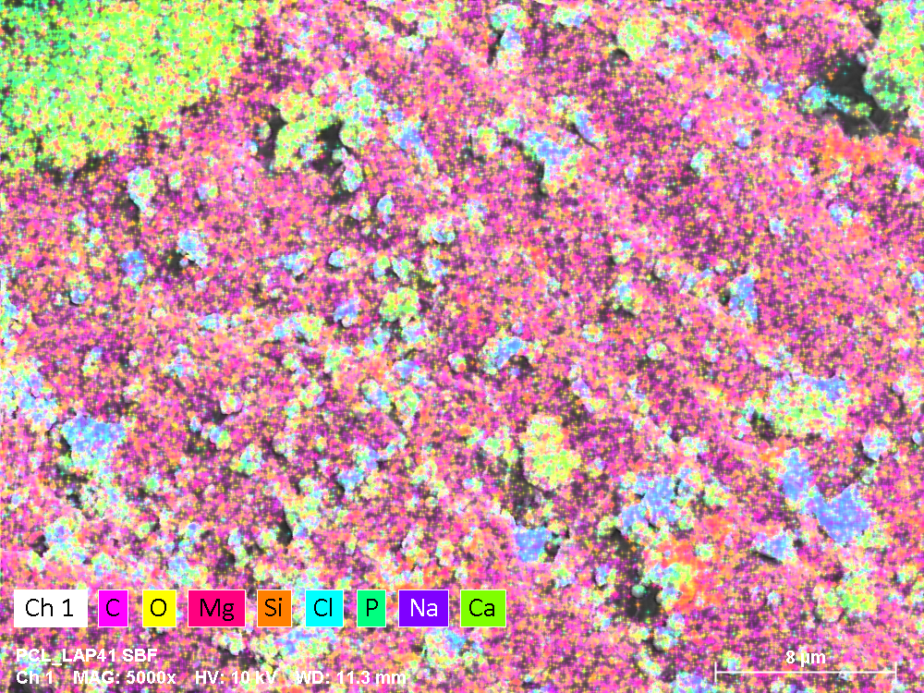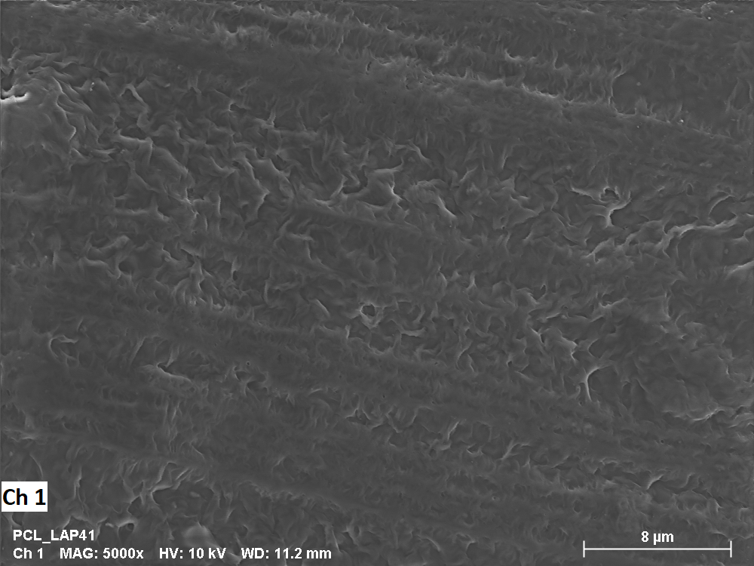
Figure S4. EDS mapping collecting from the SEM image of PCLLAP41 group

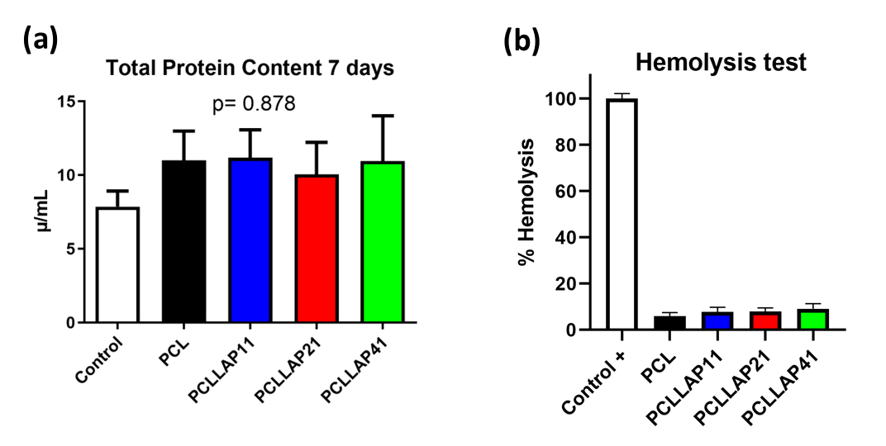
Figure S5: a) Total proteins counted after 7 days of the implantation of cells into the material surface; (b) hemolytic property trial made in each group to evaluate the material capability to cause a hemolytic process. data presented as mean value ± standard, n = 3, deviation analyzed by one-way ANOVA (p < 0.05).

