Supplementary：
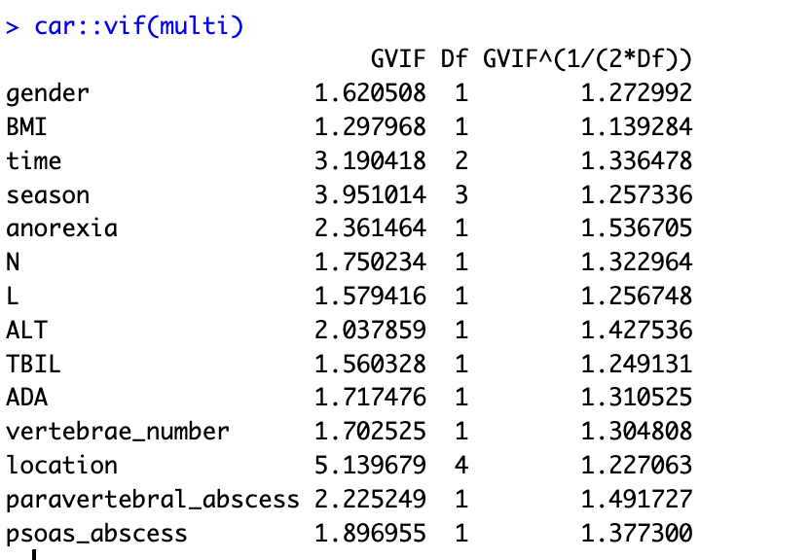
Figure S1 Results of collinearity analysis

