Supplementary Figures and legends

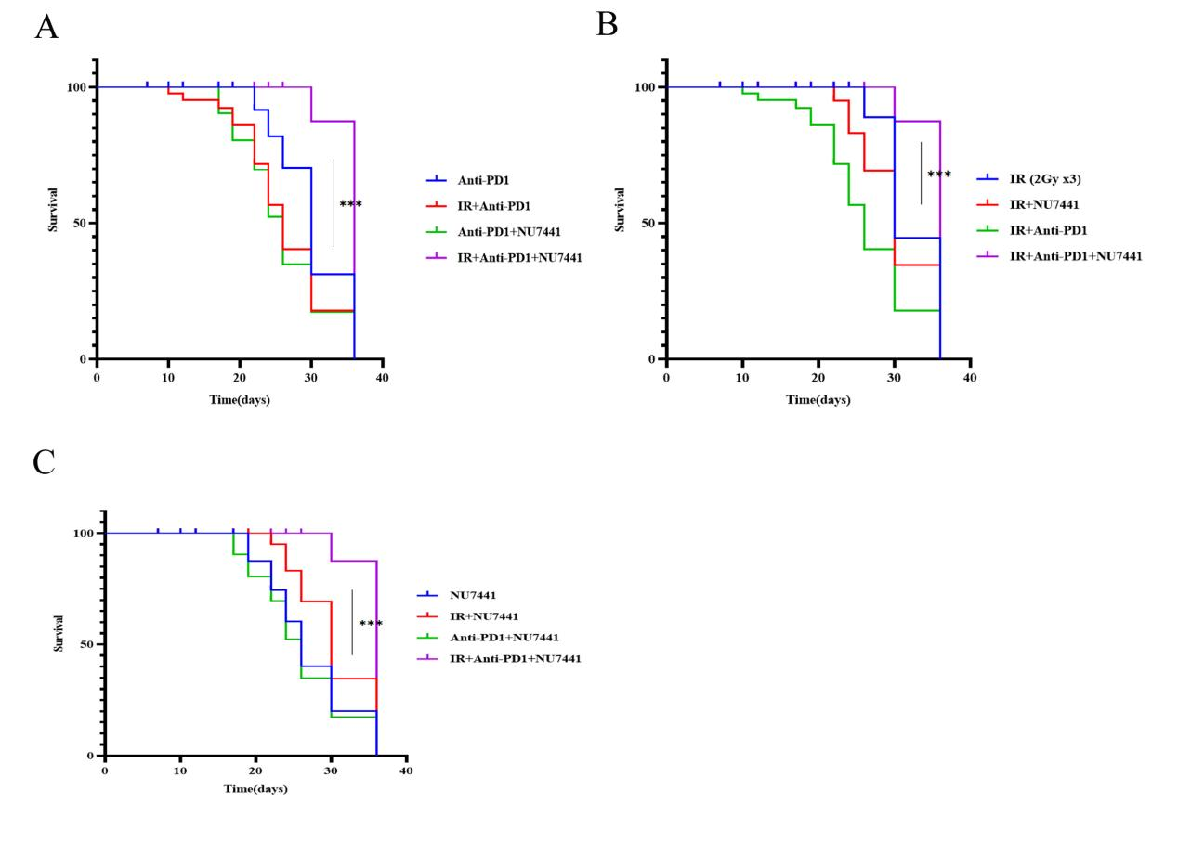
Supplementary Figure 1. The inclusion of NU7441 enhances the efficacy of radiation therapy in conjunction with anti-PD-1 treatment, leading to increased survival rates in mice. (A) Response of the HNSCC tumors to treatment with the indicated treatment regimens including IR. n=5 in each group. Data represent the mean±SEM. (B) Response of the HNSCC tumors to treatment with the indicated treatment regimens including NU7441. n=5 in each group. Data represent the mean±SEM. (C) Response of the HNSCC tumors to treatment with the indicated treatment regimens including Anti-PD1. n=5 in each group. Data represent the mean±SEM. ***p<0.001 (one-way ANOVA, with Dunnett’s correction).

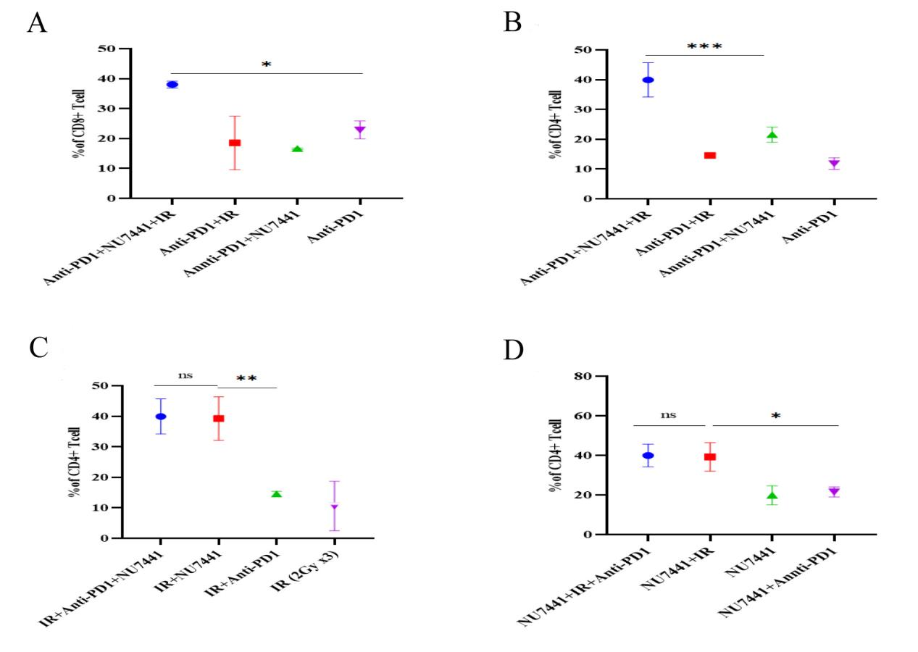
Supplementary Figure 2. Triple therapy affects T cell infiltration in mice tumors. (A) The quantitation of the percentages of TIL CD8+ Tcell was shown in the different subgroups including Anti-PD1 treatment. Data represent the mean±SEM. (B) The quantitation of the percentages of TIL CD4+ Tcell was shown in the different subgroups including Anti-PD1 treatment. Data represent the mean±SEM. (C) The quantitation of the percentages of TIL CD4+ Tcell was shown in the different subgroups including IR treatment. Data represent the mean±SEM. (D) The quantitation of the percentages of TIL CD4+ Tcell was shown in the different subgroups including NU7441 treatment. Data represent the mean±SEM. *p<0.05, **p<0.01, ***p<0.001 (one-way ANOVA, with Dunnett’s correction). Ns, not significant (significance level, α = 0.05).

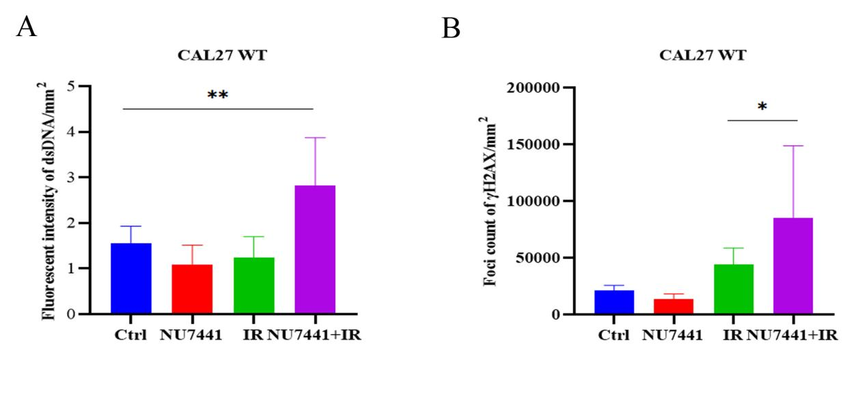
Supplementary Figure 3. Quantitative assessment of immunostaining for foci count of gamma-H2AX and fluorescent intensity of dsDNA. (A) Bar graph of fluorescent intensity of dsDNA in CAL 27 cells. (B) Bar graph of γH2AX foci count in CAL 27 cells. Data represent the mean±SEM. *p<0.05, **p<0.01, (one-way ANOVA, with Dunnett’s correction).

