ONLINE SUPPLEMENT

Contents
eMethods 1. Eligibility criteria for biologic therapy among non-initiators 2
eMethods 2. Statistical methods 2
eTable 1. CLEAR Study Working Group members and affiliations 6
eTable 2. Baseline variable definitions 14
eTable 3. Definitions of clinical outcome variables 16
eTable 4. Biologic initiation and use patterns by country 19
eTable 5. SMDs before and after IPTW among initiators and non-initiators 21
eTable 6. SMDs before and after IPTW for continuers versus switchers and continuers versus stoppers 22
eTable 7. Clinical outcomes in biologic use subgroups 23
eTable 8. Multivariable model for AAER by biologic initiator subgroup after IPTW (initiators vs non-initiators) 25
eTable 9. Multivariable model for AAER by biologic use subgroup after IPTW (continuers vs switchers vs stoppers) 27
eTable 10. Sensitivity analysis examining the impact of clustering by country on the comparison of clinical outcomes in biologic initiator subgroups (after IPTW) 29
eFigure 1. Exacerbations (A), asthma control (B), hospitalizations (C) and ER visits (D) during the baseline period among biologic initiators (pre-biologic therapy) and non-initiators (pre-study enrollment) after IPTW. 31
eFigure 2. Exacerbations (A), asthma control (B), hospitalizations (C) and ER visits (D) during the baseline period (pre-biologic therapy) among subsequent biologic continuers, switchers and stoppers after IPTW. 32

eMethods 1. Eligibility criteria for biologic therapy among non-initiators
To be eligible for biologics, patients must have had at least two exacerbations during the baseline period before enrollment into ISAR or have been receiving long-term oral corticosteroids (LTOCS). The following treatment-specific phenotypic criteria were also required:
- anti-immunoglobulin (Ig)E: positive allergen test and serum total IgE ≥30 IU/mL
- anti-interleukin (IL)-5/5 receptor α: blood eosinophil count ≥150 cells/μL while receiving LTOCS or ≥300 cells/μL without LTOCS
- anti-IL-4/13: blood eosinophil count ≥150 cells/μL while receiving LTOCS or ≥300 cells/μL without LTOCS, or fractional exhaled nitric oxide ≥25 ppb.

eMethods 2. Statistical methods
Baseline (pre-biologic treatment) demographic and clinical characteristics were summarized using descriptive statistics: continuous variables were summarized with mean and standard deviation and categorical data were summarized as a number and percentage. The differences between subgroups were assessed using t-tests or one-way analysis of variance for continuous variables and χ² tests for categorical/count data variables, except for duration of follow-up, which was assessed using a Kruskal–Wallis rank sum test.
Before assessment of follow-up outcomes, inverse probability of treatment weighting (IPTW) on the propensity score was used to correct for baseline imbalances between initiators and non-initiators, as well as between continuers, switchers and stoppers. The propensity score for the comparison of biologic initiators and non-initiators was generated from logistic regression modelling using selected patient-level baseline characteristics that were expected (on clinical grounds) to be related to the outcomes, or to both the outcomes and biologic initiation. These variables were sex, age at index date, LTOCS use, body mass index at index date, asthma control at index date, age of asthma onset, smoking status, pre-index date asthma exacerbations and pre-index date values of the other outcomes considered; inclusion of age at index date and age at asthma onset as factors in the modelling allowed differences in cohort index dates between initiators and non-initiators to be accounted for. For the comparison of continuers, switchers and stoppers, propensity scores were derived using multinomial logit models with the same set of patient-level baseline characteristics. Patients with missing data for the variables included in the propensity score models were excluded (leading to a reduced overall sample size compared with the original data set). Propensity score weights were stabilized to reduce the variance of the effect estimates. For the comparison of biologic initiators and non-initiators, the mean weight was 1.00, the minimum weight was 0.53 and the maximum weight was 6.07. For the continuers/switchers/stoppers analysis, the mean weight was 1.00, minimum weight was 0.36 and maximum weight was 5.02. Standardized mean differences (SMDs) were calculated for categorical and continuous baseline variables before and after IPTW, with an SMD of no more than 10% indicating sufficient balance.
The IPTW approach created a pseudo-population in which measured baseline characteristics were balanced across the different biologic use subgroups; the weighting did not constrain the relative sample sizes of the subgroups to match their equivalents before IPTW. Subgroup sample sizes, based on summing non-integer weights, were rounded to the nearest integer. These sample sizes reflect changes to the relative contribution of each individual according to how similar their baseline characteristics are to those of individuals in other subgroups: patients in a particular biologic initiator subgroup (e.g., continuers) who have a lower probability of being in that group (e.g., they had similar characteristics to switchers) receive larger weights and their relative influence on the comparison is increased.
Annualized asthma exacerbation rate (AAER; primary outcome) was analyzed using negative binomial regression in the IPTW cohort based on LTOCS use, age, sex, body mass index, asthma control, age of asthma onset, smoking status and pre-index date exacerbations. In the adjusted analysis, these variables were included as covariates.
Group differences in time to first asthma exacerbation were determined using Cox proportional hazards regression, adjusting for the eight IPTW propensity score variables detailed for AAER.
Asthma symptom control was analyzed using an adjusted binary logistic regression model (0 = well controlled or partially controlled, 1 = uncontrolled) in the IPTW cohort based on the eight IPTW propensity score variables detailed for AAER. In the adjusted analysis, these variables plus baseline asthma control were included as covariates.
LTOCS dose was analyzed using a generalized linear model in the IPTW cohort based on the eight IPTW propensity score variables detailed for AAER. In the adjusted analysis, these variables plus LTOCS dose at baseline were included as covariates.
Hospitalizations and ER visits were analyzed using negative binomial regression in the IPTW cohort based on the eight IPTW propensity score variables detailed for AAER. In the adjusted analysis, these variables plus pre-index date hospitalization or ER visits were included as covariates.
To account for the multilevel data structure, with patients nested within countries, a sensitivity analysis was conducted to assess whether country-level clustering and variation in disease severity might affect estimates of treatment group comparisons. The outcome analyses after IPTW for continuers versus switchers or stoppers were repeated using marginal models for the propensity scores and a random effect for country in the weighted outcome models. This approach of exploiting the multilevel structure in the second stage (outcome) model can greatly reduce bias in the presence of unmeasured cluster-level confounding (Li F et al., Stat Med. 2013;32(19):3373-87; doi: 10.1002/sim.5786)
All statistical analyses were performed using Stata version 14.2 (StataCorp, College Station, TX, USA). Statistical significance was defined as P < 0.05.

eTable 1. CLEAR Study Working Group members and affiliations
Mona Al-ahmad | Microbiology Department, Faculty of Medicine, Kuwait University, Kuwait City, Kuwait; Al-Rashed Allergy Center, Ministry of Health, Kuwait City, Kuwait
Riyad Al-Lehebi | Department of Pulmonology, King Fahad Medical City, Riyadh, Saudi Arabia; College of Medicine, Alfaisal University, Riyadh, Saudi Arabia
Leif Bjermer | Department of Clinical Sciences, Respiratory Medicine and Allergology, Skåne University Hospital, Lund University, Lund, Sweden
Anne-Sofie Bjerrum | Department of Respiratory Medicine and Allergy, Aarhus University Hospital, Aarhus, Denmark
Sinthia Bosnic-Anticevich | Quality Use of Respiratory Medicines Group, Woolcock Institute of Medical Research, Glebe, NSW, Australia; Macquarie University, Macquarie Park, NSW, Australia
John Busby | Centre for Public Health, Queen’s University Belfast, Belfast, UK
Giorgio Walter Canonica | Personalized Medicine, Asthma and Allergy, Humanitas Clinical and Research Center IRCCS, Milan, Italy; Department of Biomedical Sciences, Humanitas University, Milan, Italy
Carlos Andrés Celis-Preciado | Pulmonary Unit, Hospital Universitario San Ignacio, Bogota, Colombia; Faculty of Medicine, Pontificia Universidad Javeriana, Hospital Universitario San Ignacio, Bogota, Colombia
Kenneth R. Chapman | University of Toronto, Toronto, ON, Canada
George C. Christoff | Faculty of Public Health, Medical University Sofia, Sofia, Bulgaria
Borja G. Cosio | Son Espases University Hospital-IdISBa-Ciberes, Mallorca, Spain
Richard Costello | Department of Respiratory Medicine, Clinical Research Centre, Beaumont Hospital, RCSI, Dublin, Ireland
Andréanne Côté | Department of Medicine, Laval University, Quebec City, QC, Canada
Delbert Dorscheid | Center for Heart Lung Innovation, University of British Columbia, Vancouver, BC, Canada
J. Mark FitzGerald | Department of Medicine, University of British Columbia, Vancouver, BC, Canada
Mina Gaga | 7th Respiratory Medicine Department, Sotiria General Hospital of Chest Diseases of Athens, Athens, Greece
Peter G. Gibson | School of Medicine and Public Health, University of Newcastle, New Lambton, NSW, Australia; Department of Respiratory & Sleep Medicine, Hunter Medical Research Institute, John Hunter Hospital, New Lambton, NSW, Australia
Yahya Habis | Division of Pulmonology, Department of Medicine, Faculty of Medicine, King Abdulaziz University, Jeddah, Saudi Arabia
Liang-Wen Hang | Sleep Medicine Center, Department of Pulmonary and Critical Care Medicine, China Medical University Hospital, Taichung, Taiwan
Liam G. Heaney | Wellcome-Wolfson Centre for Experimental Medicine, Queen’s University Belfast, Belfast, UK
Enrico Heffler | Personalized Medicine, Asthma and Allergy, Humanitas Clinical and Research Center IRCCS, Milan, Italy; Department of Biomedical Sciences, Humanitas University, Milan, Italy
Mark Hew | Allergy, Asthma & Clinical Immunology Service, Alfred Health, Melbourne, VIC, Australia; Public Health and Preventive Medicine, Monash University, Melbourne, VIC, Australia
Erick Wan-Chun Huang | Division of Pulmonary Medicine, Department of Internal Medicine, Shuang Ho Hospital, Taipei Medical University, New Taipei City, Taiwan
Takashi Iwanaga | Center for General Medical Education and Clinical Training, Kindai University Hospital, Osakasayama, Japan
David Jackson | UK Severe Asthma Network and National Registry, Guy’s and St Thomas’ NHS Foundation Trust, London, UK; School of Immunology & Microbial Sciences, King’s College London, London, UK
Claus Rikard Johnsen | Allergy Clinic, Gentofte University Hospital, Hellerup, Denmark
Rupert C. Jones | Research and Knowledge Exchange, Plymouth Marjon University, Plymouth, UK
Mariko Siyue Koh | Respiratory & Critical Care Medicine, Singapore General Hospital, Singapore; Duke-NUS Medical School, Singapore
Konstantinos Kostikas | Respiratory Medicine Department, University of Ioannina, Ioannina, Greece
Piotr Kuna | Division of Internal Medicine, Asthma and Allergy, Medical University of Łódź, Łódź, Poland
Sverre Lehmann | Section of Thoracic Medicine, Department of Clinical Science, University of Bergen, Bergen, Norway
Lauri Lehtimäki | Allergy Centre, Tampere University Hospital, Tampere, Finland; Faculty of Medicine and Health Technology, Tampere University, Tampere, Finland
Désirée Larenas Linnemann | Centre of Excellence in Asthma and Allergy, Médica Sur Hospital, Mexico City, Mexico
Bassam Mahboub | College of Medicine, University of Sharjah, Sharjah, UAE; Rashid Hospital, Dubai Health Authority, Dubai, UAE
Neil Martin | Respiratory and Immunology, BioPharmaceuticals Medical, AstraZeneca, Cambridge, UK; University of Leicester, Leicester, UK
Ekaterina Maslova | BioPharmaceuticals Medical, AstraZeneca, Cambridge, UK
Jorge Maspero | Clinical Research for Allergy and Respiratory Medicine, CIDEA Foundation, Buenos Aires, Argentina; Buenos Aires University School of Medicine, Buenos Aires, Argentina
Andrew N. Menzies-Gow | Royal Brompton and Harefield Hospitals, London, UK; Respiratory and Immunology, BioPharmaceuticals Medical, AstraZeneca, Cambridge, UK
Patrick D. Mitchell | School of Medicine, Trinity College, Dublin, Ireland
Nikolaos G. Papadopoulos | Division of Infection, Immunity & Respiratory Medicine, University of Manchester, Manchester, UK; Allergy Department, 2nd Pediatric Clinic, University of Athens, Athens, Greece
Andriana I. Papaioannou | 2nd Respiratory Medicine Department, National and Kapodistrian University of Athens Medical School, Attikon University Hospital, Athens, Greece
Patricia Parada-Tovar | CINEUMO, Respiratory Research Center, Fundación Neumológica Colombiana, Bogotá, Colombia
Pujan H. Patel | Royal Brompton and Harefield Hospitals, London, UK
Luis Perez-de-Llano | Department of Respiratory Medicine, University Hospital Lucus Augusti, Lugo, Spain
Diahn-Warng Perng (Steve) | Division of Clinical Respiratory Physiology, Department of Chest Medicine, Taipei Veterans General Hospital, Taipei, Taiwan; COPD Assembly of the Asian Pacific Society of Respirology, Tokyo, Japan
Matthew Peters | Department of Thoracic Medicine, Concord Hospital, Sydney, NSW, Australia
Paul Pfeffer | Department of Respiratory Medicine, Barts Health NHS Trust, London, UK; Barts and the London School of Medicine and Dentistry, Queen Mary University of London, London, UK
Ted Popov | St. Ivan Rilski University Hospital, Sofia, Bulgaria
Celeste Porsbjerg | Respiratory Research Unit, Bispebjerg Hospital, Copenhagen, Denmark
Chin Kook Rhee | Department of Internal Medicine, Division of Pulmonary and Critical Care Medicine, Seoul St. Mary’s Hospital, College of Medicine, the Catholic University of Korea, Seoul, South Korea
Mohsen Sadatsafavi | Respiratory Evaluation Sciences Program, Faculty of Pharmaceutical Sciences, University of British Columbia, Vancouver, BC, Canada
Sundeep Salvi | Pulmocare Research and Education Foundation, Pune, India
Ana Sá-Sousa | MEDCIDS – Department of Community Medicine, Information and Health Decision Sciences; Faculty of Medicine, University of Porto, Porto, Portugal; CINTESIS@RISE – Health Research Network, Faculty of Medicine, University of Porto, Porto, Portugal
Camille Taille | Department of Respiratory Diseases, Bichat Hospital, AP-HP Nord-Université de Paris, Paris, France
Christian Taube | Department of Pulmonary Medicine, University Medical Center Essen-Ruhrlandklinik, Essen, Germany
Tunn Ren Tay | Department of Respiratory and Critical Care Medicine, Changi General Hospital, Singapore
Carlos A. Torres-Duque | CINEUMO, Respiratory Research Center, Fundación Neumológica Colombiana, Bogotá, Colombia
Eric Van Ganse | PELyon, Lyon, France; Research on Healthcare Performance RESHAPE, INSERM U1290, Université Claude Bernard Lyon 1, Lyon, France; Respiratory Medicine, Croix Rousse University Hospital, Lyon, France
Eileen Wang | Department of Medicine, Division of Allergy and Clinical Immunology, National Jewish Health, Denver, CO, USA; Department of Internal Medicine, Division of Allergy and Clinical Immunology, University of Colorado School of Medicine, Aurora, CO, USA
Michael W. Wechsler | Department of Medicine, Cohen Family Asthma Institute, National Jewish Health, Denver, CO, USA
Alexandra Wimmer-Aune | Department of Respiratory Medicine, Aalborg University Hospital, Aalborg, Denmark

eTable 2. Baseline variable definitions
Variable | Definition
Patient attributes
Age | Age in completed years. Reported as mean values and age group categories (18–45, 46–55, 56–65, >65 years)
Sex | Female or male
Body mass index | The ratio of weight (kg) to squared height (m²). Categorized as underweight (<18.5 kg/m²), normal weight (≥18.5 kg/m² and <25 kg/m²), overweight (≥25 kg/m² and <30 kg/m²) and obese (≥30 kg/m²)
Age at asthma onset | The age in completed years or months (if less than 1 year) at which asthma symptoms began
Smoking status | Categorized as non-smoker, current smoker or ex-smoker; based on last ever smoking status recorded
Diagnostic measurements
Blood eosinophil count | Count of blood eosinophils (10⁹ cells/L)
Blood IgE level | Blood level of IgE (IU/mL)
Predicted FEV₁ | Predicted value of forced expiratory volume in the first second of expiration (L)
Pre-bronchodilator FEV₁ | Measured forced expiratory volume in the first second of expiration, before the use of a bronchodilator (L)
Post-bronchodilator FEV₁ | Measured forced expiratory volume in the first second of expiration, after the use of a bronchodilator (L)
Pre-bronchodilator FVC | Forced vital capacity, before the use of a bronchodilator (L)
Post-bronchodilator FVC | Forced vital capacity, after the use of a bronchodilator (L)
Pre-bronchodilator FEV₁/FVC ratio | Measured pre-bronchodilator FEV₁ as a ratio of measured FVC, before the use of a bronchodilator
Post-bronchodilator FEV₁/FVC ratio | Measured post-bronchodilator FEV₁ as a ratio of measured FVC, after the use of a bronchodilator
FeNO test | Measurements of FeNO concentration in exhaled breath, measured in ppb at a flow rate of 50 mL/s
Skin prick test | Positive skin prick test to allergen
Therapy
LTOCS | Daily OCS use (any dose) for at least 3 months
Anti-IgE | Prescription for anti-IgE
Anti-IL-5 | Prescription for anti-IL-5 or 5 receptor
Anti-IL-4/13 | Prescription for anti-IL-4/13
FeNO, fractional exhaled nitric oxide; FEV₁, forced expiratory volume in 1 second; FVC, forced vital capacity; IgE, immunoglobulin E; IL, interleukin; LTOCS, long-term oral corticosteroid; OCS, oral corticosteroid; SCS, systemic corticosteroid.

eTable 3. Definitions of clinical outcome variables
Variable | Type | Definition
Number of asthma exacerbations | Count | Annualized number of exacerbations defined as the occurrence of the following events: 1) asthma-related hospital attendance or admission for primary care consultation; and/or 2) asthma-related emergency room visit; and/or 3) an acute OCS course of 3 days or more.  Calculated for the 12-month baseline period and for the follow-up period between index date and date of last visit (closest available to 12 months post-index date). Separate recordings of an exacerbation within a 14-day period were treated as the same exacerbation.
Asthma control in the past 4 weeks | Categorical | Categorized as controlled, partly controlled or uncontrolled according to the GINA 2018 asthma control criteria, Asthma Control Questionnaire-6 or Asthma Control Test as follows.  - Controlled (GINA: none of the following: daytime symptoms >twice/week, nighttime waking owing to asthma, reliever needed >twice/week, activity limitation owing to asthma; ACQ ≤0.75; ACT ≥20)  - Partly controlled (GINA: 1 or 2 of the following: daytime symptoms >twice/week, nighttime waking owing to asthma, reliever needed >twice/week, activity limitation owing to asthma; ACQ 0.75– ≤1.5)  - Uncontrolled (GINA: ≥3 of the following: daytime symptoms >twice/week, nighttime waking owing to asthma, reliever needed >twice/week, activity limitation owing to asthma; ACQ >1.5; ACT <20)  Evaluated at baseline, from the last available data in the 12-month period before the index date, and at follow-up, from the closest available data to 12 months post-index date (minimum 6 months post-index date). In both cases, data must have been from the past 4 weeks.
Daily dose of long-term oral corticosteroids | Continuous | Assessed by dividing patients’ cumulative total dose of OCS, calculated as label dose × frequency per day × duration of use, by the number of days of baseline or follow-up data.  Calculated for the 12-month baseline period and between the index date and date of last visit in the follow-up period (closest available to 12 months post-index date). If use of OCS started before the index date, total dose was calculated between the index date and end date of use. If use of OCS started after the index date, total dose was calculated between the start date and the end date of use. Patients must have been receiving OCS daily (at any dose) for at least 3 months in the respective period.  Change in daily LTOCS dose was calculated from the LTOCS dose during the follow-up period minus the baseline LTOCS dose.
Number of hospitalizations | Count | Annualized number of hospital admissions, calculated for the 12-month baseline period and for the follow-up period between the index date and date of last visit (closest available to 12 months post-index date).
Number of emergency room visits | Count | Annualized number of emergency room visits, calculated for the 12-month baseline period and for the follow-up period between the index date and date of last visit (closest available to 12 months post-index date).
ACQ, Asthma Control Questionnaire; ACT, Asthma Control Test; GINA, Global Initiative for Asthma; LTOCS, long-term oral corticosteroid; OCS, oral corticosteroid.

eTable 4. Biologic initiation and use patterns by country
Country | Total biologic initiators meeting study inclusion criteria per country, n (%) | Continuers per country, n (%) | Switchers per country,  n (%) | Stoppers per country,  n (%)
Argentina | 10 (0.5) | 10 (100) | 0 (0) | 0 (0)
Australia | 78 (4.2) | 61 (78.2) | 16 (20.5) | 1 (1.3)
Bulgaria | 3 (0.2) | 3 (100.0) | 0 (0) | 0 (0)
Canada | 82 (4.4) | 66 (80.5) | 14 (17.1) | 2 (2.4)
Colombia | 5 (0.3) | 5 (100) | 0 (0) | 0 (0)
Denmark | 267 (14.4) | 172 (64.4) | 92 (34.5) | 3 (1.1)
Greece | 27 (1.5) | 26 (96.3) | 1 (3.7) | 0 (0)
Italy | 187 (10.1) | 169 (90.4) | 12 (6.4) | 6 (3.2)
Japan | 12 (0.6) | 10 (83.3) | 1 (8.3) | 1 (8.3)
Korea | 8 (0.4) | 4 (50.0) | 1 (12.5) | 3 (37.5)
Kuwait | 133 (7.2) | 88 (66.2) | 25 (18.8) | 20 (15.0)
Mexico | 44 (2.4) | 44 (100) | 0 (0) | 0 (0)
Saudi Arabia | 23 (1.2) | 18 (78.3) | 4 (17.4) | 1 (4.3)
Spain | 54 (2.9) | 47 (87.0) | 5 (9.3) | 2 (3.7)
Taiwan | 15 (0.8) | 3 (20.0) | 2 (13.3) | 10 (66.7)
UAE | 7 (0.4) | 7 (100) | 0 (0) | 0 (0)
UK | 453 (24.4) | 272 (60.0) | 124 (27.4) | 57 (12.6)
USA | 451 (24.3) | 111 (24.6) | 177 (39.2) | 163 (36.1)
Total | 1,859 | 1,116 | 474 | 269

eTable 5. SMDs before and after IPTW among initiators and non-initiators
Variable | Number of observations | SMD before IPTW | SMD after IPTW
Female | 3,403 | 0.05 | 0.02
Age at index date† | 3,404 | 0.28* | 0.01
Receiving LTOCS | 3,404 | 0.41* | 0.02
BMI at index date† | 3,145 | 0.05 | 0.00
Asthma control at index date† | 2,656 | 0.44* | 0.01
Age at onset of asthma | 1,856 | 0.19* | 0.04
Smoking status | 3,010 | 0.20* | 0.01
Pre-index date asthma exacerbations | 1,968 | 0.58* | 0.01
*SMD >0.1.
†For initiators, this was biologic initiation; for non-initiators, this was at the time of study enrollment.
BMI, body mass index; IPTW, inverse probability of treatment weighting; LTOCS, long-term oral corticosteroids; SMD, standardized mean difference.

eTable 6. SMDs before and after IPTW for continuers versus switchers and continuers versus stoppers
Variable | SMD before IPTW |  | SMD after IPTW
 | Continuers vs switchers | Continuers vs stoppers | Continuers  vs switchers | Continuers  vs stoppers
Female | 0.05 | 0.21* | 0.05 | 0.01
Age at biologic initiation | 0.29* | 0.03 | 0.08 | 0.04
Age at onset of asthma | 0.25* | 0.02 | 0.07 | 0.00
BMI at biologic initiation | 0.12* | 0.16* | 0.01 | 0.07
Asthma control at biologic initiation | 0.18* | 0.31* | 0.06 | 0.03
Smoking status | 0.01 | 0.19* | 0.02 | 0.09
Pre-index date asthma exacerbations | 0.30* | 0.26* | 0.08 | 0.05
Receiving LTOCS | 0.69* | 0.12* | 0.04 | 0.03
*SMD >0.1.
BMI, body mass index; IPTW, inverse probability of treatment weighting; LTOCS, long-term oral corticosteroids; SMD, standardized mean difference.

eTable 7. Clinical outcomes in biologic use subgroups
Outcome | Initiators |  | Non-initiators |  | Continuers |  | Switchers |  | Stoppers
Outcome | Baseline | Follow-up | Baseline | Follow-up | Baseline | Follow-up | Baseline | Follow-up | Baseline | Follow-up
AAER, mean (SD) | 4.0 (4.0) | 1.6 (2.9) | 4.4 (6.5) | 2.1 (3.5) | 4.8 (4.2) | 1.4 (2.7) | 5.1 (3.9) | 2.5 (2.9) | 4.4 (4.1) | 2.0 (2.4)
Time to first exacerbation, days, median (95% CI) | - | 588  (531, 630) | - | 400  (389, 422) | - | 692  (602, 833) | - | 469  (421, 513) | - | 518  (415, 602)
Annualized number of hospitalizations, mean (SD) | 0.6 (1.5) | 0.2 (0.9) | 0.7 (1.2) | 0.2 (0.6) | 0.6 (1.5) | 0.1 (0.5) | 0.9 (1.8) | 0.5 (1.6) | 1.1 (2.2) | 0.3 (1.1)
Annualized number of ER visits, mean (SD) | 1.4 (3.6) | 0.4 (2.1) | 1.4 (3.0) | 0.3 (1.2) | 1.4 (3.0) | 0.3 (1.1) | 2.6 (5.8) | 1.3 (3.9) | 1.6 (2.3) | 0.4 (1.7)
LTOCS use
Daily dose, mg, mean (SD) | 13.0 (9.8) | 7.8 (10.0) | 11.6 (7.2) | 9.5 (8.8) | 12.2 (8.4) | 6.2 (8.7) | 14.4 (10.8) | 11.1 (11.4) | 15.0 (13.1) | 10.8 (12.5)
Daily dose, mg, median | 10 | 5 | 10 | 10 | 10 | 5 | 10 | 8 | 10 | 8
Daily dose, mg, IQR | 5–16 | 0–10 | 5–15 | 4–12.5 | 5–15 | 0–8 | 8–20 | 5–15 | 5–20 | 0–20
Receiving daily dose of ≤5 mg, % | 27.7 | 60.9 | 27.7 | 43.7 | 29.4 | 70.0 | 16.3 | 38.1 | 32.7 | 40.7
Stopped OCS treatment, % | - | 28.6 | - | 20.1 | - | 33.7 | - | 12.9 | - | 35.0
AAER, annualized asthma exacerbation rate; CI, confidence interval; ER, emergency room; IQR, interquartile range; LTOCS, long-term oral corticosteroid; OCS, oral corticosteroid; SD, standard deviation.

eTable 8. Multivariable model for AAER by biologic initiator subgroup after IPTW (initiators vs non-initiators)
Patient characteristic | IRR | Robust standard error | 95% CI | P value
Biologic therapy
Non-initiator | 1.000
Initiator | 0.758 | 0.058 | 0.652, 0.881 | < 0.001
Gender
Male | 1.000
Female | 0.931 | 0.082 | 0.783, 1.106 | 0.416
Age at index date
18–45 | 1.000
46–55 | 1.163 | 0.128 | 0.938, 1.441 | 0.169
56–65 | 0.961 | 0.106 | 0.775, 1.193 | 0.720
>65 | 1.080 | 0.133 | 0.849, 1.374 | 0.530
Age at asthma onset, years | 0.991 | 0.002 | 0.987, 0.996 | < 0.001
BMI at index date, kg/m² | 1.006 | 0.006 | 0.995, 1.018 | 0.260
Asthma control at index date
Uncontrolled | 1.000
Partially controlled | 0.879 | 0.152 | 0.625, 1.234 | 0.456
Well controlled | 0.985 | 0.141 | 0.744, 1.304 | 0.915
Smoking status
Current smoker | 1.000
Ex-smoker | 1.639 | 0.299 | 1.146, 2.344 | 0.007
Non-smoker | 1.256 | 0.219 | 0.893, 1.767 | 0.190
Asthma exacerbations in the previous 12 months
0 | 1.000
1 | 1.880 | 0.405 | 1.233, 2.868 | 0.003
2 | 2.128 | 0.500 | 1.343, 3.373 | 0.001
3 | 2.354 | 0.502 | 1.551, 3.575 | < 0.001
4 | 3.162 | 0.673 | 2.084, 4.799 | < 0.001
≥5 | 3.219 | 0.643 | 2.176, 4.762 | < 0.001
Receiving LTOCS
No | 1.000
Yes | 0.641 | 0.051 | 0.548, 0.749 | < 0.001
AAER, annualized asthma exacerbation rate; BMI, body mass index; CI, confidence interval; IRR, incidence rate ratio; LTOCS, long-term oral corticosteroids

eTable 9. Multivariable model for AAER by biologic use subgroup after IPTW (continuers vs switchers vs stoppers)
Patient characteristic | IRR | Robust standard error | 95% CI | P value
Biologic use
Continuer | 1.000
Switcher | 1.829 | 0.179 | 1.509, 2.216 | < 0.001
Stopper | 1.526 | 0.191 | 1.194, 1.950 | 0.001
Gender
Male | 1.000
Female | 0.911 | 0.106 | 0.726, 1.144 | 0.424
Age at index date
18–45 | 1.000
46–55 | 1.158 | 0.140 | 0.914, 1.468 | 0.223
56–65 | 1.098 | 0.166 | 0.816, 1.477 | 0.538
>65 | 1.092 | 0.229 | 0.724, 1.647 | 0.675
Age at asthma onset, years | 0.992 | 0.003 | 0.986, 0.998 | 0.014
BMI at index date, kg/m² | 1.014 | 0.006 | 1.001, 1.026 | 0.032
Asthma control at index date
Uncontrolled | 1.000
Partially controlled | 0.813 | 0.254 | 0.440, 1.501 | 0.507
Well controlled | 0.797 | 0.187 | 0.503, 1.264 | 0.335
Smoking status
Current smoker | 1.000
Ex-smoker | 1.474 | 0.395 | 0.872, 2.491 | 0.147
Non-smoker | 1.098 | 0.274 | 0.673, 1.791 | 0.709
Asthma exacerbations in the previous 12 months
0 | 1.000
1 | 1.173 | 0.368 | 0.634, 2.169 | 0.612
2 | 1.590 | 0.494 | 0.865, 2.924 | 0.136
3 | 1.061 | 0.317 | 0.590, 1.907 | 0.843
4 | 2.258 | 0.643 | 1.293, 3.945 | 0.004
≥5 | 1.946 | 0.513 | 1.160, 3.264 | 0.012
Receiving LTOCS
No | 1.000
Yes | 0.531 | 0.056 | 0.431, 0.654 | < 0.001
AAER, annualized asthma exacerbation rate; BMI, body mass index; CI, confidence interval; IRR, incidence rate ratio; LTOCS, long-term oral corticosteroids

eTable 10. Sensitivity analysis examining the impact of clustering by country on the comparison of clinical outcomes in biologic initiator subgroups (after IPTW)
Outcome period observations | Switchers  vs continuers |  | Stoppers  vs continuers
Outcome period observations | Marginal* | Multilevel† | Marginal* | Multilevel†
AAER | aIRR: 1.83  (1.51, 2.22) | aIRR: 1.59  (0.93, 2.75) | aIRR: 1.53  (1.19, 1.95) | aIRR: 1.45  (1.32, 1.61)
Asthma control (uncontrolled asthma) ‡ | aOR: 5.40  (3.12, 9.33) | aOR: 5.37  (4.35, 6.64) | aOR: 4.02  (2.32, 6.98) | aOR: 4.46  (2.42, 8.21)
Change in daily LTOCS dose between baseline and follow-up, mg§ | aβ: 3.77  (1.71, 4.37) | aβ: 4.66  (2.75, 6.56) | aβ: 3.09  (−0.27, 6.45) | aβ: 4.79  (2.43, 7.15)
Number of hospitalizations (annualized) | aIRR: 2.58  (1.52, 4.37) | aIRR: 2.50  (2.02, 3.10) | aIRR: 1.20  (0.59, 2.42) | aIRR: 1.17  (0.76, 1.81)
Number of ED visits (annualized) | aIRR: 2.12  (1.39, 3.24) | aIRR: 2.12  (1.40, 3.20) | aIRR: 1.10  (0.60, 2.01) | aIRR: 1.10  (0.44, 2.73)
Data are estimate (95% confidence interval)
*Marginal refers to an analysis in which both the propensity score and outcome models were functions of the observed covariates only and did not include country-specific effects.
†Multilevel refers to an analysis in which the outcome model included country-specific random effects but the propensity score model was a function of the observed covariates only.
‡Asthma control (according to the GINA 2018 asthma control criteria, Asthma Control Questionnaire-6 or Asthma Control Test) at the last available assessment; the OR is for having uncontrolled asthma.
§Assessed from patients’ cumulative total dose of OCS, calculated as label dose × frequency × duration of use of OCS; minimum 3 months’ daily OCS use; β is the difference between groups in change in daily LTOCS dose.
AAER, annualized asthma exacerbation rate; β, beta coefficient; aβ, adjusted beta coefficient; aIRR, adjusted incidence rate ratio; aOR, adjusted odds ratio; ER, emergency room; GINA, Global Initiative for Asthma; HR, hazard ratio; IPTW, inverse probability of treatment weighting; IRR, incidence rate ratio; LTOCS, long-term oral corticosteroids; OR, odds ratio.

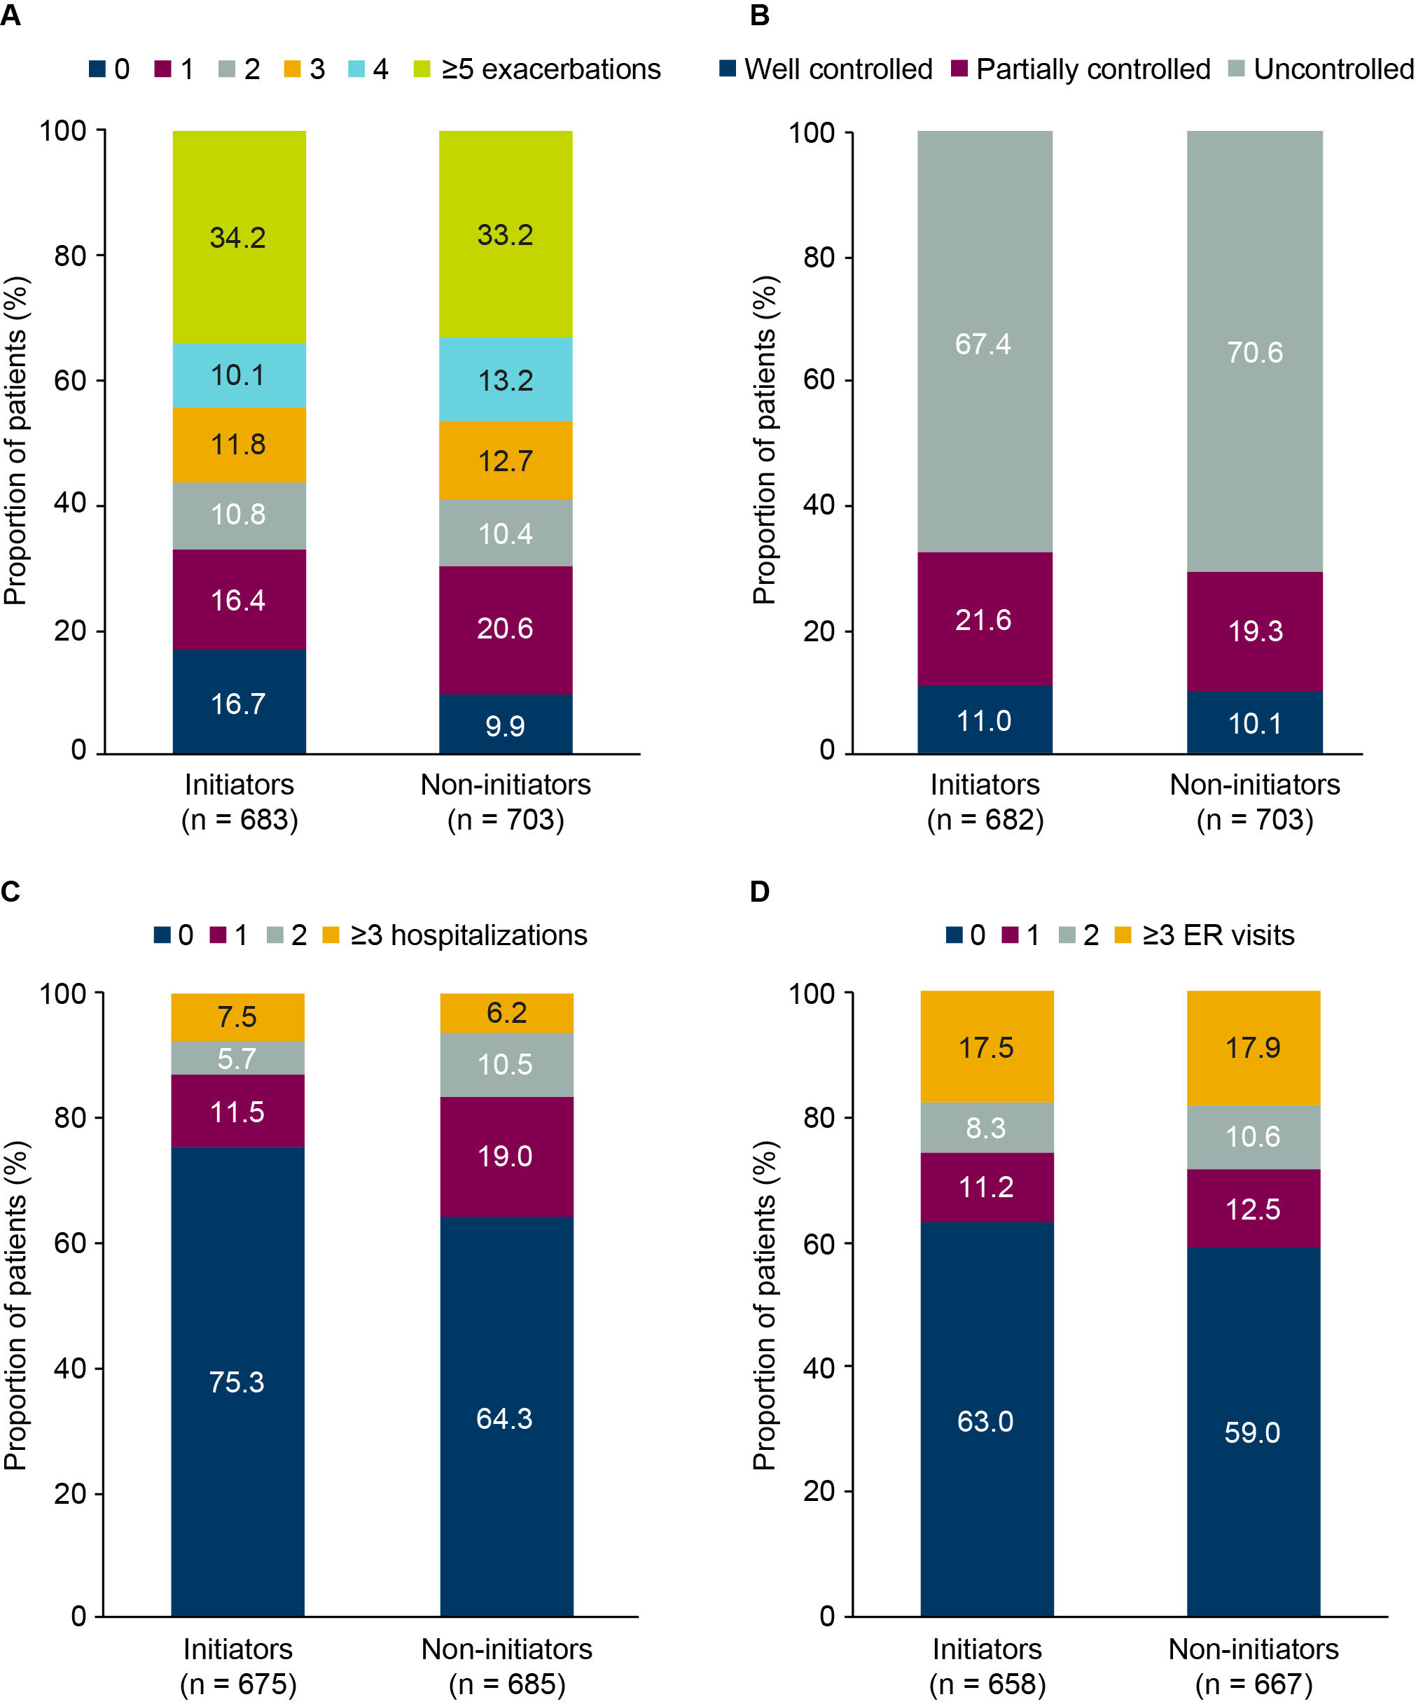

eFigure 1. Exacerbations (A), asthma control (B), hospitalizations (C) and ER visits (D) during the baseline period among biologic initiators (pre-biologic therapy) and non-initiators (pre-study enrollment) after IPTW.
Exacerbations, hospitalizations and ER visits are annualized numbers. Asthma control is last available assessment. ER, emergency room; IPTW, inverse probability of treatment weighting.
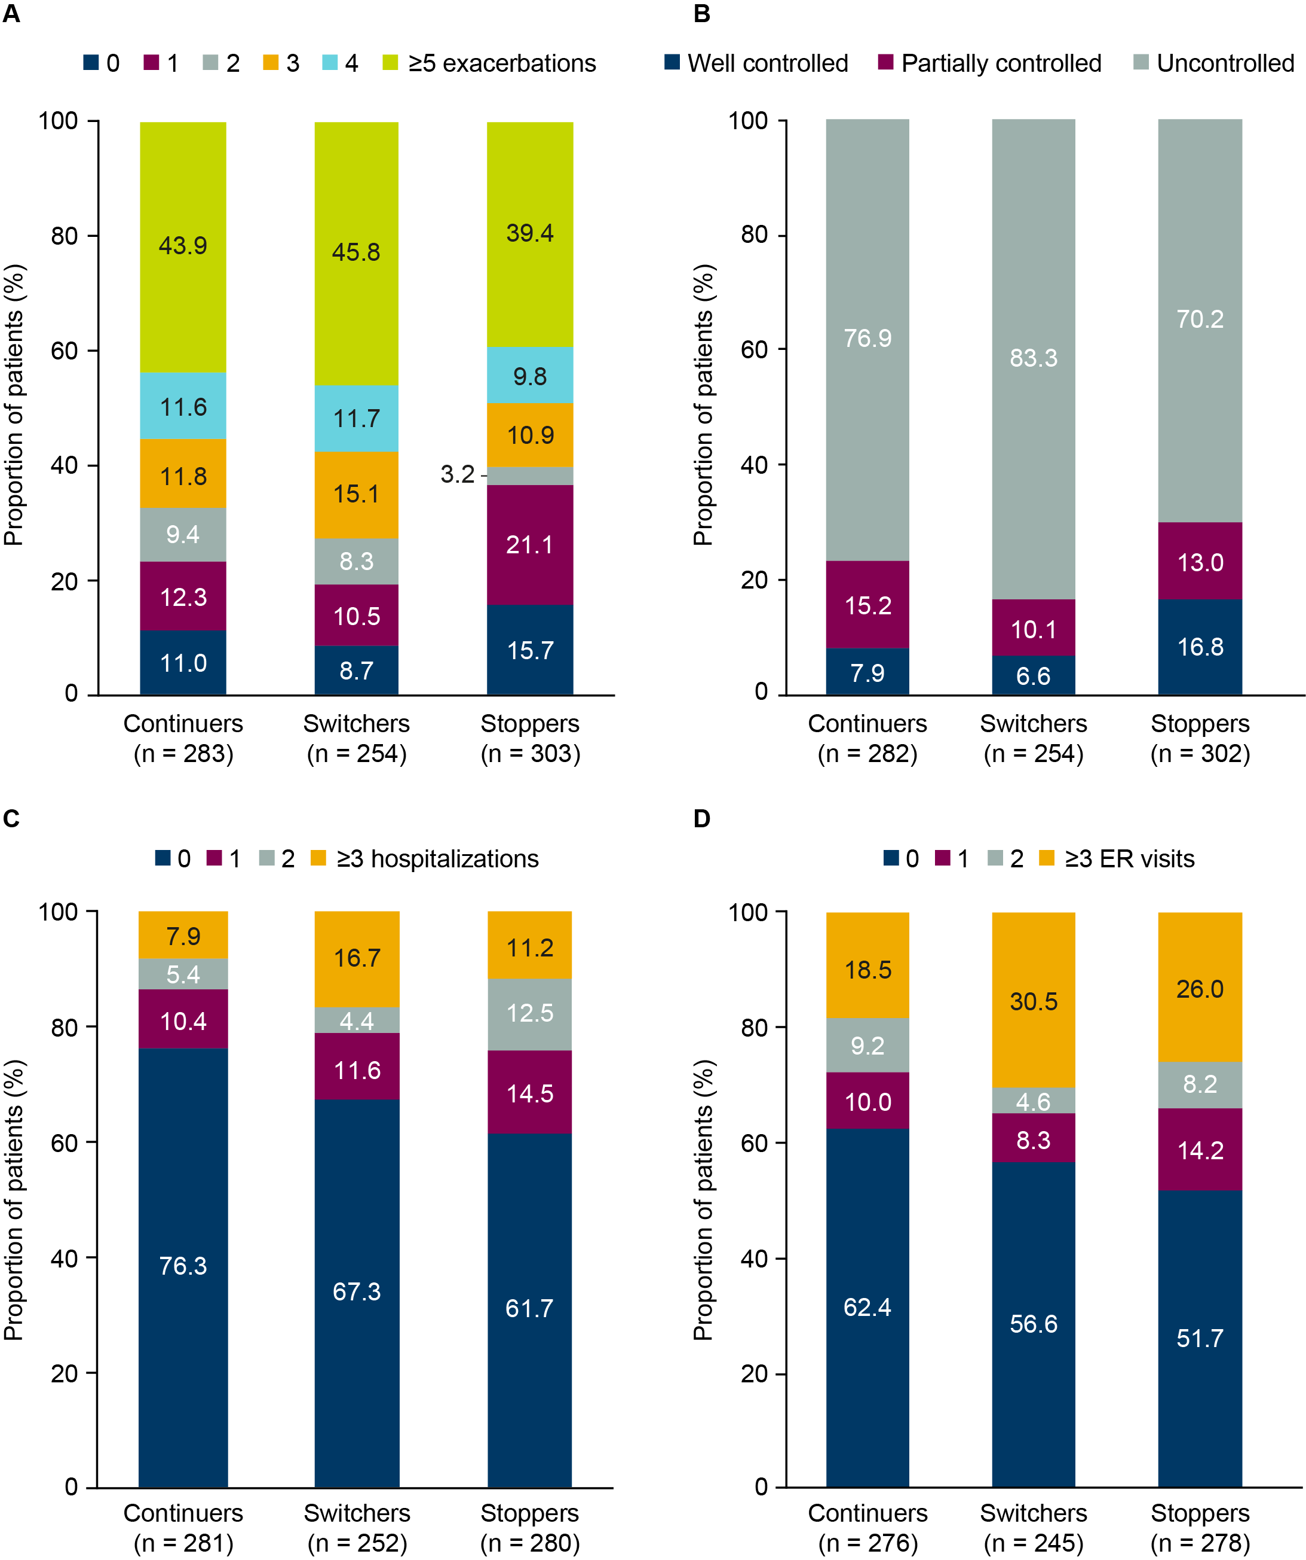

eFigure 2. Exacerbations (A), asthma control (B), hospitalizations (C) and ER visits (D) during the baseline period (pre-biologic therapy) among subsequent biologic continuers, switchers and stoppers after IPTW.
Exacerbations, hospitalizations and ER visits are annualized numbers. Asthma control is last available assessment. ER, emergency room; IPTW, inverse probability of treatment weighting.

