Supporting Information
Figure 1S RBC@ICG-DOX NPs dissolved in different solvents for 14 days stability.
Figure 2S Fluorescence stability of RBC@ICG-DOX NPs in different solvents at 0, 24 and 48 h.
Figure 3S Fluorescence stability of RBC@ICG-DOX NPs at 0, 24 and 48 h in different pH.
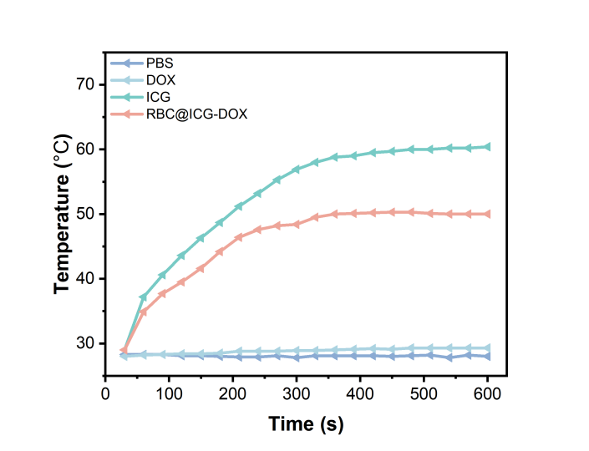
Figure 4S Temperature rise versus time profiles of PBS, free DOX, freeICG, and RBC@ICG-DOX NPs irradiated by an 808 nm laser (0.5 W cm⁻²).
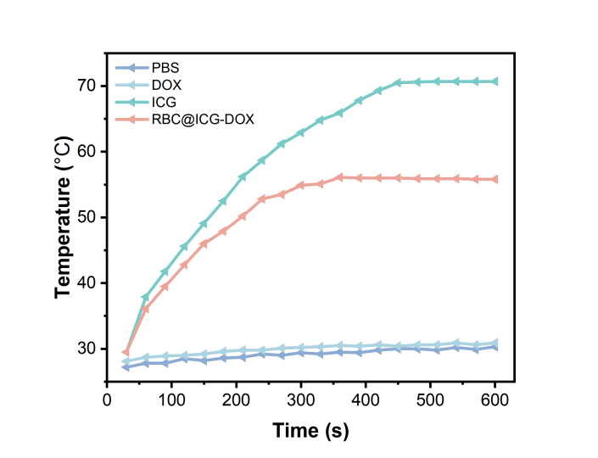
Figure 5S Temperature rise versus time profiles of PBS, free DOX, freeICG, and RBC@ICG-DOX NPs irradiated by an 808 nm laser (1 W cm⁻²).
Figure 6S Photothermal conversion efficiency of RBC@ICG-DOX.
Figure 7S Cell viability analysis of HeLa cells incubated in the dark and with laser irradiation (808 nm，1 W cm ⁻²).
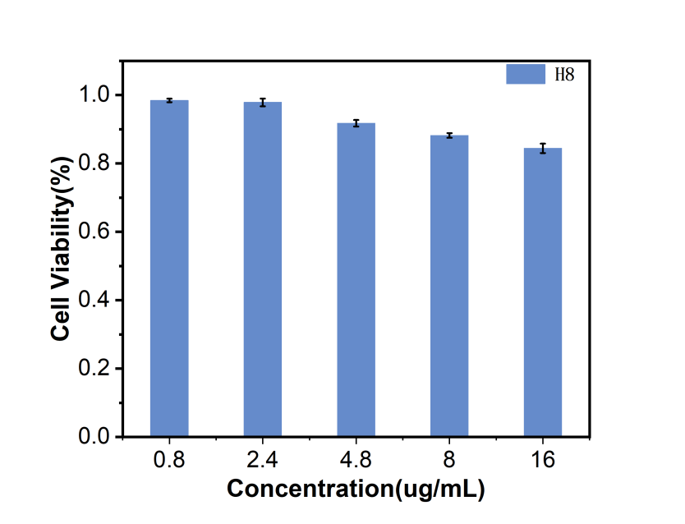
Figure 8S The cellular viability of H8 cells treated with RBC@ICG-DOX NPs.

